Matthew London

CIS 436 – JPB – 21 April 2019

NotAutoTrader

NotAutoTrader is a local automobile inventory search application. All its results are grabbed from the Market Check Vehicle Inventory Search API. In my project, you can query for:

* **New** cars by selecting a Make, Model, (new condition), your local zip code, and preferred mile radius
* **Used** cars by the same parameters above but with a model year input in addition.

I would test this functionality of this app by looking for a common car, exotic leaning vehicles will likely return a “no results found” toast.

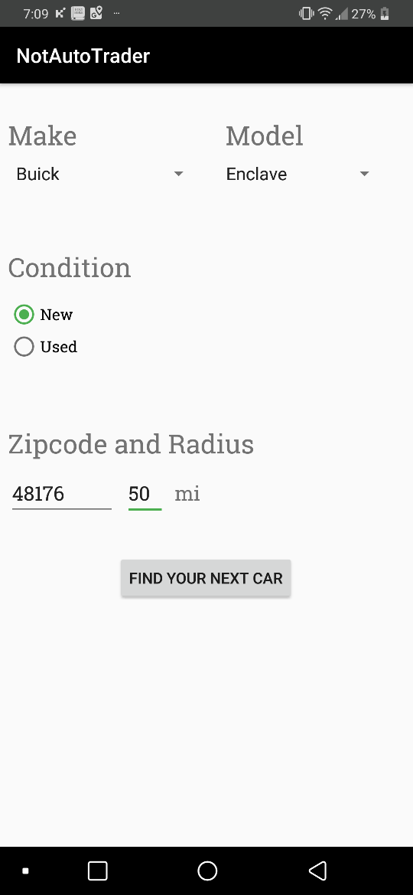Upon a successful search (like: Buick Enclave, new, 48176, 50-mile radius) (Pic 1), you will be shown a recycle-view activity of all the results returned from the API (Pic 2). Clicking on any selection will pull up a more detailed view with all the associated pictures using the Picasso Library (Pic 3). If more information is desired, follow the bottom button to the web listing (4).

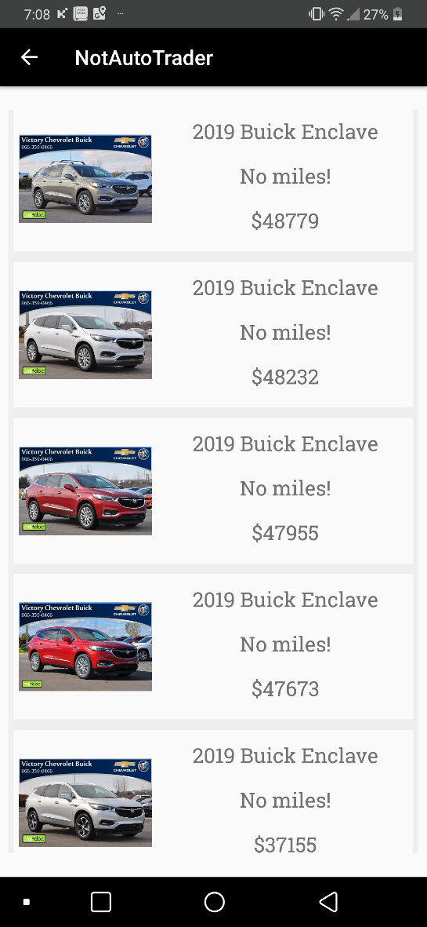

Pic 2

Pic 1

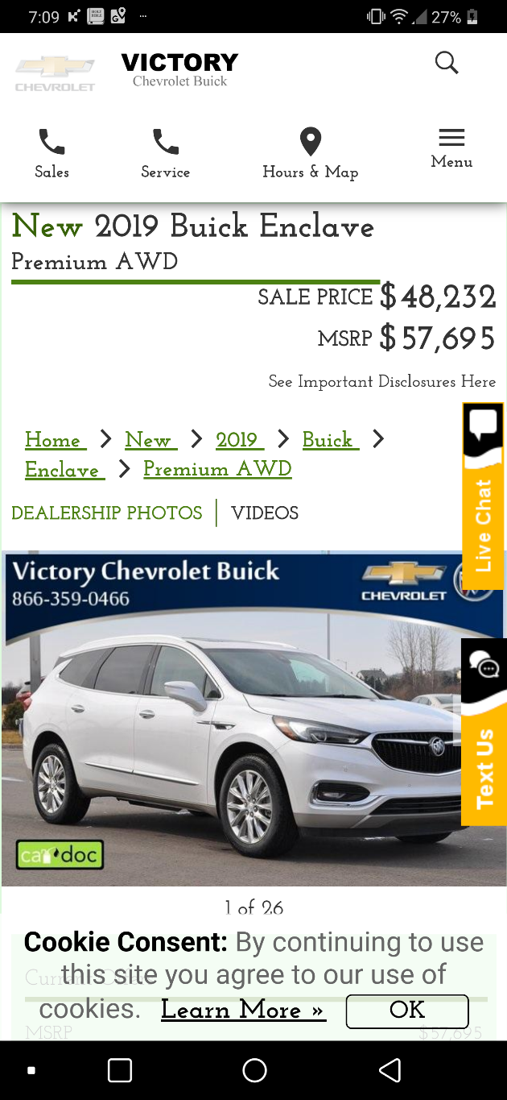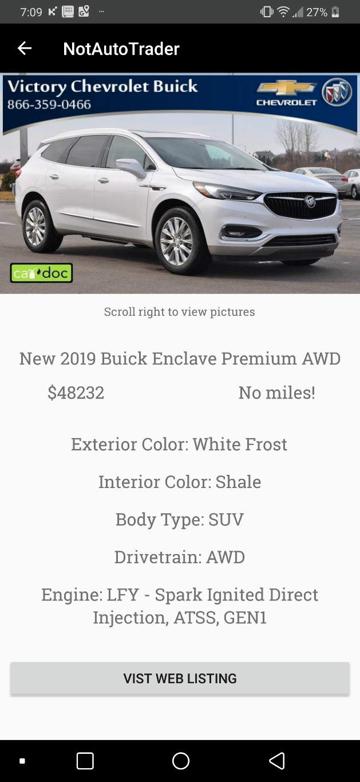

Pic 4

Pic 3

