Qubit Security (YARA Project) Matthew Jang

YARA is a tool aimed to help malware researchers identify and classify malware samples.

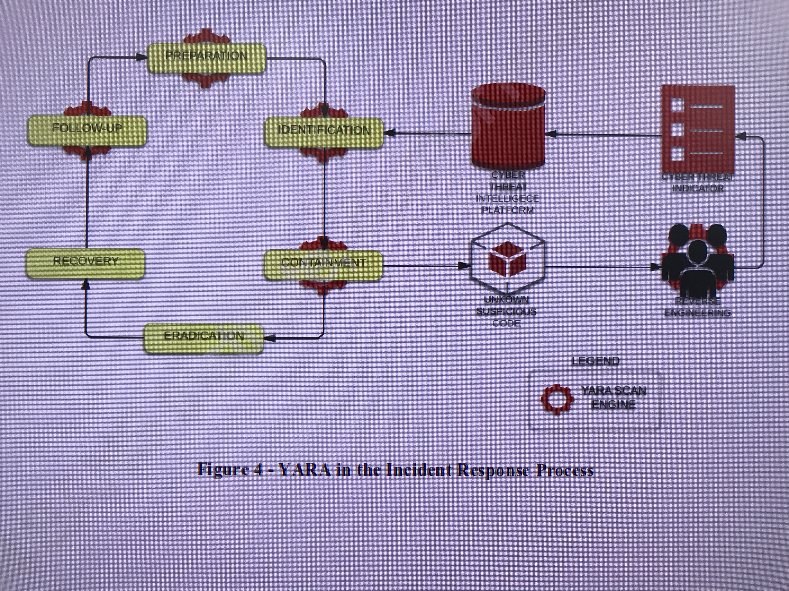
YARA Architecture

Ideas / Goals:
1) Log file 를 한 줄씩 검토하면서 malware 이 있나 말해주기 (i.e. matching).
2) 실시간 (Real Time)으로 만들기. Plura App

YARA를 이용 하기 전에 어떡해 쓰는 지를 먼저 알려드리겠습니다. 한국말 틀린 건 이해해주세요..

Rules
룰. 룰은 간단합니다. 아래 보시면 example룰 이 있습니다. 보시다시피 룰은 2 section이 있습니다: 1) strings랑 2) condition. 중요한 디테일은 ‘$’ sign 입니다.

rule ExampleRule
{
strings:
$text_string = “text_here” // This is a text string
$hex_string = {E2 34 A1 C8 23 FB} // This is a hex string

condition:
$text_string or $hex_string // Where logic of the rule resides
}

YARA Comment (코멘트) 는 이렇게 씁니다:
1) // Single-line Comment
2) /*
Multi-line Comment
*/

Strings 부분을 보겠습니다. Strings는 2가지 가 있습니다. 1) text string & 2) hex string. Text string은 그냥 보통 string 입니다. 예를 들면:

...
{
strings:
$text_string = “foobar” // Double Quotation (“ “) 을 씁니다.
…
}

Hex string은 조금 더 다양합니다. Hex string 또는 Hexadecimal string은 3가지 타입이 있습니다: a) wild-cards b) jumps & c) alternatives.
http://chxo.com/scripts/hex2string.php
a) Wild-cards를 보겠습니다.
- Uses placeholder character: ‘?’
- Used because some bytes are unknown

- Example:

…
{
strings:
$hex_string = { E2 34 ?? C8 A? FB } // ? and ?? are wild-cards.

condition:
…
}

b) Jump를 보겠습니다.
- Need to define strings with chunks of variable content & length.
- Example:

…
{
strings:
$hex_string = { F4 23 [ 4-6 ] 62 B4 } // [ 4-6 ] is a jump.

conditions:
…
}

[ X-Y ]: Any arbitrary sequence can occupy the position of this jump such that 0 <= X <= Y. X가 Y보다는 작던 지 똑같아야 됩니다.
ex) [ 4-6 ] 또는 4-byte 부터 6-byte 까지
Possibilities:
i) { F4 23 01 02 03 04 62 b4 } 4-bytes
ii) { F4 23 00 00 00 00 00 62 B4 } 5-bytes
iii) { F4 23 15 82 A3 04 45 22 62 B4 } 6-bytes

Variations:
i) if X = Y, then [ X-Y ] becomes [ X ].
ex) [ 6- 6 ] is equivalent to [6]

ii) Unbounded jumps:
ex)
[10 - ]: means [ 10 – infinite ]
[ - ]: [ 0 – infinite ]

c) Alternatives를 보겠습니다.
Python에서 if … else statement랑 많이 비슷합니다.
ex)
…
{
strings:
$hex_string = { F4 23 ( 62 B4 | 56 ) 45 }

condition:
…
}

Possibilities:
i) F42362B445 if
ii) F4235645 else

Conditions 부분을 보겠습니다.
- Basically a boolean expression, like an if statement, where strings get evaluated.
- and, or, not, >=, <=, <, >, ==, !=, +, -, *, \, %, &, |, <<, >>, ~, ^
- ex) ($a or $b) and ($c or $d) such that $a, $b, $c, and $d are all strings in a rule.

- Counting strings: string name + ‘#’sign in front instead of normal ‘$’ sign.
- ex) #a == 6 and #b > 10 ($a는 6번 나오고 $b는 10번 보다 더 나온다)

- String offset (location): using ‘at’ to find a fixed location.
- ex) $a at 100 and $b at 200 → will return True if $a is at offset 100, and if $b is at offset 200.

- ‘in’ is used to search for a string within range of offsets.
- ex) $a in (0 .. 100) and $b in (100 .. filesize) // filesize is a variable (entire file)
Sets of Strings: string 하나보다 더 검토 해야 할 경우

ex)
…
{
strings:
$a = “...”
$b = “...”
$c = “...”

conditions:
2 of ($a, $b, $c) // can also write as: a) 2 of them or b) 2 of ($*)
}

ex)
…
{
strings:
$foo1 = “...”
$foo2 = “...”
$foo3 = “...”
conditions:
2 of ($foo*) // can also write as 2 of ($foo1, $foo2, $foo3)

}

*for … of operator:
- General Format: for expression of string_set: ( boolean_expression )
- Python에서 비슷한 게 List Comprehension 이란 겁니다.
- from those strings in string_set at least expression of them must satisfy boolean_expression.

Referencing other rules in file

ex)

rule Rule1
{
…
}

rule Rule2
{
strings:
$a = “...”

conditions:
$a and Rule1 // calls Rule1 defined above Rule2
}

Global Rules
- 모든 rule이 다 따라야 하는 global rule (umbrella).
- ex)

global rule SizeLimit
{
conditions:
filesize < 2MB
}

Private Rules
- ex)

private rule PrivateRuleExample
{
…

}

Rule Tags
HTML이랑 CSS 에서 id & class 랑 비슷한 concept 인 것 같습니다.
-ex)

rule TagsExample1: Foo Bar Baz
{
…
}

rule TagsExample2: Bar
{
…
}

*Metadata

- Rule안에 additional information을 더 쓰고 싶은 경우
- ex)

rule MetadataExample
{
meta: // meta variables contain no ‘$’ sign in front of variable name
my_identifier1 = “some string data” // strings
my_identifier2 = 24 // integers
my_identifier3 = true //boolean true/false

strings:
…

conditions:
…

}

YARA Rule 에 대해서는 끝입니다. 이제부터 중요한 것은 module 입니다.

YARA 는 벌써 module들 이 몇 개 있습니다. 예를 들면 PE, ELF, Cuckoo, Magic, Hash, 그리고, Math. (More info @ http://yara.readthedocs.io/en/v3.5.0/modules.html)

Module을 사용하려면:

ex) import “pe” 또는
import “cuckoo” 등등

이제는 PE랑 Cuckoo module 들을 사용할 수 있습니다:
ex)
rule Test
{
strings:
$a = “...”

condition:
$a and pe.entry_point == 0 x 1000 // PE module
}

Module 은 우리가 만들 수도 있다고 써있습니다: (http://yara.readthedocs.io/en/v3.5.0/writingmodules.html) C language를 써야 한다네요.

Including Files: 다른 파일을 불러오기

ex) include “other.yar” // includes content of “other.yar” into current file

C Programming Language Basics

C Basic commands | Explanation
#include <stdio.h> | This is a preprocessor command that includes standard input output header file(stdio.h) from the C library before compiling a C program
int main() | This is the main function from where execution of any C program begins.
{ | This indicates the beginning of the main function.
/*_some_comments_*/ | whatever is given inside the command “/* */” in any C program, won’t be considered for compilation and execution.
printf(“Hello_World! “); | printf command prints the output onto the screen.
getch(); | This command waits for any character input from keyboard.
return 0; | This command terminates C program (main function) and returns 0.
} | This indicates the end of the main function.

ex)

#include <stdio.h>
int main()
{
/* Our first simple C basic program */
printf("Hello World! ");
getch();
return 0;
}

Steps:

- Create
- Compile
- Execute or Run
- Get the Output

Running YARA for the first time

ex) Now we can write our own rule(s) and use Terminal (command-line tool) to scan some files for malware:

$ echo “rule QubitSecurity { condition: true }” > my_first_rule
$ yara my_first_rule my_first_rule // format: yara (rule) (file to be scanned)

Should Return/Output:

QubitSecurity my_first_rule

이 뜻은 파일 my_first_rule이 우리가 만든 rule QubitSecurity랑 match 한다는 뜻입니다.

만약에 my_first_rule이 malware/virus 있는 파일 이였다면 우리가 만든 rule 이 그 malware를 발견한 거죠 (match).

*The general format to run YARA on a command line, like Terminal, is:

$ yara [Options] Rules-File Target

Rules-File is another way of referring to a file that has our rule(s), such as rules.yara above.
Target is another way of referring to a “file to be scanned”, such as our text files above.

Byte-Signatures
Byte-signature or byte detections are a signature based off a sequence of file bytes that are present in a file or data stream. Byte signatures are a very common form of detection and have been used since the first anti-virus scanner. Their usefulness is due to the accuracy they provide for detecting a sequence of bytes. The sequence of bytes is chosen because it exist in multiple variants of malware from the same family. Byte-signatures can be any type of data such as code or data contained inside of a data stream of an executable, a XORed .pdf or a Word document.

Example of a byte signature in the ClamAV format.
Simple dot exe:1:90FF1683EE0483EB0175F6
"Simple dot exe" is the output displayed by the ClamAV scanner; this is usually the malware family name. The second section is for the ClavAV engine to know the file type of the scanned file. The value '1' is for the engine to scan portable executable files. To scan any file type the value '0' needs to be used. The "90FF1683EE0483EB0175F6" is the hexadecimal representation of the opcodes. It represents the below assembly.
start: 0x401A2E length: 0xC
90 nop
FF 16 call dword ptr [esi]
83 EE 04 sub esi, 4
83 EB 01 sub ebx, 1
75 F6 jnz short loc_401A30

Example of a byte signature in the YARA format.

rule example
{
strings:
signature = { 66 90 FF 16 83 EE 04 83 EB 01 75 F6 }
condition:
signature
}

Yara's signature format is much different than ClamAV. The syntax style is similar to a C struct. The first string defines that we are creating a rule of "example". The "strings" and "condition" are keywords used by the Yara engine. The strings defines the signatures. Yara's signatures can be any many formats from strings, hex-bytes, regex and a number of other formats. The keyword "condition" defines under what circumstances Yara should alert on the signature. There are many conditions that can be constructed for Yara to detect a file. See reference 6 for more information.

