Ultima IV Tile Reference
U4TilesV.gif
Sprite sheet: 256×256 pixels, 16×16 grid of 16×16 pixel tiles (256 tiles total)
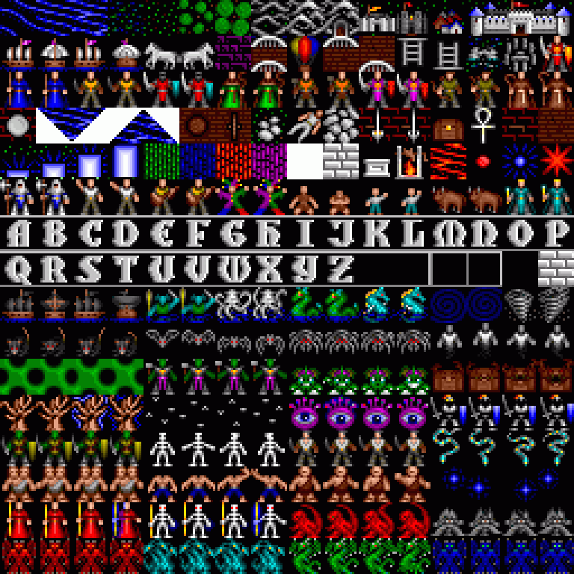
Full sprite sheet (3× scale)
Row 0: Terrain & Overworld
Pos | Tile | Name | Description
R0 C0 |  | Deep Water | Dark blue ocean water with wave animation
R0 C1 | 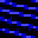 | Medium Water | Lighter blue water, coastal shallows
R0 C2 | 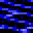 | Shallow Water | Light blue shallow water near shoreline
R0 C3 | 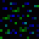 | Swamp | Green murky swamp terrain with bubbles
R0 C4 |  | Grassland | Green grass, basic overworld ground tile
R0 C5 |  | Brush | Scattered bushes on green ground
R0 C6 |  | Forest | Dense green trees, blocks movement
R0 C7 |  | Hills | Grey rocky hills, rough terrain
R0 C8 |  | Mountains | Tall grey mountain peaks, impassable
R0 C9 |  | Dungeon Entrance | Dark stone doorway leading underground
R0 C10 |  | Town (Small) | Small settlement with colored rooftops
R0 C11 | 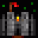 | Castle | Red-roofed castle with flag, major location
R0 C12 |  | Village | Blue-roofed village buildings
R0 C13 |  | Castle Wall (L) | Left section of castle wall fortification
R0 C14 | 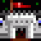 | Castle Wall (M) | Middle section of castle wall with towers
R0 C15 |  | Castle Wall (R) | Right section of castle wall fortification
Row 1: Vehicles & Structures
Pos | Tile | Name | Description
R1 C0 |  | Ship (West) | Sailing ship facing west
R1 C1 |  | Ship (North) | Sailing ship facing north
R1 C2 |  | Ship (East) | Sailing ship facing east
R1 C3 |  | Ship (South) | Sailing ship facing south
R1 C4 |  | Horse (West) | White horse facing west, rideable mount
R1 C5 |  | Horse (East) | White horse facing east, rideable mount
R1 C6 |  | Hot Air Balloon | Colorful hot air balloon, flying vehicle
R1 C7 |  | Bridge | Stone bridge over water
R1 C8 |  | Covered Wagon | White covered wagon for overland travel
R1 C9 | 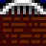 | Brick Wall | Red brick wall, interior/town structure
R1 C10 |  | Locked Door | Brown door with lock on brick wall
R1 C11 | 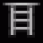 | Dungeon (Dark) | Dark dungeon background with stars
R1 C12 |  | Altar (L) | Left half of a shrine or altar
R1 C13 |  | Altar (R) | Right half of a shrine or altar
R1 C14 | 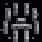 | Torch Post | Standing torch with flame on castle wall
R1 C15 | 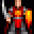 | Guard / NPC | Armored guard or NPC with weapon

Row 2: Character Classes
Pos | Tile | Name | Description
R2 C0 | 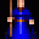 | Mage | Blue-robed spellcaster character
R2 C1 |  | Bard | Yellow-shirted bard with instrument
R2 C2 | 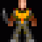 | Fighter | Armored warrior with sword
R2 C3 | 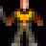 | Druid | Red-robed druid with staff
R2 C4 |  | Tinker | Red-vested tinker, crafting class
R2 C5 |  | Paladin | Green-caped paladin, holy warrior
R2 C6 |  | Ranger | Orange-clad ranger, forest scout
R2 C7 |  | Ranger (Alt) | Alternate ranger sprite variant
R2 C8 | 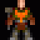 | Shepherd | Green-robed shepherd character
R2 C9 | 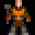 | Avatar (F1) | Avatar frame 1, purple-caped hero
R2 C10 |  | Avatar (F2) | Avatar frame 2, purple-caped hero variant
R2 C11 |  | Orc (Green) | Green-skinned orc warrior
R2 C12 | 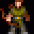 | Orc (Dark) | Dark-skinned orc warrior variant
R2 C13 | 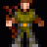 | Villager (M) | Male brown-clothed villager NPC
R2 C14 |  | Villager (F) | Female brown-clothed villager NPC
R2 C15 |  | Monk | Brown-robed monk character
Row 3: Celestial & Dungeon Features
Pos | Tile | Name | Description
R3 C0 |  | Moon (Full) | Full white moon, celestial body
R3 C1 |  | Water (Anim 1) | Water animation frame 1, diagonal waves
R3 C2 |  | Water (Anim 2) | Water animation frame 2, triangle shape
R3 C3 |  | Portcullis | Brown circular portcullis or wheel mechanism
R3 C4 |  | Brick Floor | Red brick floor with horizontal pattern
R3 C5 |  | Poison Field | Green poison gas field, damages on contact
R3 C6 | 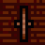 | Skeleton | Animated skeleton, combat or obstacle
R3 C7 | 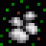 | Rock Pile | Pile of grey rocks, dungeon debris
R3 C8 | 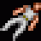 | Sparkle | White sparkle effect, item or magic
R3 C9 | 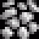 | Brick Wall (Alt) | Red brick wall, alternate pattern
R3 C10 |  | Chest | Brown treasure chest with gold trim
R3 C11 |  | Ankh | White ankh symbol on dark background, shrine marker
R3 C12 |  | Brick (Blank) | Plain red brick wall section
R3 C13 |  | Brick (Blank 2) | Plain red brick wall section variant
R3 C14 |  | Brick (Blank 3) | Plain red brick wall section variant
R3 C15 |  | Brick (Blank 4) | Plain red brick wall section variant

Row 4: Magic & Dungeon Effects
Pos | Tile | Name | Description
R4 C0 |  | Energy Field (P1) | Purple energy field, animation frame 1
R4 C1 |  | Energy Field (P2) | Purple energy field, animation frame 2
R4 C2 | 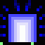 | Portal (Open) | Bright white/purple open portal or moongate
R4 C3 |  | Portal (Closed) | Dim purple closed portal or moongate
R4 C4 |  | Magical Barrier | Green and red magical barrier, striped
R4 C5 | 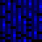 | Fire Field (Mag) | Magenta/purple fire field, magical
R4 C6 | 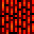 | Fire Field (Red) | Red fire field, magical barrier
R4 C7 |  | Darkness | Pure black tile, unexplored area
R4 C8 |  | Stone Wall | Grey stone block wall, dungeon
R4 C9 |  | Fireplace | Stone fireplace with metal grate
R4 C10 |  | Campfire | Open flame campfire, light source
R4 C11 | 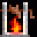 | Lava (Red) | Bright red lava, damaging terrain
R4 C12 | 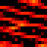 | Magic Orb (Red) | Red glowing orb, magical effect
R4 C13 |  | Magic Orb (Blue) | Blue glowing orb, magical effect
R4 C14 | 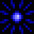 | Explosion (Red) | Red starburst explosion effect
R4 C15 |  | Explosion (Alt) | Alternate explosion or magic burst
Row 5: NPCs & Townsfolk
Pos | Tile | Name | Description
R5 C0 | 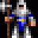 | Guard (F1) | White-armored guard, animation frame 1
R5 C1 |  | Guard (F2) | White-armored guard, animation frame 2
R5 C2 |  | Citizen (F1) | Yellow-shirted citizen, animation frame 1
R5 C3 |  | Citizen (F2) | Yellow-shirted citizen, animation frame 2
R5 C4 | 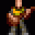 | Jester (F1) | Colorful jester character, animation frame 1
R5 C5 | 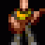 | Jester (F2) | Colorful jester character, animation frame 2
R5 C6 |  | Beggar (F1) | Brown-clad beggar NPC, animation frame 1
R5 C7 |  | Beggar (F2) | Brown-clad beggar NPC, animation frame 2
R5 C8 |  | Child (F1) | Small child NPC, animation frame 1
R5 C9 | 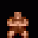 | Child (F2) | Small child NPC, animation frame 2
R5 C10 |  | Bear (F1) | Brown bear creature, animation frame 1
R5 C11 |  | Bear (F2) | Brown bear creature, animation frame 2
R5 C12 | 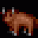 | Healer (F1) | Teal-robed healer NPC, animation frame 1
R5 C13 | 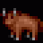 | Healer (F2) | Teal-robed healer NPC, animation frame 2
R5 C14 |  | Healer (Alt F1) | Teal-robed healer alternate, frame 1
R5 C15 |  | Healer (Alt F2) | Teal-robed healer alternate, frame 2

Row 6: Alphabet (A–P)
Pos | Tile | Name | Description
R6 C0 |  | Letter A | Stone-carved letter A for signage
R6 C1 |  | Letter B | Stone-carved letter B for signage
R6 C2 |  | Letter C | Stone-carved letter C for signage
R6 C3 |  | Letter D | Stone-carved letter D for signage
R6 C4 |  | Letter E | Stone-carved letter E for signage
R6 C5 |  | Letter F | Stone-carved letter F for signage
R6 C6 |  | Letter G | Stone-carved letter G for signage
R6 C7 |  | Letter H | Stone-carved letter H for signage
R6 C8 |  | Letter I | Stone-carved letter I for signage
R6 C9 |  | Letter J | Stone-carved letter J for signage
R6 C10 |  | Letter K | Stone-carved letter K for signage
R6 C11 |  | Letter L | Stone-carved letter L for signage
R6 C12 |  | Letter M | Stone-carved letter M for signage
R6 C13 |  | Letter N | Stone-carved letter N for signage
R6 C14 |  | Letter O | Stone-carved letter O for signage
R6 C15 |  | Letter P | Stone-carved letter P for signage
Row 7: Alphabet (Q–Z) & Extras
Pos | Tile | Name | Description
R7 C0 |  | Letter Q | Stone-carved letter Q for signage
R7 C1 |  | Letter R | Stone-carved letter R for signage
R7 C2 |  | Letter S | Stone-carved letter S for signage
R7 C3 |  | Letter T | Stone-carved letter T for signage
R7 C4 |  | Letter U | Stone-carved letter U for signage
R7 C5 |  | Letter V | Stone-carved letter V for signage
R7 C6 |  | Letter W | Stone-carved letter W for signage
R7 C7 |  | Letter X | Stone-carved letter X for signage
R7 C8 |  | Letter Y | Stone-carved letter Y for signage
R7 C9 |  | Letter Z | Stone-carved letter Z for signage
R7 C10 |  | Black (Blank) | Solid black tile, empty space
R7 C11 |  | Black (Blank 2) | Solid black tile, empty space
R7 C12 |  | Black (Blank 3) | Solid black tile, empty space
R7 C13 |  | Scroll Text (1) | Small white text on black, scroll content
R7 C14 |  | Scroll Text (2) | Small white text on black, scroll content
R7 C15 |  | Scroll Text (3) | Small white text on black, scroll content

Row 8: Sea Creatures & Weather
Pos | Tile | Name | Description
R8 C0 |  | Pirate Ship (F1) | Pirate ship animation frame 1
R8 C1 |  | Pirate Ship (F2) | Pirate ship animation frame 2
R8 C2 |  | Pirate Ship (F3) | Pirate ship animation frame 3
R8 C3 |  | Pirate Ship (F4) | Pirate ship animation frame 4
R8 C4 |  | Nixie (F1) | Green sea nixie creature, frame 1
R8 C5 |  | Nixie (F2) | Green sea nixie creature, frame 2
R8 C6 | 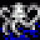 | Sea Serpent (F1) | Teal sea serpent, animation frame 1
R8 C7 | 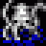 | Sea Serpent (F2) | Teal sea serpent, animation frame 2
R8 C8 |  | Sea Serpent (F3) | Teal sea serpent, animation frame 3
R8 C9 |  | Sea Horse (F1) | Cyan seahorse creature, frame 1
R8 C10 |  | Sea Horse (F2) | Cyan seahorse creature, frame 2
R8 C11 |  | Sea Horse (F3) | Cyan seahorse creature, frame 3
R8 C12 |  | Sea Horse (F4) | Cyan seahorse creature, frame 4
R8 C13 |  | Whirlpool (F1) | Dark blue whirlpool, animation frame 1
R8 C14 |  | Whirlpool (F2) | Dark blue whirlpool, animation frame 2
R8 C15 | 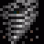 | Tornado | Grey tornado/twister, weather hazard
Row 9: Monsters – Rats, Bats & Ghosts
Pos | Tile | Name | Description
R9 C0 |  | Rat (F1) | Dark rat creature, animation frame 1
R9 C1 |  | Rat (F2) | Dark rat creature, animation frame 2
R9 C2 |  | Rat (F3) | Dark rat creature, animation frame 3
R9 C3 |  | Rat (F4) | Dark rat creature, animation frame 4
R9 C4 | 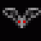 | Bat (F1) | Dark bat creature, animation frame 1
R9 C5 |  | Bat (F2) | Dark bat creature, animation frame 2
R9 C6 | 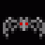 | Spider (F1) | Grey giant spider, animation frame 1
R9 C7 | 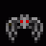 | Spider (F2) | Grey giant spider, animation frame 2
R9 C8 | 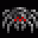 | Spider (F3) | Grey giant spider, animation frame 3
R9 C9 | 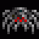 | Spider (F4) | Grey giant spider, animation frame 4
R9 C10 | 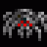 | Ghost (F1) | White translucent ghost, frame 1
R9 C11 | 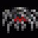 | Ghost (F2) | White translucent ghost, frame 2
R9 C12 |  | Ghost (F3) | White translucent ghost, frame 3
R9 C13 |  | Ghost (F4) | White translucent ghost, frame 4
R9 C14 |  | Ghost (F5) | White translucent ghost, frame 5
R9 C15 |  | Ghost (F6) | White translucent ghost, frame 6

Row 10: Monsters – Slimes & Trolls
Pos | Tile | Name | Description
R10 C0 |  | Slime (F1) | Green blob slime, animation frame 1
R10 C1 |  | Slime (F2) | Green blob slime, animation frame 2
R10 C2 |  | Slime (F3) | Green blob slime, animation frame 3
R10 C3 |  | Slime (F4) | Green blob slime, animation frame 4
R10 C4 | 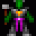 | Insectoid (F1) | Purple insect creature, animation frame 1
R10 C5 |  | Insectoid (F2) | Purple insect creature, animation frame 2
R10 C6 | 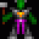 | Insectoid (F3) | Purple insect creature, animation frame 3
R10 C7 | 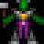 | Insectoid (F4) | Purple insect creature, animation frame 4
R10 C8 |  | Troll (F1) | Green-faced troll monster, frame 1
R10 C9 |  | Troll (F2) | Green-faced troll monster, frame 2
R10 C10 |  | Troll (F3) | Green-faced troll monster, frame 3
R10 C11 |  | Troll (F4) | Green-faced troll monster, frame 4
R10 C12 |  | Gremlin (F1) | Brown furry gremlin creature, frame 1
R10 C13 |  | Gremlin (F2) | Brown furry gremlin creature, frame 2
R10 C14 |  | Gremlin (F3) | Brown furry gremlin creature, frame 3
R10 C15 |  | Gremlin (F4) | Brown furry gremlin creature, frame 4
Row 11: Monsters – Reapers & Gazers
Pos | Tile | Name | Description
R11 C0 | 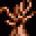 | Reaper (F1) | Brown dead tree / reaper monster, frame 1
R11 C1 | 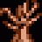 | Reaper (F2) | Brown dead tree / reaper monster, frame 2
R11 C2 | 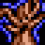 | Reaper (F3) | Brown dead tree / reaper monster, frame 3
R11 C3 | 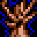 | Reaper (F4) | Brown dead tree / reaper monster, frame 4
R11 C4 | 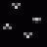 | Dark Swarm (F1) | Small dark flying swarm, frame 1
R11 C5 |  | Dark Swarm (F2) | Small dark flying swarm, frame 2
R11 C6 | 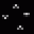 | Dark Swarm (F3) | Small dark flying swarm, frame 3
R11 C7 | 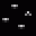 | Dark Swarm (F4) | Small dark flying swarm, frame 4
R11 C8 |  | Gazer (F1) | Large floating eye / gazer, frame 1
R11 C9 |  | Gazer (F2) | Large floating eye / gazer, frame 2
R11 C10 |  | Gazer (F3) | Large floating eye / gazer, frame 3
R11 C11 |  | Gazer (F4) | Large floating eye / gazer, frame 4
R11 C12 | 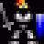 | Phantom (F1) | Blue phantom / wisp creature, frame 1
R11 C13 | 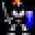 | Phantom (F2) | Blue phantom / wisp creature, frame 2
R11 C14 | 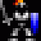 | Phantom (F3) | Blue phantom / wisp creature, frame 3
R11 C15 | 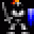 | Phantom (F4) | Blue phantom / wisp creature, frame 4

Row 12: Monsters – Orcs, Snakes & Skeletons
Pos | Tile | Name | Description
R12 C0 | 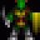 | Orc (F1) | Green orc warrior, animation frame 1
R12 C1 | 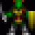 | Orc (F2) | Green orc warrior, animation frame 2
R12 C2 |  | Orc (F3) | Green orc warrior, animation frame 3
R12 C3 | 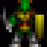 | Orc (F4) | Green orc warrior, animation frame 4
R12 C4 |  | Snake (F1) | Yellow snake creature, animation frame 1
R12 C5 |  | Snake (F2) | Yellow snake creature, animation frame 2
R12 C6 |  | Snake (F3) | Yellow snake creature, animation frame 3
R12 C7 | 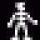 | Snake (F4) | Yellow snake creature, animation frame 4
R12 C8 | 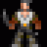 | Skeleton (F1) | Walking skeleton warrior, frame 1
R12 C9 | 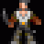 | Skeleton (F2) | Walking skeleton warrior, frame 2
R12 C10 | 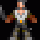 | Skeleton (F3) | Walking skeleton warrior, frame 3
R12 C11 |  | Skeleton (F4) | Walking skeleton warrior, frame 4
R12 C12 |  | Knight (F1) | Armored evil knight, animation frame 1
R12 C13 |  | Knight (F2) | Armored evil knight, animation frame 2
R12 C14 |  | Wisp (F1) | Cyan glowing wisp creature, frame 1
R12 C15 |  | Wisp (F2) | Cyan glowing wisp creature, frame 2
Row 13: Monsters – Cyclops, Ettins & Balrons
Pos | Tile | Name | Description
R13 C0 | 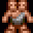 | Cyclops (F1) | Large brown cyclops, animation frame 1
R13 C1 | 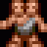 | Cyclops (F2) | Large brown cyclops, animation frame 2
R13 C2 | 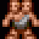 | Cyclops (F3) | Large brown cyclops, animation frame 3
R13 C3 | 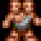 | Cyclops (F4) | Large brown cyclops, animation frame 4
R13 C4 |  | Ettin (F1) | Blue two-headed ettin, animation frame 1
R13 C5 |  | Ettin (F2) | Blue two-headed ettin, animation frame 2
R13 C6 |  | Ettin (F3) | Blue two-headed ettin, animation frame 3
R13 C7 |  | Ettin (F4) | Blue two-headed ettin, animation frame 4
R13 C8 | 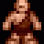 | Troll Brute (F1) | Brown large troll brute, frame 1
R13 C9 | 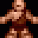 | Troll Brute (F2) | Brown large troll brute, frame 2
R13 C10 |  | Troll Brute (F3) | Brown large troll brute, frame 3
R13 C11 | 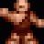 | Troll Brute (F4) | Brown large troll brute, frame 4
R13 C12 |  | Ankh (Blue F1) | Blue ankh symbol effect, frame 1
R13 C13 |  | Ankh (Blue F2) | Blue ankh symbol effect, frame 2
R13 C14 |  | Ankh (Blue F3) | Blue ankh symbol effect, frame 3
R13 C15 |  | Ankh (Blue F4) | Blue ankh symbol effect, frame 4

Row 14: Monsters – Liches, Daemons & Dragons
Pos | Tile | Name | Description
R14 C0 |  | Lich (F1) | Red-robed lich / wizard, animation frame 1
R14 C1 |  | Lich (F2) | Red-robed lich / wizard, animation frame 2
R14 C2 |  | Lich (F3) | Red-robed lich / wizard, animation frame 3
R14 C3 | 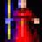 | Lich (F4) | Red-robed lich / wizard, animation frame 4
R14 C4 |  | Daemon (F1) | White skeletal daemon, animation frame 1
R14 C5 |  | Daemon (F2) | White skeletal daemon, animation frame 2
R14 C6 |  | Daemon (F3) | White skeletal daemon, animation frame 3
R14 C7 | 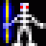 | Daemon (F4) | White skeletal daemon, animation frame 4
R14 C8 |  | Dragon (Red F1) | Red dragon, large boss creature frame 1
R14 C9 |  | Dragon (Red F2) | Red dragon, large boss creature frame 2
R14 C10 |  | Dragon (Red F3) | Red dragon, large boss creature frame 3
R14 C11 |  | Dragon (Red F4) | Red dragon, large boss creature frame 4
R14 C12 | 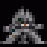 | Balron (F1) | Grey winged balron / demon lord, frame 1
R14 C13 | 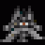 | Balron (F2) | Grey winged balron / demon lord, frame 2
R14 C14 | 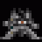 | Balron (F3) | Grey winged balron / demon lord, frame 3
R14 C15 | 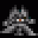 | Balron (F4) | Grey winged balron / demon lord, frame 4
Row 15: Boss Monsters
Pos | Tile | Name | Description
R15 C0 | 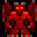 | Hydra (F1) | Red multi-headed hydra, animation frame 1
R15 C1 | 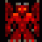 | Hydra (F2) | Red multi-headed hydra, animation frame 2
R15 C2 | 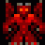 | Hydra (F3) | Red multi-headed hydra, animation frame 3
R15 C3 | 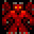 | Hydra (F4) | Red multi-headed hydra, animation frame 4
R15 C4 |  | Drake (F1) | Cyan/teal drake creature, animation frame 1
R15 C5 |  | Drake (F2) | Cyan/teal drake creature, animation frame 2
R15 C6 |  | Drake (F3) | Cyan/teal drake creature, animation frame 3
R15 C7 |  | Drake (F4) | Cyan/teal drake creature, animation frame 4
R15 C8 | 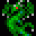 | Lizardman (F1) | Green lizardman warrior, frame 1
R15 C9 | 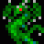 | Lizardman (F2) | Green lizardman warrior, frame 2
R15 C10 | 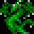 | Lizardman (F3) | Green lizardman warrior, frame 3
R15 C11 | 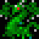 | Lizardman (F4) | Green lizardman warrior, frame 4
R15 C12 | 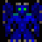 | Zorn (F1) | Dark blue zorn creature, frame 1
R15 C13 | 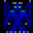 | Zorn (F2) | Dark blue zorn creature, frame 2
R15 C14 | 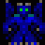 | Zorn (F3) | Dark blue zorn creature, frame 3
R15 C15 | 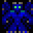 | Zorn (F4) | Dark blue zorn creature, frame 4

