Ultima III Tile Reference
U3TilesE.gif
Sprite sheet: 256×80 pixels, 16×5 grid of 16×16 pixel tiles (80 tiles total)
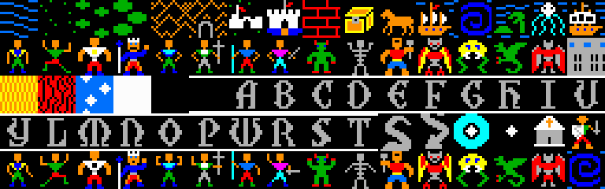
Full sprite sheet (3× scale)
Row 0: Terrain & Overworld Tiles
Pos | Tile | Name | Description
R0 C0 |  | Water (Deep Ocean) | Blue horizontal wave lines on dark background. Used for seas and oceans on the overworld map.
R0 C1 | 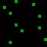 | Grass / Plains | Sparse green dots on black. The basic open terrain tile for fields and meadows.
R0 C2 |  | Brush / Scrubland | Green cross-shaped vegetation on black. Transitional terrain between grass and forest.
R0 C3 |  | Forest | Dense green foliage clusters. Heavier tree cover, may slow movement.
R0 C4 | 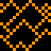 | Mountains | Orange/brown chevron pattern representing peaks. Impassable or difficult terrain.
R0 C5 | 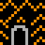 | Dungeon Entrance | Gray stone archway/doorway set against mountain terrain. Entry point to dungeon levels.
R0 C6 | 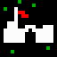 | Town / Village | White buildings with green surroundings and a red flag. Settlement that can be entered.
R0 C7 |  | Castle | White castle structure with blue base and flags. Major location such as Lord British's castle.
R0 C8 | 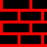 | Brick Wall | Red brick pattern. Interior wall tile used in towns and dungeons.
R0 C9 |  | Treasure Chest | Yellow/gold chest on black background. Lootable container found in dungeons and towns.
R0 C10 | 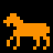 | Horse | Orange horse sprite. Mountable creature that increases overworld travel speed.
R0 C11 |  | Ship / Frigate | Sailing vessel with white sails and orange hull. Used for ocean travel.
R0 C12 |  | Whirlpool | Blue spiral pattern. Dangerous water hazard that can transport or damage the party.
R0 C13 | 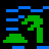 | Island / Jungle | Green land mass with palm tree on blue water. Tropical terrain or small island.
R0 C14 | 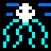 | Moongate / Portal | Cyan vertical beams with white sparkle. Magical teleportation gate tied to moon phases.
R0 C15 |  | Pirate Ship / Ship Variant | Orange hull with white upper structure. Enemy vessel or alternate ship sprite.

Row 1: Characters & Monsters (Frame 1)
Pos | Tile | Name | Description
R1 C0 | 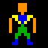 | Fighter (Frame 1) | Character with orange hair, green pants. Standard melee warrior class.
R1 C1 | 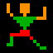 | Thief (Frame 1) | Running pose with red legs. Agile rogue class specializing in traps and ranged attacks.
R1 C2 |  | Paladin (Frame 1) | White/orange armored figure. Holy warrior with both combat and priest magic.
R1 C3 | 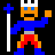 | Wizard (Frame 1) | Blue-robed figure holding a staff. Primary spellcaster with sorcerer magic.
R1 C4 | 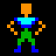 | Barbarian (Frame 1) | Green-clad figure with blue headgear. Strong melee fighter, no magic ability.
R1 C5 | 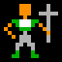 | Cleric (Frame 1) | Green figure carrying a cross/staff. Healer class with priest spells.
R1 C6 | 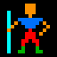 | Lark (Frame 1) | Figure with blue weapon and red pants. Hybrid class with some magical ability.
R1 C7 | 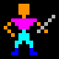 | Illusionist (Frame 1) | Magenta/purple-robed figure. Spellcaster class with both priest and sorcerer magic.
R1 C8 | 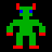 | Orc | Green-skinned humanoid creature with red eyes. Common enemy monster.
R1 C9 | 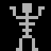 | Skeleton | Gray bone structure on black. Undead enemy found in dungeons.
R1 C10 | 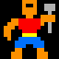 | Pirate / Brigand | Red/orange figure with blue weapon. Human enemy encountered on land or sea.
R1 C11 | 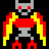 | Balron / Demon | Red-winged creature with yellow flames. Powerful late-game enemy.
R1 C12 |  | Man-Thing / Treant | Yellow and green plant-like creature. Nature-based monster.
R1 C13 | 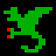 | Dragon | Green serpentine dragon shape. Powerful monster with breath attacks.
R1 C14 | 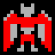 | Daemon | Red bat-winged creature. High-level demonic enemy.
R1 C15 | 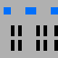 | Town Gate / Portcullis | Gray grid with blue accents. Iron gate structure used at town and castle entrances.

Row 2: Effects, Terrain Variants & Font (Part 1)
Pos | Tile | Name | Description
R2 C0 | 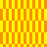 | Lava / Fire Field | Yellow and red vertical stripes. Damaging terrain found in dungeons and volcanic areas.
R2 C1 | 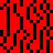 | Poison / Flames | Red chaotic pattern. Hazardous terrain that poisons or damages the party.
R2 C2 |  | Night Sky / Stars | White diamond sparkles on blue. Starfield or magical effect background.
R2 C3 |  | Void / Empty (Black) | Solid black tile. Used for unexplored areas, void, or empty space.
R2 C4 | 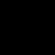 | Font: Letter A | Gray serif letter A on black background. Part of the in-game text font.
R2 C5 |  | Font: Letter B | Gray serif letter B on black background.
R2 C6 |  | Font: Letter C | Gray serif letter C on black background.
R2 C7 |  | Font: Letter D | Gray serif letter D on black background.
R2 C8 |  | Font: Letter E | Gray serif letter E on black background.
R2 C9 |  | Font: Letter F | Gray serif letter F on black background.
R2 C10 |  | Font: Letter G | Gray serif letter G on black background.
R2 C11 |  | Font: Letter H | Gray serif letter H on black background.
R2 C12 |  | Font: Letter I | Gray serif letter I on black background.
R2 C13 |  | Font: Letter U (variant) | Gray serif letter U on black background.
R2 C14 |  | Blank / Unused | Appears mostly black. Possibly unused tile slot or spacer.
R2 C15 |  | Blank / Unused | Appears mostly black. Possibly unused tile slot or spacer.

Row 3: Font (Part 2) & Special Tiles
Pos | Tile | Name | Description
R3 C0 |  | Font: Letter Y | Gray serif letter Y on black background.
R3 C1 |  | Font: Letter L | Gray serif letter L on black background.
R3 C2 |  | Font: Letter D (variant) | Gray serif letter D on black background.
R3 C3 |  | Font: Letter M | Gray serif letter M on black background.
R3 C4 |  | Font: Letter O | Gray serif letter O on black background.
R3 C5 |  | Font: Letter P | Gray serif letter P on black background.
R3 C6 |  | Font: Letter U | Gray serif letter U on black background.
R3 C7 |  | Font: Letter R | Gray serif letter R on black background.
R3 C8 |  | Font: Letter S | Gray serif letter S on black background.
R3 C9 |  | Font: Letter T | Gray serif letter T on black background.
R3 C10 |  | Font: Letter S (variant) | Gray stylized S, possibly lightning or path symbol.
R3 C11 |  | Font: Lightning / Z | Zigzag shape. Could be letter Z or a lightning bolt effect symbol.
R3 C12 |  | Moongate (Active) | Bright cyan circle with white star center. Active moongate or magical portal.
R3 C13 |  | Cursor / Sparkle | Small white four-point star on black. Selection cursor or magic effect particle.
R3 C14 |  | Shrine / Church | Gray stone building with orange cross on top. Healing or prayer location.
R3 C15 | 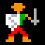 | NPC / Townsfolk | Person holding a weapon/tool. Generic NPC or town character sprite.

Row 4: Characters & Monsters (Frame 2)
Pos | Tile | Name | Description
R4 C0 | 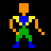 | Fighter (Frame 2) | Alternate animation frame for the Fighter class. Arms/legs in different position.
R4 C1 | 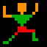 | Thief (Frame 2) | Alternate animation frame for the Thief class.
R4 C2 |  | Paladin (Frame 2) | Alternate animation frame for the Paladin class.
R4 C3 | 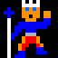 | Wizard (Frame 2) | Alternate animation frame for the Wizard class.
R4 C4 | 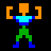 | Barbarian (Frame 2) | Alternate animation frame for the Barbarian class.
R4 C5 | 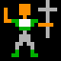 | Cleric (Frame 2) | Alternate animation frame for the Cleric class.
R4 C6 | 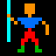 | Lark (Frame 2) | Alternate animation frame for the Lark class.
R4 C7 | 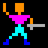 | Illusionist (Frame 2) | Alternate animation frame for the Illusionist class.
R4 C8 | 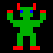 | Orc (Frame 2) | Alternate animation frame for the Orc enemy.
R4 C9 | 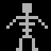 | Skeleton (Frame 2) | Alternate animation frame for the Skeleton enemy.
R4 C10 | 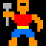 | Pirate / Brigand (Frame 2) | Alternate animation frame for the Pirate enemy.
R4 C11 | 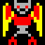 | Balron / Demon (Frame 2) | Alternate animation frame for the Balron.
R4 C12 |  | Man-Thing (Frame 2) | Alternate animation frame for the plant creature.
R4 C13 | 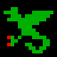 | Dragon (Frame 2) | Alternate animation frame for the Dragon.
R4 C14 |  | Daemon (Frame 2) | Alternate animation frame for the Daemon.
R4 C15 |  | Whirlpool (Frame 2) | Blue spiral variant. Alternate animation or secondary portal graphic.

