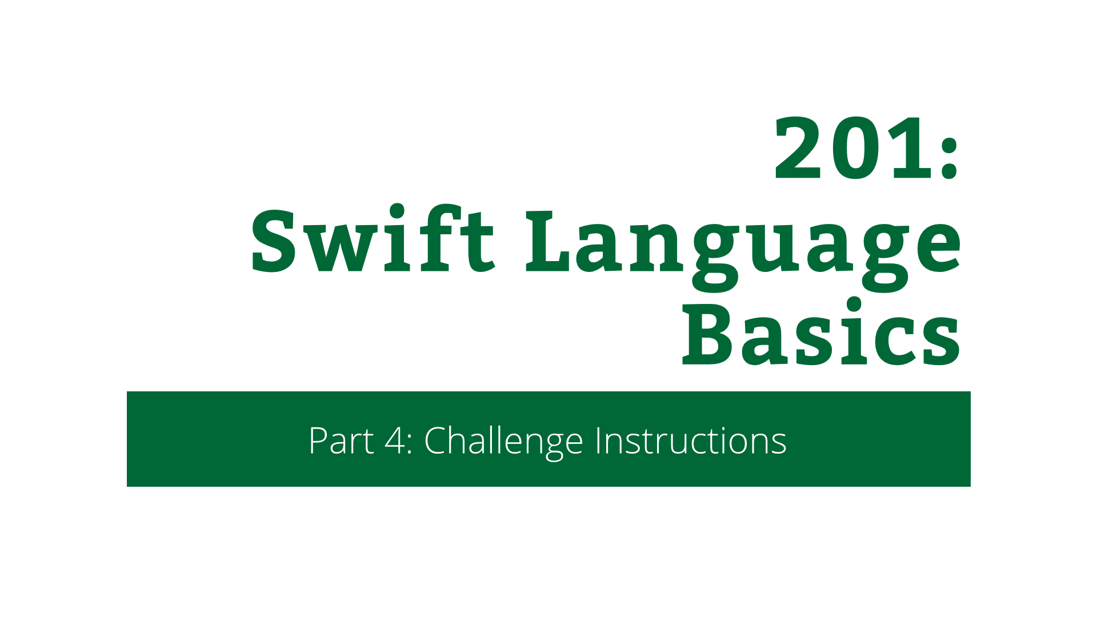

201: Swift Language Basics

Part 4: Challenge Instructions

Copyright © 2014 Razeware LLC.

All rights reserved. No part of this book or corresponding materials (such as text, images, or source code) may be reproduced or distributed by any means without prior written per- mission of the copyright owner.

This book and all corresponding materials (such as source code) are provided on an "as is" basis, without warranty of any kind, express or implied, including but not limited to the warranties of merchantability, fitness for a particular purpose, and noninfringement. In no event shall the authors or copyright holders be liable for any claim, damages or other liability, whether in action of contract, tort or otherwise, arising from, out of or in connec- tion with the software or the use or other dealings in the software.

All trademarks and registered trademarks appearing in this book are the property of their respective owners.

# Everyone’s a Winner

1. In the game as it stands, once someone has won a game, or all positions are filled, there’s no way to restart the game and you have to kill the app and restart it. That’s not a great experience! In this challenge, you’re going to fix that.

First, you’re going to need a method in ViewController to reset the board. Call it reset(). You’ll need it to clear the turns and refresh the board.

Then you’re going to need a method that checks if there’s a win on the board. There’s a trick you can do to make this easier. A win can only happen after a player has just played. And the only person who can have just won, is the player who just played. Using this knowledge, create a method with this signature in ViewController:

private func checkEnd(

lastMove: (position: Position, player: Player))

This takes a tuple describing the last move – where the play was, and who played there. Inside this method, check if there is a win on the row where the play was. Then check if there is a win on the column where the row was. Finally, check if there’s a win on either diagonal.

If there was a win, then show an alert indicating who won. If there was not a win, but there are all 9 moves taken, then show an alert that nobody has won. On both these alerts, make it so that the refresh method you added previously gets called when the alert is dismissed.

Finally, in board(board:didPressPosition:), call checkEnd(lastMove:) when the move has been played.

Good luck, and no peeking at the answer until you’ve finished it!