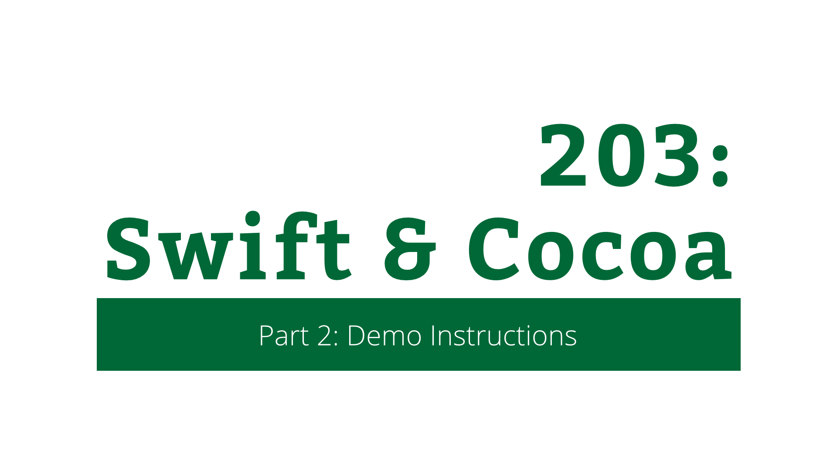

203: Swift & Cocoa

Part 2: Demo Instructions

Copyright © 2014 Razeware LLC.

All rights reserved. No part of this book or corresponding materials (such as text, images, or source code) may be reproduced or distributed by any means without prior written per- mission of the copyright owner.

This book and all corresponding materials (such as source code) are provided on an "as is" basis, without warranty of any kind, express or implied, including but not limited to the warranties of merchantability, fitness for a particular purpose, and noninfringement. In no event shall the authors or copyright holders be liable for any claim, damages or other liability, whether in action of contract, tort or otherwise, arising from, out of or in connec- tion with the software or the use or other dealings in the software.

All trademarks and registered trademarks appearing in this book are the property of their respective owners.

# Title

Body