Analysis of Blackboard Usability

# Visibility of system status (Neilson, J. 1995)

The Blackboard system requires the user to stay informed about relevant information. A student user would need to know about upcoming tests, coursework dates, teaching materials and results from coursework or exams.

In evaluation, the system is mostly effective at fulfilling usability through visibility of system status. This is because when greeted on the homepage, there is a newly added feature which is shown in the top right corner of the screenshot below.

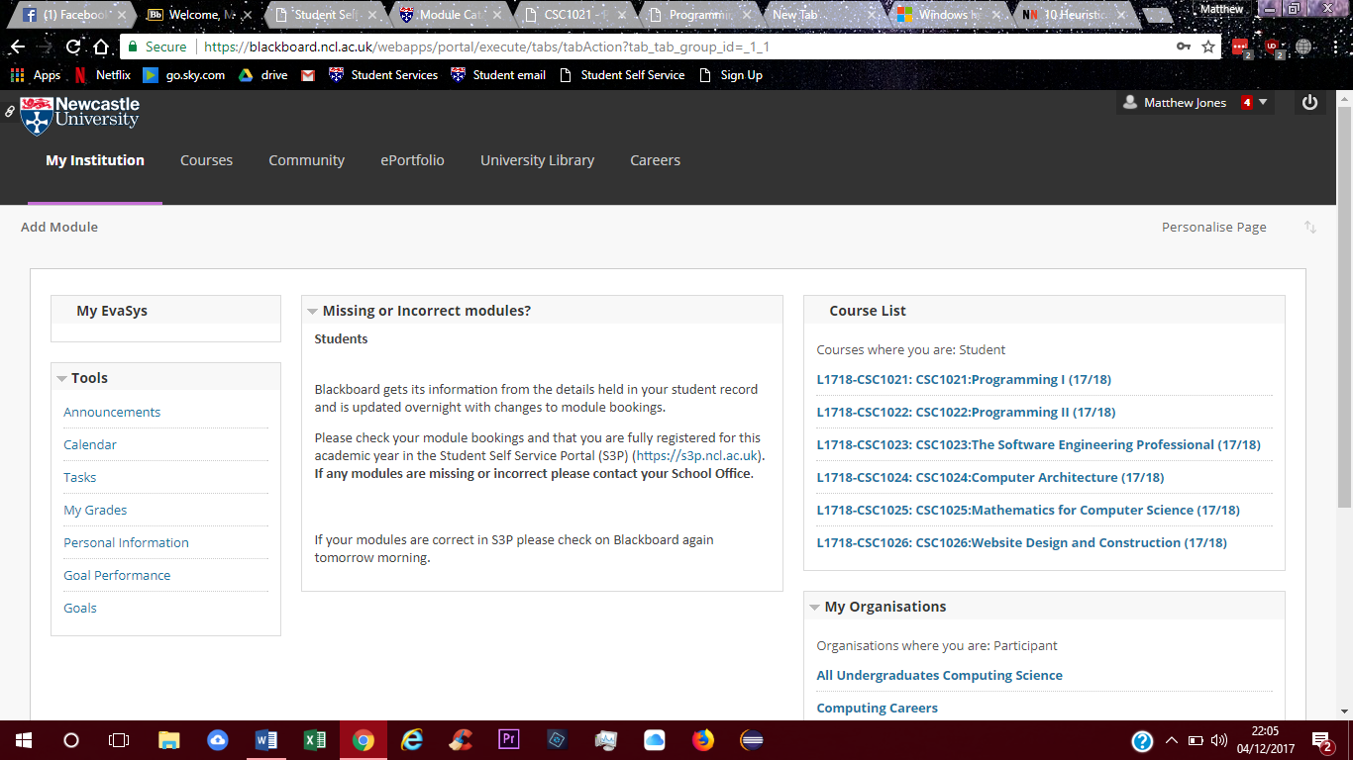

When clicking on this, you can see the new activities and information on the courses that are taken by the user. This helps to keep the user informed by directing the user’s attention towards the red prompt in the top right-hand, shown in the screenshot above.

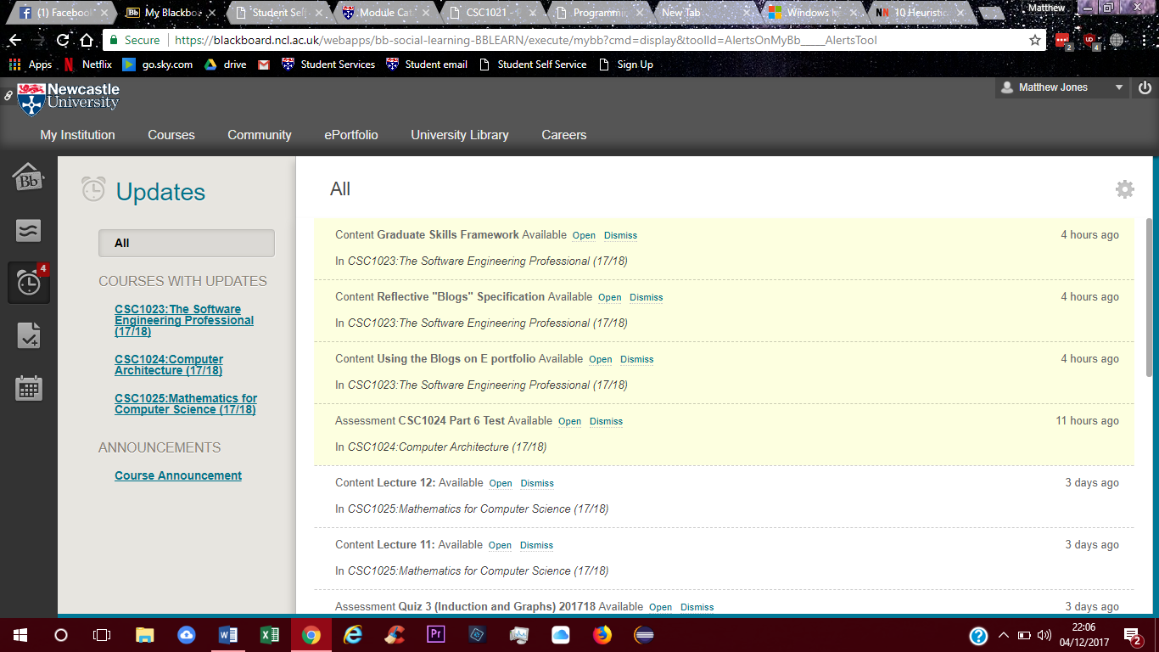

Another part of the system which informs the user of upcoming information, is the tasks and announcement pages. The tasks page showcases upcoming and outstanding activities for each course. Here, it is easy to see and plan upcoming work. The announcement page shows what is new in the course, as well as information that students will need to know about deadlines and updates.

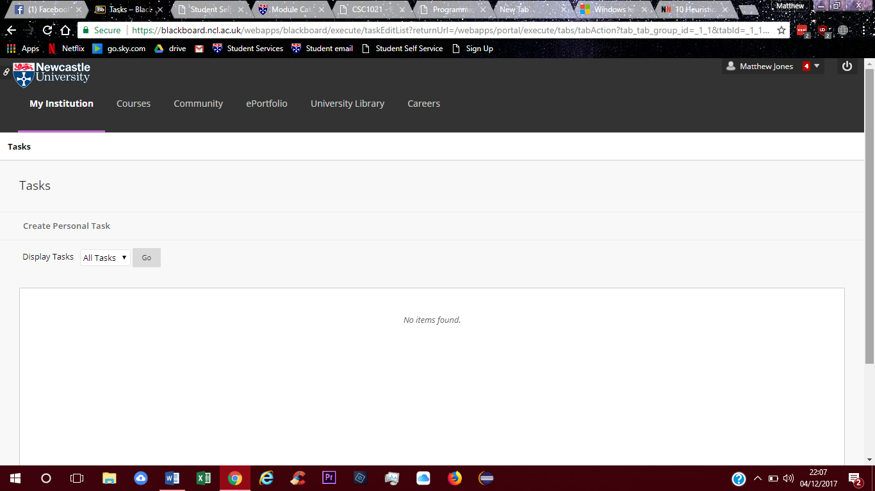

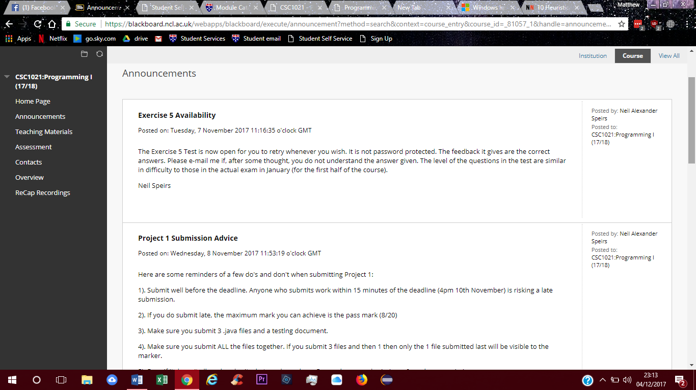

As an improvement, a system that would send emails about urgent information would be extremely helpful as it would alert a user to check updates, instead of when only when Blackboard is accessed next.

# Match between system and the real world (Neilson, J. 1995)

The Blackboard system should also be able to speak in a language that the user should understand and be able to comprehend without trouble.

With Blackboard, the text and dialogue throughout the website is short and simple allowing the user to easily understand it. Other posts are made by lecturers who use jargon familiar to the user. This increases the usability of Blackboard as users will be able to understand how to actually use the system.

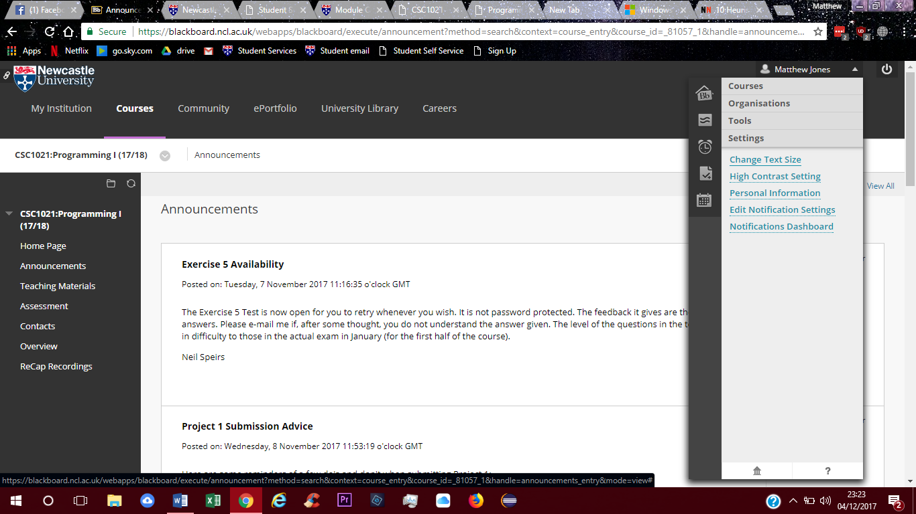As shown on the announcement page below, the announcement from Neil Speirs is easily readable and words are used which are familiar to the user. As for the text in which people use to navigate the website, it is also easy to understand and allows people to edit the text so it easier to read.



A problem that the system has, is that the terms to navigate the website on the left side are extremely general and information could fit in several different headers.

# User control and freedom (Neilson, J. 1995)

The webpage should support the action to go back to a homepage using undo and redo type tokens.

With Blackboard, there are no distinguished undo or redo buttons which can be a problem in some circumstances. However, the system does allow the user to click on the headings on the left to go to various parts of the courses page easily.

In evaluation, the user control is poor as there is not an emergency exit button – which would allow the user to leave the page to return to the previous page.



# Consistency and standards (Neilson, J. 1995) (Neilson, J. 1999)

Blackboard shows consistency and standards by allowing the users to have a search bar available, which will help to navigate to a certain web page or header. This is shown in the screenshot below. Although, Blackboard is not consistent with some courses showing home page and some do not as also seen below.

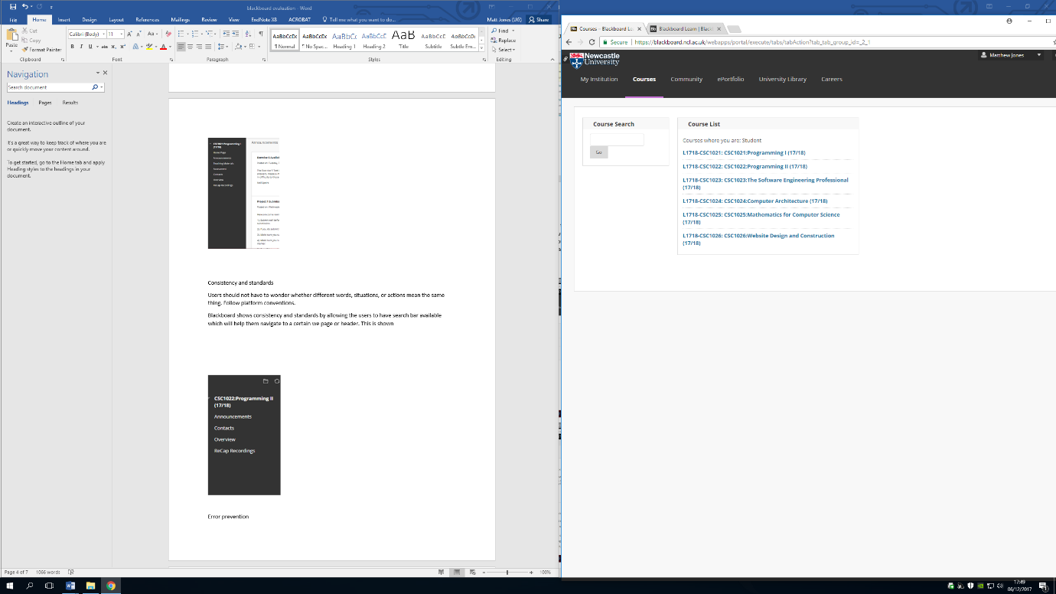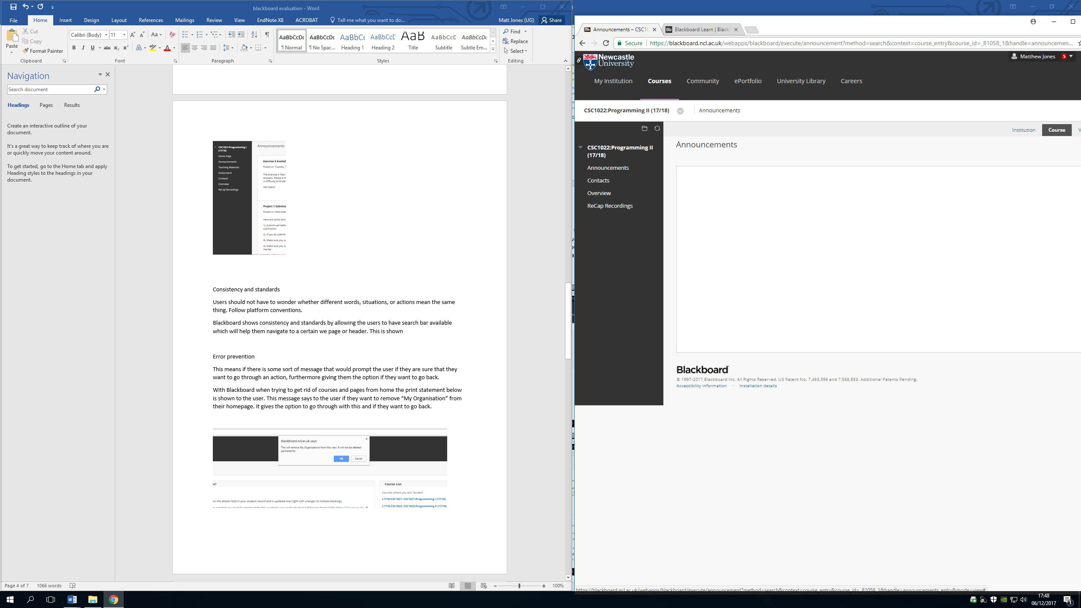

# Error prevention (Neilson, J. 1995)

Blackboard has an error prevention system which will help a user if they accidentally click a marked “X” in the homepage. When trying to delete courses and pages from home, the print statement below is shown to the user. This error message is shown if the user wants to remove “My Organisation” from their homepage. It provides the option to commit to the action or if they wish to cancel.

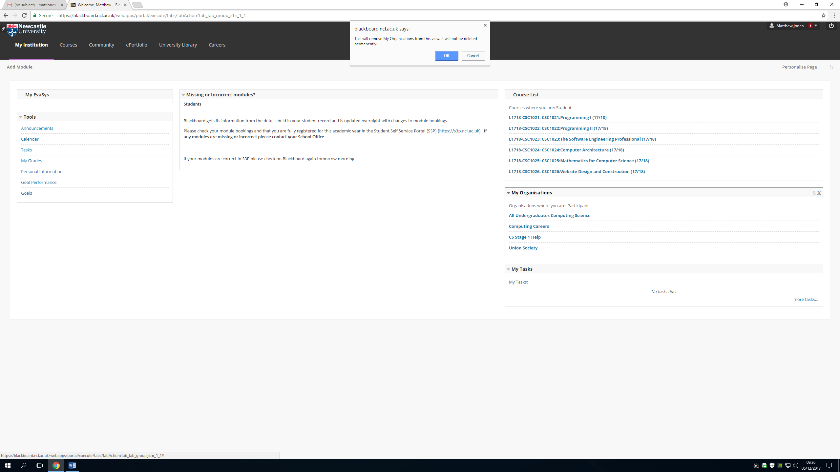

# Recognition rather than recall (Neilson, J. 1995), (Budiu, R. 2014)

The most prominent type of recognition that Blackboard has, is the user interface on the left allowing the user to go through Blackboard after picking a course. This is a good example of recognition, as when accessing Blackboard the user can see that this object is available which will then guide their path throughout the website with ease. Therefore, increasing usability.

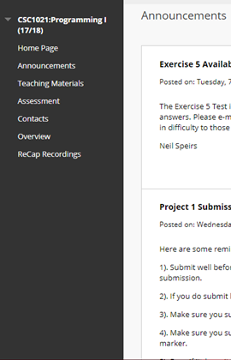

# Flexibility and efficiency of use (Neilson, J. 1995)

The flexibility and efficiency of use is shown in Blackboard is far and few. This is because, the layout requires certain knowledge to be able to use the website and navigate through it. Only users that have taken courses of Newcastle University can access their pages. It is only when explained to student users that the structure of Blackboard becomes clear. On the other hand, the system still has context which is mostly understandable to an everyday user and supports a home page which is interchangeable.

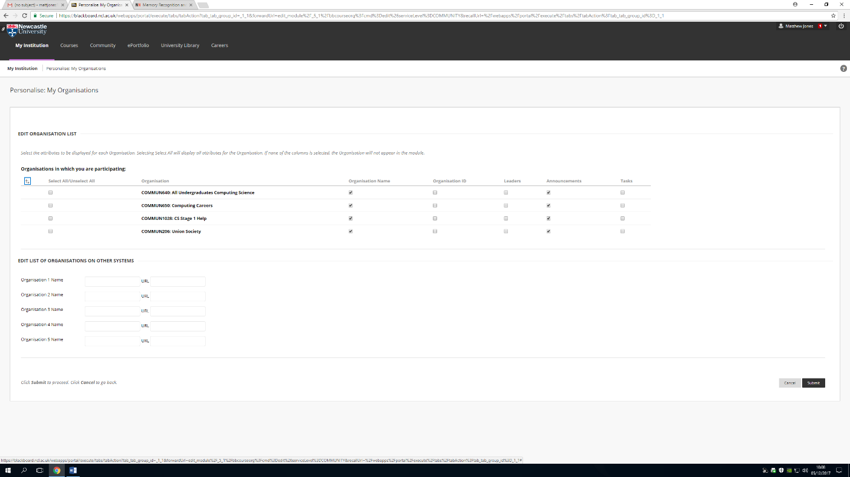

# Aesthetic and minimalist design (Neilson, J. 1995)

Blackboards design is the optimisation of a minimalist design. This is because the webpage and layout is concise and doesn’t include information which is not relevant to the user. Another reason is because Blackboard has a simple colour code of black, white and grey. This helps the user as the colours might distract and impure the users ability to understand the text.

# Help users recognise, diagnose, and recover from errors (Neilson, J. 1995)

Blackboard helps the user manage self-caused errors by diagnosing and suggests solutions with the error code shown earlier. This helps the user by identifying whether they would like to remove “My Organisation” from their homepage. Even if ‘OK’ was clicked and the user changed their mind, the system allows the user to bring it back. The message doesn’t involve any code and is easy to read.

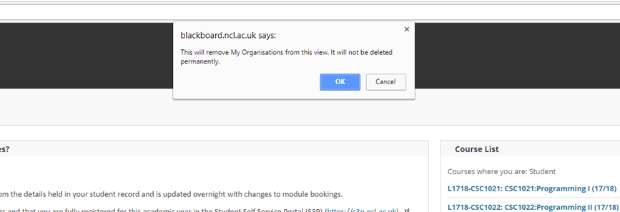

# Help and documentation (Neilson, J. 1995)

Blackboard shows documentation and help to the user by using the page shown in the screenshot below. Here, a user would be able to get help from the system providers. Users can retrieve answers from questions through methods such as FAQs, and allows the user to download a mobile version which could help a user on the go and helps the functionality of Blackboard. However, there is no direct help from the Blackboard system itself as you get directed to another webpage from the same company.

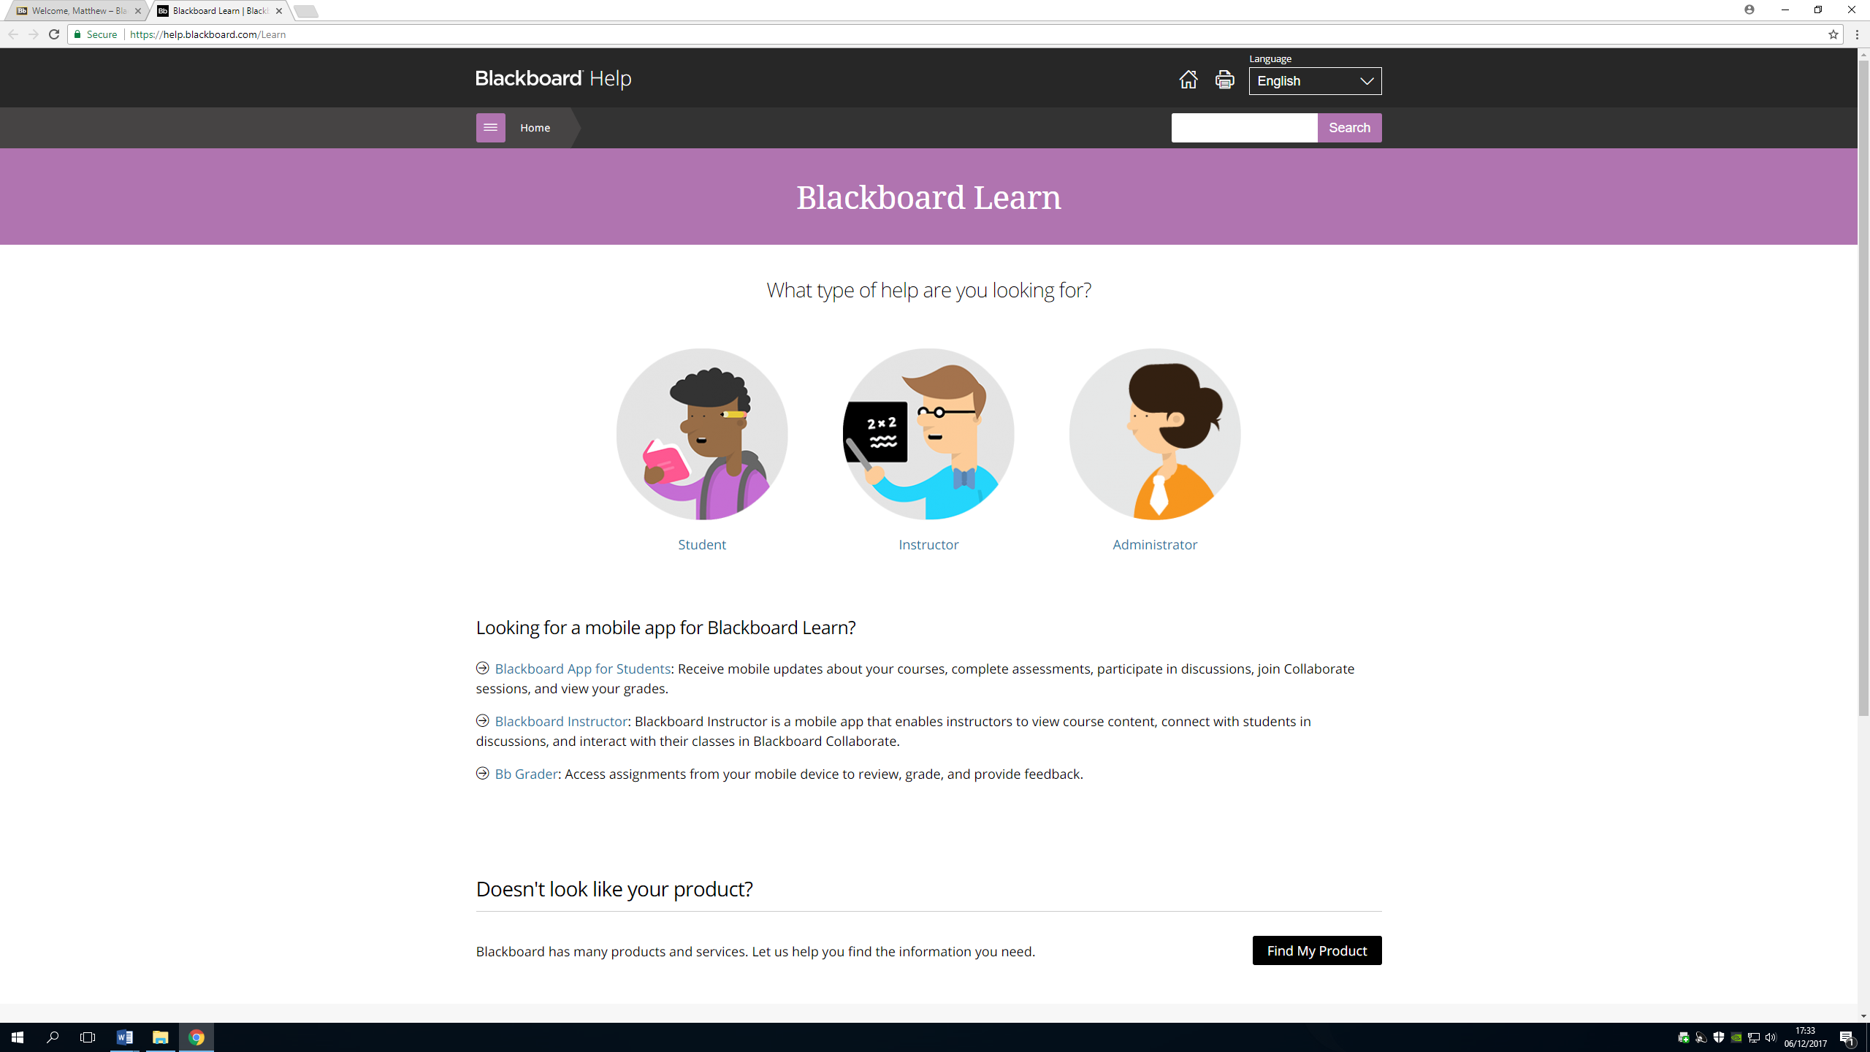

# References

Blackboard.ncl.ac.uk. (2017). [online] Available at: https://blackboard.ncl.ac.uk/webapps/portal/execute/tabs/tabAction?tab_tab_group_id=_1_1 [Accessed 8 Dec. 2017].

Nielsen Norman Group. (1995). Neilson, J. 10 Heuristics for User Interface Design: Article by Jakob Nielsen. [online] Available at: https://www.nngroup.com/articles/ten-usability-heuristics/ [Accessed 7 Dec. 2017].

Nielsen

Nielsen Norman Group. (1999). Neilson, J. Do Interface Standards Stifle Design Creativity. [online] Available at: https://www.nngroup.com/articles/do-interface-standards-stifle-design-creativity/ [Accessed 7 Dec. 2017].

Nielsen Norman Group. (2014). Budiu, R. Memory Recognition and Recall in User Interfaces. [online] Available at: https://www.nngroup.com/articles/recognition-and-recall/ [Accessed 7 Dec. 2017].