**Can improving a person's mood affect their ability to play football**

1. **Motivations**

There are several motivations to not just me but to society to develop more research into how we think, and feel can correlate with how our bodies work and function. When looking into my own personal motivations for doing this project there are few which stand out. The first is that I have a big passion into both the main subject, psychology and football. This is because I have been playing football since I was very young and I studied psychology at sixth form, nearly picking a degree in the subject. This I feel will make the project a lot more engaging. Another motivation for myself is the fact that I have had this exact thought and problem before. When I used to play five a side, at a certain time the stress of University was getting to me mentally. So, because of this I felt that doing research into finding out whether there’s truth behind it.

There are also many societal motivations for doing this project. The first I will explain is the fact that mental health and wellbeing is directly correlated to your body’s health and wellbeing.[7] As the target audience of this application would be Sunday league players and players who don’t have access to trained player liaisons officers. I have seen this in my observations for the background data as most of these Sunday league clubs have next to no funding. this kind of mental wellbeing checks are not carried out. This leaves a big gap in the market for an application to do just that. If aim is proved to be that it can affect a player’s football performance, then teams that adopt this app will have an advantage to the opposition around them making them more likely to win taking out football skill. Another societal motivation for doing this project would be that the target demographic which are working class people are more likely to experience mental health problems compared to people further up the social ladder. [8] This means that just even educating people that mental wellbeing would affect not just them playing football but their everyday lives. The application is targeted to both male and females but just on the sheer number from each gender that play Sunday league males will be more likely to use the service. As the rate of suicides in the UK are 78% males and that mental wellbeing and health are at the forefront of the media, this app is needed.[1]

1. **Aims and Objectives**

The main aim of this project is “ Is it possible to affect a person's mood to allow them to play better in a football match by developing an application, assessing how someone’s feeling and help with a selection of activities and videos”. To come to a conclusion with this aim there are several objectives which will need to be developed and fulfilled so that the evaluation of the aim can be as accurate as possible.

My objectives are:

* Collect background information on mood psychology to better understand the subject better and to shape user requirements. The criteria is to have 6 or more relevant and reliable articles about the subject. This objective is needed because I need to have a level of understand in the subject to conduct this dissertation properly.
* Develop an application which can determine a player’s mood and if it is a negative emotion auto suggest videos which can help them get out of it. The main criteria for meeting this objective would be to have a fully developed application. This would have to follow the user requirements, is able to find out the user’s mood, give the user useful video suggestions and be able to evaluate itself with the questionnaire. This objective is needed because If there is no application, I would not able to test or even conduct my project.
* Conduct several rounds of testing and user testing to bug fix. The main criteria for this part would be that the user must be able to use all of the functions of the app competently without problems. Also, because sometime all apps crash, I would need to make a threshold which if the app crashes too much It has not failed these criteria. This objective is needed because if the app doesn’t work properly then the results that it makes will be unreliable and not useable giving me false information.
* Take data records of players using the app making my data. The main criteria for this objective are to have over 10 sets of results each from several different participants at the same Power League game. This object is needed for the aim because this will be the sets of information which I use to evaluate the aim and conclude.
* Conduct a through evaluation of the data then collated. The criteria of this would have an accurate representation of the data collected in graphs and statistics. This needs to be visible and clear to see the results easily. This objective is needed for the aim as this is the fact which will decide if my aim is correct or not.

**Background Information**

|  |  |  |
| --- | --- | --- |
| Source | Summary | Why it is relevant |
| [1] MayoClinic, Stress management | The webpage conveys how mood can affect your body physically. It lists out common effects of having stress and how they change your body and behaviour. | This is relevant to the project as these are the effects that I am trying to prevent with the application. This means that identifying and eradicating these side affects will be essential to the success of the application. Also, looking at this the other way I can use the behaviours started here as questions for my survey to accurately assess someone’s mood. |
| [2] Stack -How Your Mood Can Affect Your Sports Performance | This webpage explains how positive and negative emotions can affect your football game. It also explains how confidence can affect your body and brain in a football match. | This is relevant to the project as this would be the main selling point of how my application might be able to help football players. It explains how things like stress can result in negative traits like muscle tightening. Furthermore, it explains the positive emotions and how they help your game. This is what I would need my users to be at or worked towards when using my application. Having this source explains how my app could improve a player’s game. |
| [3]SportVillage - How do emotions influence sport performance? | This webpage goes in detail about how emotions can affect behaviour. It goes through different things sport psychologist look at like ‘activation level’ when looking to improve emotions in sport. | This is relevant because its information is more about techniques to train your mind in sports practice rather than the side effects. This is important because I will need to know key indicators of emotions to calculate what the users are feeling. It explains how arousal levels and doing different activities before a game can help a player focus and concentrate. |
| [4] ScienceDaily -Weighing the pros and cons of mental-health apps | This webpage goes into detail about the positives and negatives of mental wellbeing apps. It goes over key topic of how they are useful and not. | This is relevant because I am myself doing a mental wellbeing app. Knowing what the major pitfalls of other apps on the market or reasons why people do not like them is useful. This is because I can steer clear of these things or evaluate on the, why they could have affected the results. Also, it gives positives to these apps which should be included in my user requirements as they are what people like about these apps. |
| [5] Everyday Heath - The 6 Best Mood Apps | This webpages details some of the best mental wellbeing apps on the market right now. It explains why they are used and new features they have added to break apart. | This is relevant because as a developer you should always know your competition and how they work. This is so you can either look at key trends which gained them a lot of users or look at aspects of their apps, how you could change or better them to create a superior app. For the usefulness of my own app this source can point me in the direction of what the finished article needs to come up against. |
| [6] Health Science Journal - Stress management techniques: evidence-based procedures that reduce stress and promote health | This scientific research paper is about stress management techniques and how they can reduce stress quickly. This is done with evidence-based techniques which are easy to learn. | This is relevant to my project as this will be the main video ideas which can be incorporated into the video selection part of the application. As the techniques have been thoroughly researched using them would have a much more reliable chance of the application having a positive effect on the user. Knowing what activities are useful will save me time in testing as these have proven to work thus reducing my time spent. |

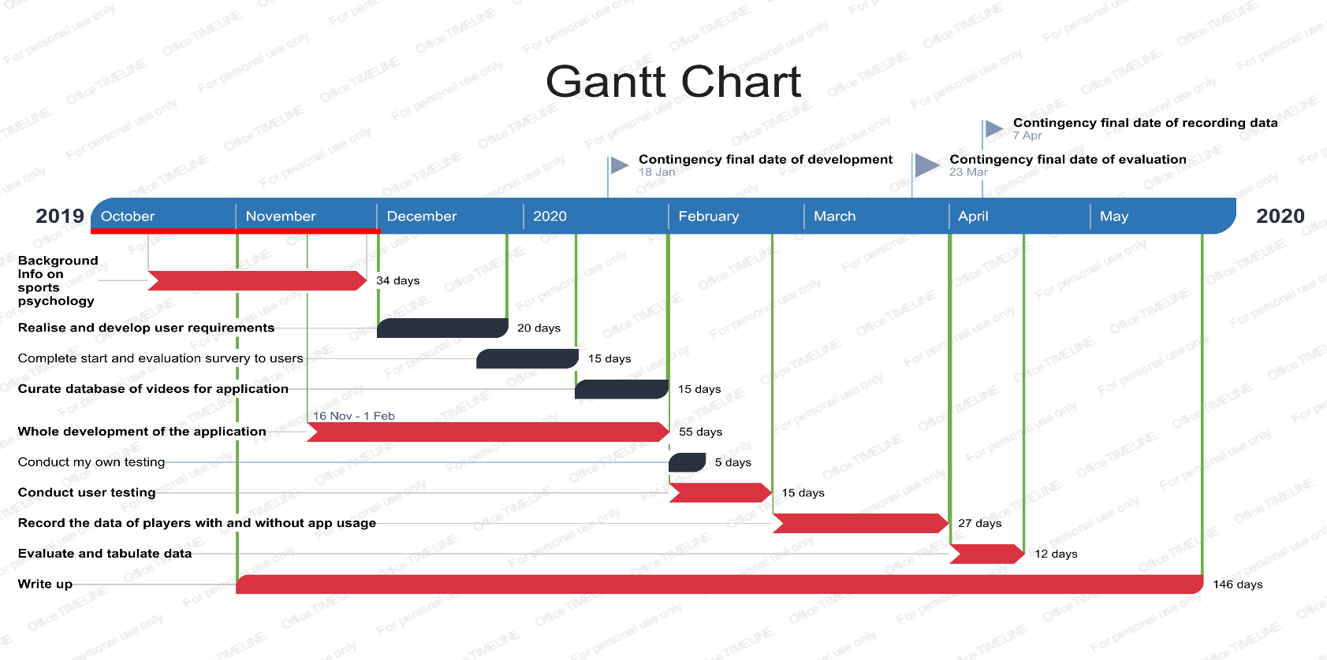**Diagrammatic Work Plan**

*Figure 1: A Gannt chart reprinting the current work plan for this project*

I plan to work under the agile development model. This is because I am familiar with how it works having used it before. Also, it will allow me to evaluate the work I do frequently giving better chance for reflection as I go forward. The first phase, getting background information, won’t be affected by the agile model. This is because I will only need to reflect after this has been done and there will be no parts which will have hard deadlines. The development phases will be the most affected, as there will be parts which will be chopped and changed. Agile will help me see what is realistic in the time frame I have given myself above. Lastly, the evaluation phases will be helped with agile as I will have a deeper understand of why parts might have not been added with data to back it up. Looking at the Gannt chart here, this will be the main plan that I will be undertaking when doing this project. The ones in blue are essential tasks that need to be completed to meet the objective. The chevrons in red are the objectives with timelines to see when about they will finish. There are however some key risks which I might encounter in this work plan. The first is that the development of the application might take longer than expected if parts of the code do not work. If this were to happen it will be manageable to correct it as I have given myself some buffer days when looking at the time of the key objectives. This will allow me to catch up if my work timeline gets extended.

Another key risk that could happen is that the user testing might uncover several faults in the pp that would need to be addressed before I can get the data. This could severely impact my timeline in a negative way, and I could be forced to change my plan when it comes to the other later deliverables. My contingency plan for this would be to look if the feature which is not working, look if it’s essential to the application then if it isn’t and the task is too long, cut it from the final application. If it is fixable or essential, then look to complete it as quickly as possible and revaluate my time remaining since then to calculate how much time I have left. The last key risk could be that I could not find enough appropriate videos for the database. If this happens, I will try to make as many as I can myself but this is an unlikely risk. This is because YouTube is teeming with wellbeing videos and will more than likely have videos.

## **References**

[5] EverydayHealth.com. (2019). *The 6 Best Mood Apps*. [online] Available at: https://www.everydayhealth.com/columns/therese-borchard-sanity-break/the-6-best-mood-apps/ [Accessed 4 Dec. 2019].

[6] Liza, V. (2019). *Stress management techniques: evidence-based procedures that reduce stress and promote health*. [online] Hsj.gr. Available at: http://www.hsj.gr/medicine/stress-management-techniques-evidencebased-procedures-that-reduce-stress-and-promote-health.php?aid=3429 [Accessed 4 Dec. 2019].

[1] Mayo Clinic. (2019). *How stress affects your body and behavior*. [online] Available at: https://www.mayoclinic.org/healthy-lifestyle/stress-management/in-depth/stress-symptoms/art-20050987 [Accessed 4 Dec. 2019].

[2] Moller, G. (2019). *How Your Mood Can Affect Your Sports Performance*. [online] STACK. Available at: https://www.stack.com/a/how-your-mood-can-affect-your-sports-performance [Accessed 4 Dec. 2019].

[7] Ontario.cmha.ca. (2019). *Connection Between Mental and Physical Health*. [online] Available at: https://ontario.cmha.ca/documents/connection-between-mental-and-physical-health/ [Accessed 4 Dec. 2019].

[4] ScienceDaily. (2019). *Weighing the pros and cons of mental-health apps: People use apps for everything from eating disorders to psychosis -- but should they?*. [online] Available at: https://www.sciencedaily.com/releases/2016/04/160426144555.htm [Accessed 4 Dec. 2019].

[3] Sportvillage.cambrilspark.com. (2019). *How do emotions influence sport performance?*. [online] Available at: https://sportvillage.cambrilspark.com/en/blog/how-do-emotions-influence-sport-performance/ [Accessed 4 Dec. 2019].

[8] Mental Health Foundation. (2019). *Mental health statistics: poverty*. [online] Available at: https://www.mentalhealth.org.uk/statistics/mental-health-statistics-poverty [Accessed 4 Dec. 2019].