CSC3721 – Coursework A micro:bit Curriculum Portal

By Matthew Jones

Student Number: 170363855

Word Count: 1498

**Persona**

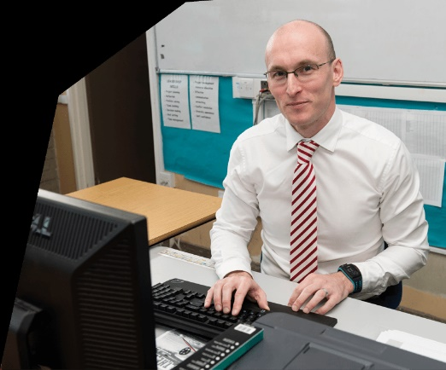

Name: Chris Dawson

Occupation: Teacher

Age: 48

<https://teachinscotland.scot/wp-content/uploads/2017/03/Ian-Power.png>

Bio:

Chris Dawson is a non-specialist teacher from Wilmington Academy who teaches both statistics for sixth form and computing from year 7 to 8. He has been at the school for 9 years and at first was maths and IT teacher at the school. Later as computing was put into the national curriculum in 2015 the school found it suitable to give Chris the role to teach the classes. As he struggled with all the classes together, he was then moved to statistics with less of a focus on general maths. He still struggles with the number of classes he has as the school have very little resources to bring in another teacher for computing.

Motivation:

Chris’s motivation for using the portal is to improve his overall lesson structure. Chris struggles with teaching some parts of the curriculum because he doesn’t come from a computing background himself. Having this portal would allow Chris to even learn about the subject himself more, thus engaging with the curriculum and passing that onto the students. Furthermore, the troubleshooting area in the portal would allow him to query if he had questions from more adept teachers at computing.

Frustrations:

One frustration he has is the lack of resources to keep up with the ever-changing curriculum. As he must teach several classes in the day and going home to assess and mark leaves Chris with little time to think of ideas to bring to the students. This is reflected in the lessons allowing to be plain and by the book. Another frustration is the support he gets from the rest of the staff as he is the most intelligible in the school about computing leaving him with very little advice in where to take the lesson planning.

Ideal experience and goals

After this Chris is hoping to fall back in love with teaching computing and feel comfortable with the certain parts of the curriculum. This is so he can give confidence to the pupils and show that computing is fun and rewarding. Also, Chris is hoping that he would be able to get more teachers at the school interested in teaching the subject by showing them the portal. This could make it less daunting to start at.

Quote:

“After a long time of doing this type of subject all I would like is some support as I feel as I by myself with the curriculum. It’s a least what the kids deserve you know? To really give them a chance of being our next tech giants or even just be intrested.”

Usage scenario

Craig woke up in the morning extremely tired after marking his statistics exams last night. As he is in this state, he doesn’t check over the classes he has today and tries to get to work as quick as possible, he leaves the house and heads to the school. When he arrives, he suddenly realises that the slides from lasts year for the curriculum are now outdated and doesn’t include parts which are needed. Panicking, Craig logs on at the online portal, and goes to the micro:bit section on the contents page of the portal. Here he can see all of the uploaded slides to the portal, he looks at the top rated and see that another teacher has uploaded lessons slides for this exact part with a really high number of likes. He downloads these slides and is impressed with the direction the teacher has took for this part of the curriculum. As Craig gets ready for the class, he puts up the downloaded slides and changes the appropriately for his own class. Craig then has a sudden worry, some of the kids might really struggle trying to learn basic code. As this is needed for the micro:bit he asks some of the teachers on the portal any good video or ideas to make it easier for the kids. One of the teachers directs him to a video on YouTube which shows python as expressions as well to show code and actions together simply. When the students engaged with the slides, they were all very positive and liked the lesson plan. After the successful lesson Craig thought it was a good idea to reupload the slides he just changed using the remix button.

As Craig uses the portal it will be used in only short periods of time and doesn’t need to be running in the background Craig doesn’t have a need for a timeout function. Neither does he have to worry about having interrupted connection or use as it only needs to be downloaded. Craig feels as there would need to be some control on the file types that can be added to the portal. This will stop people not being able to use the slide if they don’t have the application it was made on. As power point is the main application people makes slides on this would be an ideal choice. Teachers that will be using this probably don’t want a complex system this takes more time to navigate. A clear concise layout with easy to use functions would allow Craig to use the portal quickly and for teachers this is ideal.

After using the portal Craig feels very relieved to have it. Most weeks he might not need it but because time was short, he didn’t have enough to change his own lesson plan and it was there to help him. The problem with this though is it could make teachers that have it rely on the fact that a teacher may have put up a lesson plan. This could make certain teachers lazy and not have any real connection to the lesson they are giving. Furthermore, teaches would only rely on this and teaching would be very similar across people that use the platform. Craig also feels as if he is a member of a community when he is also uploading his slides to the portal. This could in turn help him with his confidence about teaching the subject as he has support if he needs it and also give support to those who need it.

Functional requirements

|  |  |  |
| --- | --- | --- |
| Requirement | Description | Why? |
| R1 | Login gate | As there would be some sort of membership, they would need some sort of account to access the portal. This is because in the interview the teacher says” So a teacher could login to the platform and look at the scheme of work?” thus inferring only teachers should be able to get on the platform. |
| R2 | Search Bar | This is to be able to look for a type of lesson plan or video and you don’t know the right unit. This is asked for in the interview here “They maybe need to be able to search based on some keywords as they may not know where to find a lesson about a particular topic.”. |
| R3 | Download slides | When a teacher adds content to the portal it will need some sort of download function which would save the files on the local computer being used. This is asked for here “download the file and make some tweaks for their students”. |
| R4 | Messaging area | There will need to be a messaging part of the portal when teachers can talk to each other about problems they might have. This is asked for in the interview here “so some sort of forum where they can discuss and ask questions”. |
| R5 | Upload slides | Teachers will need an icon which can let them upload slides which they have made. This is needed as teacher will need to download slides. This is described in the interview here “Where teachers can access and share the resources and talk about them?” |
| R6 | Contents page | When logging on to the portal there should be some file directory which can let teacher go to syllabus they are looking for. This is described in the interview here “Could be a case of “right, you need to go on this page and look at these resource”. |
| R7 | Like button | There would be a like button which would let the better slides rise to the top and the first that are seen. This would mean people using the portal would be able to see the best slides first and not sift through themselves. |
| R8 | Tagging videos | There would need to be some sort of tagging system which would describe what ability eve the students need to be at for the lesson plan. This is described here “It would be great if they could be tagged and maybe searched, something about an ability level.”. |
| R9 | Remix slides | There can also be a function which lets teacher change an existing slide on the portal and upload a separate version which can be more or less challenging for other users. This is described here “What about allowing teachers to “remix” the resources?”. |