Design process

Looking to evaluating my interactive design, I sought after my peers and asked them to use and test the design. I conducted three different types of observation when they were testing the design. These were normal observation, think aloud and cooperative evaluation. This allows me to compare the different evaluations as they will provide me with different but useful information about the usability. Doing this gives me a well-rounded look at how the design works well, how it could be improved and how easy it is to navigate.

The first I conducted is a normal observation. This is where I just observe someone using the design without any dialog. This has its advantages as you can really find out if a user would be able to navigate through the design without help. When I conducted this, the tester was not able to navigate to the inbox section. After the test I asked why that was the case. The tester said that he didn’t even realise there was an inbox section. The inbox icon was located through the forum at this point. This showed that in the design it was not clear or prominent enough for someone that’s using it to be able to see that section of the site. To amend this, I decided to have a very clear inbox button located at the start of the account page. You can get to the account page from nearly any other page, so it is easy to navigate too. Furthermore, it is now a lot more visible from where it was located before meaning if a new user were to interact with the site, they would come across it very quickly. Another point I got from observing was that the consistency for through the site wasn’t good enough. I came to that conclusion when it took some time for the user to get used to each page regarding main functionality in buttons. When using a site, the user should get used to the design and layout after some use, but this was not happening. This is a problem because the user will not feel comfortable with the site leading to a negative view on the design as it is confusing. To solve this problem, I started to look at ways I could keep the main buttons on each page in the same place. This is so when a new page is entered the main functionality stays very similar and you won’t have to learn the new button positioning. I ended up with a very conformed layout on each with the back, home and account buttons all in the same place for most of the pages. When letting the user test it again after the changes it was much quicker and smoother to run through compared previously.

The second evaluation I done was using the think aloud method. This is where the person who is testing the system talks out loud about their thoughts and feelings regarding the design and interactivity. The main advantages for this will be that I can get a feel for what the first thoughts and opinions are on the design which I might have missed in a normal observation. Furthermore, it allows the tester to talk through functionalities compared to just thinking them to allow for more developed opinions. When the tester was evaluating my design, the main comment that I received was that the forum was hard to get to when at selected slides and it would be difficult to get to that specific forum when you were already there. I took this on board and looked at making a new way to access the forums. I came up a “go to forum” button available on every uploaded lesson plan so they can go direct from there to that specific forum. Another point that was made is that there was no function in the planner to go to a specific date in the calendar. The tester demonstrated that it should be a core part of the planner otherwise you would have to scroll down the whole planner to find the date you wanted. After this observation I added the functionality of being able to put in a specific date to find a day in the calendar. This was done by adding a button in the top left to be able to write a specific date. When the tester tried the design after he complimented me in adding the two parts that he mentioned earlier and didn’t have to much more to add meaning that to him it worked well.

The last evaluation I done was a cooperative observation. This is where I can openly talk with the person who is testing the system as they test it. This method has quite a few positives when it comes to getting a good observation of the system being used. One of these is that fact you can deliberate how things can be different when they are testing and talk about thoughts to rectify the problem at the same time. When I conducted this evaluation the main points I received was about the layout of the log in and forgotten password section. We concluded that forgotten password shouldn’t be outside of the log in page. This is because you wouldn’t have known you had forgotten your password without being on that page. I amended this by placing it in the log in page and creating the functionality for it to “reset your password”. Another point we talked about was the fact there wasn’t enough visual feedback when downloading or uploading a lesson. To amend this I created a pop up window which shows the user has downloaded the lesson and after the clicking the box away it would take you back to the same position. This gives the user confirmation that it has been downloaded and uploaded as some users might be confused otherwise with no feedback. This is a main point in the cognitive walkthrough so was key to include. This could have led to users downloading or uploading multiples of the same lesson without realising.

Design Rational

1. **Log in page**

Design space:

The first design choice I’m going to talk about is the log in page at the start of the design. This is used to be able to access the portal via email. The three options I picked from were a normal log in, a log in page with the functionality to be able to sign in using Google or Facebook accounts and a log in page with a guest functionality included.

Design criteria:

The first part of criteria for this design choice was the data pack. This is because the data pack describes who needs to use the system and this directly correlates with the log in gate. In the data pack there is no mention of guests and because of the nature of the material (pupils work) the only people using it should be school teachers. Another piece of criteria which was used is research I conducted about the main points a website needs in its log in page. [1] In this website, it holds many points like keep the page clear, have distinguished log in and sign up pages and adding a forgotten password option.

Final design:

Using the criteria above I picked just a normal log in page. This is because a guest function for anything school related would be not be sensible seeing as there could be sensitive information on the site and only teachers should be using it. The option to log in using social media accounts would also not be a good option because school teachers don’t mix their personal lives with work and using there own accounts instead of email would take all anonymity for users then needed. Furthermore, it may be a school account which is used, and an external account might not be allowed to use if multiple people are using the same account.

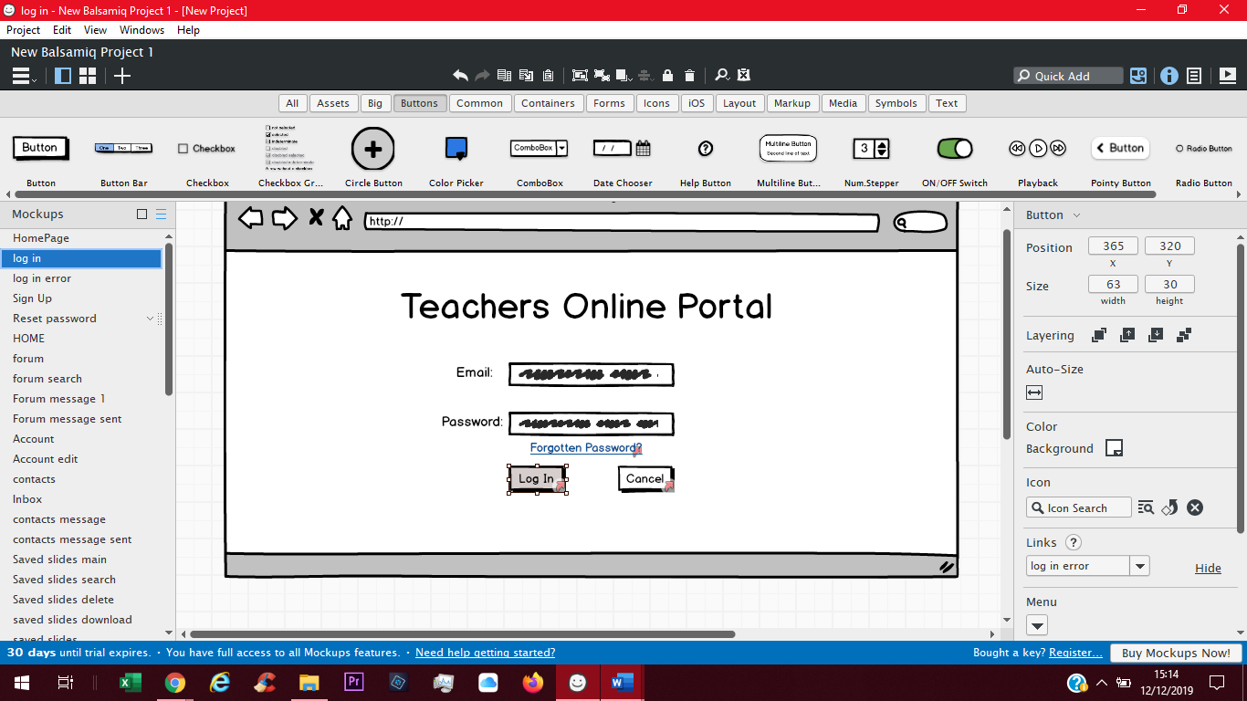

1. **Planner**

Design space:

The second design choice I picked was the planner or scheduler made for the teacher to store and hold information on each teaching day. The three options I picked from was a calendar style to overlay the page, a daily task list or an actual planner which show days as pages. I came up with these design choices when looking at similar ones on the internet.

Design criteria:

The first part of the criteria for this design choice is the peer evaluation of designs I had chosen. This is because the users testing the system would be one of the best ways to see if the planner works, is clear and concise. Having a peer look at your work also gives me as the designer a chance to see if its only me that likes the design. I gave the tester a system usability scale to assess the design. The second piece of criteria I used was research for what planners are available on other sites and how they work.[2] This is useful to assess with as these have all already been user tested and would have been changed if the public using it didn’t understand how it works. These two criteria have shaped the decision for its usability and clarity.

Final design:

Using the criteria stated above I came to decision about what design I would use for my planner in the portal. I went with calendar overlay; this is because meeting with the criteria in the peer evaluation the user gave the best score on the system usability scale for the calendar. This showed to me that it was the easiest to use out of the three given to the tester. I didn’t pick the daily task list as when looking how they would work in my research it would not be easy to navigate through several days. This was further backed up with it scoring low on usability on the scale. Furthermore, I didn’t pick the days as pages design for the very same reason and also the fact it takes a lot of space up on the screen and this doesn’t make it easy to see multiple days ahead without flicking through them all.

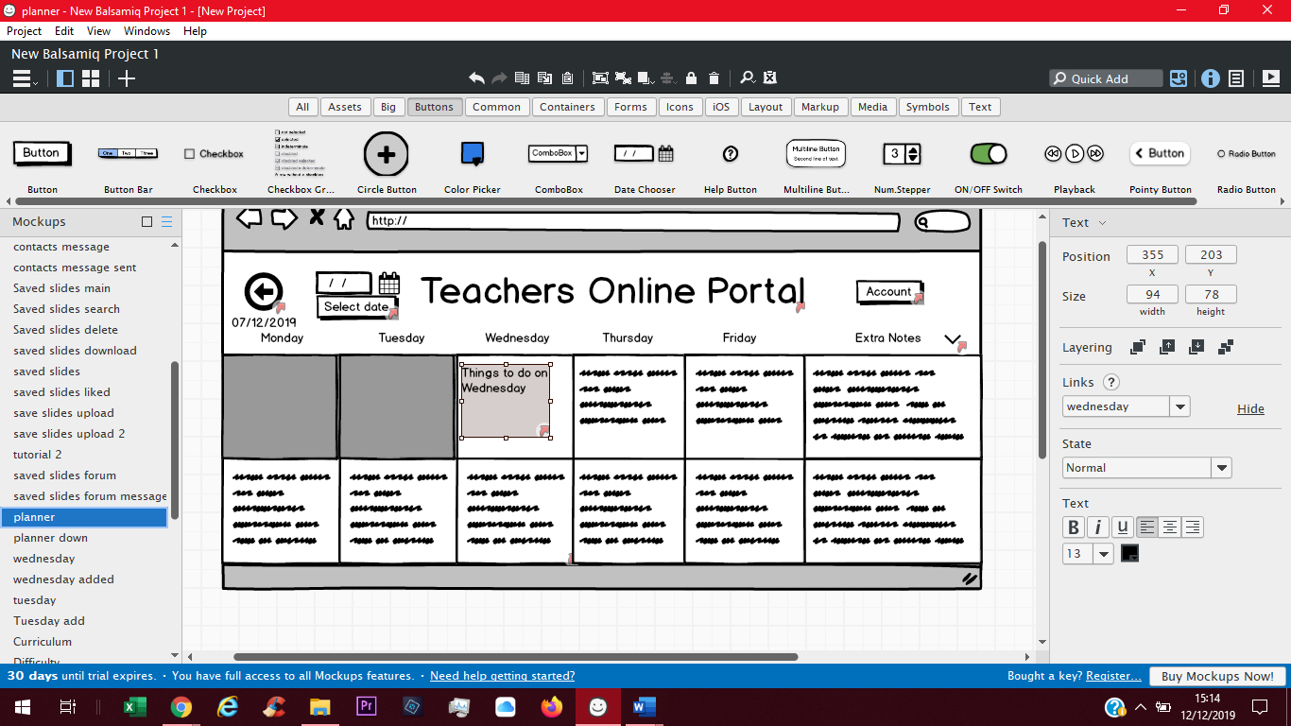

1. **Forum**

Design space:

The last design choice I picked was how the forum was going to look. This is important because people will be messaging on here frequently so good user interaction is essential. The first was a up vote and down vote styled forum. Next, a forum where the maker of the forum’s posts shown differently i.e. having the author have blue backgrounded posts. Also, just a normal forum as well.

Design criteria:

The first criteria I have for this is Shneidermans’s Eight rules.[4] These outline rules which should be followed in interface design and correlate well with how the forum should be designed. These are reliable and respected by the computing community. The next criteria are design principles which I have researched.[3] This goes from using contrast where needed to keep the user interface clean and simple. This is useful as I feel a forum can get cluttered easily and this should prevent this.

Final design:

Using the criteria above the style I picked was a simple forum. This is was because in Shneidermans’s Eight rules, one states that to reduce short term memory load displays should be simple and consistent throughout the design. So, when looking at the other designs, the added functionality is most probably not needed or will not be used. This means up and down votes are maybe doing too much and blue colouring would not be consistent with the design. I also didn’t pick the different author posts because of the design principles that I researched. The idea went against the consistency of the pages by having a sudden block of colour. This felt out of lace and makes the forum more complicated if you don’t know what the colour meant. These points make the simple forum the most desirable in the site and make the most sense.

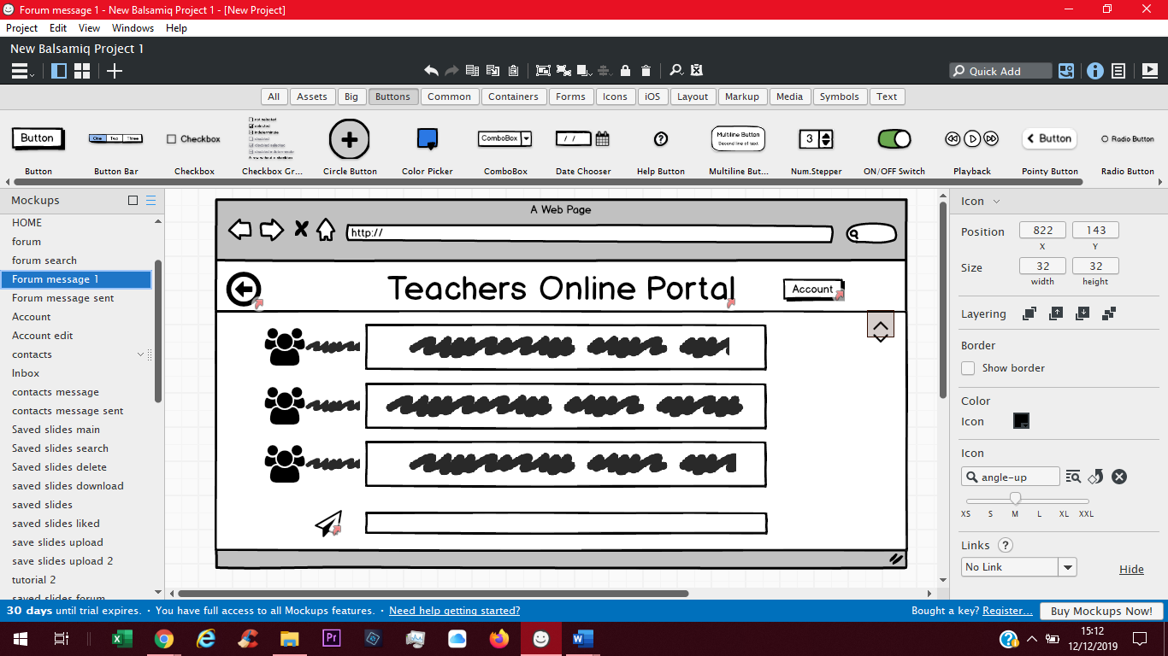

Appendix

|  |  |  |
| --- | --- | --- |
| Requirement | Description | Why? |
| R1 | Login gate | As there would be some sort of membership, they would need some sort of account to access the portal. This is because in the interview the teacher says” So a teacher could login to the platform and look at the scheme of work?” thus inferring only teachers should be able to get on the platform. |
| R2 | Search Bar | This is to be able to look for a type of lesson plan or video and you don’t know the right unit. This is asked for in the interview here “They maybe need to be able to search based on some keywords as they may not know where to find a lesson about a particular topic.”. |
| R3 | Download slides | When a teacher adds content to the portal it will need some sort of download function which would save the files on the local computer being used. This is asked for here “download the file and make some tweaks for their students”. |
| R4 | Messaging area | There will need to be a messaging part of the portal when teachers can talk to each other about problems they might have. This is asked for in the interview here “so some sort of forum where they can discuss and ask questions”. |
| R5 | Upload slides | Teachers will need an icon which can let them upload slides which they have made. This is needed as teacher will need to download slides. This is described in the interview here “Where teachers can access and share the resources and talk about them?” |
| R6 | Contents page | When logging on to the portal there should be some file directory which can let teacher go to syllabus they are looking for. This is described in the interview here “Could be a case of “right, you need to go on this page and look at these resource”. |
| R7 | Like button | There would be a like button which would let the better slides rise to the top and the first that are seen. This would mean people using the portal would be able to see the best slides first and not sift through themselves. |
| R8 | Tagging videos | There would need to be some sort of tagging system which would describe what ability eve the students need to be at for the lesson plan. This is described here “It would be great if they could be tagged and maybe searched, something about an ability level.”. |
| R9 | Remix slides | There can also be a function which lets teacher change an existing slide on the portal and upload a separate version which can be more or less challenging for other users. This is described here “What about allowing teachers to “remix” the resources?”. |
| R10 | Planner | There is a function which allows the user to add plans to a calendar style planner s that they can plan and organise their lessons plans. |
| R11 | Save lesson plan | There is a function which is used to save a lesson plan that a user has searched for. This will then appear in a separate section of the homepage for quick and easy access. |
| R12 | Account | There is a function which will allow a user to store details about themselves and their time on the system to give the portal a personal feel. |
| R13 | Tutorial | There is a function which will allow a user to see tutorial videos on a lesson plan so that they or the students can easily understand what is going on and give further detail into what the lesson talks about. |

References

[1] Amelia Booking WordPress Plugin. (2019). *Login Page Design: Do's and Don'ts*. [online] Available at: https://wpamelia.com/login-page-design/ [Accessed 12 Dec. 2019].

[2] The Balance Small Business. (2019). *The 9 Best Planner Apps of 2019*. [online] Available at: https://www.thebalancesmb.com/best-planner-apps-4174743 [Accessed 12 Dec. 2019].

[3] non-designers, F. (2019). *Fundamental design principles for non-designers*. [online] The freeCodeCamp Forum. Available at: https://www.freecodecamp.org/forum/t/fundamental-design-principles-for-non-designers/284979 [Accessed 12 Dec. 2019].

[4] The Interaction Design Foundation. (2019). *Shneiderman’s Eight Golden Rules Will Help You Design Better Interfaces*. [online] Available at: https://www.interaction-design.org/literature/article/shneiderman-s-eight-golden-rules-will-help-you-design-better-interfaces [Accessed 12 Dec. 2019].