NOTICE TO EXPLAIN (NTE) FORM v0.1
Employee Name: | Richie Gayo | Account Name: | CareMedica
Designation: | Medical Biller | Date: | July 23, 2025
Supervisor: | Frances Manatad | NTE/NOD Entry Log No. | 00171

RE: ATTENDANCE ISSUE

Please be advised that you were allegedly been reported for attendance issues due to your tardiness. During the month of July 2025. You were late on 7/3, 7/14, 7/15, 7/18, 7/21 and on 7/22.
Below is a screen shot of your login time report for the month of July 2025:
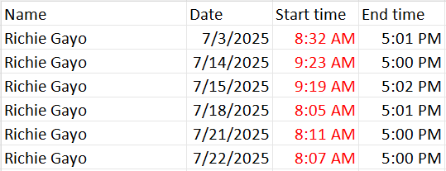

As stated in the Code of Conduct, your attendance plays as a large contribution to your work.

During your employment orientation, you are trained about company policies and provided with handbook and documents which explained in fine details company rules and regulations, especially attendance and attrition. You also signed the same documents indicating that you agreed and understand each provision that has been stipulated.

Please be reminded that you are evaluated on your overall job performance by means of not only output in tasks assigned, but also your compliance to company policies.

You are given 48 hours to answer this offence and explain in detail your side why you have committed such infraction. Your answer will help us immensely evaluate your present job and its continuity here in Ideal Tech Staffing Phils. As with others who were given the opportunity to air their side, this will be your chance to rebut any information indicated in this document.

By affixing your signature in the conforme below you are acknowledging that you understand each statement herein and the offense that have been hurled against your person, and that you agreed to comply with our request.

Sincerely yours,
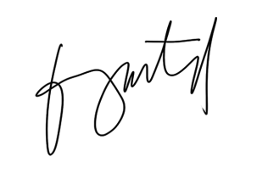

Frances G. Manatad
Operations Manager

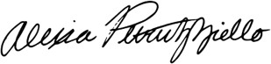

Alexia Petruzziello
President

Employee’s Explanation (Please explain your side on why the above ground and corresponding sanction will not be given due course):

Date:
Signature Over Printed Name of Employee

(You may use a separate page as continuation of your explanation above. Please make sure to affix the above signature on top of the affixing of your signature over your printed name at the end of your statement in the subsequent page as well. Submit this to the Superior within 5 Days from service thereof. Your Superior will make a copy thereof and will return this same form to you with the Notice of Decision below accomplished. The superior will log the file to HR 201 File.). Hearing may be called.

NOTICE OF DECISION (NOD)
(To be filed-out by the direct superior. An appeal of this decision shall be made within 5 days from service thereof)

Date:

Sanction Incurred
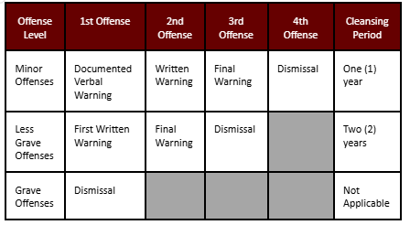
(Superior will encircle correspondingly)

Signature Over Printed Name of Superior

Sanction to Progress into:

(Superior will encircle correspondingly)

