Name: Matthew Zhou

Batch code: LISUM20

Submission Date: 5/7/2023

Submitted to: Canvas/Github

Dataset: Salary_Data

Model Creation and Serialization:

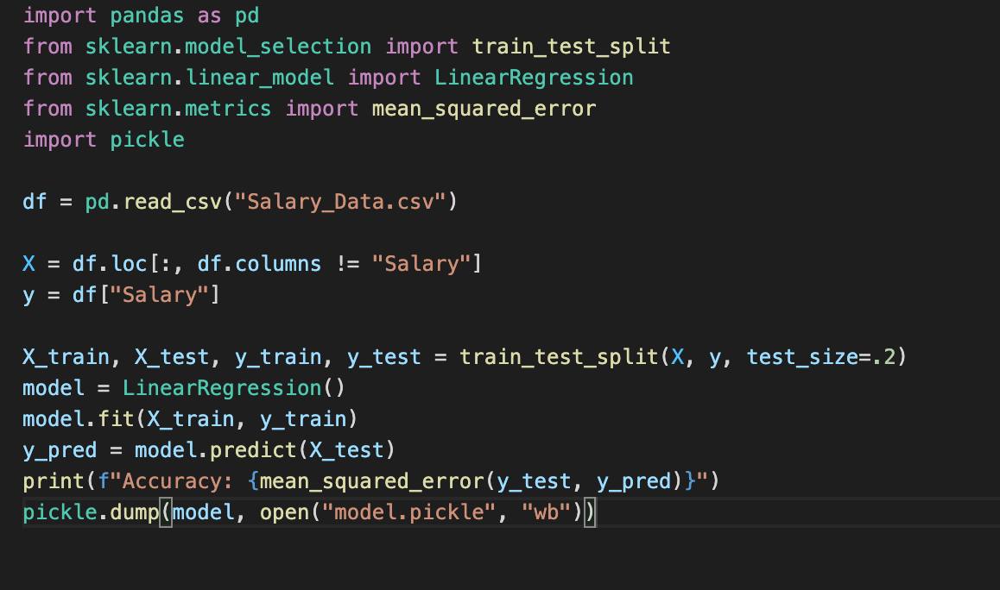

Accuracy: 28688602.326753754

HTML Template for Website:

Deserialization of Model, Prediction using POST:

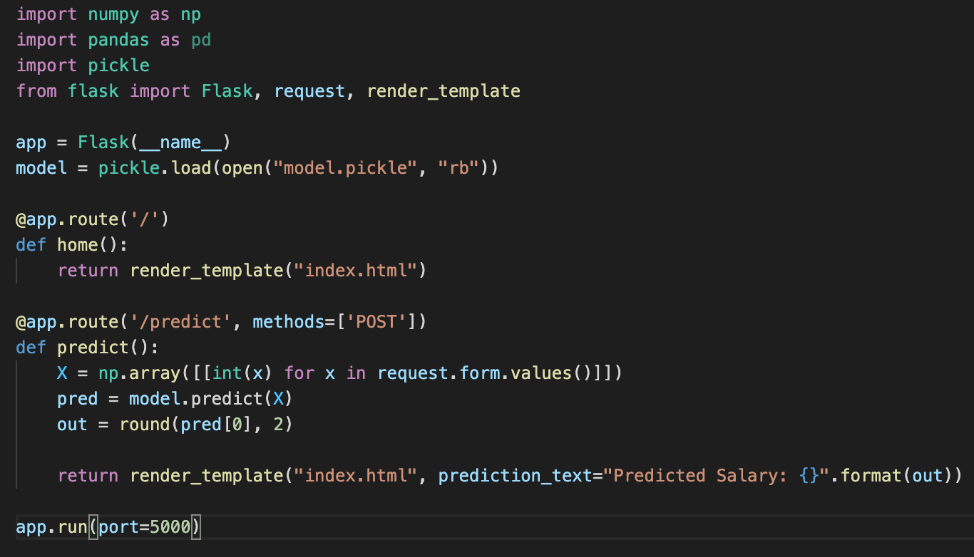

Example Run:

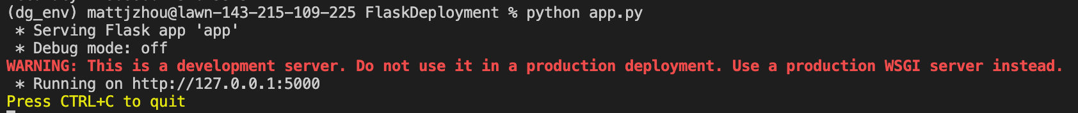

Update to local network

Created AWS EC2 Instance in Ubuntu

SSH into instance

Clone repo and download packages

Run in instance

Example run at web IP address

