If we drop any constants that do not depend on the parameters 𝑤0, 𝑤1, or 𝑤2, we can rewrite 𝑙(𝑤) as,

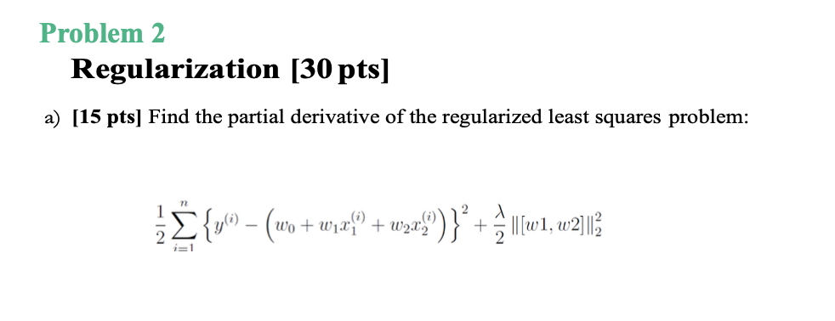

Let us denote $h\left(w\right)=\frac{1}{2}\sum_{i=1}^{n}{\frac{∂h\left(w\right)}{∂w_{i}}(y^{i}-{w_{0}-w_{1}x_{1}^{i}-w_{2}x_{2}^{i})}^{2}+\frac{λ}{2}(\frac{∂h\left(w\right)}{∂w_{i}}\left(w_{1}^{2}+w_{2}^{2}\right))}$

The partial derivative of h(w) with respect to $w_{0}$ is:

$$\frac{∂h\left(w\right)}{∂w_{0}}= \frac{1}{2}\sum_{i=1}^{n}{\frac{∂h\left(w\right)}{∂w_{0}}(y^{i}-{w_{0}-w_{1}x_{1}^{i}-w_{2}x_{2}^{i})}^{2}+\frac{λ}{2}(\frac{∂h\left(w\right)}{∂w_{0}}\left(w_{1}^{2}+w_{2}^{2}\right))}$$

$= \frac{1}{2}\sum_{i=1}^{n}{-2{(y}^{i}-w_{0}—w_{1}x_{1}^{i}-w_{2}x_{2}^{i})}$

$= -\sum_{i=1}^{n}{{(y}^{i}-w_{0}—w_{1}x_{1}^{i}-w_{2}x_{2}^{i})}$

The partial derivative of h(w) with respect to $w_{1}$ is:

$$\frac{∂h\left(w\right)}{∂w_{1}}= \frac{1}{2}\sum_{i=1}^{n}{\frac{∂h\left(w\right)}{∂w_{1}}(y^{i}-{w_{0}-w_{1}x_{1}^{i}-w_{2}x_{2}^{i})}^{2}+\frac{λ}{2}(\frac{∂h\left(w\right)}{∂w_{1}}\left(w_{1}^{2}+w_{2}^{2}\right))}$$

$= \frac{1}{2}\sum_{i=1}^{n}{-2x_{1}^{i}{(y}^{i}-w_{0}—w_{1}x_{1}^{i}-w_{2}x_{2}^{i})}+\frac{λ}{2}\left(2w_{1}\right)$

$= \sum_{i=1}^{n}{ x_{1}^{i}{(y}^{i}-w_{0}—w_{1}x_{1}^{i}-w_{2}x_{2}^{i})}+\left(λw_{1}\right)$

The partial derivative of h(w) with respect to $w_{2}$ is:

$$\frac{∂h\left(w\right)}{∂w_{2}}= \frac{1}{2}\sum_{i=1}^{n}{\frac{∂h\left(w\right)}{∂w_{2}}(y^{i}-{w_{0}-w_{1}x_{1}^{i}-w_{2}x_{2}^{i})}^{2}+\frac{λ}{2}(\frac{∂h\left(w\right)}{∂w_{2}}\left(w_{1}^{2}+w_{2}^{2}\right))}$$

$= \frac{1}{2}\sum_{i=1}^{n}{-2x_{2}^{i}{(y}^{i}-w_{0}—w_{1}x_{1}^{i}-w_{2}x_{2}^{i})}+\frac{λ}{2}\left(2w_{2}\right)$

$= \sum_{i=1}^{n}{ x_{2}^{i}{(y}^{i}-w_{0}—w_{1}x_{1}^{i}-w_{2}x_{2}^{i})}+\left(λw_{2}\right)$

The gradient descent update rules for is:

