CS419 assignment 6

**Group members Sujay Gami , Kunal Mishra, Siskia Erissa , Matthew Kalita SR**

Standard java program built on eclipse tested on ILab

Certs were generated with java keytool on desktop and transferred to ilab

Compile server and client then run Server and select server.jks file from your file system:

**The argument is the port number**

**Pass word** for both station503

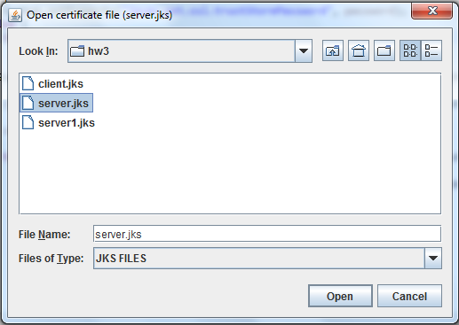

Next, run Client and select client.jks file:

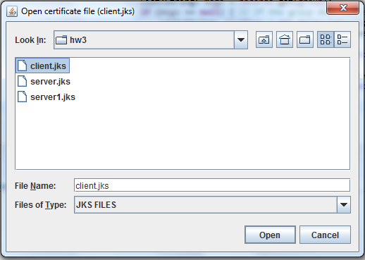

Client’s console: all below have been removed so new ones can be made in run thru see below examples:

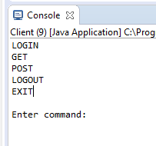

Testing

Let’s test GET, POST and LOGOUT commands without authentication:

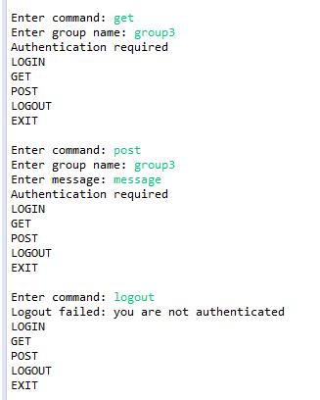

Next, let’s use empty login or password in LOGIN command:

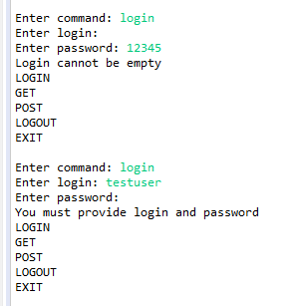

Next, use valid login and password (not previously stored):

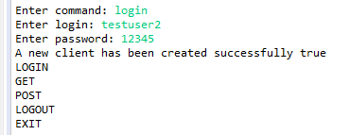

Next, GET not existing group:

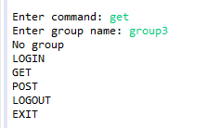

Next, create new group, post messages and get these messages:

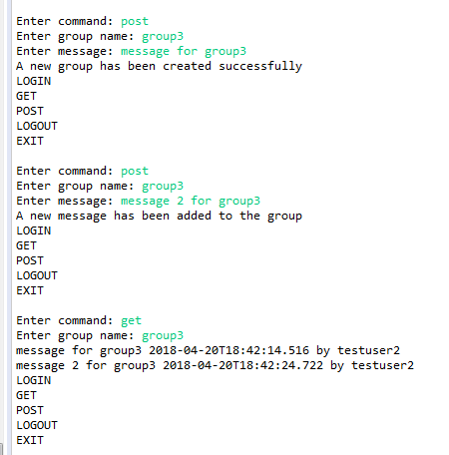

Next, logout, create new user and get messages from group3, and post new message for this group:

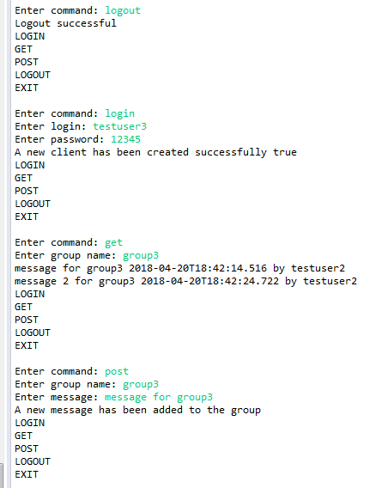

Now, get all messages from group3 (first two messages was posted by testuser2, last message by testuser3); also check invalid password option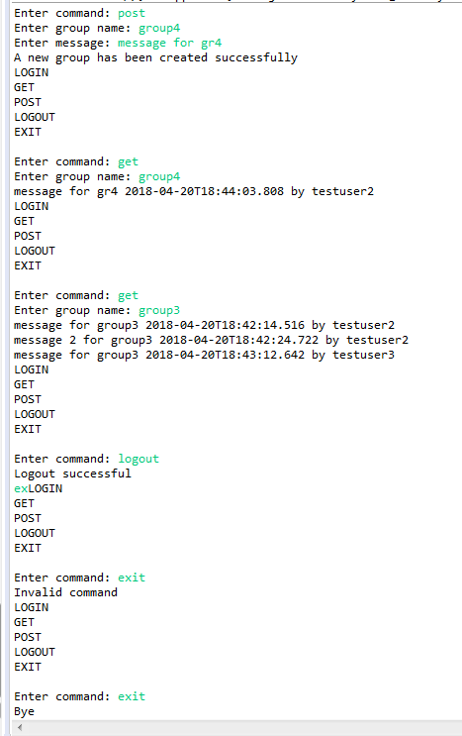:

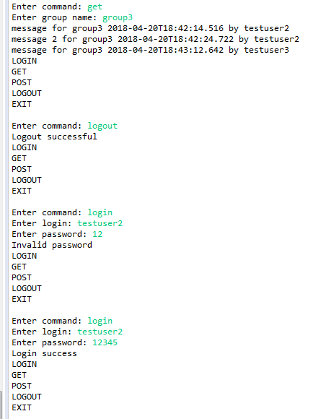

**Now, let’s test invalid certificate for server:**

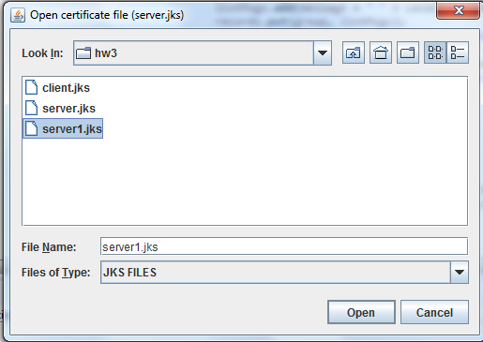

And output for client:

