Vaccination Rate Mini Project

Matt Hashimoto

12/3/2021

## Getting Started

Let’s first start by loading our data from the .csv file:

# Import vaccination data  
vax <- read.csv("covid19vaccinesbyzipcode_test.csv")  
head(vax)

## as_of_date zip_code_tabulation_area local_health_jurisdiction county  
## 1 2021-01-05 92091 San Diego San Diego  
## 2 2021-01-05 92116 San Diego San Diego  
## 3 2021-01-05 95360 Stanislaus Stanislaus  
## 4 2021-01-05 94564 Contra Costa Contra Costa  
## 5 2021-01-05 95501 Humboldt Humboldt  
## 6 2021-01-05 95492 Sonoma Sonoma  
## vaccine_equity_metric_quartile vem_source  
## 1 4 CDPH-Derived ZCTA Score  
## 2 3 Healthy Places Index Score  
## 3 1 Healthy Places Index Score  
## 4 4 Healthy Places Index Score  
## 5 2 Healthy Places Index Score  
## 6 4 Healthy Places Index Score  
## age12_plus_population age5_plus_population persons_fully_vaccinated  
## 1 1238.3 1303 NA  
## 2 30255.7 31673 45  
## 3 10478.5 12301 NA  
## 4 17033.0 18381 NA  
## 5 20566.6 22061 NA  
## 6 25076.9 28024 NA  
## persons_partially_vaccinated percent_of_population_fully_vaccinated  
## 1 NA NA  
## 2 898 0.001421  
## 3 NA NA  
## 4 NA NA  
## 5 NA NA  
## 6 NA NA  
## percent_of_population_partially_vaccinated  
## 1 NA  
## 2 0.028352  
## 3 NA  
## 4 NA  
## 5 NA  
## 6 NA  
## percent_of_population_with_1_plus_dose  
## 1 NA  
## 2 0.029773  
## 3 NA  
## 4 NA  
## 5 NA  
## 6 NA  
## redacted  
## 1 Information redacted in accordance with CA state privacy requirements  
## 2 No  
## 3 Information redacted in accordance with CA state privacy requirements  
## 4 Information redacted in accordance with CA state privacy requirements  
## 5 Information redacted in accordance with CA state privacy requirements  
## 6 Information redacted in accordance with CA state privacy requirements

#### Q1

“What column details the total number of people fully vaccinated?”

Column 9, titled “persons_fully_vaccinated”.

#### Q2

“What column details the Zip code tabulation area?”

Column 2, titled “zip_code_tabulation_area”.

#### Q3

“What is the earliest date in this dataset?”

This can be found by looking at the first entry in the “as_of_date” column:

# View the first entry in the as_of_date column  
vax$as_of_date[1]

## [1] "2021-01-05"

Thus, the earliest date is January 5th, 2021.

#### Q4

“What is the latest date in this dataset?”

Similarly to the last question, this can be found by looking at the last entry in the “as_of_date” column:

vax$as_of_date[length(vax$as_of_date)]

## [1] "2021-11-30"

Thus, the latest date is November 30th, 2021.

Let’s try calling the skim function to get a better idea of what’s in the dataset:

# Call the skim function  
skimr::skim(vax)

Data summary

|  |  |
| --- | --- |
| Name | vax |
| Number of rows | 84672 |
| Number of columns | 14 |
| _______________________ |  |
| Column type frequency: |  |
| character | 5 |
| numeric | 9 |
| ________________________ |  |
| Group variables | None |

**Variable type: character**

| skim_variable | n_missing | complete_rate | min | max | empty | n_unique | whitespace |
| --- | --- | --- | --- | --- | --- | --- | --- |
| as_of_date | 0 | 1 | 10 | 10 | 0 | 48 | 0 |
| local_health_jurisdiction | 0 | 1 | 0 | 15 | 240 | 62 | 0 |
| county | 0 | 1 | 0 | 15 | 240 | 59 | 0 |
| vem_source | 0 | 1 | 15 | 26 | 0 | 3 | 0 |
| redacted | 0 | 1 | 2 | 69 | 0 | 2 | 0 |

**Variable type: numeric**

| skim_variable | n_missing | complete_rate | mean | sd | p0 | p25 | p50 | p75 | p100 | hist |
| --- | --- | --- | --- | --- | --- | --- | --- | --- | --- | --- |
| zip_code_tabulation_area | 0 | 1.00 | 93665.11 | 1817.39 | 90001 | 92257.75 | 93658.50 | 95380.50 | 97635.0 | ▃▅▅▇▁ |
| vaccine_equity_metric_quartile | 4176 | 0.95 | 2.44 | 1.11 | 1 | 1.00 | 2.00 | 3.00 | 4.0 | ▇▇▁▇▇ |
| age12_plus_population | 0 | 1.00 | 18895.04 | 18993.94 | 0 | 1346.95 | 13685.10 | 31756.12 | 88556.7 | ▇▃▂▁▁ |
| age5_plus_population | 0 | 1.00 | 20875.24 | 21106.04 | 0 | 1460.50 | 15364.00 | 34877.00 | 101902.0 | ▇▃▂▁▁ |
| persons_fully_vaccinated | 8472 | 0.90 | 9709.47 | 11714.06 | 11 | 526.00 | 4309.50 | 16316.00 | 71552.0 | ▇▂▁▁▁ |
| persons_partially_vaccinated | 8472 | 0.90 | 1891.41 | 2100.88 | 11 | 197.00 | 1268.50 | 2874.00 | 20158.0 | ▇▁▁▁▁ |
| percent_of_population_fully_vaccinated | 8472 | 0.90 | 0.43 | 0.27 | 0 | 0.21 | 0.45 | 0.63 | 1.0 | ▇▆▇▇▂ |
| percent_of_population_partially_vaccinated | 8472 | 0.90 | 0.10 | 0.10 | 0 | 0.06 | 0.07 | 0.11 | 1.0 | ▇▁▁▁▁ |
| percent_of_population_with_1_plus_dose | 8472 | 0.90 | 0.51 | 0.26 | 0 | 0.31 | 0.54 | 0.71 | 1.0 | ▅▅▇▇▅ |

#### Q5

“How many numeric columns are in this dataset?”

As seen from the skim results, there are 9 numeric columns.

#### Q6

“Note that there are “missing values” in the dataset. How many NA values are there in the persons_fully_vaccinated column?”

The “n_missing” column shows that there are 8472 NA values in the “persons_fully_vaccinated” column.

#### Q7

“What percent of persons_fully_vaccinated values are missing (to 2 significant figures)?”

# 8472 missing values out of 84672  
8472 / 84672

## [1] 0.1000567

10% of the values are missing.

#### Q8

“[Optional]: Why might this data be missing?”

This data may be missing because there is no method of collecting data from specific zip codes. As mentioned earlier in the lab document, certain institutions or organizations may have no obligation or reason to report their vaccination data, and certain zip codes may be entirely managed by these institutions or organizations.

## Working With Dates

Let’s use the lubridate library to help us deal with dates:

library(lubridate)

##   
## Attaching package: 'lubridate'

## The following objects are masked from 'package:base':  
##   
## date, intersect, setdiff, union

Check today’s date:

today()

## [1] "2021-12-03"

Let’s convert our dates into a lubridate format to make analysis easier:

# Speciffy that we are using the Year-mont-day format  
vax$as_of_date <- ymd(vax$as_of_date)

Now we can use lubridate functions to check things like how many days have passed since the first data was collected:

# Check time since first measurement  
today() - vax$as_of_date[1]

## Time difference of 332 days

We can also calculate how much time the data spans:

# Check time span  
vax$as_of_date[nrow(vax)] - vax$as_of_date[1]

## Time difference of 329 days

#### Q9

“How many days have passed since the last update of the dataset?”

today() - vax$as_of_date[nrow(vax)]

## Time difference of 3 days

3 days have passed since the last update.

#### Q10

“How many unique dates are in the dataset (i.e. how many different dates are detailed)?”

length(unique(vax$as_of_date))

## [1] 48

There are 48 unique dates in the dataset.

## Working With ZIP Codes

Let’s load in the zipcodeR library:

# Load the zipcodeR library  
library(zipcodeR)

Next let’s find the centroid of the 92037 zip code area (UCSD):

# Find centroid of the 92037 zip code  
geocode_zip('92037')

## # A tibble: 1 × 3  
## zipcode lat lng  
## <chr> <dbl> <dbl>  
## 1 92037 32.8 -117.

We can also calculate the distance between any two zip codes in miles:

# Distance in miles  
zip_distance('92037','92109')

## zipcode_a zipcode_b distance  
## 1 92037 92109 2.33

We can also pull census data about zip codes:

# Pull census data  
reverse_zipcode(c('92037', "92109") )

## # A tibble: 2 × 24  
## zipcode zipcode_type major_city post_office_city common_city_list county state  
## <chr> <chr> <chr> <chr> <blob> <chr> <chr>  
## 1 92037 Standard La Jolla La Jolla, CA <raw 20 B> San D… CA   
## 2 92109 Standard San Diego San Diego, CA <raw 21 B> San D… CA   
## # … with 17 more variables: lat <dbl>, lng <dbl>, timezone <chr>,  
## # radius_in_miles <dbl>, area_code_list <blob>, population <int>,  
## # population_density <dbl>, land_area_in_sqmi <dbl>,  
## # water_area_in_sqmi <dbl>, housing_units <int>,  
## # occupied_housing_units <int>, median_home_value <int>,  
## # median_household_income <int>, bounds_west <dbl>, bounds_east <dbl>,  
## # bounds_north <dbl>, bounds_south <dbl>

We can use this to pull census data for all the zip codes we may be interested in:

# Pull data for all ZIP codes in the dataset  
#zipdata <- reverse_zipcode( vax$zip_code_tabulation_area )

## Focus on the San Diego Area

We can restrict ourselves to San Diego county using base R:

# Subset to San Diego county only areas  
sd <- vax[vax$county == "San Diego",]

Or we could use the dplyr library:

# Load library  
library(dplyr)

##   
## Attaching package: 'dplyr'

## The following objects are masked from 'package:stats':  
##   
## filter, lag

## The following objects are masked from 'package:base':  
##   
## intersect, setdiff, setequal, union

# Filter just results from SD  
sd <- filter(vax, county == "San Diego")  
nrow(sd)

## [1] 5136

The dplyr package is more convenient when trying to subset across multiple criteria:

# All SD counties with populations over 10000  
sd.10 <- filter(vax, county == "San Diego" &  
 age5_plus_population > 10000)

#### Q11

“How many distinct zip codes are listed for San Diego County?”

# Check for uniqueness  
length(unique(sd$zip_code_tabulation_area))

## [1] 107

107 distinct zip codes are listed for SD county.

#### Q12

“What San Diego County Zip code area has the largest 12 + Population in this dataset?”

# Check for max population value  
sd$zip_code_tabulation_area[which.max(sd$age12_plus_population)]

## [1] 92154

The 92154 area has the largest 12+ population.

# All data for Nov 16  
sd.nov16 <- filter(vax, county == "San Diego" &  
 as_of_date == "2021-11-16")

#### Q13

“What is the overall average “Percent of Population Fully Vaccinated” value for all San Diego “County” as of “2021-11-16”?”

# Average percent of population fully vaccinated  
mean(sd.nov16$percent_of_population_fully_vaccinated, na.rm = TRUE)

## [1] 0.6722183

The average percent of population fully vaccinated is 67.22%.

#### Q14

“Using either ggplot or base R graphics make a summary figure that shows the distribution of Percent of Population Fully Vaccinated values as of “2021-11-16”?”

# Plot distribution of percent fully vaccinated  
hist(sd.nov16$percent_of_population_fully_vaccinated,  
 main = "Histogram of Vaccination Rates Across San Diego County",  
 xlab = "Percent of Population Fully Vaccinated on 2021-11-16",  
 col = "gray")

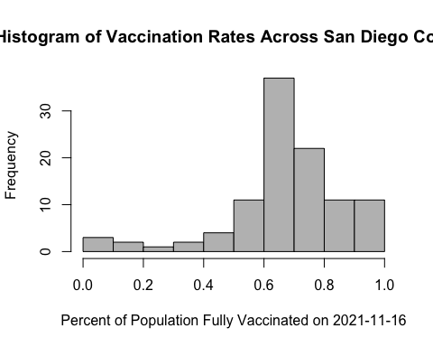

## Focus on UCSD/La Jolla

Let’s filter to the UCSD area zip code:

# Filter to UCSD zip code and check 5+ population  
ucsd <- filter(sd, zip_code_tabulation_area == "92037")  
ucsd[1,]$age5_plus_population

## [1] 36144

#### Q15

“Using ggplot make a graph of the vaccination rate time course for the 92037 ZIP code area:”

# Load ggplot library  
library(ggplot2)  
  
# Use ggplot to create a graph  
ggplot(ucsd) +  
 aes(ucsd$as_of_date,  
 ucsd$percent_of_population_fully_vaccinated) +  
 geom_point() +  
 geom_line(group = 1) +  
 ylim(c(0,1)) +  
 labs(x = "Date", y = "Percent Vaccinated") +  
 ggtitle("Vaccination Rate for La Jolla, CA 92037")

## Warning: Use of `ucsd$as_of_date` is discouraged. Use `as_of_date` instead.

## Warning: Use of `ucsd$percent_of_population_fully_vaccinated` is discouraged.  
## Use `percent_of_population_fully_vaccinated` instead.

## Warning: Use of `ucsd$as_of_date` is discouraged. Use `as_of_date` instead.

## Warning: Use of `ucsd$percent_of_population_fully_vaccinated` is discouraged.  
## Use `percent_of_population_fully_vaccinated` instead.

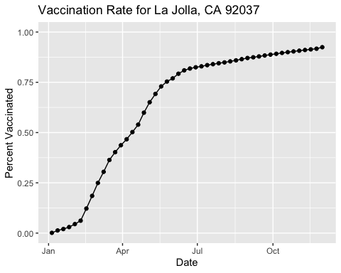

## Comparing 92037 to Other Similarly Sized Areas

Let’s filter our vaccination data once again to data at least as large as the population in 92037:

# Subset to all CA areas with a population as large as 92037  
vax.36 <- filter(vax, age5_plus_population > 36144 &  
 as_of_date == "2021-11-16")  
  
head(vax.36)

## as_of_date zip_code_tabulation_area local_health_jurisdiction county  
## 1 2021-11-16 92345 San Bernardino San Bernardino  
## 2 2021-11-16 92553 Riverside Riverside  
## 3 2021-11-16 92058 San Diego San Diego  
## 4 2021-11-16 91786 San Bernardino San Bernardino  
## 5 2021-11-16 92507 Riverside Riverside  
## 6 2021-11-16 93021 Ventura Ventura  
## vaccine_equity_metric_quartile vem_source  
## 1 1 Healthy Places Index Score  
## 2 1 Healthy Places Index Score  
## 3 1 Healthy Places Index Score  
## 4 2 Healthy Places Index Score  
## 5 1 Healthy Places Index Score  
## 6 4 Healthy Places Index Score  
## age12_plus_population age5_plus_population persons_fully_vaccinated  
## 1 66047.5 75539 35432  
## 2 61770.8 70472 37411  
## 3 34956.0 39695 14023  
## 4 45602.3 50410 30834  
## 5 51432.5 55253 31939  
## 6 32753.7 36197 24918  
## persons_partially_vaccinated percent_of_population_fully_vaccinated  
## 1 4389 0.469056  
## 2 4846 0.530863  
## 3 2589 0.353269  
## 4 3132 0.611664  
## 5 3427 0.578050  
## 6 2012 0.688400  
## percent_of_population_partially_vaccinated  
## 1 0.058102  
## 2 0.068765  
## 3 0.065222  
## 4 0.062131  
## 5 0.062024  
## 6 0.055585  
## percent_of_population_with_1_plus_dose redacted  
## 1 0.527158 No  
## 2 0.599628 No  
## 3 0.418491 No  
## 4 0.673795 No  
## 5 0.640074 No  
## 6 0.743985 No

#### Q16

“Calculate the mean “Percent of Population Fully Vaccinated” for ZIP code areas with a population as large as 92037 (La Jolla) as_of_date “2021-11-16”. Add this as a straight horizontal line to your plot from above with the geom_hline() function?”

# Calculate mean  
mean(vax.36$percent_of_population_fully_vaccinated, na.rm = TRUE)

## [1] 0.6645132

# Add line to plot  
ggplot(ucsd) +  
 aes(ucsd$as_of_date,  
 ucsd$percent_of_population_fully_vaccinated) +  
 geom_point() +  
 geom_line(group = 1) +  
 ylim(c(0,1)) +  
 labs(x = "Date", y = "Percent Vaccinated") +  
 ggtitle("Vaccination Rate for La Jolla, CA 92037") +  
 geom_hline(yintercept = mean(vax.36$percent_of_population_fully_vaccinated,  
 na.rm = TRUE),  
 color = "red", linetype = "dashed")

## Warning: Use of `ucsd$as_of_date` is discouraged. Use `as_of_date` instead.

## Warning: Use of `ucsd$percent_of_population_fully_vaccinated` is discouraged.  
## Use `percent_of_population_fully_vaccinated` instead.

## Warning: Use of `ucsd$as_of_date` is discouraged. Use `as_of_date` instead.

## Warning: Use of `ucsd$percent_of_population_fully_vaccinated` is discouraged.  
## Use `percent_of_population_fully_vaccinated` instead.

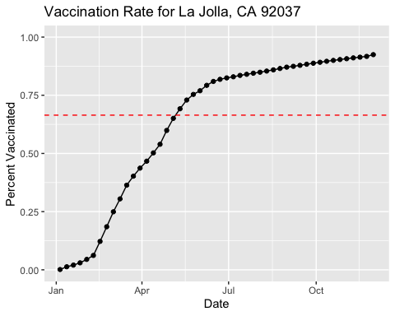

#### Q17

“What is the 6 number summary (Min, 1st Qu., Median, Mean, 3rd Qu., and Max) of the “Percent of Population Fully Vaccinated” values for ZIP code areas with a population as large as 92037 (La Jolla) as_of_date “2021-11-16”?”

# Use fivenum to get min, 1st qu, median, 3rd qu, and max  
fivenum(vax.36$percent_of_population_fully_vaccinated)

## [1] 0.353269 0.591029 0.666919 0.731112 1.000000

# Use mean()  
mean(vax.36$percent_of_population_fully_vaccinated)

## [1] 0.6645132

#### Q18

“Using ggplot generate a histogram of this data.”

ggplot(vax.36) +  
 aes(vax.36$percent_of_population_fully_vaccinated) +  
 geom_histogram() +  
 xlim(0,1) +  
 labs(x = "Percent Vaccinated")

## Warning: Use of `vax.36$percent_of_population_fully_vaccinated` is discouraged.  
## Use `percent_of_population_fully_vaccinated` instead.

## `stat_bin()` using `bins = 30`. Pick better value with `binwidth`.

## Warning: Removed 2 rows containing missing values (geom_bar).

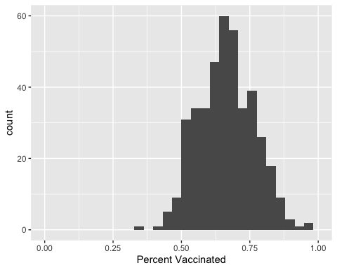

#### Q19

“Is the 92109 and 92040 ZIP code areas above or below the average value you calculated for all these above?”

# The average value  
mean(vax.36$percent_of_population_fully_vaccinated)

## [1] 0.6645132

# Check 92109  
vax %>% filter(as_of_date == "2021-11-16") %>%   
 filter(zip_code_tabulation_area=="92109") %>%  
 select(percent_of_population_fully_vaccinated)

## percent_of_population_fully_vaccinated  
## 1 0.68912

# Check 92040  
vax %>% filter(as_of_date == "2021-11-16") %>%   
 filter(zip_code_tabulation_area=="92040") %>%  
 select(percent_of_population_fully_vaccinated)

## percent_of_population_fully_vaccinated  
## 1 0.52142

As you can see, the 92109 zip code is above the average vaccination percentage, while the 92040 zip code is below.

#### Q20

“Finally make a time course plot of vaccination progress for all areas in the full dataset with a age5_plus_population > 36144.”

# Filter data for all days  
vax.36.all <- filter(vax, age5_plus_population > 36144)  
  
# Plot with ggplot  
ggplot(vax.36.all) +  
 aes(vax.36.all$as_of_date,  
 vax.36.all$percent_of_population_fully_vaccinated,   
 group = zip_code_tabulation_area) +  
 geom_line(alpha = 0.2, color = "blue") +  
 ylim(0,1) +  
 labs(x = "Date", y = "Percent Vaccinated",  
 title = "Vaccination Rate Across California",  
 subtitle = "Only areas with a population above 36k are shown.") +  
 geom_hline(yintercept = mean(vax.36$percent_of_population_fully_vaccinated,  
 na.rm = TRUE),  
 linetype = "dashed")

## Warning: Use of `vax.36.all$as_of_date` is discouraged. Use `as_of_date`  
## instead.

## Warning: Use of `vax.36.all$percent_of_population_fully_vaccinated` is  
## discouraged. Use `percent_of_population_fully_vaccinated` instead.

## Warning: Removed 177 row(s) containing missing values (geom_path).

