**Title: Automatic Bandpass Filter Designer and Tester**

**Programmer: Matt Kwan**

**December 17, 2014**

**ES-55**

## Description:

The program is designed to create a bandpass filter using a Low Pass RC filter cascaded with High Pass RC filter, keeping total resistance and capacitance within a given range. The optimization process is animated for the user, and plots of example signals and FFTs are generated from using the filter. Furthermore, audio output is used to help illuminate characteristics of the signals.

## Inputs:

The program relies on a number of parameters. The key ones are:

* Component parameters: highest/lowest usable resistance and highest/lowest usable capacitance.
* Step parameters: step sizes, to determine the accuracy and speed of the calculations.
* Calculation parameters: desired pass band frequency.

In addition, initial values of resistance and capacitance must be specified.

## Outputs:

The program does the following:

* A bandpass filter is designed whose Bode plot and semilog plots are displayed/animated (respectively) for the user.
* The components needed to physically build the bandpass filter are output to the terminal. Additional information about the filter is also provided.
* A signal is generated and analyzed in the time and frequency domains (fft). The signal plays through the computer speakers.
  + In Example 1, it is a sum of two harmonics.
  + In Example 2, it is a sound file of my voice (audioread).
* The signal is passed through the filter designed earlier via its Fourier transform.
* The output signal is analyzed in the frequency and time domain (ifft).
* The output signal plays through the computer speakers.

## Numerical Methods (MATLAB Functions):

* Audio file 🡪 data (audioread)
* Data 🡪 output (audioplayer; play)
* Fast Fourier transform (fft)
* Inverse fast Fourier transform (ifft)
* Animation (getframe; movie)
* Waitbar GUI (waitbar)

## Validation of Results

*Validation of bandpass shape and location:*

Figure 1: LTSPICE Frequency Response

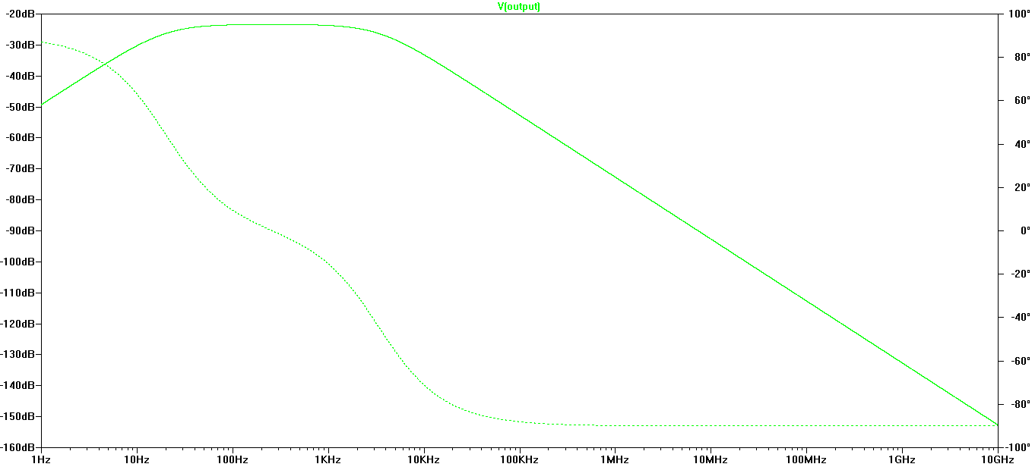

Figure 2: MALTLAB Frequency Response



*Validation of peak bandpass gain and frequency:*

Figure 3: LTSPICE Peak Frequency Response

## C:\Users\Matt\Desktop\TUFTS\14 Junior\ES55 Numerical Methods\Kwan_gain_proof_Exact.png

In Figure 4 above, the cursor resides on the peak of the Bode plot at f = 257.793Hz and Mag = -23.3758dB

Figure 4: MATLAB Peak Frequency Response

*The peak bandpass gain is: 0.444388*

*The peak bandpass gain occurs at: 260.000000 Hertz*

Conversion of MATLAB bandpass gain to decibels to compare with LTSPICE output in Appendix III.

*Validation of FFT:*

Figure 5: Wavepad FFT Calculation of Example 2

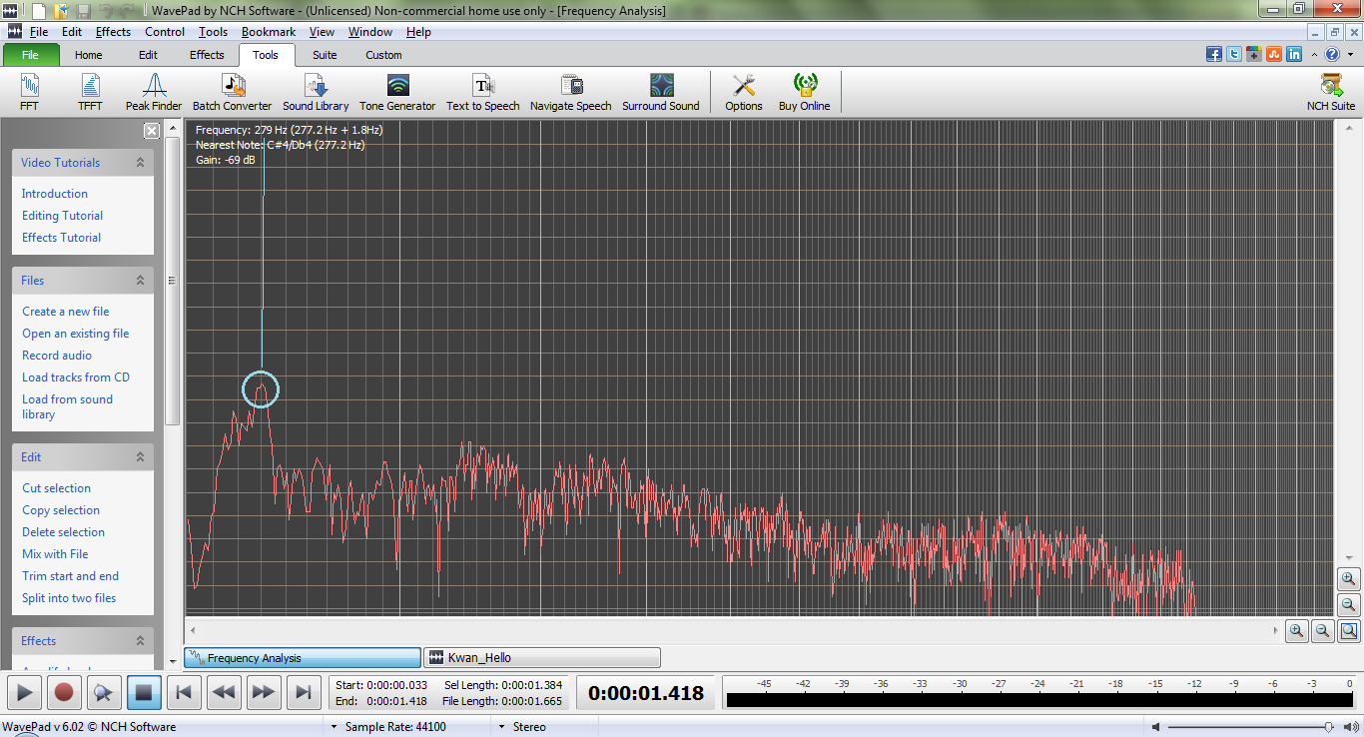

The peak frequency indicated above is at 279Hz

Figure 6: MATLAB FFT Calculation of Example 2 & Fundamental Frequency Output



*The fundamental frequency is at: 286.660767 Hertz*

## Discussion

The circuit simulator LTSPICE confirms the accuracy of the peak frequency, but disagrees with the gain at this frequency. This is because LTSPICE is a significantly more in-depth simulator which takes into account dozens of other factors such as phase shift from the imaginary component of capacitors, and non-linear equations unlike the simplified versions used in hand calculations and implemented into MATLAB.

Fortunately, the shape and location of the frequency responses closely match one another, indicating that the circuit provides realistic filtering to frequencies relative to each other. The exact calculations of amplification can therefore be set aside without loss, as it is outside the scope/objective of this project. This can be also be confirmed by observing the FFT of the input signal of Example 2 between MATLAB and the audio analyzer Wavepad. Their fundamental frequencies shown above are very close to one another, indicating a successful fast Fourier transform.

## App. I and II: Example Output and Code:

* See attached .pdf **“Kwan\_Final\_Project\_14.pdf”** for published documentation of MATLAB script file “Kwan\_Final\_Project\_14.m”

Here is the function that computes the values for the output voltage:

function [Vout, Vlow] = Kwan\_bandpass(Vin, f, Clow, Rlow, Chigh, Rhigh)

% Determines the voltage output of an RC low-pass->RC high-pass bandpass filter

% from the given voltage input and frequency.

Vlow = Vin\*((1/(1j\*2\*pi\*f\*Clow))/(1/(1j\*2\*pi\*f\*Clow) + Rlow));

Vout = Vlow \* (Rhigh/(1/(1j\*2\*pi\*f\*Chigh) + Rhigh));

***App. III: Mathematics details***

*Conversion of MATLAB bandpass gain to decibels to compare with LTSPICE output*:

20log|Gain| = GaindB

20log|.444388| = GaindB

GaindB = -7.044 dB

*Hand calculations of gain for Example 1*:

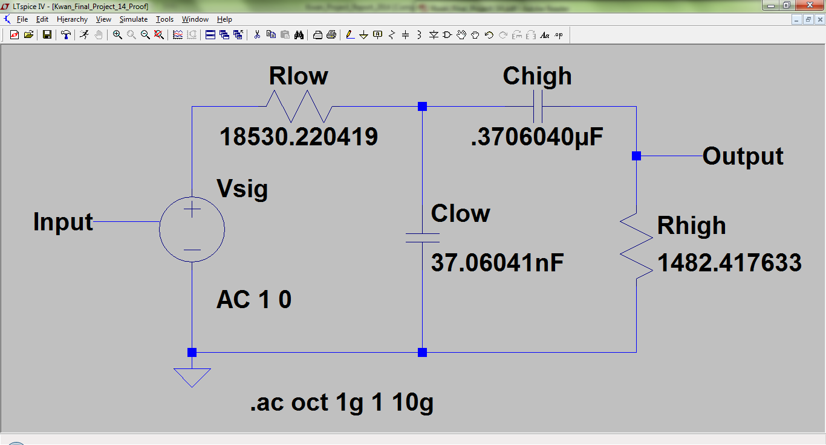

Via voltage divider wherein impedance of capacitors = 1/(jωC)

* j is the symbol for 1 imaginary unit.
* ω is radial frequency, i.e. 2πf where f is frequency
* Circuit diagram above for reference.
* Vlow is taken as voltage across Clow

Numerically:

$$V_{low}= 1V* \frac{1/{\left(j2π\left(6120Hz\right)\left(37.1 nF\right)\right)}}{1/{\left(j2π\left(6120Hz\right)\left(37.1 nF\right)\right)}+18.5kΩ}= .0365 V$$

$$V_{out}= .0365V* \frac{1.48kΩ}{1/{\left(j2π\left(6120Hz\right)(.371μF\right)}+1.48kΩ}= .0348 V$$

$$Gain= \frac{V_{out}}{V_{in}}= \frac{.0348V}{1V}= .0348$$