Purpose:

Associate Discount:
To provide PUMA Associates with a merchandise discount to support the PUMA Dress Code requirements as well as provide an employee benefit to all members of PUMA, their spouses and dependents living within their household.

Family & Friends Discount Card:
The Associate Family & Friends Discount card is valid for the duration of the relationship that Puma has with the cardholder. The discount entitles a fixed discount as Associate Discount and MUST have one spending limit (defined locally) for both cards. Restrictions will apply during certain promotions without notice to the cardholder.

Policy:
In order to qualify for the PUMA Associate discount, individuals must be currently employed by PUMA, a spouse of a PUMA employee, or a dependent living in the employee’s household.

The employee discount is available to all Global PUMA Associates, including full-time and part-time employees, their spouses and dependents, as well as Interns. PUMA Employees, their spouse, or dependent may use their discount to purchase gifts at PUMA Stores. The discount is not transferable to anyone else, which includes, but is not limited to parents, relatives, friends or business partners.

Reimbursement and/or repayment, including but not limited to; money, services, reselling or favors is considered discount abuse. Goods that are purchased and resold to a third party is also considered discount abuse. Any abuse of the Employee Discount or failure to follow the Employee Discount Policy may result in loss of employee discount privilege or further disciplinary action, up to and including termination.

The Employee Discount, including percentage amounts and the merchandise designated for discount, is subject to change at any time and without notice. PUMA Global does not sell any product to known resellers and reserves the right to limit quantities without notice and at any time.

Procedure:

Purchasing Limitations (recommendation):
- Full Time/Part Time employees: €2.000 discounted amount (equal to local currency) annual cap after applied discount on all products purchased from PUMA Retail Stores including Puma.com (subject to local tax limit)
- Seasonal employees: €500 discounted amount (equal to local currency) annual cap after applied discount on all products purchased from PUMA Retail Stores
- Associates may not purchase more than 6 items of the same style and color, unless approved in writing by Retail Operations.
- Corporate Management may limit quantities further, at any time, and without notice, in order to preserve purchasing equality as well as to protect the Brand, for all Customers.
- The Same Rule applies for Regional offices across all Departments/ Functions – “Fair Play”
Associates, including Managers, may not process their own discount transactions. All discount transactions must be processed by a member of Store Management.

Associates are not eligible to receive an employee discount when purchasing a PUMA gift card. Associates are able to use their employee discount when paying with a PUMA gift card.

Identifying an Associate and Discount Amount:
All PUMA Associates must provide a Puma Employee Card or picture ID or current pay stub (without disclosing any sensitive information such as salary, tax, private addresses etc.…) to identify themselves. PUMA Associates from other countries or regions must provide a picture ID as well as PUMA ID. Identity and status may also be verified with Human Resources. If PUMA employee status cannot be verified, the discount will not be extended until the Associate’s employment status can be verified.

The following discounts apply to all Global PUMA Associates:
45% discount off the recommended retail price (RRP) for all regular Full Price store and full price items, 25% during sale period in Full Price. In addition, they will receive 25% off PUMA Outlets
and not valid in conjunction with other promotions, discounts, coupons, discount codes. i.e. Buy one get one free, 50% clearance etc…
Puma Employee Card Global HQ (if available)

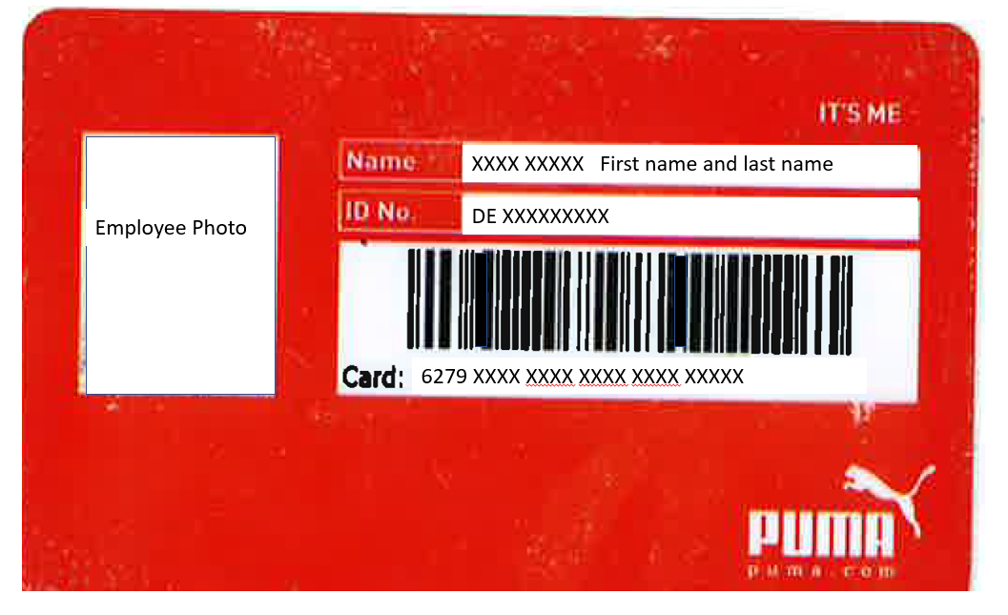

EMPLOYEE CARD

FRONT
BACK
Local Employee Card (if available):

Identifying a PUMA Associate’s Spouse or Dependent and Discount Amount:
A PUMA Associate’s spouse or dependent must provide the related PUMA Associate’s employee ID number, along with a picture ID which links them to the PUMA Associate; i.e. last name matches that of the PUMA Associate. If the above-mentioned identification cannot be provided, a member of Retail Operations must be contacted for approval.

The following discounts apply to all PUMA Employee Spouses or Dependents:
45% discount off the Manufacturer’s Suggested Retail Price (MSRP) for all regular Full Price store and full price items, 25% during sale period in Full Price. In addition, they will receive 25% off PUMA Outlets
and not valid in conjunction with other promotions, discounts, coupons, discount codes. i.e. Buy one get one free, 50% clearance etc.
Puma Family & Friends Card (if available)

Processing an Associate Discount (for regions participating in Puma Employee Cards):
Once the PUMA Associate has been identified at the Cash wrap, a member of Management must process the entire sale in Retail Pro.

***Print screen below may vary as per region:
Click on:   | 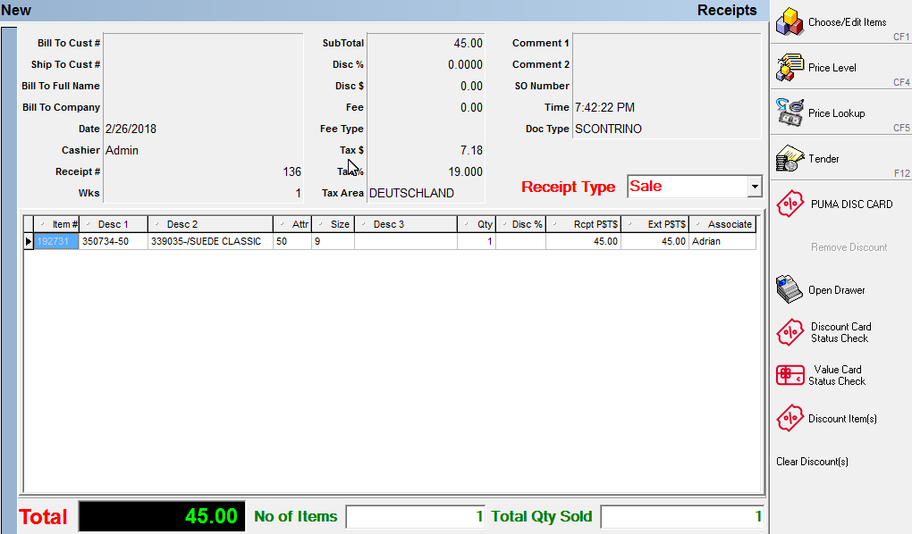
Scan Puma Associate/F&F  Card  Discount Value – enter % as per channel -  FP: 45% - FOC: 25%  Check Details for Expiry Date | 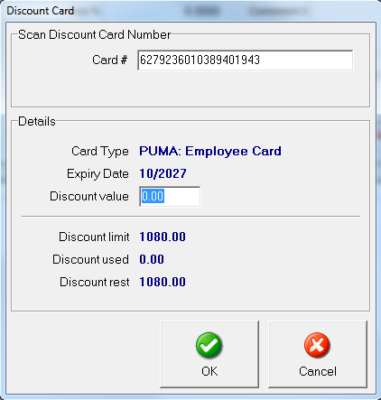

Associates may not process their own transactions at any time. Associates will be entered into Retail Pro at the time of hire and their discount will be noted in the comment area. If an Associate is not listed in Retail Pro as receiving a discount, then the Associate must be referred to Retail Operations or Human Resources before a discounted transaction can take place.

Global PUMA Associates, their spouses, and dependents must provide payment in full at the time of the transaction. The same forms of payment that are applicable for Customers are accepted for Associate transactions. However, the form of payment must be in the PUMA Associate’s name. Forms of payment from spouses or dependent children may be in the Associate’s or Spouse’s name. Once the sale is completed, the Associate will be asked to sign the sale receipt and be given a copy of the receipt for their records.

Store Associates may only make purchases at the end of their shift or on their day off. Once purchases are completed, the bag should have a copy of the receipt stapled to the outside and counted and compared to the receipt upon the Associate exiting the Store by a member of Management.

Processing Global PUMA Associate, Spouse, and Dependent Returns:
Global PUMA Associates, their spouses, or dependents may return merchandise within 30 days of the purchase within the following guidelines, but not limited to:
- All Associate returns must be processed in the home Store of the Associate and at the beginning of the Associate shift.
- All Associate returns must be processed by a member of Store Management.
- No Associate can process their own return or a return resulting from a purchase made by their spouse, or dependent.
- All returns must be accompanied by a valid receipt. Credit card statements are not acceptable.
- Returns that are presented with a valid receipt, within 30 days, will receive reimbursement in the form of the original tender that is noted on the receipt.
- Merchandise must be in sellable condition; original condition is considered to be merchandise that is in sellable condition with the sales tags still attached.
- Merchandise that is unsellable or defective must be approved by the Area Manager, in writing, before processing.
- Returns that can be verified in Retail Pro but that do not have a receipt, will receive a PUMA Gift Card.
- Associates will be required to sign the receipt at the end of the transaction and have the original receipt returned with the returned items noted.

Store Associates Only:
Returns will not be accepted after 30 days unless a written exception is received from the Area Manager. If the exception is granted, a copy of the e-mail or signed receipt must be attached to the Store copy of the media.
PUMA reserves the right to refuse to accept an Associate return, at any time, and without notice.

60_Employee Without Card (not applicable for German Employee). Same applies for F&F Discount without Card:
Once established it’s a Puma Employee and no employee card is available then under Comment 1: Add full name, Comment 2 (if available). Job Title. Additional photo i.d. is required to ensure the business card belongs to the same individual.

Any missing information will be verified by Area/District Manager/ Operations or Loss Prevention.

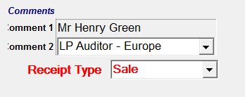
Click on Comment: Full name and (25 Characters)
Comment 2: Job Title

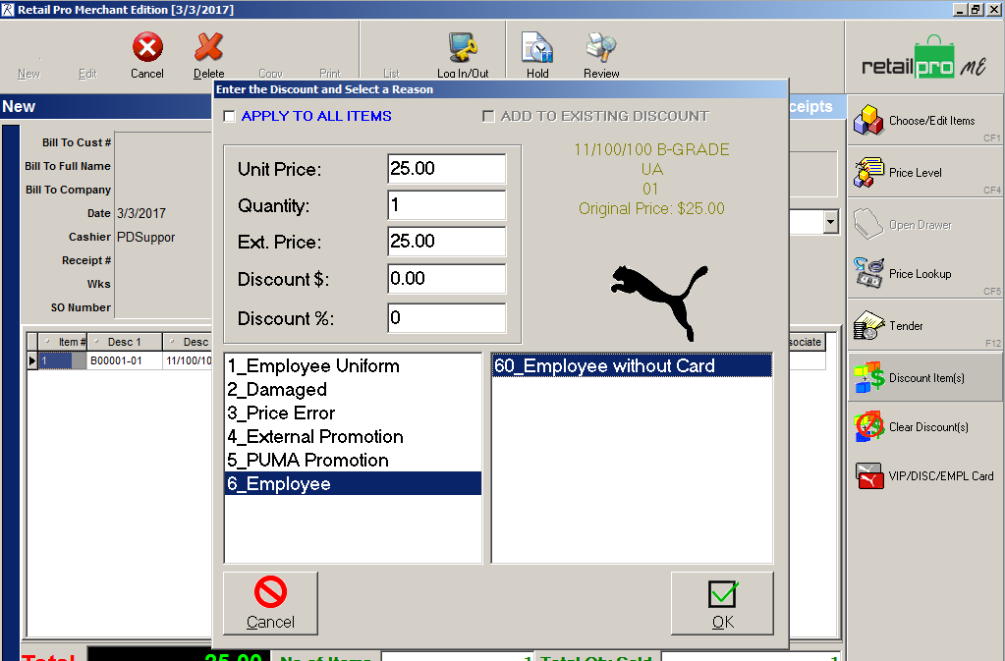

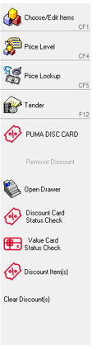

Staff Uniform allowance: Refer to Staff Uniform Policy

