Purpose: To provide a uniform allotment that allows Associates to comply with the Associate Dress Code Policy, which requires all Associates to represent PUMA in the most current merchandise.

Policy

Regular Associate Allotment: (Full and Part Time)

Regular Associates will receive an allotment of merchandise to ensure and support the requirement of wearing current merchandise at all times. This allotment is distributed at the direction of Retail Operations.

Exceptions may be made at the discretion of Retail Operations and are always provided in writing. No local Management may make an exception to the Uniform Policy.

Allotment limit for every 6 months:
Store employee

For a full time:

6 T-shirts
2 Hoodies
2 Footwear can be selected at own choice, with some exceptions.

Part time: (24h or less/week) will get half.

Please note this does not affect your normal employee purchase.
The limit can be also split quarterly (depending on uniform availability or season)

Management reserves the right to limit selection of collections and mandate the selection of merchandise.

Employees who have given notice to end their employment will not receive allotment.

Regular Uniform may not be returned or resold.

The following items are not part of Regular Hire Allotment, however not limited to and can be altered without notice:
- Outerwear
- Body Wear
- PUMA Jewelry
- Bags of Any Kind
- Scarves & Belts
- Socks
- Specialty Niche Product
- Sunglasses
- Watches

Procedure

- Employee uniform must be processed as p02. In Store Stock or as per local region must be used for one employee only. Do not mix more employees in one transaction or document.
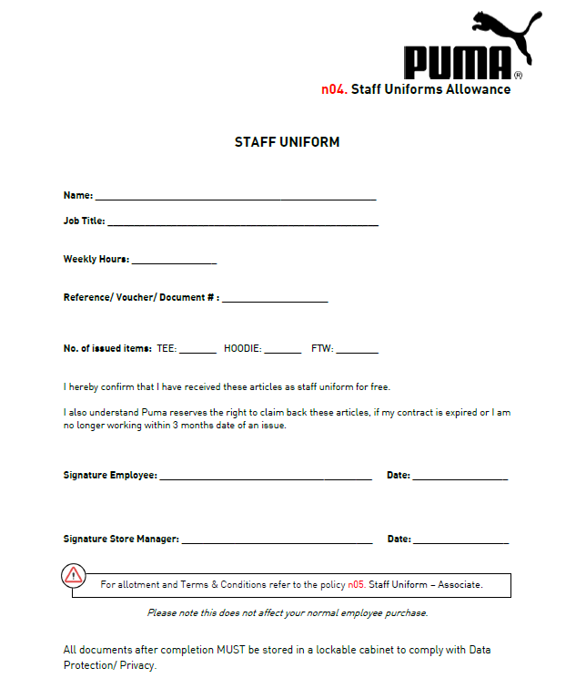
- The Employee receiving the uniform will complete and sign the Uniform Allowance form with a Store Manager’s signature.

- Once processed on retail pro and log signed, all paperwork MUST be archived in a staff uniform folder for Audit purposes.

All documents after completion MUST be stored in a lockable cabinet to comply with Data Protection/ Privacy.

There are no exceptions or substitutions to Uniform Allowance.
Any Employee found substituting or making exceptions may be subject to disciplinary action, up to, and including, termination.

New Hire Uniform
All New Hires will receive uniform, regardless of the current uniform period within five days of their employment.
In the event that New Hires are hired by PUMA during the uniform period, New Hires will receive only one Allotments. For example, only the New Hire uniform or Regular uniform, not both.

Questions or concerns regarding Uniform for New Hires should be directed to the Store’s District/ Area Manager and not to Human Resources.

