Purpose: To provide a program that provides outside PUMA contractors (vendors, promoters) with a discount card that entitles the bearer to a discount in all owned and operated PUMA Retail Stores, which easily identifies the bearer to Stores and efficiently monitors their discount use.

Policy

The Friends of PUMA Discount Card is valid for the duration of the relationship that PUMA has with the cardholder. It entitles the bearer to a fixed discount of 20% off purchases in all participating owned and operated PUMA Retail Stores.

Procedure

All Cashiers must be trained on how to process the Friends of PUMA Discount Card so that it is identified and accepted, when presented. The 20% discount may be applied to any item, except items restricted for employee discount, which are communicated by PUMA.

PUMA cannot be held liable for any lost or stolen cards.
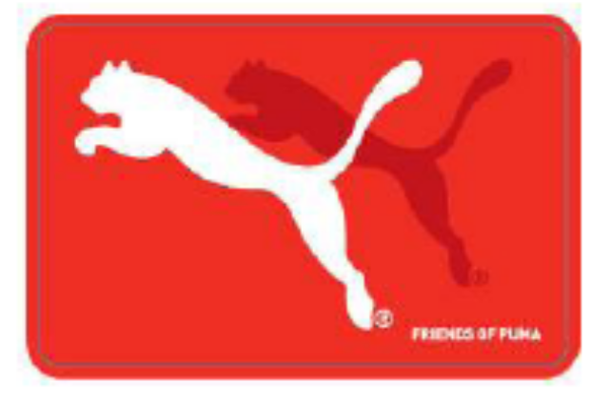
The following discounts apply without Friends of Puma Cards to all Kering, Volcom, Puma Affiliation and Electric Employees:

- 20% discount off the Manufacturer’s Suggested Retail Price (MSRP) for all items, regardless of sale, promotion, or clearance price in PUMA Retail Stores.
- Kering, Volcom, Puma Affiliation and Electric Employees must present a company picture I.D. in order to qualify for the discount above.
- Use Comment 1 Field where possible to add the Full name and Company for each transaction.

