Purpose: Two main types of Puma Cards (subject to regional availability):

1. Puma Ambassador Card/ ON Behalf Card or

2. Seeding Card is the means of administrating the allotment of PUMA goods to marketing assets and other external recipients (=Brand Ambassadors). The approved Puma Ambassador Card holder can receive products in PUMA retail stores or ecom without having to use a regular means of payment (e.g. cash, credit card, etc.) for the transaction.

Policy

Ambassador/ Seeding Card can be used globally in all PUMA stores that have implemented the Puma Cards program.

- Puma Ambassador/ On Behalf Cards
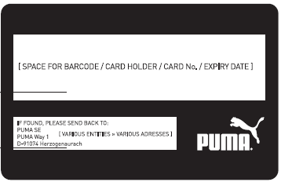



- Puma Seeding Card

Any customer who holds the Puma Card is entitled to a purchase and a cashier is NOT required to verify the identity of the cardholder unless a card was stolen or communicated.

Note: Offline Store(s) due to power failure may not work as PayLoop is a “LIVE” system and MUST be connected to a network always.

Purchasing Limitations:

- The Puma Card (Ambassador/On Behalf/ Seeding Card) is not a credit/debit card.
- The Puma Ambassador/ Seeding Card always has a pre- charged amount (balance check can be done prior to the transaction).
- All Puma Ambassador/ On Behalf/ Seeding Card number on the receipt is encrypted ending:

  - Ambassador Card - AM
  - On Behalf Card – ON
  - Seeding Card - SE

- The Puma Card have an expiration date and MUST be checked before a transaction
- One Puma Card per transaction only
- The Puma Card has no product limitations – except on limited editions (e.g. Creeper), the purchase is limited to 3 units per article per Puma Card transaction
- Any returns MUST be done as an original method of payment and in this case the same Puma Card without any exception.
- DO NOT ACCEPT Puma Card number in the email or phone call
- Do not offer cash or return on credit card
- Any Puma Card abuse or manipulation will be subject to disciplinary action, up to and including termination.
- The sales by Puma Cards are booked at retail prices for the stores, sale with the cards above is the same as any other sale)

Procedure

For all stores which participate in the Gift Card Program: The card holder goes to a PUMA retail store and selects the desired products. The following steps should be taken at the cash desk:
- Cashier starts a new transaction and scans all articles  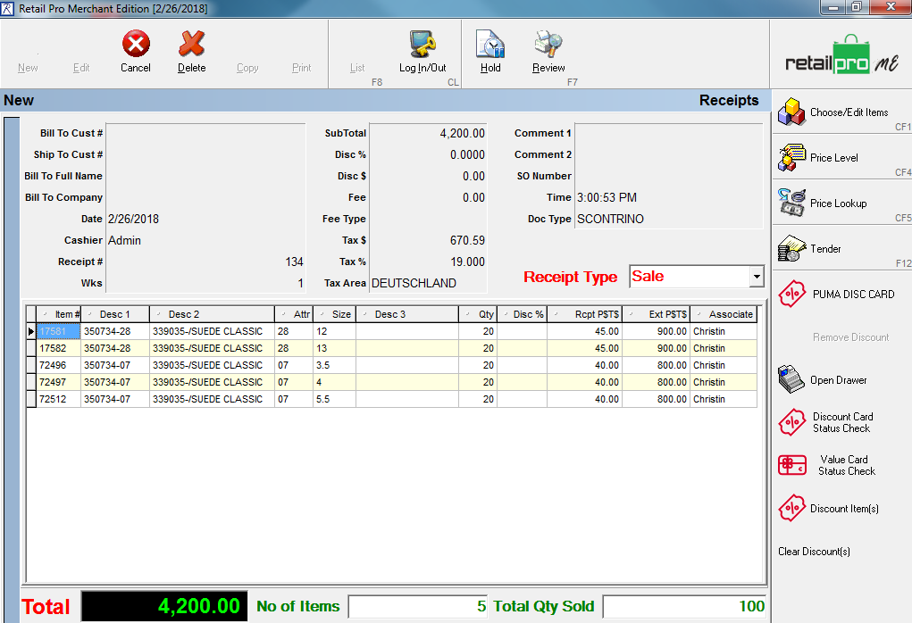 |   - Select “Tender Selection”    - Select Payment Type:  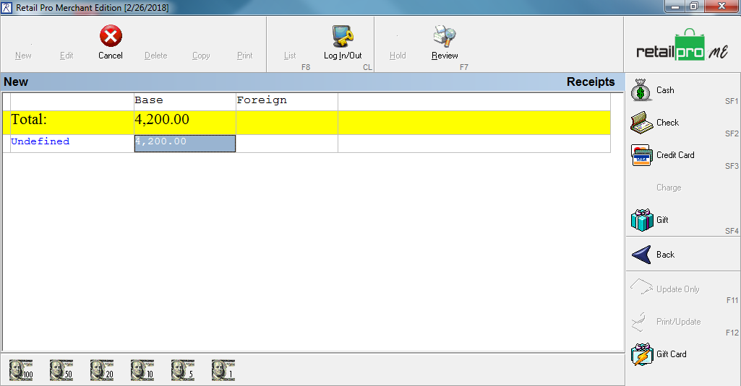
- Click on Redeem Card  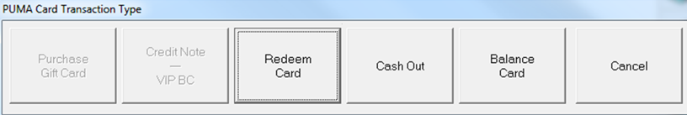 | - Double Check the amount and Type Ambassador/ Seeding Card  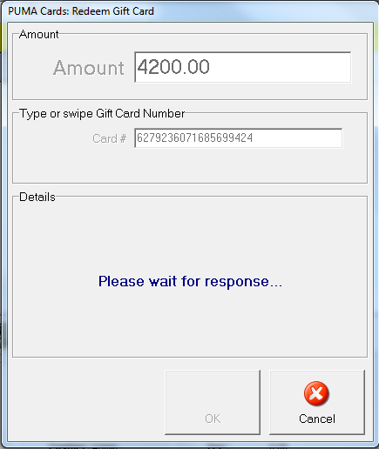  XXXXXXXXXXXX42

- Double Check Total -> Tender-> amount  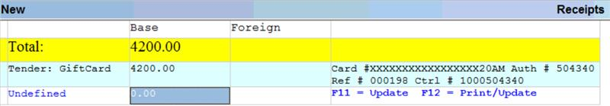  You can reduce the amount manually but cannot increase it! |   - F12 print and update

Return on Ambassador/ Seeding Card:
- Change receipt type to “Return”

- Scan all the articles
- Select Tender

- Click on:
- Select Credit Note- VIP BC
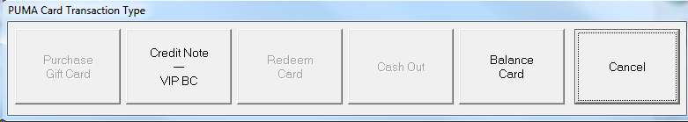

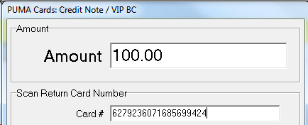
- Double check the return amount, type Ambassador/ Seeding Card. F12 Print/ Update

XXXXXXXXXXXX20

Trouble Shooting Processes:

Case 1:
- Balance Check
  - Click | 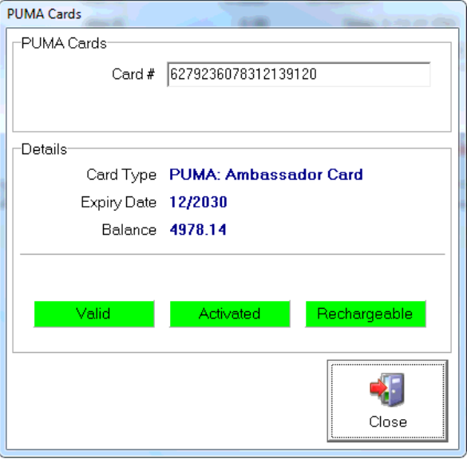  - Scan Ambassador/ Seeding Card : If status all green “You are good to go”  XXXXXXXXXXXX20

- Expired/ Blocked Cards: If valid status is red then card will not work

Case 2:
Split payments - Remaining payment tendered as below

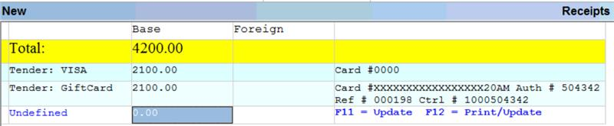
F12. Print and update to complete.

Process:
  - Option 1: The available amount on the Puma Card is being deducted and Retail Pro asks for another payment method for the outstanding amount which must be paid. Please advise the card holder that he/she needs to pay for the balance using an alternative payment method (cash/credit card/…) and should approach their PUMA Sports Marketing Contact Person for refund.

Case 3:
- Problem: Card has expired or has been blocked (in case of loss/theft)

- Process: If Valid/ Rechargeable highlighted red then Card is expired or Blocked. Inform the Card holder that the Card is not valid anymore and that you will retain & destroy the Card. Please kindly ask him/her to refer to his PUMA Sports Marketing Contact Person for a replacement. The Brand Ambassador may choose to proceed with an alternative payment method and refer to his PUMA Sports Marketing Contact Person for a refund. Please hand-over the card to your Area Manager who is responsible for destroying the card.

Case 4:
- Problem: Puma Card has been forgotten
- Process:
- Option 1: Please kindly ask the Card holder that they should choose an alternative payment form (cash / credit card / …) and refer to their PUMA Sports Marketing Contact Person for a refund.

- Option 2: In case Card holder is not willing to choose an alternative payment form, please follow the following process:
  - The Manager on Duty informs his Area Manager. The Area Manager Contacts Sports Marketing Contact Person

Asset briefing

Advance notice
The assets are briefed to give a minimum of 24 hours advance notice which retail store they intend to visit and where they intend to use their Puma Card. This allows the retail store staff to prepare and give premium service to the asset as well as prepare for stock replenishment.

Please note that this cannot be guaranteed at all time and the store manager is asked to still provide the best service feasible within the constraints e.g. not enough staff on the shift, etc.

