**Purpose:** To provide an internal guideline and process for Assets/Ambassadors and Puma SE Departments needs of PUMA products.

Policy

This policy sets a structure of how to process products for Puma Assets/Ambassadors and PUMA SE Departments by Store Management on Retail Pro

For the PUMA RETAIL “PEG” team this option is NOT available – please refer to policy p05. Internal Consumption.

Only management is authorized to process this transaction and will be held accountable for ALL transaction’s in the concerning store. Under NO CIRCUMSTANCE are staff members allowed to process this transaction.

Management is responsible to reprint the receipt with a signature and storing it in a folder under “SPONSORSHIP” and attach an authorized email or any communication regarding a transaction. The folder will be audited during Store visit recap, Loss Prevention Audit, Internal Audit and MUST be available in store at all times for the minimum period of 2 years.

Check I.D. (if available) for each transaction to ensure extra security, preferably photo I.D. or company I.D. In the event no I.D is available then it must be reported to Loss Prevention/ Area Manager in an email.

Transactions are monitored weekly and monthly for the finance team to do a cross charge. The internal department’s COST CENTER MUST be added to all charge transactions

All items must be scanned at full retail price. The ONLY Discounts to be added are the Stores Promotions (if any) for that day. NO STAFF DISCOUNT TO BE APPLIED on this transaction.

NO GIFT CARDS can be used in connection with Charge option or any Split transactions.

If this feature is abused and policy not followed as above, this may result in a disciplinary action taken against them.

Overview – Sponsorship

|  |  |  |
| --- | --- | --- |
| Reason for Charge | Tender/In-store movement type | Referring policy |
| Marketing /Ambassadors with PUMA CARD | PUMA AMBASSADOR/ON BEHALF/ SEEDING CARD (Tender) | n05. Puma Card - Ambassador-OnB-Seeding Card |
| Marketing/Ambassadors without PUMA CARD | CHARGE (Tender)   * Cost Center available (1.) * Cost Center NOT available (2.) | n03. Sponsorship |

Process

1. Cost Center available

a. Select Customer - POS – Receipts- New

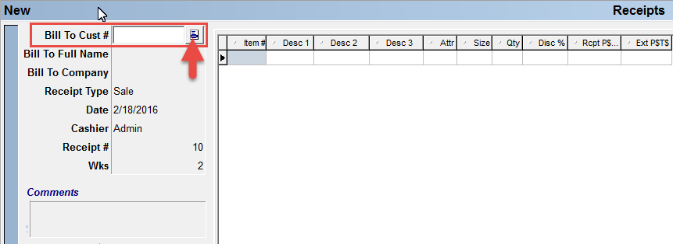

## b. Select Customer from Customer List



c. In Customer List View, sort by Company and go to PUMA SE. Click on the customer and confirm.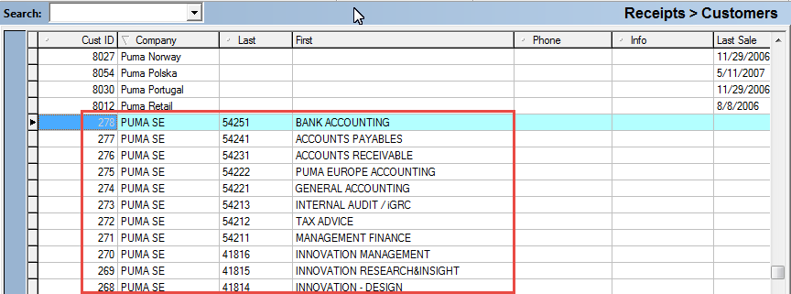

*Enter PUMA SE or the cost center number where PUMA SE will bring you to the customer list view*

*and the cost center number will result in an exact match without further selection.*

d. Select Tender

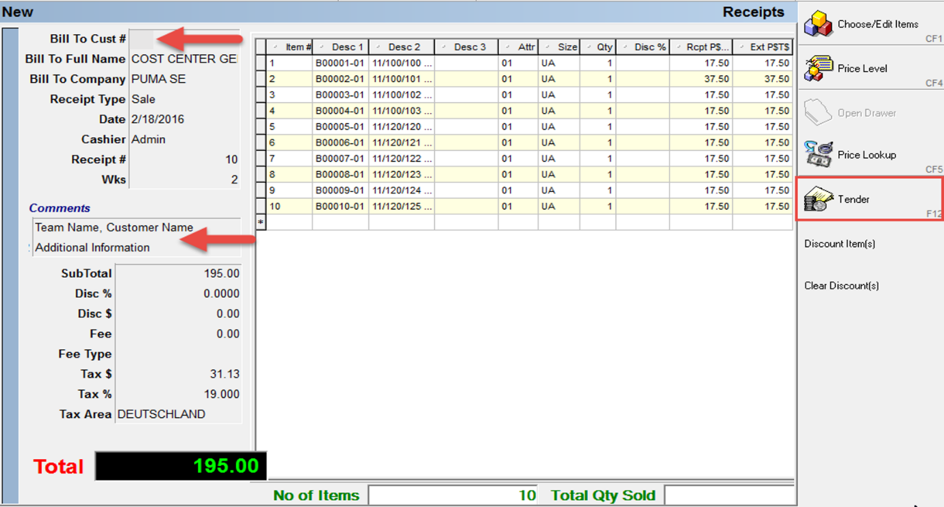

*Please* enter PUMA cost center number into the field “Comment 1”. *“*Comment 2*” for any additional information, e. g. PUMA employee’s name who picked up the product, etc.*

e. Select Charge and Press “Yes” (bug that displays in RetPro) in order to proceed 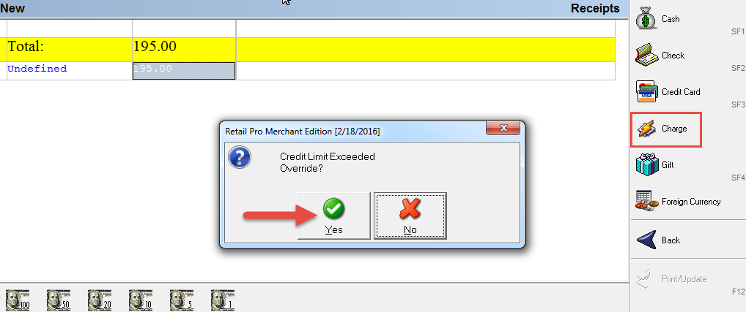

f.Confirm Charge Tender Default Terms window with “OK”.

2. Cost Center NOT available

## a1. FOR PUMA SE DEPARTMENT - Search under “GENERIC” and select “152 Cost Center (PPM)”



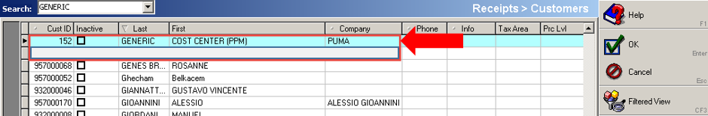

a2. FOR PUMA ASSETS/AMBASSADORS - Search under GENERIC and select “153 SPONSORSHIP”

*Please Note:* Sponsoring Partners/Playerswho do NOT have a PUMA Card*but have the option to spend their Sponsoring-Budgets in PUMA Retail Stores*(Sponsoring contract exists between PUMA Subsidiary and the Sponsoring Partner). For this transaction under Customer always select “153 Generic Sponsorship”

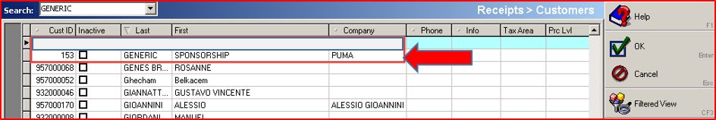

b. Enter or scan item 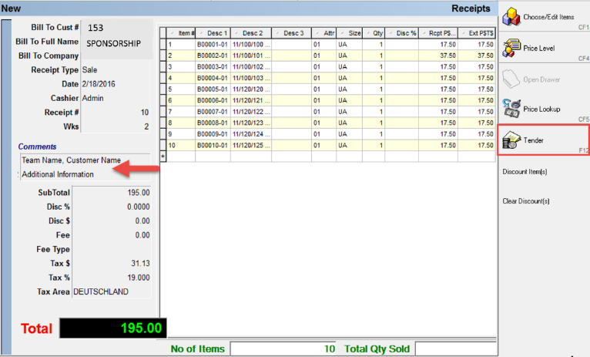

*Please note:*

In field “Comment 1” the full name of the Sponsoring Partner has to be entered.

In field “Comment 2” please enter the Sponsoring Partner’s country (e. g. Italian Player “buys” in German store 🡪 enter “Italian Sponsoring Partner” in comment 2

c. Select Tender

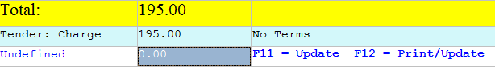

Charge appearance on X/Z Out:

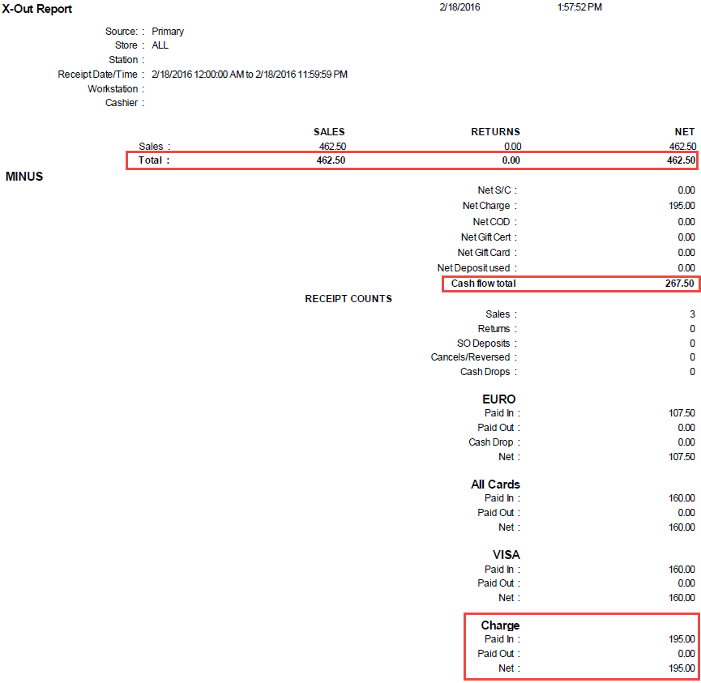

The Charge amount will be shown in the currency’s breakout under “Charge”.

NOTE**:** A charge payment will affect your Net Sales but does not show up under Cash Flow.