Purpose: To provide PUMA Store Associates with a secure place to store their personal belongings during their shifts as well as provide guidelines surrounding their use and purpose.

Policy

Associates must Store personal belongings in a locker with Company provided lock. At no time should PUMA merchandise be stored in the lockers nor should any personal belongings be stored within the Store as PUMA is not responsible for Associate belongings.

Procedure

* Any purchases made during the shift, either at PUMA Store or at another location, must be kept in bags that have been sealed and inspected by a member of Management. The bags must have a valid receipt stapled to the outside.
* All cellular phones and music players (iPods, etc.) must be kept in a locker with the Associate’s personal belongings. Cellular phones and iPods or any other musical device may not be worn, or carried, during a scheduled shift. All exceptions must have prior permission of the Store Manager.
* Associate’s personal belongings must be kept secure in a locker (See Lockers Below).
* The store must have one lock per Store Associate on hand. Each lock must be numbered and labeled.
* The Store Manager must maintain a master list of lock numbers and combinations.
* Lockers must be cleaned out at the end of the Associate’s scheduled shift. No personal belongings may remain in an Associate’s locker overnight.
* Personal belongings are never to be secured in the Safe or the office
* The Manager on Duty is expected to inspect all lockers at the end of every day to ensure that all lockers are free of any items.
* Locker fronts must remain clean and free for stickers, photos, or any other items obstructing a clean view.

Company Lockers

All Associates have access to lockers in order to secure their personal belongings. Associates must secure any personal belongings that they have brought into the Store in a Company Locker. No personal belongings may be left out in the open in either the stock room, office or Sales Floor areas. Lockers containing personal items must be locked using the lock assigned to that Associate for the duration of their shift.

Each Associate is assigned a lock which they will use to secure their belongings in a locker for every shift. At the end of a shift, each Associate will empty the locker they use and leave the lock in a designated storage space in the back room. Management reserves the right to inspect any locker at any time, and for any reason, without warning or permission. If an Associate has suspicions that the locker combination for their lock has been compromised, they must bring this to the attention of the Manager on Duty.

PUMA is not responsible for any personal items that are stored in the lockers, whether locked or unlocked, or any belongings that are left behind at the end of a shift.

Searches and Inspections:

In order to protect the safety and property of our Associates and the Store, PUMA Europe. reserves the right to inspect, but not limited to:

* Lockers
* Desks
* Cabinets
* Personal Belongings

These items are the property of PUMA Europe and, with choosing to use PUMA property, imply their consent to random searches. Associate’s lockers are subject to search at any time, for any reason without warning and permission. Property kept in lockers, desks, and cabinets are not private, and Associates should have no expectation of privacy for items stored in or on Company property.

Two types of Logs:

* q04. Lockers Log**:** Stores with one locker per employee.

Example:

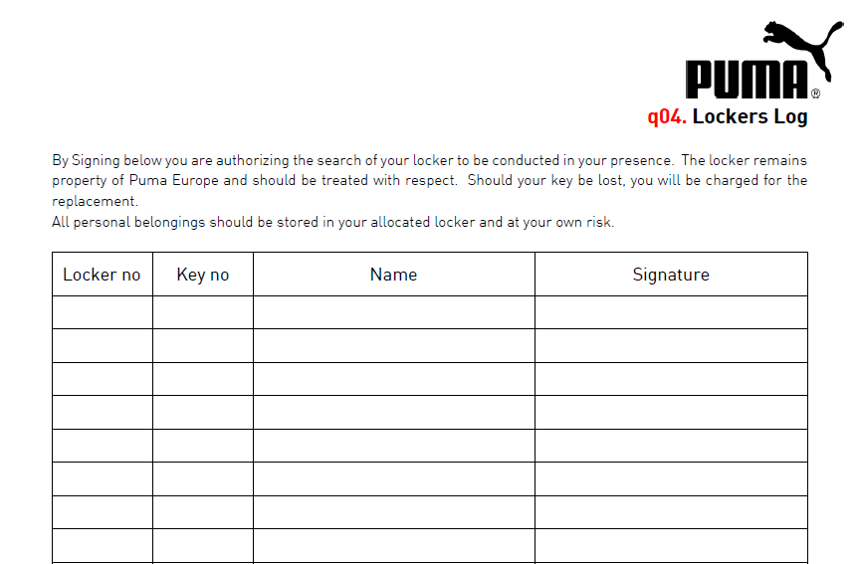

1 10901 Alex Santana

2 10902 John Smith

3 10903 Thomas Black

4 10904 Andreas Kean

Santana

Smith

Black

Keen

* q04. Lockers Log - Daily use**:** When locker is used on daily basis and the same day key is returned. For a deposit an additional i.d. maybe required until the key is returned.

Example:

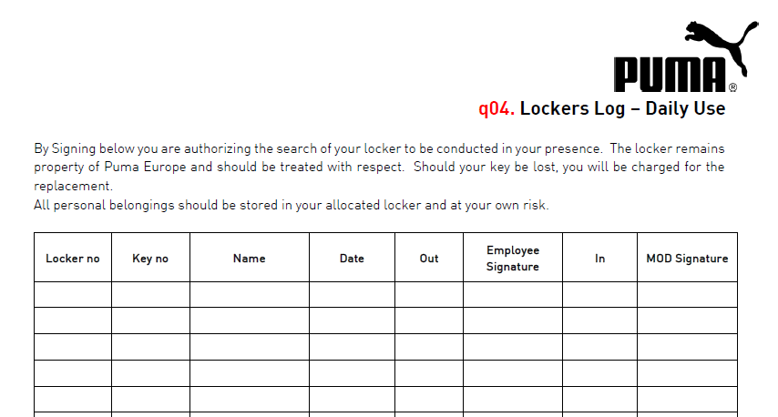

Smith Burns

Santana Burns

Black Burns

1 10901 John Smith 3.4.2020 8:00 14:30

2 10902 Alex Santana 3.4.2020 8:02 17:00

3 10903 Thomas Black 3.4.2020 10:00 18:30