Capacity
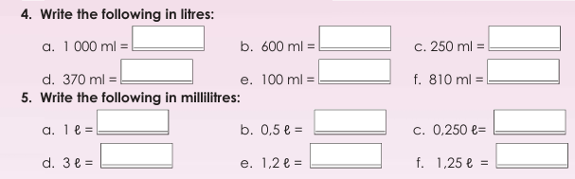

Lesson1: reading time
In previous grades, you learnt to tell time on analogue clocks and digital clocks. Working accurately with time is one of the most important skills you will ever learn.
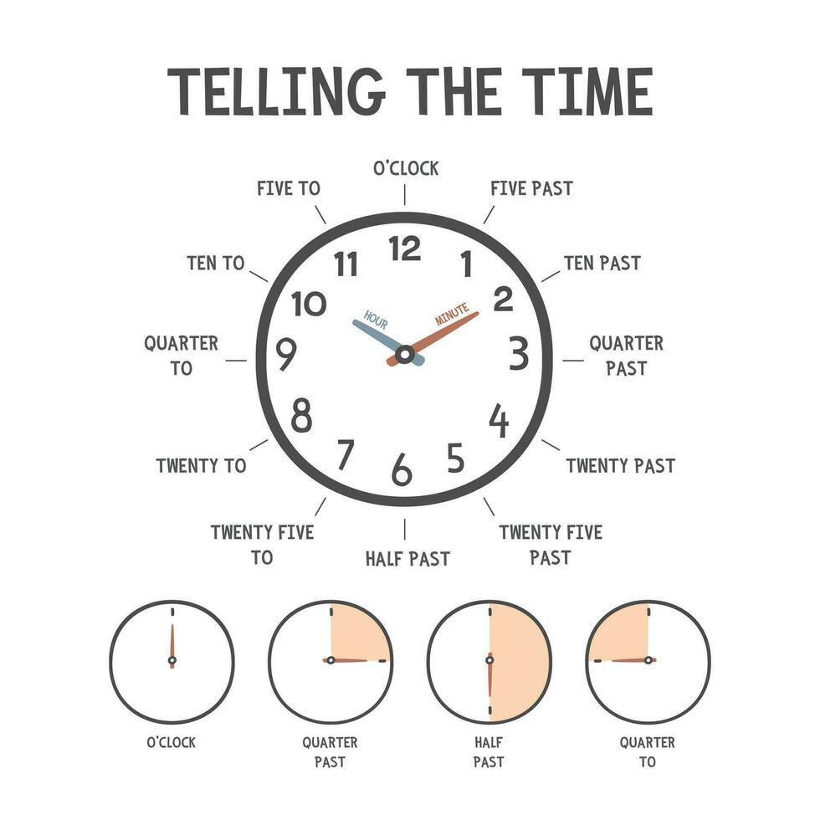 | 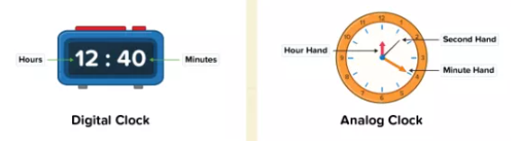  For digital we can just read as:  10:30 as ten thirty  how about 10:14:59?  Ten fourteen and fifty-nine seconds

We can say 10:49 as 49 minutes past 10 OR as 11

Method – reading analogue clocks  We say how much time it is past the hour or To the hour | Eg: Ten minutes and fifteen seconds past one  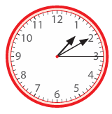
If it on the hour, then we say x o’clock | Eg: its 5 o’clock  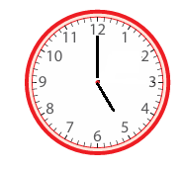
If it multiples of 5, then we will say x past or x to [the next number]  But remember to use quarter/half for 15 and 30  Eg: first is quarter past 5  Eg: second is 10 to 6 | 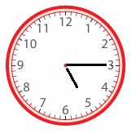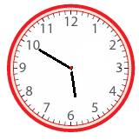

Same for digital
Method – reading digital clocks  We say how much time it is past the hour To the hour  Eg: 10 past 15  Or 15.10 | 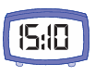

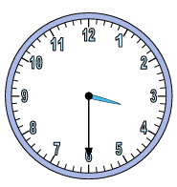  3:30 | 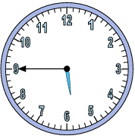  5:45 | 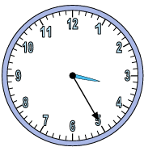  3:25 | 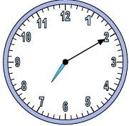  7:10

24Hour and 12 Hour
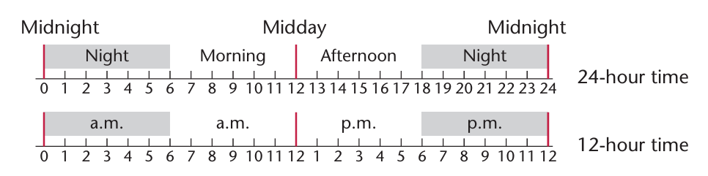

Time | Meanings / Various Forms
00:25 | 12.25 a.m., or twenty-five minutes past twelve at night / in the early morning
01:00 | 1 hour, or 1.00 a.m., or one o'clock in the morning
07:33 | 7.33 a.m., or twenty-seven minutes to eight in the morning
11:59 | 11.59 a.m., or one minute to twelve noon / one minute before noon
12:00 | 12 hours, or 12.00 p.m., or twelve o'clock (noon / midday)
12:10 | 12.10 p.m., or ten minutes past twelve in the afternoon
13:48 | 1.48 p.m., or twelve minutes to two in the afternoon
17:40 | 5.40 p.m., or twenty minutes to six in the evening
20:20 | 8.20 p.m., or twenty minutes past eight in the evening
23:59 | 11.59 p.m., or one minute to midnight / one minute to twelve at night
24:00 is actually 00:00 | 24 hours, or 12.00 a.m. (midnight), or twelve o'clock at night

When converting 24h to 12h, we can picture the analogue question.
We do not have “00” therefore we are actually using from 12

AM – if 12 then 00, if 00 then 12 | PM
Convert 00:10 to 12 hr  We do not have “00” so its runs from 12 and its in the morning  Answer: 12:10 am | 12:10 then its 12:10pm  Otherwise, just add pm
Convert 12:10 am to 24 hr  Am = morning therefore: 00:10 | 12:10pm  Then its 12:10

AM/PM control
When you write time in 24-hour notation, the day runs from midnight to midnight, which is 24 hours. This means that 12:00 is 12 noon and midnight is written as 00:00.
Technically, 00:00 is neither "AM" nor "PM" in strict linguistic terms because it represents the exact instant of midnight (00:00 and 24:00 are Identical)

However, under standard digital time conventions and international standards:
00:00 is 12:00 AM (Midnight).

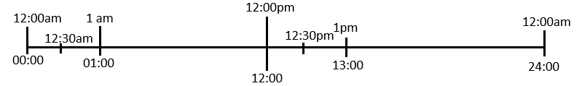
Basically 12 can be thought of as zero o’clock

Time Zones
Intro
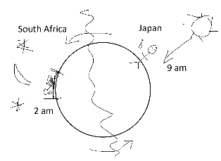
The Earth is round. The means that some countries will be in direct sunlight (day time) while others will be in darkness (night time)

Before Time Zones

Long ago, every town used its own "sun time." Clocks were set to 12:00 noon right when the sun was highest in the sky. Because towns were in different places, their clocks were slightly out of sync.
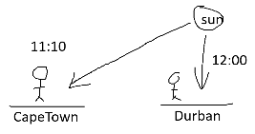
Example: 12:00 noon in Durban would only be 11:10 am.

When people travelled by foot or horse, this didn't matter much.

Why Time Zones Changed Everything:
Two big inventions in the 1800s made sun time a huge problem:

- Trains: Trains let people travel far in just a few hours. And because there were so many local times it was hard to keep track.
This actually lead to train accidents as many trains used the same rails and getting the times incorrect
- Telegraphs: Messages could now be sent instantly over long distances, but people were confused because their clocks didn't match.

The Solution
In 1879, a railway engineer named Sir Sandford Fleming proposed splitting the Earth into 24 standard time zones (one for each hour of the day).

- November 18, 1883: North American railroads officially adopted standard time zones.
- 1884: Countries met at a conference and chose Greenwich, England, as the starting point (Prime Meridian, or 0°) to anchor world time.

This reduced the number of different times and help us to keep track of the times.

Question: why zone boundaries are not straight lines?
Answer: The zone boundaries are not straight lines because adjustments were made according to the needs of the local people living within some time zones.

International Date Line
Days: add going forward, minus going back

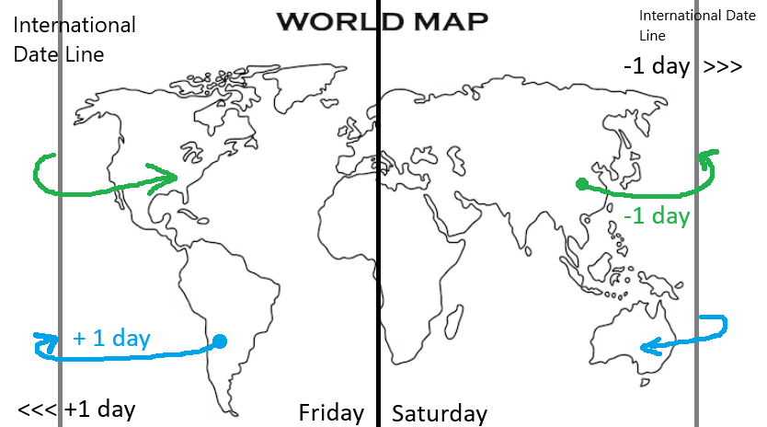

The International Date Line (IDL) is an imaginary line on Earth's surface, located roughly along the 180° meridian in the middle of the Pacific Ocean, that establishes where one calendar day officially ends and the next begins.
Crossing the line changes the calendar date by exactly one day:
- Traveling West (e.g., from the US to Asia or Australia): You add a day (move forward to tomorrow).
- Traveling East (e.g., from Australia or Asia to the US): You subtract a day (move back to yesterday).

The Missing International Date Line
When Jules Verne published the novel in 1873, the International Date Line had not yet been established.

If Fogg made the same journey today, he would have had to reset his calendar back by one day when crossing the International Date Line (eastward) in the middle of the Pacific Ocean (traveling east from Asia toward North America). Adjusting his date back by 24 hours at the line would have kept his count synchronized with London's calendar, preventing the surprise ending.

Calculations

Greenwich Mean Time (GMT) is anchored directly to the (Greenwich meridian) Prime Meridian, which is defined as $0^{∘}$ longitude.

Every ${15}^{o}$ of lines of longitude represents 1 hour

Note: UTC and GMT are basically the same, but
- GMT: time zone based on astronomical observation
- UTC: time standard measured using ultra-precise atomic clocks

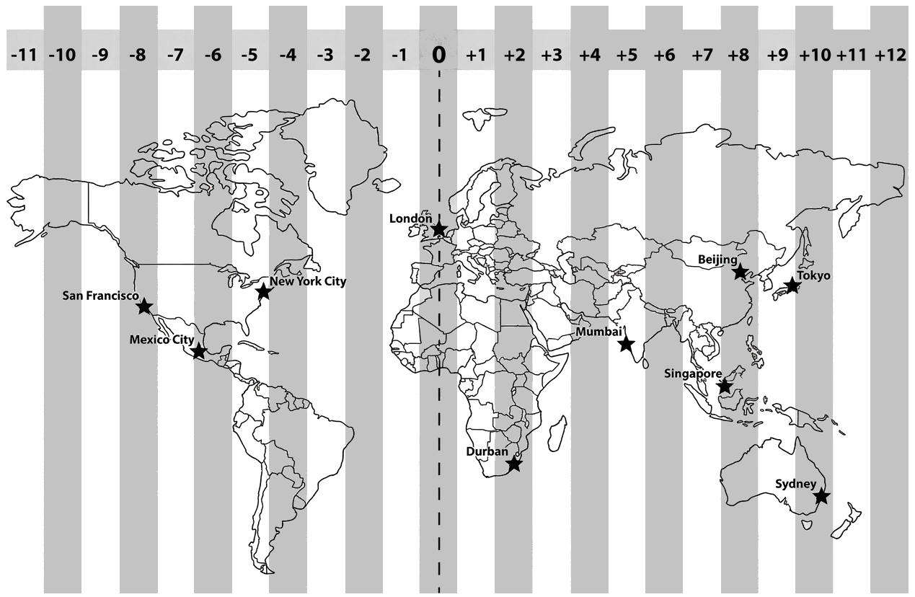

How to calculate the time:
- Add going forward (East)
- Minus going back (West)

# | Question | Answer PNG | Explanation PNG
1 | If the time in London ($0$) is 08:00, what is the time in Singapore ($+8$)? | 16:00 (4:00 PM) | Singapore is 8 hours ahead
2 | If the time in Durban ($+2$) is 14:00, what is the time in Mexico City ($-6$)? | 06:00 (6:00 AM) | Mexico City is 8 hours behind
3 | If the time in Singapore ($+8$) is 15:30, what is the time in Mexico City ($-6$)? | 01:30 (1:30 AM) | Mexico City is 14 hours behind
4 | If the time in Mexico City ($-6$) is 10:45, what is the time in Sydney ($+10$)? | 02:45 (Next Day) (2:45 AM) | Sydney is 16 hours ahead
5 | If the time in Tokyo ($+9$) is 19:00, what is the time in Singapore ($+8$)? | 18:00 (6:00 PM) | Singapore is 1 hour behind
6 | If the time in New York City ($-5$) is 06:00, what is the time in Mexico City ($-6$)? | 05:00 (5:00 AM) | Mexico City is 1 hour behind
7 | If the time in Singapore ($+8$) is 22:00, what is the time in Durban ($+2$)? | 16:00 (4:00 PM) | Durban is 6 hours behind
8 | If the time in Mexico City ($-6$) is 18:15, what is the time in Beijing ($+8$)? | 08:15 (Next Day) (8:15 AM) | Beijing is 14 hours ahead
9 | If the time in Sydney ($+10$) is 11:00, what is the time in Singapore ($+8$)? | 09:00 (9:00 AM) | Singapore is 2 hours behind
10 | If the time in San Francisco ($-8$) is 04:00, what is the time in Mexico City ($-6$)? | 06:00 (6:00 AM) | Mexico City is 2 hours ahead

Duration and time zones
Method
1. first do the duration
2. then do the time adjustment

Flight from London to Durban takes 10 hours and 45 minutes
If London is 2 hours behind Durban London, what time do they arrive in Durban if it departs Londan at 18:00

Answer
18:00 + 10h +45min = 4:45
If London is 2 hours behind, then the destination is 2 hours ahead, thus +2h
Answer 6:45am

Age confusion
Who is older? Someone born on BOB Nov 2019 or Tom Feb 2020?
ERLIER DATES ARE OLDER AS THEY WERE BORN FIRST
Answer: Nov 2019, and that person is 3 months older

Pete is 9 years and 5 months older then BOB
Minus the years then count the months
Years 2019 – 9 = 2010
Months: N->--june

Older is granny who was born in 1954?
Find the difference: 2019-1954 =65

These do not work as different time zone map
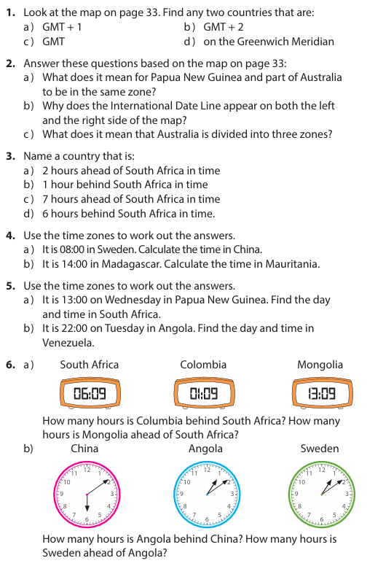 | 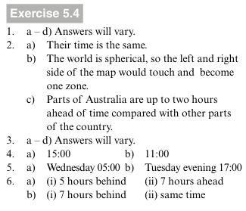

Lesson: time units
Century
1st Century: Years 1 through 100
20th Century: Years 1901 through 2000
21st Century: Years 2001 through 2100
So, the centre is always 1 behind until it lands directly on it.eg: 2100 is the 21st century but 2101 is the 22nd century

A leap year is a year that has an extra day in February.
• Every fourth year is a leap year.
• Leap years are multiples of four, for example, 2028 is a leap year.

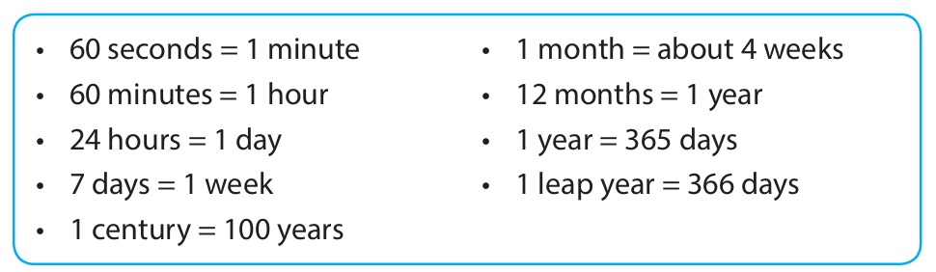

Example: How many days are there in 3 years?
Answer: $3×365\text{ days}=1 095\text{ days}$

Example: How many years are there in $994\text{ days}$?
Answer: $994÷365=2\text{ years and }264\text{ days left over}$

Example: How many years are there in 5 centuries?
Answer: $5×100=500\text{ years}$

Example: How many centuries are there in $1 207\text{ years}$?
Answer: $1 207÷100=12\text{ with }7 \text{years }\text{remaining}$

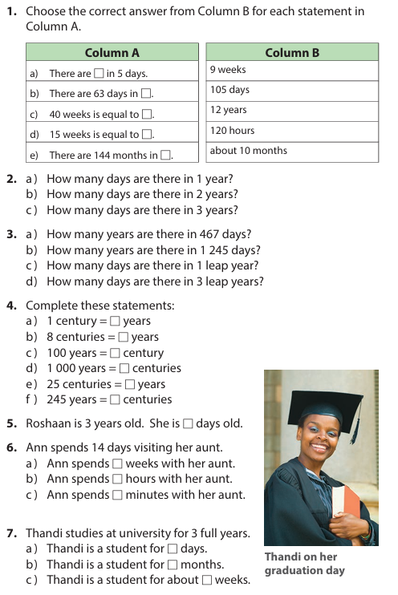 | 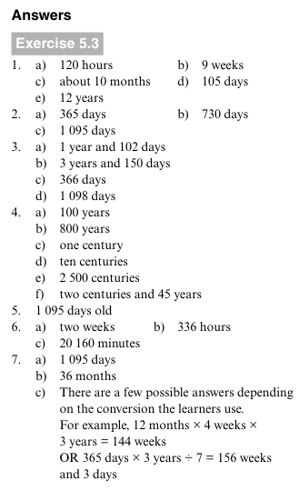

Date
Method
1. first count the number of days left of the month.
2. then count the full months between
3. then count the day left
4. then work out the hours

Example LEAVE OUT???
Calculate how much time passes from 12 June at 09:00 until 23 July at 18:00.
Answer:
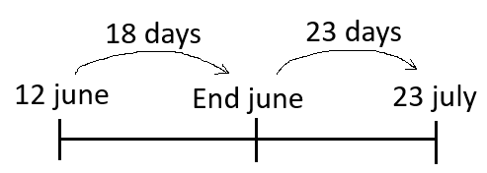
So, there are 18+23 = 41 days
For the hours: 09:00 to 18:00 = 9hours

Therefore, the total time is 41 days and 9 hours

Example
Calculate how much time passes from 15 March until 10 August.
Answer
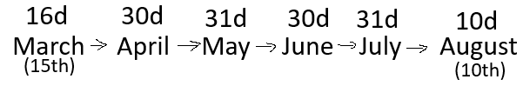
$$\text{Total}=16+30+31+30+31+10=148\text{ days}$$

How to know the number of days in each month  Make a fist, then list off the months starting with Jan for the first knuckle and then Feb is the space between. Then March is the second knuckle. Continues like this. When get to the end, start on the other hand with the knuckle. Each knuckle is 31 days and between is 30  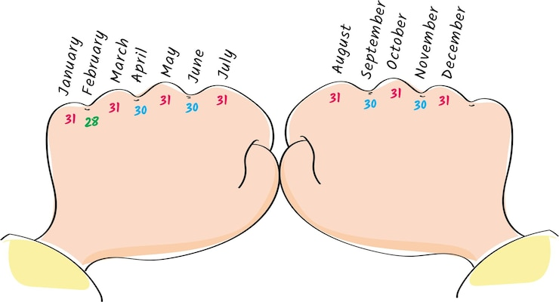 | 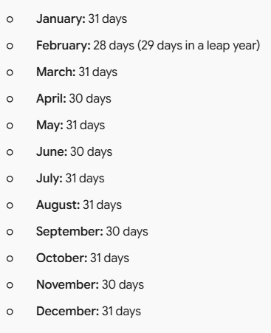

Questions
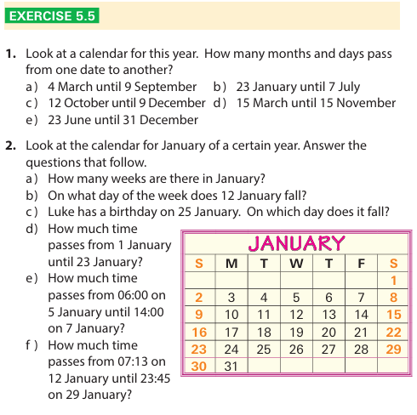 | 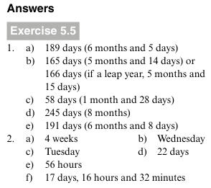

More questions
 | Calculate how much time passes from
1 | 5 April at 08:00 until 18 April at 14:00 | Days: 5 April to 18 April = 13 days  Time: 8:00 to 14:00 = 6hours  Total: 13 days + 6hours
2 | 14 February at 10:30 until 3 March at 16:30. | Days: 14 Feb to 3 March = 14+3= 17 days  Time: 10:30 to 16:30 = 6 hours  Total: 17 days + 6hours
3 | 28 May at 07:15 until 12 June at 19:45. | Days: 28 May to 12 June = 3+12= 15 days  Time: 07:15 to 19:45 = 12 hours 30 mins  Total: 15 days + 12 hours 30 mins
4 | 10 July at 11:00 until 25 September at 11:00. | Days: 10 July to 25 Sept = 21+31+25= 77 days  Time: 11:00 to 11:00 = 0 hours  Total: 77 days
5 | 19 August at 06:00 until 4 November at 18:00. | Days: 19 Aug to 4 Nov = 12+30+31+4= 77 days  Time: 06:00 to 18:00 = 12 hours  Total: 77 days + 12 hours
6 | 1 March at 09:15 until 31 March at 21:45. | Days: 1 March to 31 March = 30 days  Time: 09:15 to 21:45 = 12 hours 30 mins  Total: 30 days + 12 hours 30 mins
7 | 3 September at 08:30 until 17 December at 12:00. | Days: 3 Sept to 17 Dec = 27+31+30+17= 105 days  Time: 08:30 to 12:00 = 3 hours 30 mins  Total: 105 days + 3 hours 30 mins
8 | 30 January at 13:00 until 14 April at 17:30 | Days: 30 Jan to 14 April = 1+28+31+14= 74 days  Time: 13:00 to 17:30 = 4 hours 30 mins  Total: 74 days + 4 hours 30 mins
9 | 11 June at 05:45 until 29 October at 20:15. | Days: 11 June to 29 Oct = 19+31+31+30+29= 140 days  Time: 05:45 to 20:15 = 14 hours 30 mins  Total: 140 days + 14 hours 30 mins

If the initial time is larger than end, then reduce the day by 1 and subtract the deficit from 24hours
10 | 22 October at 15:00 until 15 January at 09:00 | Days: 22 Oct to 15 Jan = 9+30+31+14= 84 days  Time: 15:00 to 09:00 = -6 hours, thus 24-6 = 18 hours  Total: 84 days + 18 hours

Mass
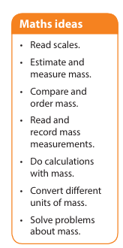

mass – the amount of matter contained in an object
We use scales to measure mass and weight. Most people use both words as if they are the same, though they are different. The mass of an object is how much matter it contains. It does not change. The weight of an object changes according to gravity. An objects weighs six times more on earth than on the moon, and weighs nothing in empty space, even though its mass remains the same everywhere. A balance scale measures mass. A spring scale measures weight. On earth both types of scale give us the same approximate reading, so for everyday practical activities we can also use spring scales (such as bathroom and kitchen scales) to measure mass.
Measurements
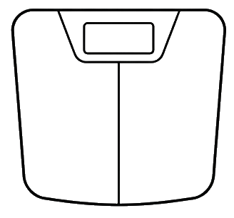  Bathroom scale | 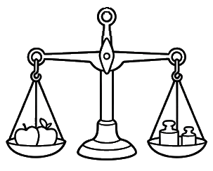  Balance scale  Beam balance  Equal-arm balance
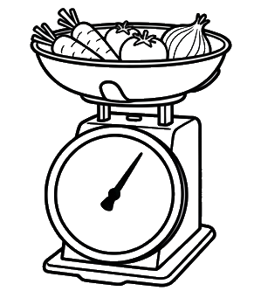  Kitchen scale  spring dial scale |   spring scale  Spring balance
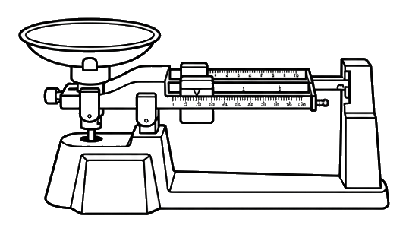
Triple Beam Balance

Instruments
Instruments

Bathroom scale | Measures human body weight (mass or weight, typically in kilograms or pounds).
Balance scale | Measures mass by directly comparing an unknown mass against known standard counterweights (independent of gravity).
Kitchen scale | Measures the mass or weight of food items and ingredients (typically in grams or ounces) for cooking and baking.
spring scale | Measures force (specifically weight due to gravity, typically in Newtons) or mass based on the distance a spring stretches under load.
Triple Beam Balance | Measures mass with high precision in laboratory settings by moving sliding weights (poises) along three calibrated beams

Bathroom Scale
- Body weight of a person
- A pet (like a dog or cat) while holding them
- Heavy luggage or a suitcase before traveling
Balance Scale
- Fresh produce (like apples or oranges) against standard weights at a market
- Chemical powders or solid reagents in a science lab
- Loose grains, spices, or coffee beans
Kitchen Scale
- Baking ingredients like flour, sugar, or butter
- Portions of meat or vegetables for meal prepping
- A 2-liter bottle of fizzy drink or small packages for shipping
Spring Scale
- The pulling force required to drag an object across a surface
- A fish caught on a line (using a hanging hook)
- The weight of a bag or heavy bucket suspended from the hook
Triple Beam Balance
- The mass of a small rock, mineral sample, or fossil
- A single pencil, eraser, or metal coin
- Small amounts of chemicals or laboratory specimens requiring precise measurement

• Pencil (~5 g)
- Best Instrument: Triple beam balance or a digital precision scale.
- Unit: Grams ($\text{g}$).
• Apple (~150–200 g)
- Best Instrument: Balance scale, kitchen scale, or spring scale.
- Unit: Grams ($\text{g}$).
• 1 Liter of Water (1 kg)
- Best Instrument: Kitchen scale or spring scale.
- Unit: Kilograms ($\text{kg}$) or grams ($\text{g}$). (1 liter of pure water equals exactly $1\text{ kg}$ or $1,000\text{ g}$).
• Elephant (~3,000–6,000 kg)
- Best Instrument: Industrial truck scale / weighbridge or heavy-duty platform scale.
- Unit: Kilograms ($\text{kg}$) or metric tons ($\text{t}$).
2L Bottle of water = 2kg
Cat = 4-5kg

Estimations
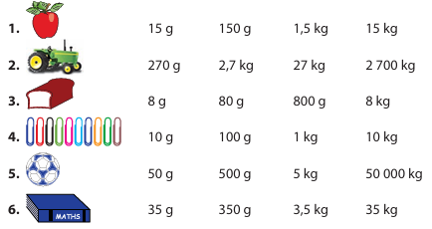

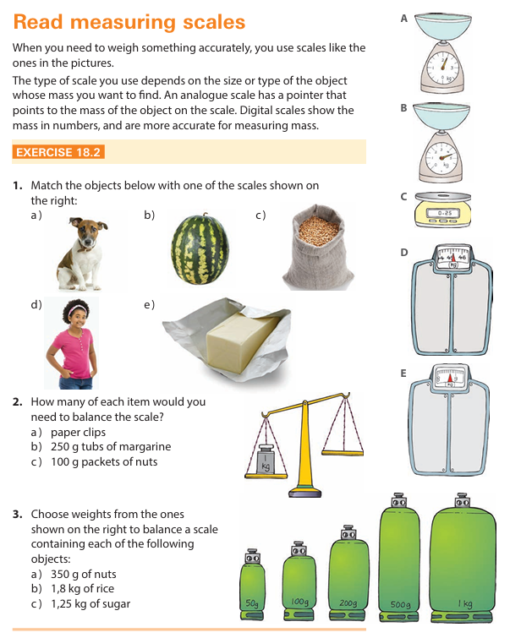 | 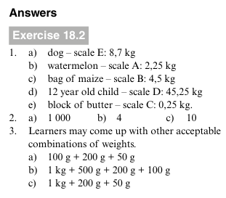

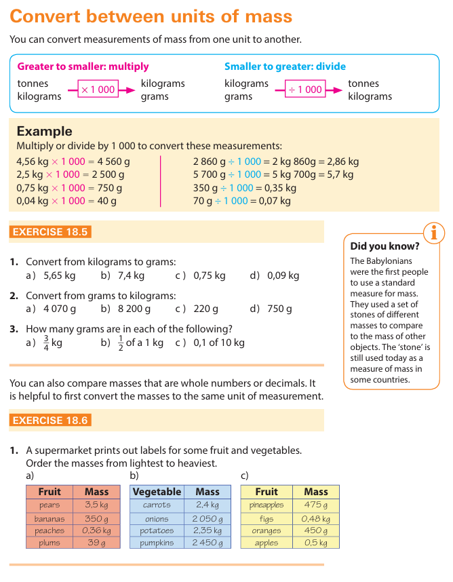

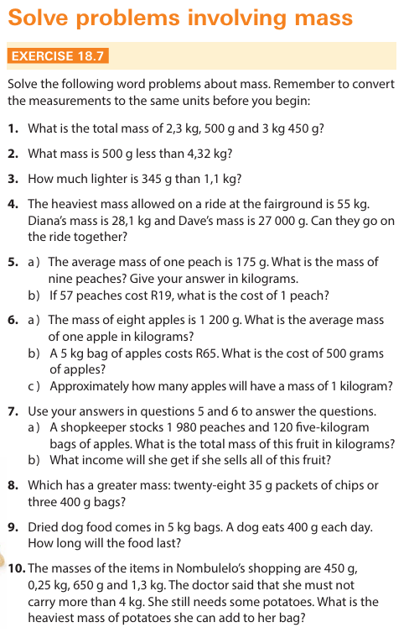 | 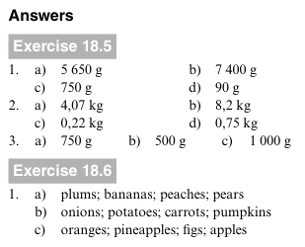  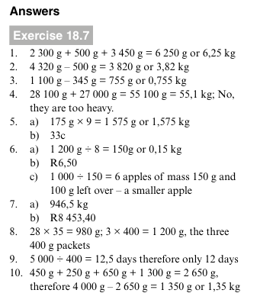

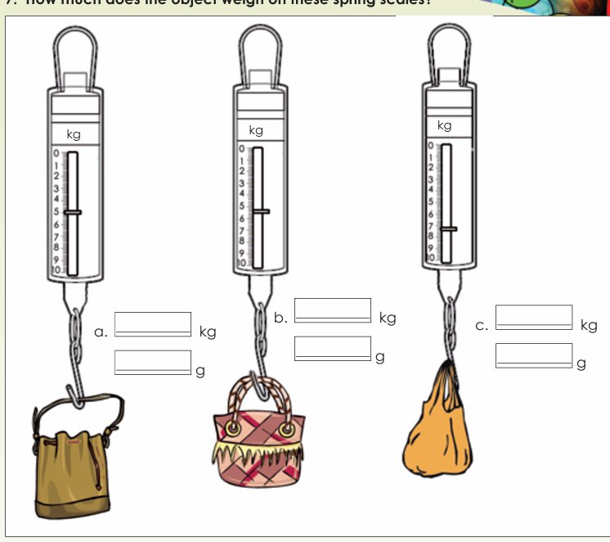

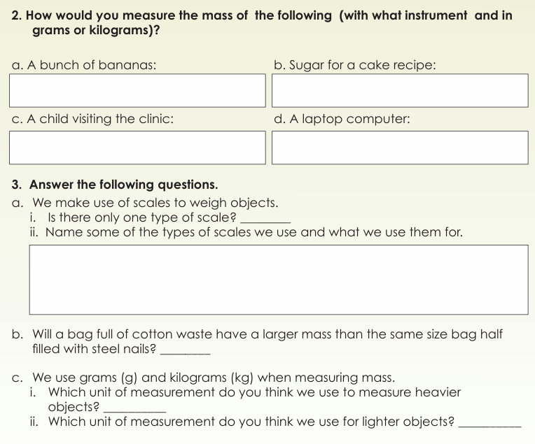
[Top Section - Units of Measurement]
- a. A bunch of bananas: Grams (g) or Kilograms (kg)
- b. Sugar for a cake recipe: Grams (g)
- c. A child visiting the clinic: Kilograms (kg)
- d. A laptop computer: Kilograms (kg)
3. Answer the following questions.
a. We make use of scales to weigh objects.
- i. Is there only one type of scale? No
- ii. Name some of the types of scales we use and what we use them for:
  - Kitchen scale / Digital food scale: Used to weigh food ingredients (like flour or sugar).
  - Bathroom scale / Body scale: Used to measure a person's body weight.
  - Baby scale: Used at clinics/hospitals to weigh infants safely.
  - Hanging scale / Produce scale: Used in supermarkets or markets to weigh fruits and vegetables.
  - Balance scale / Two-pan scale: Used to compare or measure weights by balancing masses.
b. Will a bag full of cotton waste have a larger mass than the same size bag half filled with steel nails? No (Steel is much denser and heavier than cotton waste, so even half a bag of steel nails will have a greater mass).
c. We use grams (g) and kilograms (kg) when measuring mass.
- i. Which unit of measurement do you think we use to measure heavier objects? Kilograms (kg)
- ii. Which unit of measurement do you think we use for lighter objects? Grams (g)

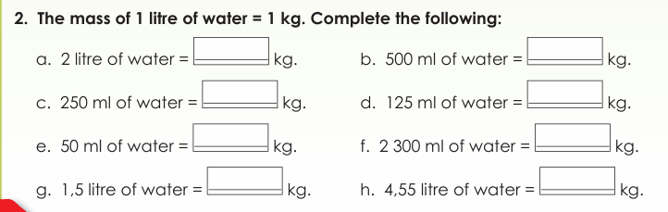
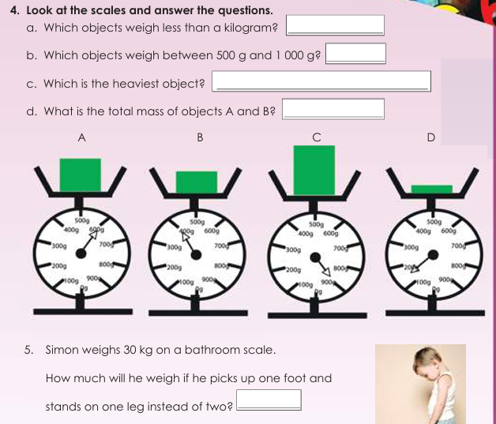
Data
Collect and organise data

You already know that you can collect data by counting things, by asking questions and by doing surveys.
You also know that you can use tallies and tables to organise the data that you collect.

Tally tables

While you are counting you can add the tallies, then at the end you add them all up | 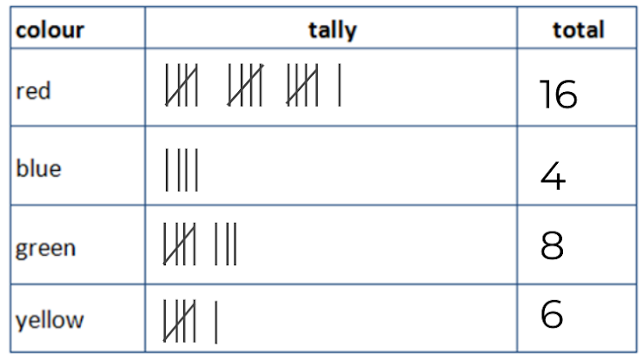

Questionnaire

You can also collect data using a questionnaire. A questionnaire is a form that has a list of questions printed on it. People fill in the questionnaire by ticking blocks, circling their choices or writing answers

Example:  This is a questionnaire for students at a school which will collect data on what sports each gender prefers. | 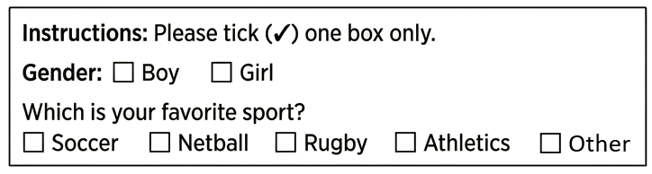

More
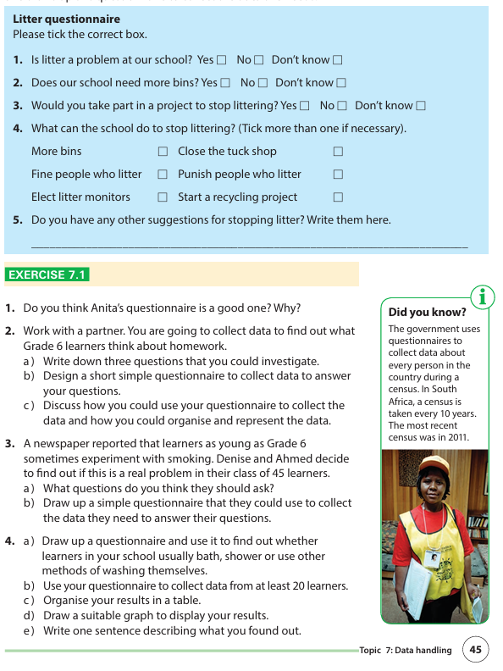 | 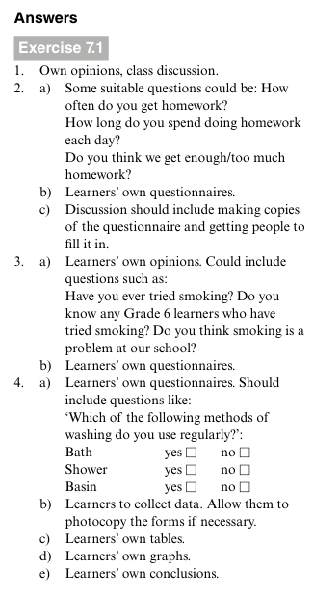

Graphs that must be able to make

Bar graphs | 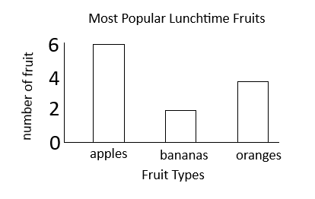 | Data type:  - (X-axis) Discrete / Categorical  - Ungrouped  Note: Leaves space between bars
Horizontal bar graphs | 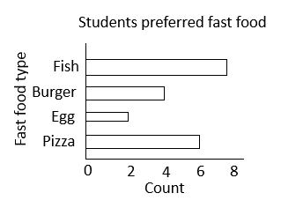 | Data type:  - (X-axis) Discrete / Categorical  - Ungrouped  Used:  - Long Category Labels,  - Large Number of Categories (many bars)
Double or compound | 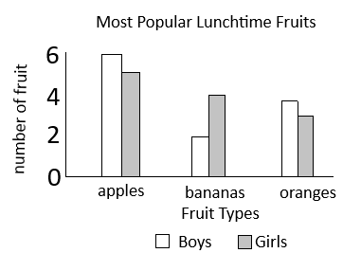 | Data type:  - (X-axis) Discrete / Categorical  - Ungrouped  Used: Ideal for comparing two related data series across the same set of groups.  Note: No spaces between bars within the same category  Note: make sure to add a key
Pictographs | 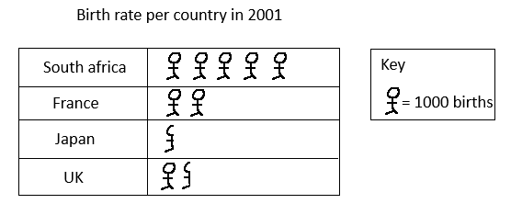 | Uses:  - data instantly recognizable without requiring readers to parse numerical axes  - High Engagement  Limitations:  - Imprecise for Fractions  - Impractical for Large Datasets
Pictographs horizontal stacking | 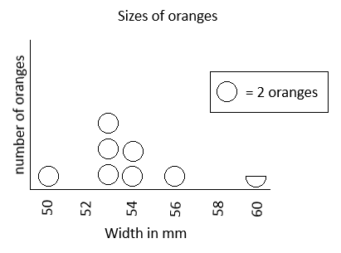

Graphs to read
Pie charts | 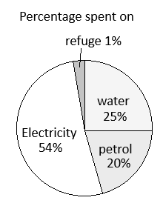 | A pie chart is a circle that is divided into slices where the size of the slice represents the percentage of the data.  Sector size = $\frac{frequency}{total number of data points}×360$  $$Data in a sector = percent×total data$$  $$Percentage=\frac{angle}{360}$$  Note: You may need to add a key if cant place names on or around the pie.

Pictographs
Read and draw pictographs. Pictographs use symbols, or pictures, to show data.
A key tells you what the symbols represent.
The symbols must equally placed.

We use pictographs primarily because they make data visual, intuitive, and easy to understand at a glance

Example
This is an example of many-to-one as one “man” represents 1000 births

Read and draw bar graphs
Bar graphs are a useful way to compare sets of data.

Example:  Luke did a survey to find out which type of music was most popular in Grade 6. He asked each learner to choose only one type of music. The bar graph shows the results of the survey.  Notes  The horizontal axis shows the type of music.  The vertical axis shows the number of learners that chose each type.  The data  If you read the data, you will see that most learners liked hip hop.  Rap music was least liked because only six learners liked rap.  You add the number of learners to find out how many learners took part in the survey.  A total of 45 learners took part in the survey. | 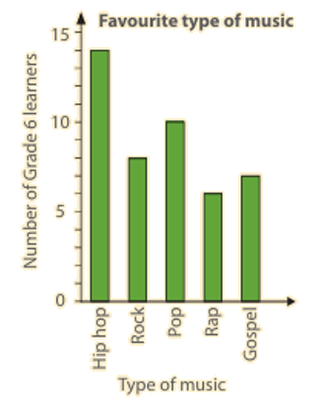

Double bar graphs
A double bar graph has two bars for each item in the data. Each bar shows a sub-group of the data item. A double bar graph has a key to show what the bars represent.

Example:  Luke wanted to know if there was a difference between the music that boys liked and the music that girls liked. He used his earlier data to draw this graph to show the data for boys and girls.  - Hip hop, rock and rap music was more popular with girls than boys.  - Pop and gospel music was more popular with boys than girls.  - Very few girls chose pop music compared with boys.  - Very few boys chose rock music compared with girls. | 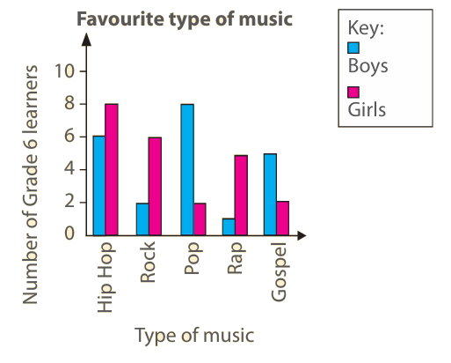

Questions
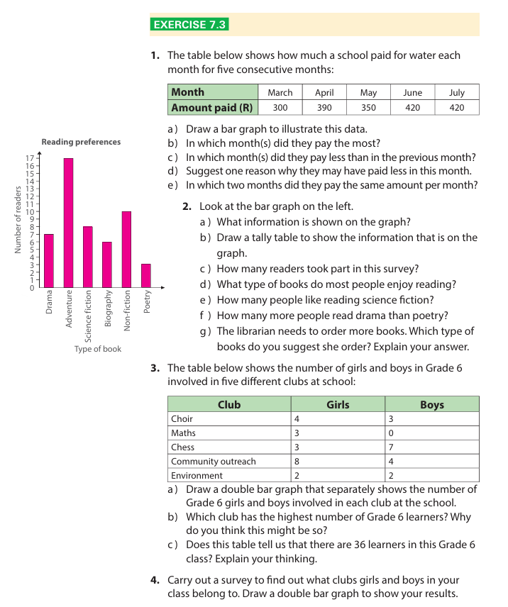 | 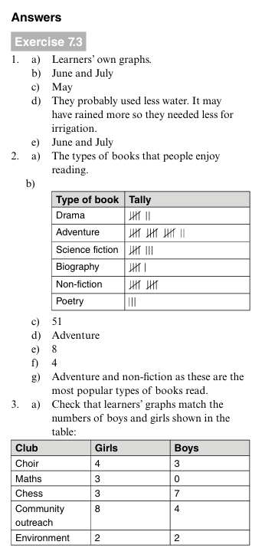  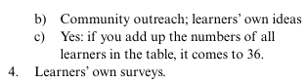
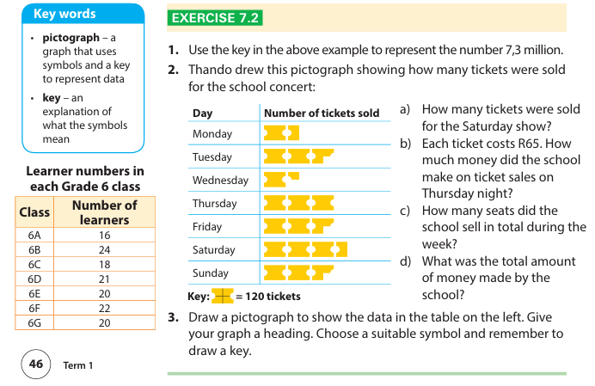 | 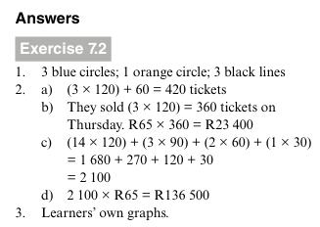

Pie charts
What is a Pie Chart?
A pie chart (or pie graph) is a circular graph used to show how a whole amount is divided into different parts or categories.
Think of the entire circle as a whole pizza or pie:
- The entire circle represents $100\%$ of the data (or the total number of responses).
- Each slice (called a sector) represents a portion (or percentage) of that total.
- The bigger the slice, the larger the number or fraction it represents!

Generally
- Half a circle ($\frac{1}{2}$): Represents $50\%$ of the total data.
- A quarter of a circle ($\frac{1}{4}$): Represents $25\%$ of the total data

Example  A survey was conducted with a Grade 6 class of 60 students to find out their favourite colours. The results are displayed in the pie chart.  Which colour was the most popular choice among the students?  Answer blue, it’s the largest percentage of piece of the pie chart  How many students chose green as their favourite colour?  $\frac{10}{100}*60=\frac{600}{100}=6$ students | 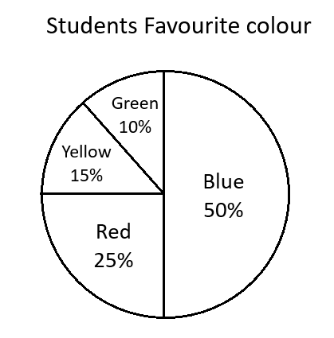

Questions
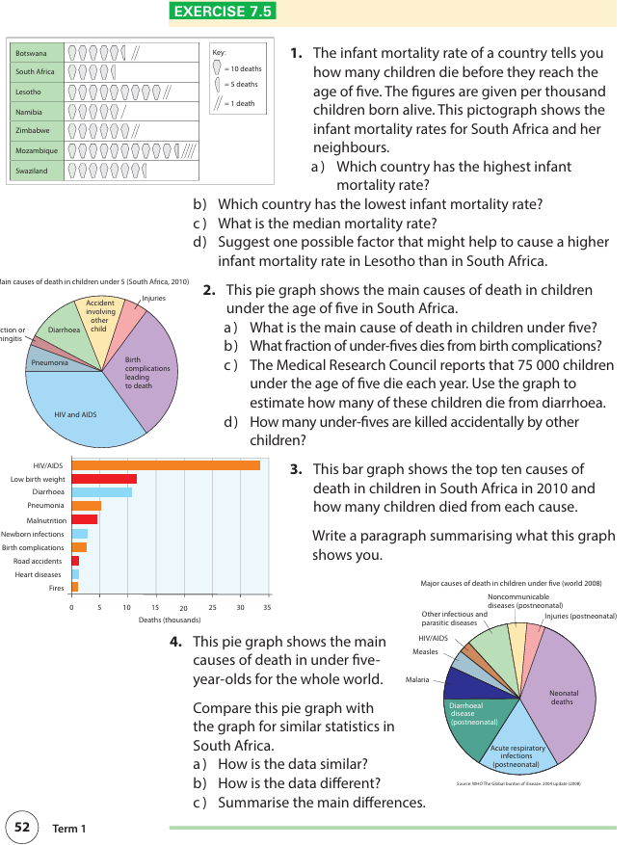 | 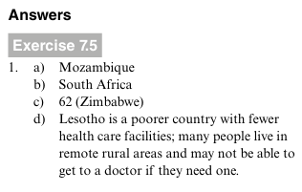  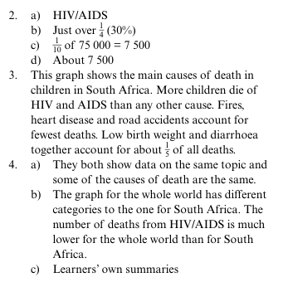

The mode and median in a set of data

Last year you learnt that the mode is the number or item that appears most often in a set of data.

The median is the middle number in an ordered data set.

These are the rules to find the median:
- First arrange the numbers in ascending order
- Select the middle number

Condition for mode
E.g. (1,2,3, no mode) (1,1,2,2,3, bimodal) (1,2,2 mode) (??????1,1,2,2,3,3 no mode)

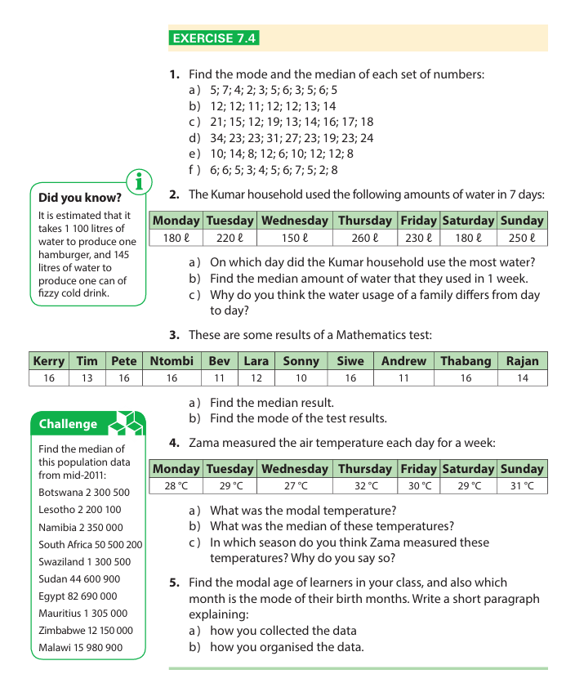 | 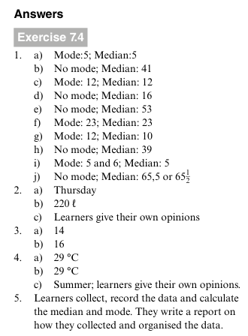

Interpret Analysing data

What can affect data | Graphs that show the same data can look quite different. Some reasons for this are:  The source of the data is different, for example:  - The data was collected from different groups of people, so their answers were different  (Example: A survey on Favourite Music given to Grade 6 learners vs. Grade 12 learners will show very different top genres.)  - The data was collected in different places, so the results were different  (Example: Asking learners about their Favourite Winter Sport at a coastal school in Cape Town versus an inland school in Gauteng where facilities or climates differ.)  The data was collected in different contexts, for example:  - The data was collected at different times, so different things were happening  (Example: A graph of Ice Cream Sales in January (summer) will show peak numbers, while a graph of sales in July (winter) will show very low numbers.)  - The data was collected in different ways, so the results were different.  (Example: An anonymous paper questionnaire about smoking habits vs. a direct verbal show of hands in front of the class. Learners are far more likely to be honest in an anonymous survey, leading to different results.)
1. Source = Who or Where (The Origin of the Data)
The source answers the question: "From whom or from what place did we get these numbers?"
- Who: Grade 6 learners vs. Grade 12 learners.
- Where: A school in Cape Town vs. a school in Johannesburg.

2. Context = The Circumstances / Environment (The Conditions Around the Data)
The context answers the question: "Under what conditions was the data gathered?"
- When, how, or
- under what conditions was it collected

Summary Checklist for Comparing Graphs on the Same Topic
When learners evaluate two conflicting graphs on the same topic, prompt them to ask:

Question to Ask | What it reveals
Who was surveyed? | Differences in sample groups (age, gender, interests).
Where was it done? | Regional or environmental factors.
When was it measured? | Seasonal, time-of-day, or historical differences.
How was data gathered? | Anonymous survey vs. interview vs. observation differences.

Example: Salma and Anita are in the same class. For a science project, they measured the temperature in their classroom each day for a week. They drew these graphs to display their data.  What is the same?  If you compare the graphs, you can see that the pattern for the week was the same. Both graphs show a low temperature on Monday, getting hotter on Tuesday and being the hottest on Wednesday and Thursday and then dropping down again on Friday.  However, Salma’s graph includes temperatures that are higher than Anita’s. The reason is that:  - Salma measured the temperature each day at lunchtime.  - Anita measured the temperature when she got to school in the morning.  This caused the girls to get different results because the mornings are cool and then it gets warmer during the day. In other words, each set of data was collected in a different context, one showing the minimum temperatures for each day, the other showing the maximum temperature for each day. | 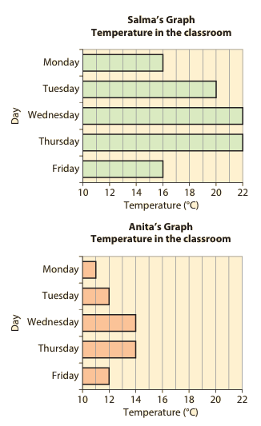

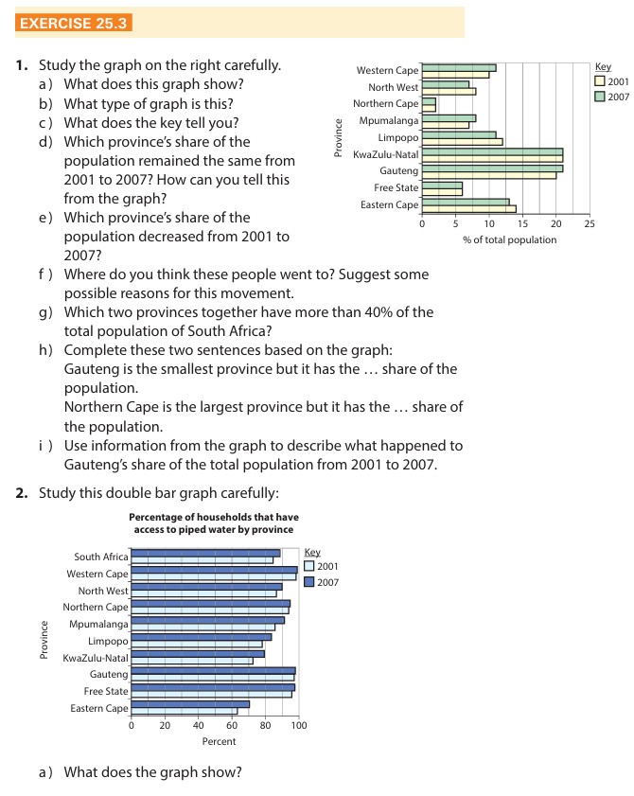 | 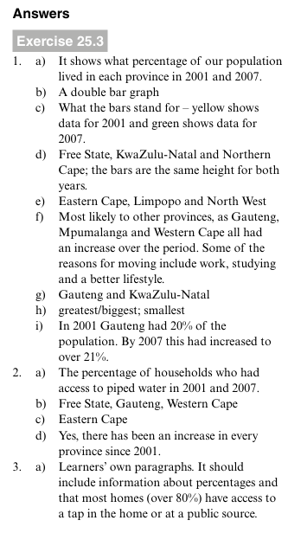
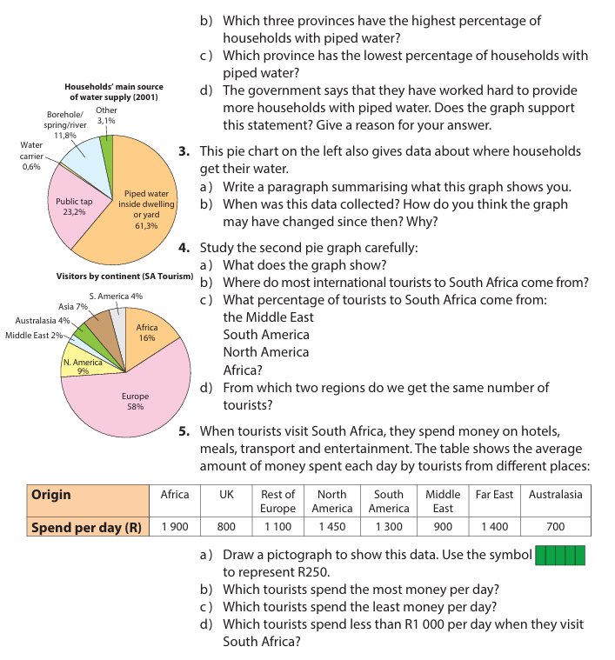 | 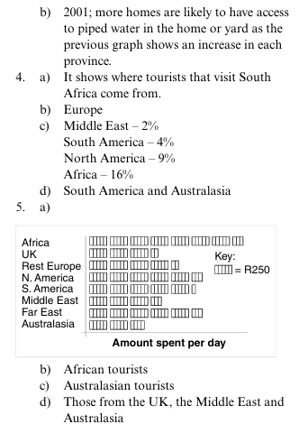

Interpret data

Interpret and make sense of graphs
To interpret, or understand data, we study graphs and tables to find patterns in the data.
We then look for factors that might influence or cause these patterns.
However, you must remember that you cannot always be sure exactly what is causing the results.

Question: What is the main factor influencing this pattern of sales throughout the year?  Answer: Weather and temperature (Seasonality).  January and December are warm summer months (leading to high sales), while May, June, and July are cold winter months (leading to low sales). | 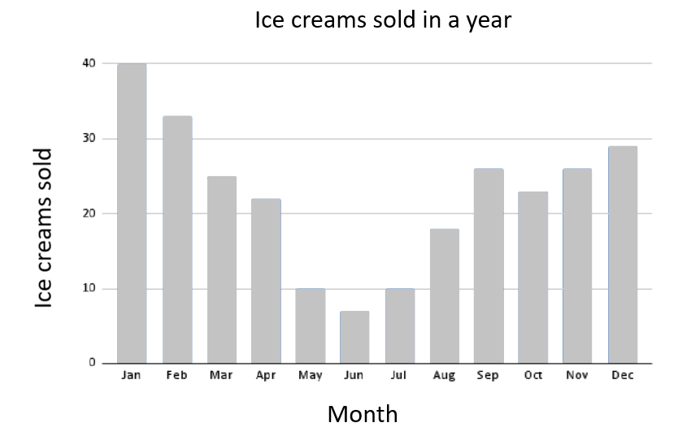

Example  The pictograph shows the number of pieces of litter found in a school’s grounds before, during and after the school introduced an anti-litter project.  The graph shows that from day 1 to day 5, learners littered a lot.  The anti-litter project started on day 6 and learners responded immediately. The result was that there was very little littering from day 6 to day 10.  The data also shows that from day 11, littering increased.  This suggests that learners probably forgot about the anti-litter project and started to litter again  Other factors?  Weather differences: Days 6–7 might have been rainy days where learners stayed inside their classrooms during break instead of eating outside. | 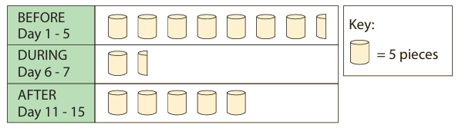

Data Cycle
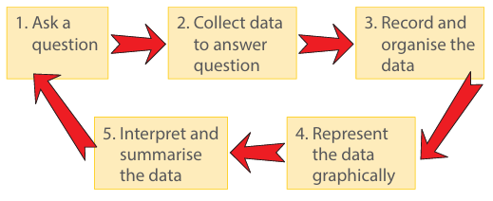

Step | What To Do
1. Pose a question | Decide what you want to find out.  E.g.: What is the favourite sport in Grade 6?
2. Collect data | Ask people questions using a survey or questionnaire. Could also be measuring/counting  E.g.: Ask 20 learners to pick: Soccer, Netball, Swimming, or Cricket.
3. Organise data | Put raw answers into order.  E.g.: Use tally marks and count them up in a frequency table.
4. Present data | Draw a picture or graph of your numbers.  E.g. Draw a bar graph.
5. Summarise & Interpret | Find the main facts and answer your question.  E.g.: Mode: Soccer (8 learners).  E.g.: Conclusion: Soccer is the most popular sport!

MEMORANDUM: EXERCISE 7.1

1. Evaluation of Anita's Questionnaire
- Answer: Yes, it is a good questionnaire (or No, depending on the specific criteria evaluated).
- Reasoning:
  - Why it is good: The questions are short, clear, and easy for Grade 6 learners to understand. They offer multiple-choice options or tick boxes which make the data easy to count and organise into frequency tables.

  - Possible improvement (if critique is needed): Ensure the options do not overlap and that sensitive questions allow for anonymous responses so learners answer truthfully.

2. Homework Survey (Grade 6 Opinions)
a) Three Investigative Questions:
- How much time do Grade 6 learners spend doing homework each day?
- Which subject gives the most homework?
- Do Grade 6 learners feel they get too much homework?

b) Short Questionnaire Design:
Plaintext
============================================================
GRADE 6 HOMEWORK QUESTIONNAIRE
============================================================
Please tick (✓) ONE box for each question:

1. How long do you spend on homework every day?
[ ] Less than 30 minutes
[ ] 30 minutes to 1 hour
[ ] More than 1 hour

2. Which subject gives you the most homework?
[ ] Mathematics
[ ] Languages (English / Afrikaans)
[ ] Natural Sciences / Social Sciences

3. How do you feel about the amount of homework you get?
[ ] Too much
[ ] Just the right amount
[ ] Too little
============================================================
c) Collection, Organisation, and Representation:
- How to collect: Distribute paper questionnaires anonymously to Grade 6 classmates to ensure honest answers.
- How to organise: Count the responses using tally marks in a frequency table for each question.
- How to represent: Draw a bar graph for each question showing the frequencies clearly on the vertical axis ($y$-axis).

3. Smoking Investigation (Class of 45 Learners)
a) Questions to Ask:
- Have you ever tried smoking a cigarette?

- Do any of your friends or family members smoke?

- Do you think smoking is harmful to your health?

b) Simple Questionnaire Design:
Important Note: Because smoking is a sensitive and illegal topic for minors, this questionnaire MUST be strictly anonymous (no names) so learners feel safe telling the truth.

Plaintext
============================================================
CONFIDENTIAL HEALTH SURVEY (NO NAMES)
============================================================
Please tick (✓) your answer:

1. Have you ever tried smoking, even once?
[ ] Yes
[ ] No

2. Do you have close friends or family members who smoke?
[ ] Yes
[ ] No

3. Do you think smoking is bad for your health?
[ ] Yes
[ ] No
[ ] Not sure
============================================================
4. Washing Habits Survey (Sample size = 20 Learners)
a) Questionnaire Design:
Plaintext
============================================================
PERSONAL HYGIENE SURVEY
============================================================
Which method do you USUALLY use to wash yourself every day?
(Tick ONE option)

[ ] Bathing
[ ] Showering
[ ] Washing using a basin / bucket
============================================================
b & c) Data Collection and Frequency Table:
(Sample data for 20 learners):

Washing Method | Tally | Frequency (Number of Learners)
Bathing | `
Showering | `
Basin / Bucket | `
Total |  | $$20$$
d) Suitable Graph (Bar Graph):
e) Summary Sentence:
- Answer: Most learners in the surveyed group usually shower to wash themselves, while using a basin or bucket was the least common method.

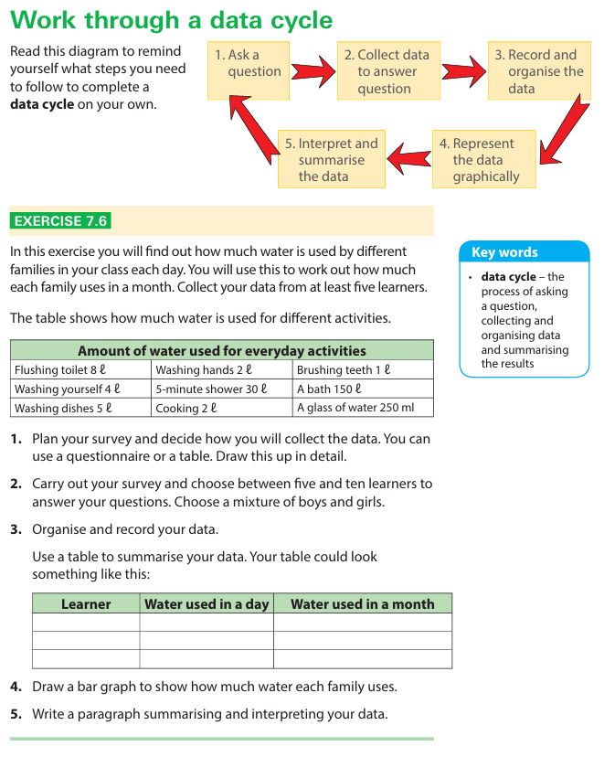

MEMORANDUM & WORKED EXAMPLE: EXERCISE 7.6
Step 1: Ask a Question
Research Question: How much water does each learner’s family use in a day and in a 30-day month?

1. Plan and Design the Data Collection Tool
Give a table for the learner to fill out for their family
Water Usage Questionnaire
Tick ($✓$) how many times your family completes each activity in one day.
Learner Name: Sipho, Number of people in family: $4$

Activity | Water per time | Tally / Count per day | Total Litres (ℓ)
Flushing toilet | $$8 l$$ | $10$ times | $$80 l$$
Washing hands | $$2 l$$ | $12$ times | $$24 l$$
Brushing teeth | $$1 l$$ | $8$ times | $$8 l$$
5-minute shower | $$30 l$$ | $2$ times | $$60 l$$
A bath | $$150 l$$ | $1$ time | $$150 l$$
Cooking | $$2 l$$ | $3$ times | $$6 l$$
Washing dishes | $$5 l$$ | $4$ times | $$20 l$$
Total Daily Usage ($l$) |  |  | $$348 l$$
(Repeat this survey form for 5 sample learners.)

2 & 3. Carry Out Survey, Organise, and Record Data
Note for 30-day month calculation: $\text{Monthly usage}=\text{Daily usage}×30\text{ days}$.

Learner | Water used in a day (ℓ) | Water used in a month (30 days) (ℓ)
1. Sipho | $$348 l$$ | $$348×30=10 440 l$$
2. Ayanda | $$250 l$$ | $$250×30=7 500 l$$
3. Liam | $$420 l$$ | $$420×30=12 600 l$$
4. Fatimah | $$180 l$$ | $$180×30=5 400 l$$
5. Johan | $$300 l$$ | $$300×30=9 000 l$$

4. Represent the Data Graphically

5. Summarise and Interpret the Data
The survey gathered water consumption data from five Grade 6 learners' families. Daily water usage ranged from a low of $180 l$ (Fatimah) to a high of $420 l$ (Liam). Over a 30-day month, total family usage varied between $5 400 l$ and $12 600 l$.

The primary factor causing these differences is family size and bathing habits—families that took baths ($150 l$ per bath) used significantly more water than those relying strictly on 5-minute showers ($30 l$). However, without knowing the exact number of people in each home, we cannot be $100\%$ certain if Liam's household is wasteful or simply has more family members.

