Mass
Reference Weigts
1 gram (g) | 1 Paperclip or 1 Wooden Toothpick
5g | Pencil
200 grams (g) | Apple
1 kilogram (kg) | 1 Litre Bottle of Water or 1 Bag of Sugar
Sack of potatoes | 7kg sack of potatoes
40–50 kilograms (kg) | An Average Grade 6 Student
80-100kg | Adult man
1000kg, 1 metric tonne (t) | Car
6000kg | Elephant

Estimation
No. | Question | Option A | Option B | Option C | Option D
1 | Estimate the mass of a single paperclip. | 1 g | 10 g | 100 g | 1 kg
2 | Estimate the mass of a single chicken egg. | 60 g | 600 g | 6 kg | 60 kg
3 | Estimate the mass of a Grade 6 mathematics textbook. | 8 g | 800 g | 8 kg | 80 kg
4 | Estimate the mass of a standard bag of sugar. | 2 g | 20 g | 200 g | 2 kg
5 | Estimate the mass of an average Grade 6 learner. | 400 g | 4 kg | 40 kg | 400 kg
6 | Estimate the mass of a fully grown male lion. | 1,9 kg | 19 kg | 190 kg | 1 900 kg
7 | Estimate the mass of a small passenger car. | 12 kg | 120 kg | 1 200 kg | 12 000 kg
8 | Estimate the mass of a farm tractor. | 270 g | 2,7 kg | 27 kg | 2 700 kg
9 | Estimate the mass of a large African elephant. | 60 kg | 600 kg | 6 000 kg | 60 000 kg
10 | Estimate the mass of a fully loaded city bus. | 150 kg | 1 500 kg | 15 000 kg | 150 000 kg

No. | Question | Option A | Option B | Option C | Option D
1 | Estimate the mass of a Grade 6 mathematics textbook. | 8 g | 800 g | 8 kg | 80 kg
2 | Estimate the mass of a single chicken egg. | 60 g | 600 g | 6 kg | 60 kg
3 | Estimate the mass of a full-grown domestic cat. | 45 g | 450 g | 4,5 kg | 45 kg
4 | Estimate the mass of a single paperclip. | 1 g | 10 g | 100 g | 1 kg
5 | Estimate the mass of a standard bag of sugar. | 2 g | 20 g | 200 g | 2 kg
6 | Estimate the mass of an average Grade 6 learner. | 400 g | 4 kg | 40 kg | 400 kg
7 | Estimate the mass of a slab of chocolate. | 1 g | 100 g | 1 kg | 10 kg
8 | Estimate the mass of a standard building brick. | 3 g | 30 g | 300 g | 3 kg
9 | Estimate the mass of a standard bicycle. | 12 g | 120 g | 1,2 kg | 12 kg
10 | Estimate the mass of a standard loaf of bread. | 7 g | 70 g | 700 g | 7 kg

Able to read instruments
Before you give the reading make sure to know where 0 starts and which direction its counting up
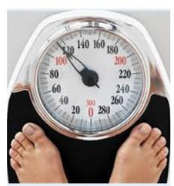 | 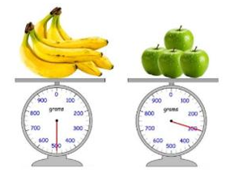 | 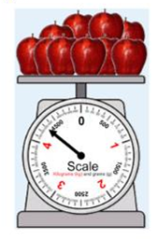

Conversions
Question # | Question | Answer
1 | Half a kilogram of apples is equal to [_____] grams. | 500 g
2 | Quarter of a kilogram of flour is equal to [_____] grams. | 250 g
3 | Convert from kilograms to grams: $3,8\text{ kg}=\left[\text{_____}\right]\text{ g}$ | 3 800 g
4 | Convert from kilograms to grams: $0,65\text{ kg}=\left[\text{_____}\right]\text{ g}$ | 650 g
5 | Convert from kilograms to grams: $7,2\text{ kg}=\left[\text{_____}\right]\text{ g}$ | 7 200 g
6 | Convert from kilograms to grams: $0,08\text{ kg}=\left[\text{_____}\right]\text{ g}$ | 80 g
7 | Convert from grams to kilograms: $2 845\text{ g}=\left[\text{_____}\right]\text{ kg}$ | 2,845 kg
8 | Convert from grams to kilograms: $15 210\text{ g}=\left[\text{_____}\right]\text{ kg}$ | 15,21 kg
9 | Convert from grams to kilograms: $630\text{ g}=\left[\text{_____}\right]\text{ kg}$ | 0,63 kg
10 | Convert from grams to kilograms: $9 005\text{ g}=\left[\text{_____}\right]\text{ kg}$ | 9,005 kg

Order it
Question Number | Question | Answer
1 | Order the masses in descending order: 1/2 kg ; 1 200 g ; 3,5 kg ; 800 g | 3,5 kg ; 1 200 g ; 800 g ; 1/2 kg
2 | Order the masses in ascending order: 2 500 g ; 1/4 kg ; 1,8 kg ; 600 g | 1/4 kg ; 600 g ; 1,8 kg ; 2 500 g
3 | Order the masses in descending order: 3/4 kg ; 0,9 kg ; 2 100 g ; 600 g | 2 100 g ; 0,9 kg ; 3/4 kg ; 600 g
4 | Order the masses in ascending order: 5,2 kg ; 750 g ; 4/5 kg ; 520 g | 520 g ; 750 g ; 4/5 kg ; 5,2 kg
5 | Order the masses in descending order: 1/10 kg ; 3 000 g ; 2,4 kg ; 150 g | 3 000 g ; 2,4 kg ; 150 g ; 1/10 kg

Story sums
Question Number | Question | Answer
1 | What is the total mass of 2,3 kg, 500 g and 3 kg 450 g? | 6,25 kg (or 6 250 g)
2 | What mass is 500 g less than 4,32 kg? | 3,82 kg (or 3 820 g)
3 | How much lighter is 345 g than 1,1 kg? | 755 g (or 0,755 kg)
4 | The heaviest mass allowed on a ride at the fairground is 55 kg. Diana's mass is 28,1 kg and Dave's mass is 27 000 g. Can they go on the ride together? | No, their total mass is 55,1 kg, which exceeds 55 kg.
5 | (a) The average mass of one peach is 175 g. What is the mass of nine peaches in kilograms? (b) If 57 peaches cost R19, what is the cost of 1 peach? | (a) 1,575 kg; (b) R0,33 (or 33,3c)
6 | (a) The mass of eight apples is 1 200 g. What is the average mass of one apple in kilograms? (b) A 5 kg bag of apples costs R65. What is the cost of 500 grams of apples? (c) Approximately how many apples will have a mass of 1 kilogram? | (a) 0,15 kg; (b) R6,50; (c) 7 apples
7 | Use your answers in questions 5 and 6: (a) A shopkeeper stocks 1 980 peaches and 120 five-kilogram bags of apples. What is the total mass of this fruit in kilograms? (b) What income will she get if she sells all of this fruit? | (a) 946,5 kg; (b) R8 460,00
8 | Which has a greater mass: twenty-eight 35 g packets of chips or three 400 g bags? | Three 400 g bags (1 200 g vs 980 g)
9 | Dried dog food comes in 5 kg bags. A dog eats 400 g each day. How long will the food last? | 12,5 days
10 | The masses of the items in Nombulelo's shopping are 450 g, 0,25 kg, 650 g and 1,3 kg. The doctor said that she must not carry more than 4 kg. What is the heaviest mass of potatoes she can add to her bag? | 1,35 kg (or 1 350 g)

Q1 TIME
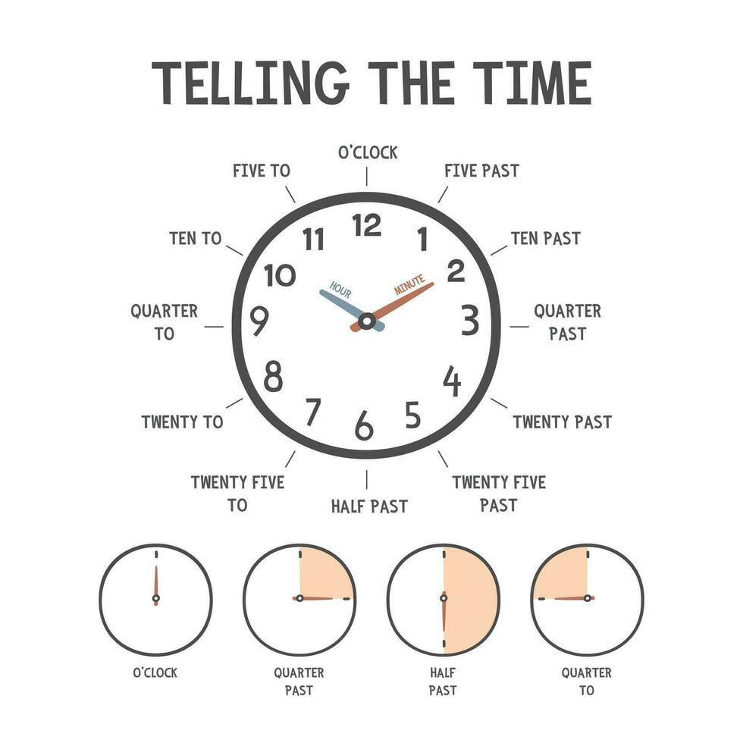
Read the clock questions, time: without am/pm
Careful, there could be confusion if just change to numbers. SAY IT FIRST
E.g. the second clock you could make the mistake of thinking its 6:45. But if you say it you would have 15 to 6, so it’s not 6 yet. Other ways are to see that the minute hand has not reached the 6 yet.
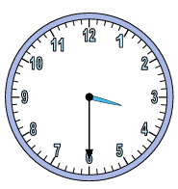  Half past 3 | 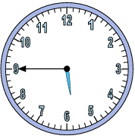  Quarter to 6 | 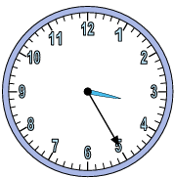  25 past 3 | 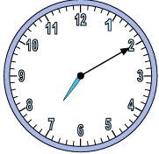  10 past 2

Now write in digital
Hours in the first column minutes in the second; 00:00
3:30 | 5:45 | 3:25 | 7:10

Then read digital
3:10 | 10 past 3
11:45 | Quarter to 12
3:30 | Half past 3
8:25 | Twenty five past 8
12:00 | 12 o’clock
2:13 | 13 past 2

Intro to 12 hour
Time Span | Description / Term | 12-Hour Example
00:00 – 11:59 | in the morning (a.m.) | 6:00 in the morning = 6:00 a.m.
12:00 | midday or noon | 12:00 p.m. | Noon
12:01 – 16:59 | in the afternoon (p.m.) | 3:00 in the afternoon = 3:00 p.m. | Afternoon starts after 12:00pm
17:00 – 21:59 | in the evening (p.m.) | 6:00 in the evening = 6:00 p.m. | The evening starts at 6:00pm
22:00 – 23:59 | at night (p.m.) | 11:00 at night = 11:00 p.m.
00:00 | midnight | 12:00 a.m. | Midnight

Now with: am and pm
Question | Time Given in Words | Answer (12-Hour Notation)
1. | 8 o'clock in the morning | 8:00 a.m.
2. | Half past 3 in the afternoon | 3:30 p.m.
3. | Quarter past 7 in the evening | 7:15 p.m.
4. | 10 o'clock at night | 10:00 p.m.
5. | 20 minutes past 6 in the morning | 6:20 a.m.
6. | Quarter to 5 in the afternoon | 4:45 p.m.
7. | 11 o'clock at night | 11:00 p.m.
8. | 5 minutes to 9 in the morning | 8:55 a.m.
9. | Half past 6 in the evening | 6:30 p.m.
10. | 12 o'clock in the middle of the day (midday) | 12:00 p.m.

24-hour clock, note this is where we add a 0 Infront of a single number eg. 06:00 not 6:00
Write out a list of numbers
1,2,3,….,10,11 am then 12,1 ,2,3,4,…. 11 pm 12

Then write the 24 underneath so they can see it

12 to 24 hours | 12 to 24 hour
  Question | Time Given in Words | Answer (24-Hour Format)
  1. | 6 o'clock in the morning | 06:00
  2. | Half past 4 in the afternoon | 16:30
  3. | Quarter past 8 in the evening | 20:15
  4. | 9 o'clock at night | 21:00
  5. | 10 minutes past 7 in the morning | 07:10
  6. | Quarter to 3 in the afternoon | 14:45
  7. | 11 o'clock at night | 23:00
  8. | 25 minutes to 10 in the morning | 09:35
  9. | Half past 7 in the evening | 19:30
  10. | 12 o'clock midnight | 00:00 (or 24:00)
  Time | Meanings / Various Forms
  00:25 | 12.25 a.m.
  01:00 | 1.00 a.m.
  07:33 | 7.33 a.m.
  11:59 | 11.59 a.m.
  12:00 | 12 p.m.
  12:10 | 12.10 p.m.
  13:48 | 1.48 p.m.
  17:40 | 5.40 p.m.
  20:20 | 8.20 p.m.
  23:59 | 11.59 p.m.
  24:00 is actually 00:00 | 12.00 a.m.

In words
In words | More
  Question | 24-Hour Time | Answer (Time in Words)
  1. | 07:00 | 7 o'clock in the morning
  2. | 14:30 | Half past 2 in the afternoon
  3. | 19:15 | Quarter past 7 in the evening
  4. | 22:00 | 10 o'clock at night
  5. | 08:20 | 20 minutes past 8 in the morning
  6. | 15:45 | Quarter to 4 in the afternoon
  7. | 23:00 | 11 o'clock at night
  8. | 09:35 | 25 minutes to 10 in the morning
  9. | 18:30 | Half past 6 in the evening
  10. | 00:00 | 12 o'clock midnight (or midnight)
  3:10 | 10 past 3 in the morning
  11:45 | Quarter to 12 in the
  15:30 | Half past 3 in the afternoon
  20:25 | Twenty five past 8 in the afternoon.
  12:00 | Noon
  24:00/00:00 | Mid-night

24 hour | 12 hour
add a zero in front of the number | Do not add a zero in front of the number
Do not use am, pm | Must use: am, pm  Otherwise use in the morning/afternoon

Past | To
E.g. 6:05/ 6:12 | 6: 35 is 25 to 7  Quarter to 8 is 7:45

Lesson 2 Durations
Duration between
8:35 to 11:10  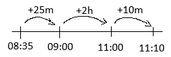 | 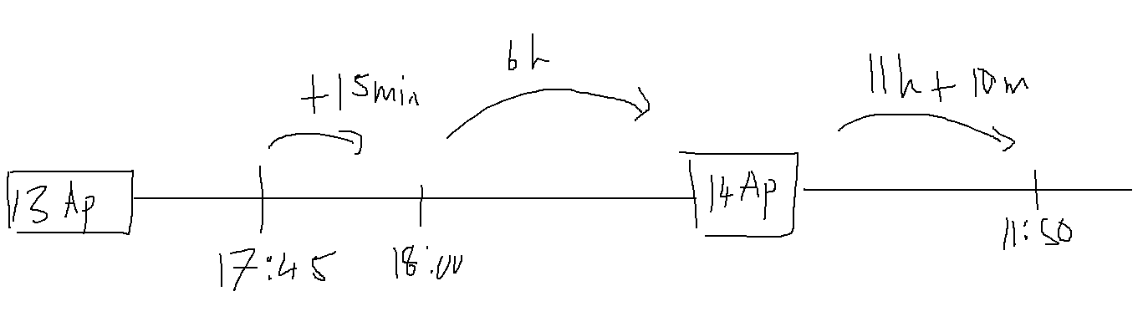  Therefore 6h+11h = 17h  Minutes: 50+15 = 65  Therefore: 18h 5 minutes

Question | Answer
1. School starts at 07:45 and breaks for tea at 10:15. How long is the first session? | 2 hours and 30 minutes
2. Sipho starts reading at 14:20 and stops at 15:05. How long did he read? | 45 minutes
3. A bus leaves the station at 08:35 and arrives at its destination at 11:10. How long was the trip? | 2 hours and 35 minutes
4. Thabo starts his homework at 16:40 and finishes at 18:15. How long did he spend on homework? | 1 hour and 35 minutes
5. A movie starts at 19:15 and ends at 21:05. What is the duration of the movie? | 1 hour and 50 minutes
6. Lerato went for a bike ride at 09:50 and returned home at 12:15. How long was her ride? | 2 hours and 25 minutes
7. An exam starts at 11:30 and finishes at 13:15. How long do the learners have to complete it? | 1 hour and 45 minutes
8. A football match kick-off was at 15:30 and the final whistle blew at 17:20. How much time passed? | 1 hour and 50 minutes
9. A train departs at 22:45 on Tuesday and arrives at 04:15 on Wednesday. How long was the journey? | 5 hours and 30 minutes
10. Dinner preparations started at 17:25 and supper was served at 19:10. How long did cooking take? | 1 hour and 45 minutes

Harder
Start Time | End Time | Answer
13 Apr at 05:45 | 14 Apr at 10:50 | 29 hours 5 minutes (or 1 day 5 hours 5 minutes)
10 Jan at 08:15 | 11 Jan at 14:40 | 30 hours 25 minutes (or 1 day 6 hours 25 minutes)
22 Mar at 11:30 | 23 Mar at 16:15 | 28 hours 45 minutes (or 1 day 4 hours 45 minutes)
05 Jun at 07:20 | 06 Jun at 12:55 | 29 hours 35 minutes (or 1 day 5 hours 35 minutes)
18 Jul at 09:10 | 19 Jul at 15:30 | 30 hours 20 minutes (or 1 day 6 hours 20 minutes)
03 Sep at 14:45 | 04 Sep at 18:10 | 27 hours 25 minutes (or 1 day 3 hours 25 minutes)
12 Oct at 06:05 | 13 Oct at 11:50 | 29 hours 45 minutes (or 1 day 5 hours 45 minutes)
27 Nov at 10:25 | 28 Nov at 17:05 | 30 hours 40 minutes (or 1 day 6 hours 40 minutes)
14 Dec at 16:50 | 15 Dec at 21:15 | 28 hours 25 minutes (or 1 day 4 hours 25 minutes)
08 Feb at 13:15 | 09 Feb at 19:40 | 30 hours 25 minutes (or 1 day 6 hours 25 minutes)

Before After
Method: slowly work backwards, first remove the hours, then the minutes
Method 1: The Step-by-Step "Jump" Method (Most Common)
- Subtract the full hour first:
$$14:15-1\text{ hour}=13:15 \left(1:15\text{ p.m.}\right)$$

- Subtract the remaining 30 minutes in chunks to bridge the hour:
  - Split 30 minutes into $15\text{ mins}+15\text{ mins}$.
  - Subtract the first 15 minutes to get to the top of the hour:
$$13:15-15\text{ mins}=13:00 \left(1:00\text{ p.m.}\right)$$

  - Subtract the final 15 minutes:
$$13:00-15\text{ mins}=12:45 \left(12:45\text{ p.m.}\right)$$

Question | Answer
1. Time is 14:15. Sarah had a doctor's appointment 1 hour and 30 minutes before this time. What time was her appointment? | 12:45
2. Time is 10:20. The morning train left 3 and a half hours before this time. What time did the train leave? | 06:50
3. Time is 18:05. Ben finished his homework 45 minutes before this time. What time did he finish? | 17:20
4. Time is 09:10. The bakery opened 2 hours and 15 minutes before this time. What time did it open? | 06:55
5. Time is 13:00. Mia ate lunch 1 and a quarter hours before this time. What time did she eat lunch? | 11:45
6. Time is 08:45. The school bus arrives 1 hour and 20 minutes later. What time does the bus arrive? | 10:05
7. Time is 11:30. A movie starts 2 and a half hours later. What time does the movie start? | 14:00
8. Time is 15:50. Soccer practice starts 40 minutes later. What time does soccer practice start? | 16:30
9. Time is 07:15. The library opens 3 hours and 45 minutes later. What time does the library open? | 11:00
10. Time is 16:40. Dinner will be ready 1 and a quarter hours later. What time will dinner be ready? | 17:55

Time zone
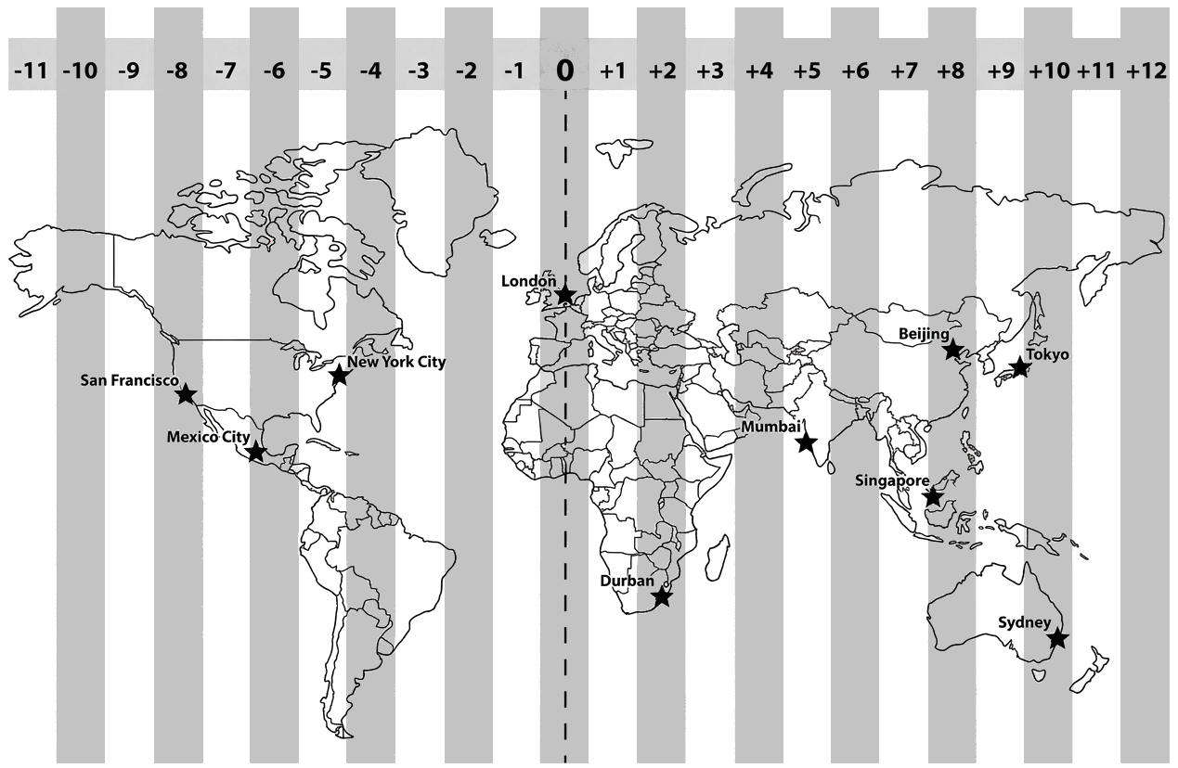

How many hours is London ahead of New York? | 5 hours ahead

How to calculate the time:
- Add going forward (East)
- Minus going back (West)

# | Question | Answer PNG | Explanation PNG
1 | If the time in London ($0$) is 08:00, what is the time in Singapore ($+8$)? | 16:00 (4:00 PM) | Singapore is 8 hours ahead
2 | If the time in Durban ($+2$) is 14:00, what is the time in Mexico City ($-6$)? | 06:00 (6:00 AM) | Mexico City is 8 hours behind
3 | If the time in Singapore ($+8$) is 15:30, what is the time in Mexico City ($-6$)? | 01:30 (1:30 AM) | Mexico City is 14 hours behind
4 | If the time in Mexico City ($-6$) is 10:45, what is the time in Sydney ($+10$)? | 02:45 (Next Day) (2:45 AM) | Sydney is 16 hours ahead
5 | If the time in Tokyo ($+9$) is 19:00, what is the time in Singapore ($+8$)? | 18:00 (6:00 PM) | Singapore is 1 hour behind
6 | If the time in New York City ($-5$) is 06:00, what is the time in Mexico City ($-6$)? | 05:00 (5:00 AM) | Mexico City is 1 hour behind
7 | If the time in Singapore ($+8$) is 22:00, what is the time in Durban ($+2$)? | 16:00 (4:00 PM) | Durban is 6 hours behind
8 | If the time in Mexico City ($-6$) is 18:15, what is the time in Beijing ($+8$)? | 08:15 (Next Day) (8:15 AM) | Beijing is 14 hours ahead
9 | If the time in Sydney ($+10$) is 11:00, what is the time in Singapore ($+8$)? | 09:00 (9:00 AM) | Singapore is 2 hours behind
10 | If the time in San Francisco ($-8$) is 04:00, what is the time in Mexico City ($-6$)? | 06:00 (6:00 AM) | Mexico City is 2 hours ahead

We add going right, subtract going left
Ahead means their time is further on, e.g. if tom is 1pm and jake is 2 hours ahead then its 3pm by him
Behind means that their time is behind, .e.g. if its 1pm and john is 5 hours behind then 8am
In words
Question | Answer (24-hour time) | Answer (12-hour time)
1. At 14:30, Sarah calls her friend in London, England. London is 2 hours behind South Africa. What time is it in London? | 12:30 | 12:30 p.m.
2. At 21:15, Liam calls his brother in New York, USA. New York is 6 hours behind South Africa. What time is it in New York? | 15:15 | 3:15 p.m.
3. At 18:45, Thabo calls his sister in Tokyo, Japan. Tokyo is 7 hours ahead of South Africa. What time is it in Tokyo? | 01:45 (next day) | 1:45 a.m. (next day)
4. At 09:20, Maya calls her aunt in Dubai, UAE. Dubai is 2 hours ahead of South Africa. What time is it in Dubai? | 11:20 | 11:20 a.m.
5. At 16:50, David calls his cousin in Auckland, New Zealand. Auckland is 10 hours ahead of South Africa. What time is it in Auckland? | 02:50 (next day) | 2:50 a.m. (next day)

Time zones and duration
Note: for the proper time adjustments, use(suppose L is the destination) “if D is 5 hours behind, then the destination is +5 hours ”
Set up start and end  Put an arrow for duration and the time  Put + or – the hours if ahead or behind  If A is behind therefore B is a head and vice versa. | 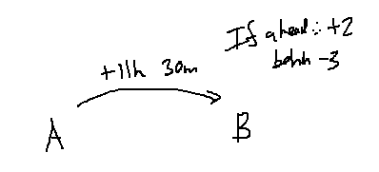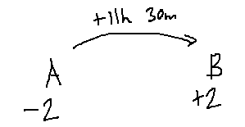

Question | Answer
1. A flight from London to Durban takes 10 hours 45 minutes. London is 2 hours behind Durban. What time (local time) will the flight arrive in Durban if it departs London at 18:00? | 06:45 (the next day)
2. A flight from Johannesburg to London takes 11 hours 15 minutes. Johannesburg is 2 hours ahead of London. If the plane leaves Johannesburg at 20:30, what local time does it land in London? | 05:45 (the next day)
3. A flight from Cape Town to Dubai takes 9 hours 30 minutes. Dubai is 2 hours ahead of Cape Town. If the flight departs Cape Town at 13:15, what local time will it arrive in Dubai? | 00:45 (the next day)
4. A flight from Perth to Johannesburg takes 10 hours 20 minutes. Perth is 6 hours ahead of Johannesburg. If the flight leaves Perth at 23:40 on Monday, what local time does it land in Johannesburg? | 04:00 (on Tuesday)
5. A flight from Johannesburg to Sydney takes 11 hours 50 minutes. Sydney is 8 hours ahead of Johannesburg. If the plane departs Johannesburg at 11:00, what is the local arrival time in Sydney? | 06:50 (the next day)
6. A flight from New York to Johannesburg takes 15 hours 10 minutes. New York is 6 hours behind Johannesburg. If the flight departs New York at 11:15, what local time does it arrive in Johannesburg? | 08:25 (the next day)
7. A flight from Durban to Mauritius takes 4 hours 15 minutes. Mauritius is 2 hours ahead of Durban. What local time does a flight arrive in Mauritius if it departs Durban at 08:35? | 14:50
8. A flight from Singapore to Johannesburg takes 10 hours 40 minutes. Singapore is 6 hours ahead of Johannesburg. If the plane departs Singapore at 02:10 on Thursday, what local time does it land in Johannesburg? | 06:50 (on Thursday)
9. A flight from Paris to Cape Town takes 11 hours 25 minutes. Paris is 1 hour behind Cape Town. What local time will a plane land in Cape Town if it departs Paris at 21:50? | 10:15 (the next day)
10. A flight from Johannesburg to Atlanta takes 16 hours 35 minutes. Atlanta is 6 hours behind Johannesburg. If the flight departs Johannesburg at 20:10, what local time does it land in Atlanta? | 06:45 (the next day)

Age and months
Bob was born on Nov 2019 and Tom Feb 2020.  Who is older and by how much? | ERLIER DATES ARE OLDER AS THEY WERE BORN FIRST  Answer: Nov 2019, and that person is 3 months older
Pete is 9 years and 5 months older then BOB? | Method: Minus the years then count the months  Years 2019 – 9 = 2010  Months: N->--june
How much older is granny who was born in 1954? | Method: we only interested in years  Find the difference: 2019-1954 =65

1. Sarah was born in August 2018 and Mia was born in May 2019.  a) Who is older and by how much?  b) Max is 4 years and 3 months older than Sarah. In which month and year was Max born?  c) How much older is Sarah than her brother Leo, who was born in August 2023? | a) Sarah is older by 9 months.  b) May 2014.  c) 5 years older.
2. David was born in October 2017 and Luke was born in March 2018.  a) Who is older and by how much?  b) Uncle Ben was born in October 1987. How much older is Uncle Ben than David?  c) Sam is 2 years and 7 months younger than Luke. In which month and year was Sam born? | a) David is older by 5 months.  b) 30 years older.  c) October 2020.
3. Emma was born in January 2020 and Noah was born in July 2020.  a) Who is older and by how much?  b) Grandma was born in January 1960. How much older is Grandma than Emma?  c) Jack is 6 years and 4 months older than Noah. In which month and year was Jack born? | a) Emma is older by 6 months.  b) 60 years older.  c) March 2014.
4. Chloe was born in September 2015 and Ethan was born in April 2016.  a) Who is older and by how much?  b) Maya is 3 years and 8 months older than Chloe. In which month and year was Maya born?  c) Grandpa was born in 1955. How much older is Grandpa than Chloe? | a) Chloe is older by 7 months.  b) January 2012.  c) 60 years older.
5. Liam was born in December 2021 and Ava was born in June 2022.  a) Who is older and by how much?  b) Oliver is 5 years and 2 months older than Liam. In which month and year was Oliver born?  c) How much older is Ava than her baby sister, who was born in June 2025? | a) Liam is older by 6 months.  b) October 2016.  c) 3 years older.

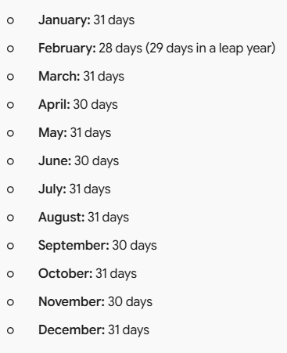

Unit conversions
Century
1st Century: Years 1 through 100
20th Century: Years 1901 through 2000
21st Century: Years 2001 through 2100
So, the centre is always 1 behind until it lands directly on it.eg: 2100 is the 21st century but 2101 is the 22nd century

A leap year is a year that has an extra day in February.
• Every fourth year is a leap year.
• Leap years are multiples of four, for example, 2028 is a leap year.

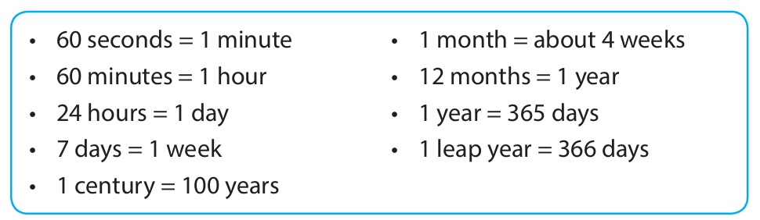

Example: How many days are there in 3 years?
Answer: $3×365\text{ days}=1 095\text{ days}$

Example: How many years are there in $994\text{ days}$?
Answer: $994÷365=2\text{ years and }264\text{ days left over}$

Example: How many years are there in 5 centuries?
Answer: $5×100=500\text{ years}$

Example: How many centuries are there in $1 207\text{ years}$?
Answer: $1 207÷100=12\text{ with }7 \text{years }\text{remaining}$

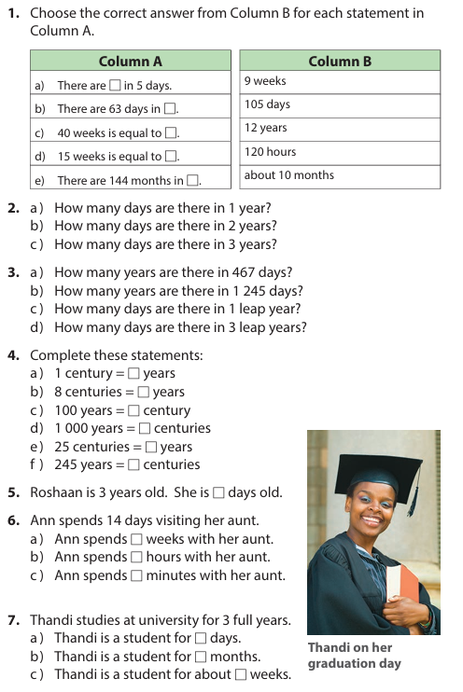 | 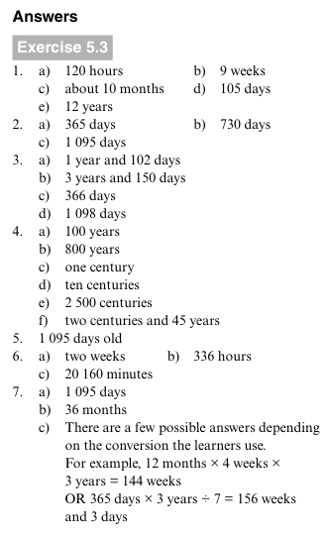

Capacity
Important reference points
Teaspoon = 5ml
Tablespoon = 15 ml
Cup 250ml
Coke = 2L bottle
Bucket 7L
Bath 150L
Swimming pool 50KL

Able to read the instruments
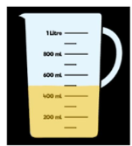 | 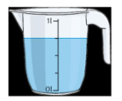

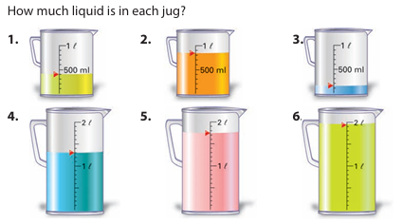 | 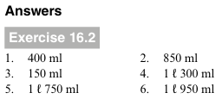

Order

Question Number | Question | Answer
1 | Arrange the capacities from greatest to smallest: 3,7 l ; 2 000 ml ; 0,9 l ; 1/2 l ; 4 l 300 ml | 4 l 300 ml ; 3,7 l ; 2 000 ml ; 0,9 l ; 1/2 l
2 | Arrange the capacities from smallest to greatest: 2,5 l ; 1 200 ml ; 1/4 l ; 800 ml ; 1 l 500 ml | 1/4 l ; 800 ml ; 1 200 ml ; 1 l 500 ml ; 2,5 l
3 | Arrange the capacities from greatest to smallest: 1,8 l ; 3 500 ml ; 3/4 l ; 4 l ; 250 ml | 4 l ; 3 500 ml ; 1,8 l ; 3/4 l ; 250 ml
4 | Arrange the capacities from smallest to greatest: 3/5 l ; 1/10 l ; 1 000 ml ; 2,2 l ; 1 l 400 ml | 1/10 l ; 3/5 l ; 1 000 ml ; 1 l 400 ml ; 2,2 l
5 | Arrange the capacities from greatest to smallest: 5 l ; 4 800 ml ; 1,5 l ; 4/5 l ; 2 l 100 ml | 5 l ; 4 800 ml ; 2 l 100 ml ; 1,5 l ; 4/5 l

Estimation
No. | Question | Option A | Option B | Option C | Option D
1 | Estimate the capacity of a single teaspoon. | 5 ml | 50 ml | 500 ml | 5 L
2 | Estimate the capacity of a standard juice box. | 2 ml | 200 ml | 2 L | 20 L
3 | Estimate the capacity of a standard mug of tea. | 2,5 ml | 25 ml | 250 ml | 2,5 L
4 | Estimate the capacity of a large bottle of soft drink. | 20 ml | 200 ml | 2 L | 20 L
5 | Estimate the capacity of a standard household bucket. | 100 ml | 1 L | 10 L | 100 L
6 | Estimate the capacity of a household wheelbarrow. | 6 ml | 60 ml | 6 L | 60 L
7 | Estimate the capacity of a residential water JoJo tank. | 5 L | 50 L | 500 L | 5 000 L (5 kl)
8 | Estimate the capacity of a standard residential swimming pool. | 50 L | 500 L | 50 kl | 500 kl
9 | Estimate the capacity of a large municipal water tower. | 2 kl | 20 kl | 2 000 kl | 200 000 kl
10 | Estimate the capacity of an Olympic-sized swimming pool. | 2,5 L | 25 kl | 250 kl | 2 500 kl

More
No. | Question | Option A | Option B | Option C | Option D
1 | Estimate the capacity of a single drop of water. | 0,05 ml | 5 ml | 50 ml | 500 ml
2 | Estimate the capacity of a tablespoon. | 1,5 ml | 15 ml | 150 ml | 1,5 L
3 | Estimate the capacity of a standard glass of water. | 25 ml | 250 ml | 2,5 L | 25 L
4 | Estimate the capacity of a standard box of milk. | 10 ml | 100 ml | 1 L | 10 L
5 | Estimate the capacity of a kettle. | 17 ml | 170 ml | 1,7 L | 17 L
6 | Estimate the capacity of a standard kitchen sink filled to the top. | 250 ml | 2,5 L | 25 L | 250 L
7 | Estimate the capacity of a standard bathtub. | 1,5 L | 15 L | 150 L | 1 500 L
8 | Estimate the capacity of a garden watering can. | 100 ml | 1 L | 10 L | 100 L
9 | Estimate the capacity of a school wheelie bin. | 240 ml | 2,4 L | 24 L | 240 L
10 | Estimate the capacity of a home water tank (JoJo tank). | 50 L | 500 L | 5 000 L (5 kl) | 50 000 L (50 kl)

Conversion
Question Number | Question | Answer
1 | Convert $2.5\text{ L}$ to $\text{mL}$ | $$2 500\text{ mL}$$
2 | Convert $7 500\text{ mL}$ to $\text{L}$ | $$7.5\text{ L}$$
3 | Convert $4.2\text{ kL}$ to $\text{L}$ | $$4 200\text{ L}$$
4 | Convert $8 000\text{ L}$ to $\text{kL}$ | $$8\text{ kL}$$
5 | Convert $650\text{ mL}$ to $\text{L}$ | $$0.65\text{ L}$$
6 | Convert $0.09\text{ kL}$ to $\text{L}$ | $$90\text{ L}$$
7 | Convert $3 000 000\text{ mL}$ to $\text{kL}$ | $$3\text{ kL}$$
8 | Convert $0.005\text{ kL}$ to $\text{mL}$ | $$5 000\text{ mL}$$
9 | Convert $12.75\text{ L}$ to $\text{mL}$ | $$12 750\text{ mL}$$
10 | Convert $15 400\text{ L}$ to $\text{kL}$ | $$15.4\text{ kL}$$

Question Number | Question | Answer
1 | Convert $\frac{1}{2}\text{ L}$ to $\text{mL}$ | $$500\text{ mL}$$
2 | Convert $\frac{1}{4}\text{ kL}$ to $\text{L}$ | $$250\text{ L}$$
3 | Convert $\frac{3}{4}\text{ L}$ to $\text{mL}$ | $$750\text{ mL}$$
4 | Convert $250\text{ mL}$ to a fraction of a litre | $$\frac{1}{4}\text{ L}$$
5 | Convert $500\text{ L}$ to a fraction of a kilolitre | $$\frac{1}{2}\text{ kL}$$
6 | Convert $1\frac{1}{2}\text{ kL}$ to $\text{L}$ | $$1 500\text{ L}$$
7 | Convert $750\text{ mL}$ to a fraction of a litre | $$\frac{3}{4}\text{ L}$$
8 | Convert $\frac{1}{10}\text{ L}$ to $\text{mL}$ | $$100\text{ mL}$$
9 | Convert $2\frac{1}{4}\text{ L}$ to $\text{mL}$ | $$2 250\text{ mL}$$
10 | Convert $200\text{ L}$ to a fraction of a kilolitre | $$\frac{1}{5}\text{ kL}$$

Story sums

Question Number | Question | Answer
1 | One jug holds 1,2 ℓ, a second holds 850 ml and a third holds 2 ℓ 400 ml. What is their total capacity in litres? | 4,45 ℓ (or 4 450 ml)
2 | Sipho drank 2 100 ml of water today and Thabo drank 1,65 ℓ. How much more water did Sipho drink than Thabo? | 450 ml (or 0,45 ℓ)
3 | A large container of dishwashing liquid holds 4 ℓ. (a) How many 200 ml bottles can you fill from this? (b) If the 4 litre container costs R58,00, what is the price per litre? | (a) 20 bottles, (b) R14,50 per litre
4 | One cup holds 200 ml of juice. How many litres of juice will be needed for 35 learners if each learner gets one cup of juice? | 7 ℓ
5 | Lindiwe makes 5 ℓ of punch using orange juice, pineapple juice, and ginger ale. She uses 1 200 ml of pineapple juice and 2,3 ℓ of ginger ale. How many litres of orange juice does she need? | 1,5 ℓ
6 | Which is more: six bottles of 330 ml or 2 ℓ? | 2 ℓ (1 980 ml vs 2 000 ml)
7 | A medicine bottle holds 180 ml. A teaspoon measure is 5 ml. The dosage is 2 teaspoons three times a day. How many days will the medicine last? | 6 days
8 | Ayrton drank four 400 ml glasses of water and his friend drank five 300 ml bottles of water. Who drank more water? | Ayrton (1 600 ml vs 1 500 ml)
9 | A farm dam holds 750 kl of water. In the summer, 500 ℓ is lost each day due to evaporation. How much water will be left in the dam after 6 days? | 747 kl (or 747 000 ℓ)
10 | A dairy farmer produces 120 ℓ of milk per day. If the milk is packed into 500 ml cartons, how many cartons can be filled each day? | 240 cartons

DATA

For frequency tables
1. how many in a category(count the tallies)?
2. which one has 5 learners?
3. total number of people surveyed?

Bar charts
1. total number people surveyed
2. how many like sport(read from the column height)?
3. compare the data(how much more like sport over music?)
4. most popular?
5 . how many got below 10?
6. identify the mode
7. the median (the column = a value e.g. first is 10, then 8, then 4 so median is 8)

Double bar charts
1. who got the highest for the first term? (boy or girl)
2. compare different categories

Pie charts
1. what percentage is (can include multiple sectors)
2. compare how much more
3.()
4. write a section as a fraction

Pictograph (both vertical(categorical like a bar chart) and horizontal)
1. how much each picture is worth
2. now much like sport
3. total number of people
4. various other comparing

Median mode
1. find the median + mode
2. can be 1 mode or no mode(if none appears more than once)

About the data
1. who provided the data for the graph? (source may be stated somewhere near the title or foot note)
And any other information of sorts
2. what is the conclusion of the data? (e.g. temp where warmer up north then south)

Rate and ratios
Here are the 5 unit rate questions formatted in a table with a column for student answers and a separate answer key column:
# | Question | Answer Key
1 | 12 packs of colored pencils cost R 360 in total. How much will one pack of colored pencils cost? | R 30 ($\text{R }360÷12$)
2 | 18 soccer balls cost R 1 440 altogether. How much will one soccer ball cost? | R 80 ($\text{R }1 440÷18$)
3 | 25 identical notebooks cost R 875. How much will one notebook cost? | R 35 ($\text{R }875÷25$)
4 | 14 entry tickets to a theme park cost R 1 120. How much will one entry ticket cost? | R 80 ($\text{R }1 120÷14$)
5 | 16 boxes of chocolates cost R 960. How much will one box of chocolates cost? | R 60 ($\text{R }960÷16$)

Here are 5 Grade 6 problems based on rates, ratios, and direct proportion covering different topics, formatted in a table with student answer boxes and the full answer key:
# | Topic | Question | Answer Key
1 | Distance & Time (Speed) | A group of cyclists cycle 5 km in 10 minutes. How many km will they cycle in 30 minutes? | 15 km ($30÷10=3$; $5×3$)
2 | Baking / Recipes (Proportion) | A baker uses 4 cups of flour to make 12 cupcakes. How many cups of flour are needed to make 36 cupcakes? | 12 cups ($36÷12=3$; $4×3$)
3 | Work / Productivity | A printer prints 40 pages in 2 minutes. How many pages can it print in 10 minutes? | 200 pages ($10÷2=5$; $40×5$)
4 | Fuel Consumption | A car uses 6 litres of petrol to travel 80 km. How many litres of petrol will it use to travel 240 km? | 18 litres ($240÷80=3$; $6×3$)
5 | Ratios / Sharing | A paint blend uses a ratio of 3 litres of blue paint for every 2 litres of yellow paint. How many litres of blue paint are needed for 10 litres of yellow paint? | 15 litres ($10÷2=5$; $3×5$)

# | Question | Answer Key
1 | A shop sells 9 rolls of Brand A toilet paper for R 36 and 12 rolls of Brand B toilet paper for R 42. Which brand is cheaper per roll? | Brand B
2 | Supermarket A sells 6 cans of cool drink for R 48. Supermarket B sells 8 cans of cool drink for R 56. Which supermarket offers the cheaper price per can? | Supermarket B
3 | Brand X sells a 5 kg bag of rice for R 120. Brand Y sells a 4 kg bag of rice for R 100. Which brand is cheaper per kilogram? | Brand X
4 | Store 1 sells 15 pens for R 90. Store 2 sells 20 pens for R 140. Which store has the cheaper price per pen? | Store 1
5 | Pack A contains 8 slabs of chocolate for R 96. Pack B contains 12 slabs of chocolate for R 132. Which pack is cheaper per slab? | Pack B

Ratio in parts
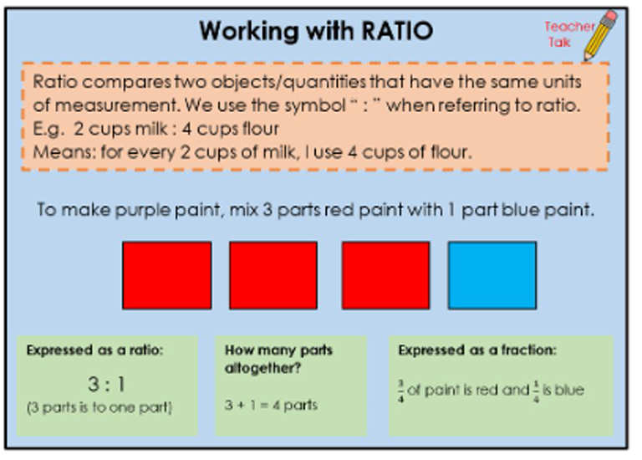

Here is the teacher's memorandum table with all completed answers filled directly in bold:

Ratio to Fraction Teacher's Memorandum
# | Expressed as a ratio | How many parts altogether? | Expressed as a fraction
1 | 2 : 3 (2 parts red paint to 3 parts blue paint) | 2 + 3 = 5 parts | $\frac{2}{5}$ of paint is red and $\frac{3}{5}$ is blue
2 | 1 : 4 (1 part apple juice to 4 parts water) | 1 + 4 = 5 parts | $\frac{1}{5}$ of drink is apple juice and $\frac{4}{5}$ is water
3 | 5 : 2 (5 parts boys to 2 parts girls) | 5 + 2 = 7 parts | $\frac{5}{7}$ of group is boys and $\frac{2}{7}$ is girls
4 | 3 : 5 (3 parts milk to 5 parts flour) | 3 + 5 = 8 parts | $\frac{3}{8}$ of mixture is milk and $\frac{5}{8}$ is flour
5 | 7 : 3 (7 parts sand to 3 parts cement) | 7 + 3 = 10 parts | $\frac{7}{10}$ of concrete is sand and $\frac{3}{10}$ is cement

Here are 3 sets of questions formatted as a teacher's memo table, covering each of the 3 question types shown in the image:

Type 1: Given a part-to-part ratio, find the missing quantity (Set A)
# | Question | Student Box | Memorandum / Answer Key
1.1 | To make purple paint, mix 3 parts red paint with 1 part blue paint. How much red paint (in $ml$) would you need if you already have $200\text{ ml}$ of blue paint? | Answer = [ ] $ml$ red paint | $600\text{ ml}$ ($200\text{ ml}×3$)
1.2 | To make orange paint, mix 4 parts yellow paint with 1 part red paint. How much yellow paint (in $ml$) would you need if you already have $150\text{ ml}$ of red paint? | Answer = [ ] $ml$ yellow paint | $600\text{ ml}$ ($150\text{ ml}×4$)
1.3 | To make green paint, mix 2 parts blue paint with 5 parts yellow paint. How much yellow paint (in $ml$) would you need if you already have $300\text{ ml}$ of blue paint? | Answer = [ ] $ml$ yellow paint | $750\text{ ml}$ ($300\text{ ml}÷2=150\text{ ml}$; $150\text{ ml}×5$)
Type 2: Scaling up the base ratio with a larger starting amount (Set B)
# | Question | Student Box | Memorandum / Answer Key
2.1 | How much red paint (in $ml$) would you need if you already have $600\text{ ml}$ of blue paint? (Using the 3 parts red to 1 part blue ratio) | Answer = [ ] $ml$ red paint | $1 800\text{ ml}$ ($600\text{ ml}×3$)
2.2 | How much yellow paint (in $ml$) would you need if you already have $500\text{ ml}$ of red paint? (Using the 4 parts yellow to 1 part red ratio) | Answer = [ ] $ml$ yellow paint | $2 000\text{ ml}$ ($500\text{ ml}×4$)
2.3 | How much yellow paint (in $ml$) would you need if you already have $800\text{ ml}$ of blue paint? (Using the 2 parts blue to 5 parts yellow ratio) | Answer = [ ] $ml$ yellow paint | $2 000\text{ ml}$ ($800\text{ ml}÷2=400\text{ ml}$; $400\text{ ml}×5$)
Type 3: Scaling down a batch total for fewer items (Set C)
# | Question | Student Box | Memorandum / Answer Key
3.1 | You have mixed $400\text{ ml}$ of blue paint with $1 200\text{ ml}$ of red paint and this is enough to paint 2 walls. How much red paint (in $ml$) will you need if you only want to paint 1 wall? | Answer = [ ] $ml$ red paint | $600\text{ ml}$ ($1 200\text{ ml}÷2$)
3.2 | You have mixed $500\text{ ml}$ of milk with $1 500\text{ ml}$ of water to make enough juice for 5 jugs. How much water (in $ml$) will you need if you only want to make 1 jug? | Answer = [ ] $ml$ water | $300\text{ ml}$ ($1 500\text{ ml}÷5$)
3.3 | You have mixed $600\text{ ml}$ of oil with $1 800\text{ ml}$ of vinegar to make dressing for 4 salads. How much vinegar (in $ml$) will you need if you only want to make 1 salad? | Answer = [ ] $ml$ vinegar | $450\text{ ml}$ ($1 800\text{ ml}÷4$)

