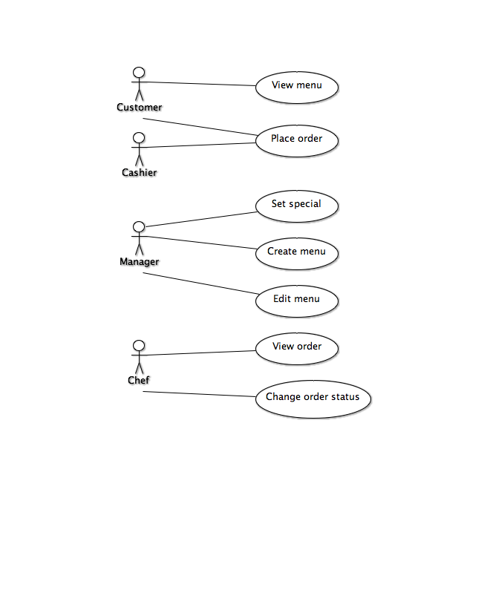

Use Case UC1: View Menu
Scope: Pizza Shop Management Subsystem of Pizza Shop Program
Level: user goal
Primary Actor: Customer
Stakeholders and Interests:
- Manager: Wants the full menu to be easily accessible by a customer
- Customer: Wants to see what they can order
- Chef: Want the customer to only order what he/she is capable of preparing
- Cashier: Wants orders to be things that are actually on the menu
Preconditions: The kiosk is on and functional and a menu is not currently displayed on the kiosk.
Postcondition: The customer was able to view the menu and now is able to continue with placing an order.
Main Success Scenario:
1. A customer opens the restaurant’s menu from the kiosk
2. The kiosk displays the menu contents
3. The customer closes the menu
Technology and Data Variations List:
There should be either a keyboard and mouse with a normal display or touch screen to navigate menus.
Frequency of Occurrence: From zero to many times per day.
Open Issues:
Use Case UC2: Place Order
Scope: Pizza Shop Management Subsystem of Pizza Shop Program
Level: user goal
Primary Actor: Customer and Cashier
Stakeholders and Interests:
- Manager: Wants the customers to be able to place orders
- Customer: Wants to place orders easily and accurately
- Chef: Wants orders to be place accurately
- Cashier: Needs to place the order given to him/her from the customer.
Preconditions: The kiosk is available.
Postcondition: The order has been placed
Main Success Scenario:
1. A customer or cashier initiates the order process in store from a kiosk.
2. The initiator selects the food they want to order.
3. Once finished the system will display a success message with order total.
4. Payment is accepted into the system.
5. System generates a receipt.
Extensions:
Step 2: A customer can open up the menu while filling out their order.
Step 4: Customer cannot pay, cancel the order.

Technology and Data Variations List:
There should be either a keyboard and mouse with a normal display or touch screen to navigate menus and place the order.
Frequency of Occurrence: From zero to many times per day.
Open Issues:

Use Case UC3: Set Special
Scope: Pizza Shop Management Subsystem of Pizza Shop Program
Level: user goal
Primary Actor: Manager
Stakeholders and Interests:
- Manager: Wants to create the specials of the day without much hassle and preferably with speed.
- Customer: Wants to take advantage of specials of the day as they ought to be cheaper or more varied than the usual items.
- Chef: Needs to know what goes into each special of the day so that it can be prepared properly. Assumes specials will be popular and can keep those ingredients on hand, needs to inform manager if those ingredients are out.
- Cashier: Needs to know the price to charge for the special of the day.
Preconditions: The manager has identified themselves to the system and is authorized.
Postcondition: The special of the day has been set and priced accordingly.
Main Success Scenario:
1. The manager prompts the system to create a special.
2. The system presents the manager with a list of possible foods to make special (pizza, soda, soup, breadsticks, etc).
3a. Manager selects to create a pizza.
1. System presents the crusts that can be selected.
2. Manager selects a crust for the pizza special.
3. System presents the sauces for selection.
4. Manager selects a sauce for the pizza special.
5. System presents the toppings available.
6. Manager selects toppings to place on the pizza.
7. System asks if non-pizza items will be part of the special.
8a. Manager selects yes.
1. System goes to 3b.
8b. Manager selects no.
1. System goes to step 4.
3b. Manager selects a non-pizza item for special.
1. System presents the non-pizza items for special.
2. System presents items available for special.
3. Manager selects items to make part of the special.
4. Manager confirms and the special is set.
5. System asks for manager to enter price.
6. Manager enters price.
7. System shows price and asks if any changes are to be made.
8a. Manager confirms price and items are final.
8b. Manager selects to change price.
1. System goes to Step 6.
8c. Manager selects to alter special.
1. System goes to Step 3a or 3b as is appropriate for special type.
9. System requests special to be named.
10. Manager enters special name.
11. System confirms name is as desired.
12a. Manager selects yes.
1. System goes to 13.
12b. Manager selects no.
1. System goes to 10.
13. System exits set special.
Extensions:
*a. Manager wants to quit without setting the special.
1. Manager requests to quit set special menu.
2. System confirms exit.
3a. Manager confirms.
3b. Manager does not confirm.
1. System returns to previous location in main flow.
4. System exits set special.
Special Requirements:
Manager must have a means of viewing in stock items so that all specials are viable.
Technology and Data Variations List:
There should be either a keyboard and mouse with a normal display or touch screen to navigate menus.
Frequency of Occurrence: From zero to many times per day. There could be multiple specials for a day or none.
Open Issues:

Use Case UC4: Create Menu
Scope: Pizza Shop Management Subsystem of Pizza Shop Program
Level: user goal
Primary Actor: Manager
Stakeholders and Interests:
- Manager: Wants to create the menu to be used by cashiers, customers, and chefs. The manager would like to do so quickly and without difficulty.
- Customer: Wants to know what this particular pizza shop has on its menu.
- Chef: Needs to know what goes into each menu item so that it can be prepared properly.
- Cashier: Needs to know the price to charge for the menu items.
Preconditions: The manager has identified themselves to the system and is authorized.
Postcondition: The menu has been created and made available for viewing by cashiers, chefs, and customers.
Main Success Scenario:
1. The manager prompts the system to create a new menu.
2. The system presents the items which can be a part of the menu.
3. The manager selects what item type they want to add to the menu.
4. System prompts for a name.
5. Manager enters name for the menu item.
6. System prompts for a price.
7. Manager enters the price for the item.
8. System asks for confirmation.
9. Manager confirms.
10. System exits.
Extensions:
*a. Manager selects pizza as a menu item.
1. System presents the crusts that can be selected.
2. Manager selects a crust for the pizza special.
3. System presents the sauces for selection.
4. Manager selects a sauce for the pizza special.
5. System presents the toppings available.
6. Manager selects toppings to place on the pizza.
*b. Manager wants to remove an item from the menu in creation.
Handled in main flow of Edit Menu Use Case.
*c. Manager wants to quit without creating new menu.
1. Manager selects to quit.
2. System prompts for confirmation.
3a. Manager confirms.
1. System exits Create Menu flow and returns to previous state.
3b. Manager cancels the quit.
1. System returns to previous state in Create Menu Use Case.
Special Requirements:
Manager must have a means of viewing in stock items and ingredients in order to create the menu.
Technology and Data Variations List:
There should be either a keyboard and mouse with a normal display or touch screen to navigate menus.
Frequency of Occurrence: Rare, should be done initially and perhaps again if a pizza shop completely alters its menu items.
Open Issues:

Use Case UC5: Edit Menu
Scope: Pizza Shop Management Subsystem of Pizza Shop Program
Level: user goal
Primary Actor: Manager
Stakeholders and Interests:
- Manager: Wants to edit the menu to be used by cashiers, customers, and chefs. The manager would like to do so quickly and without difficulty and be able to add, delete, or alter items.
- Customer: Wants to know what this particular pizza shop has on its menu at the current time, needs to be able to view an edited menu not just the old one.
- Chef: Needs to know what goes into each menu item so that it can be prepared properly and what items are on the menu at the current time.
- Cashier: Needs to know the price to charge for the menu items.
Preconditions: The manager has identified themselves to the system and is authorized.
Postcondition: The manager was able to edit the current menu by adding, deleting, or altering an item. The new menu is propagated through the system for use by cashiers, chefs, and customers.
Main Success Scenario:
1. The manager requests to edit the current menu.
2. System displays the current menu and an option to add menu item.
3a. Manager chooses to edit a current menu item.
1. System displays properties of item to edit.
2. Manager chooses which property to edit (including adding topping for pizza).
3. System prompts for new value or deletion.
4. Manager enters new value or deletes.
5. System asks for confirmation.
6. Manager confirms.
3b. Manager chooses to add a menu item.
1. The manager selects what item type they want to add to the menu.
2. System prompts for a name.
3. Manager enters name for the menu item.
4. System prompts for a price.
5. Manager enters the price for the item.
6. System asks for confirmation.
7. Manager confirms.
4. System asks if editing is complete.
5. Manager confirms.
6. System exits Edit Menu Case.
Extensions:
*a. Manager selects pizza as a menu item.
1. System presents the crusts that can be selected.
2. Manager selects a crust for the pizza special.
3. System presents the sauces for selection.
4. Manager selects a sauce for the pizza special.
5. System presents the toppings available.
6. Manager selects toppings to place on the pizza.
*c. Manager wants to quit without creating new menu.
1. Manager selects to quit.
2. System prompts for confirmation.
3a. Manager confirms.
1. System exits Edit Menu flow and returns to previous state.
3b. Manager cancels the quit.
1. System returns to previous point in Edit Menu Use Case.
Special Requirements:
Manager must have a means of viewing in stock items and ingredients in order to create the menu.
Technology and Data Variations List:
There should be either a keyboard and mouse with a normal display or touch screen to navigate menus.
Frequency of Occurrence: Rare, once every month or so in order to keep the menu fresh and customers looking at the entire menu instead of assuming it never changes.
Use Case UC6: View Order
Scope: Pizza Shop Management Subsystem of Pizza Shop Program
Level: user goal
Primary Actor: Chef
Stakeholders and Interests:
- Manager: Want chef to be able to see the orders easily and accurately to be able to prepare the food efficiently
- Customer: Wants his/her food to be prepared correctly and in a timely fashion
- Chef: Needs to know what the details of each order are in order to prepare the order correctly and in a timely fashion
Preconditions: Order has been placed.
Postcondition: Order is visible on the screen
Main Success Scenario:
- An order is placed by either a customer at a kiosk or a cashier
- The order automatically is displayed to the chef.
Extensions:
1. An order is placed by either a customer at a kiosk or a cashier
2. Order is automatically displayed to chef with a notification (sound)
Technology and Data Variations List:
There should be a display available to the chef
Frequency of Occurrence: Zero to many times daily
Open Issues:

Use Case UC7: Change Order Status
Scope: Pizza Shop Management Subsystem of Pizza Shop Program
Level: user goal
Primary Actor: Chef
Stakeholders and Interests:
- Manager: Want chef to be able to mark the orders as in progress or complete so that the other employees can do their jobs more efficiently and be ready to take the order to the customer
- Customer: Wants his/her food to be prepared correctly and in a timely fashion
- Chef: Wants to be able to mark orders as complete so that it is easier to see what is left to be done
Preconditions: Order has been placed and is displayed.
Postcondition: Order is complete and no longer displayed on the screen.
Main Success Scenario:
1. Chef sees the order on the screen
2. Once the chef starts on the order, the order is marked as 'in progress'
3. Once the order is complete, the order is marked as complete and removed from the chef's view on the screen
Technology and Data Variations List:
There should be a display available to the chef with buttons or some way to mark the order as either 'in progress' or 'complete'
Frequency of Occurrence: Zero to many times daily
Open Issues:

