NIST2Stout

# Setting up files:

## NIST Levels File:

Go to the [NIST Atomic Spectral Database](http://www.nist.gov/pml/data/asd.cfm).

Click “Levels”

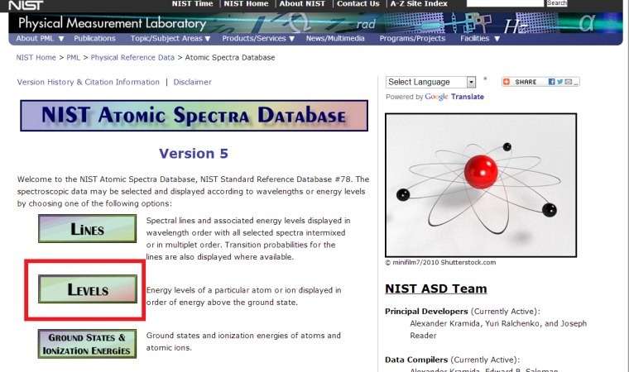

Input the spectrum you are looking for and set the parameters as shown to the right.

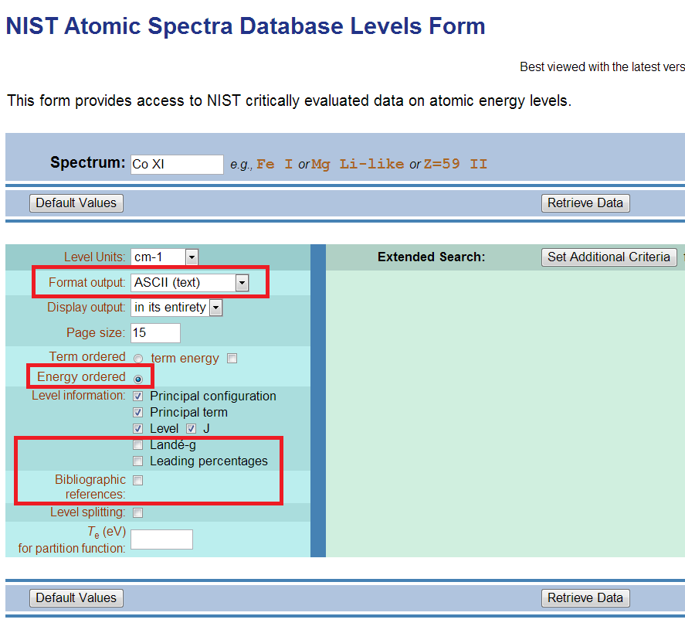

The results columns should look like this:

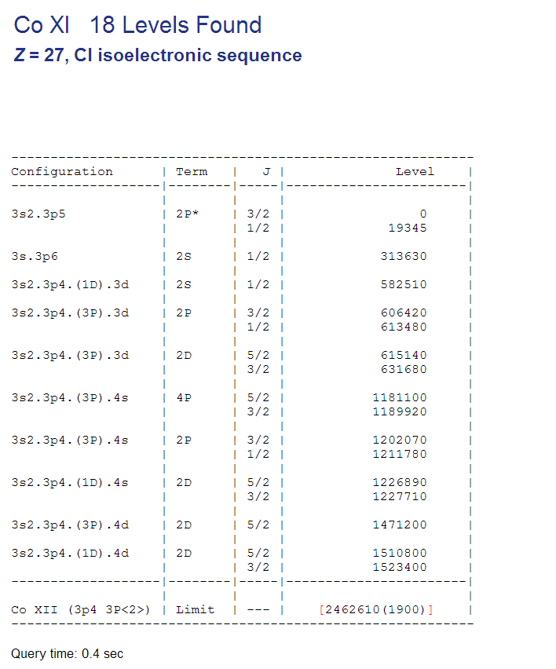

Higlight the levels you want to include and copy them to the clipboard.

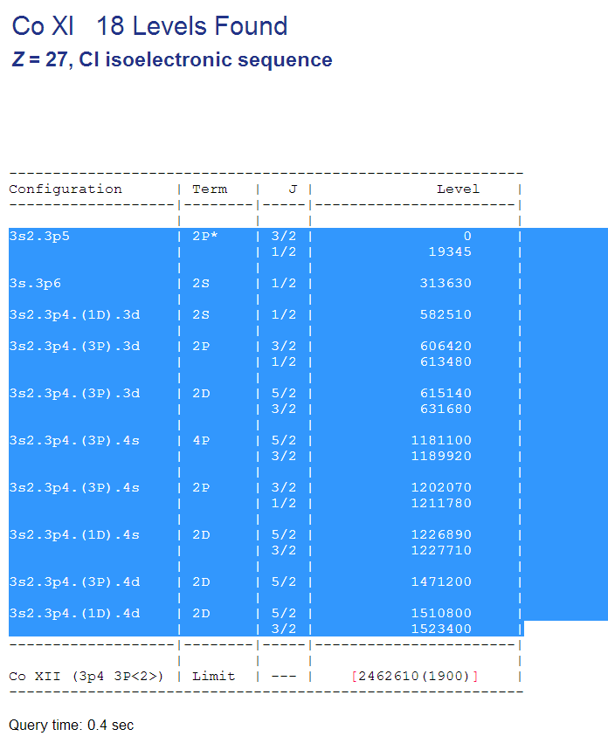

Paste the contents into an empty text file. The name of the file should be X.NIST.txt, where X is whatever you want the base output name to be.

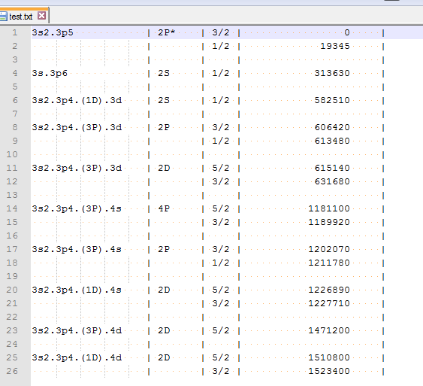

## 1.2 NIST Lines File:

Go to the Lines section of the NIST Atomic Spectral Database

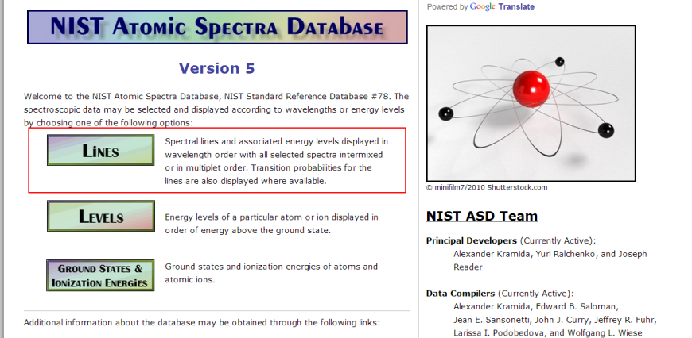

Enter the spectrum to match the levels file and edit the following parameters

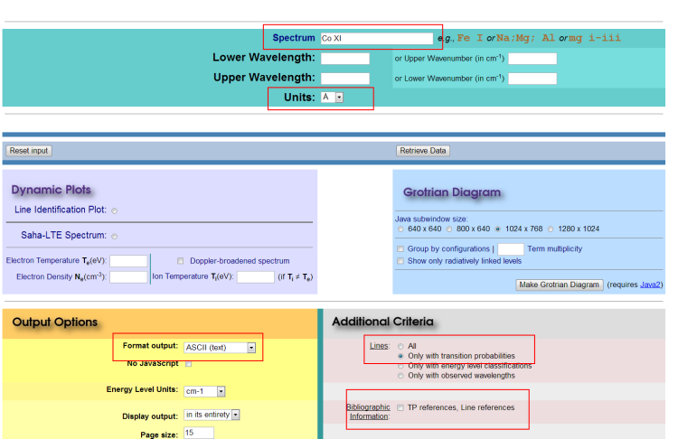

Continue to edit parameters on the Line form

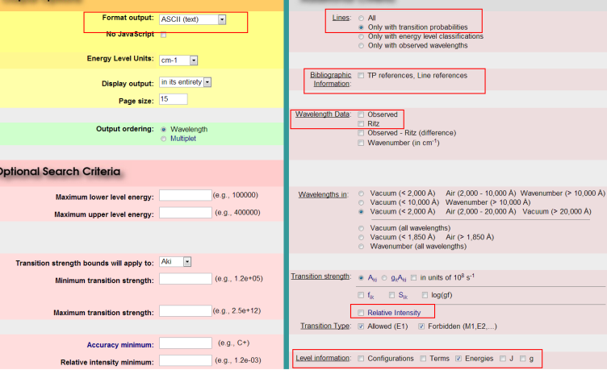

Select the lines and copy them to the clipboard.

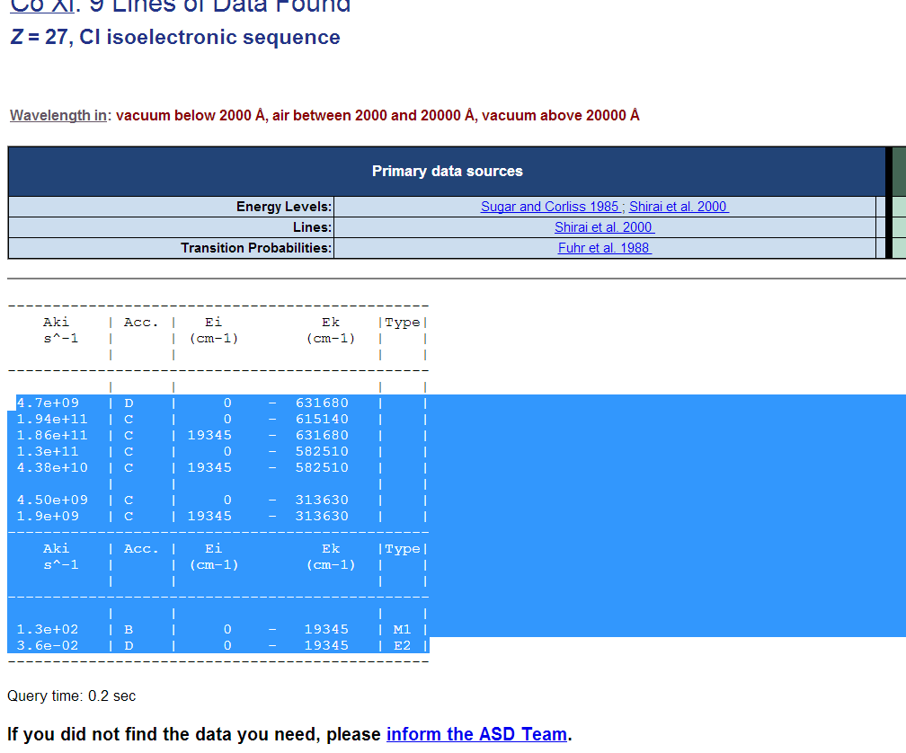

Paste the line data to a blank text file. Name the text file X.tp.NIST.txt where X is the same base name used for the level file.

# 2. Running the script:

The program has 2 parts, nist2stout.py and n2sWrapper.py. The program can be run for one species with nist2stout.py or in a batch mode with n2sWrapper.py.

## 2.1 Running for a Single Species:

Running the program for a single species has a simple syntax. From the command line enter nist2stout.py <name of level file> <name of line file>. The code will run and you will end up with X.nrg.txt and X.tp.txt.

## 2.2 Running as a Batch:

Consider this directory structure:

<Base>

<Ar>

ar_2.nist.txt

ar_2.tp.nist.txt

<Be>

be_3.nist.txt

be_3.tp.nist.txt

be_4.nist.txt

bet_4.tp.nist.txt

You can automatically run NIST2Stout on all of these species by copying nist2stout.py and n2sWrapper.py to the Base directory. Then execute n2sWrapper.py with no other parameters. The code will go through all subdirectories looking for matching pairs of level files (X.nist.txt) and line files (X.tp.nist.txt). For each pair it finds, it will execute nist2stout.py as in described in Section 2.1. The Stout formatted files should end up in the same directories as the NIST source files for that species.

# 3. Gotchas and Troubleshooting:

* Make sure that all of the levels necessary to reference the transitions in the lines file (X.tp.nist.txt) are included in the levels file (X.nist.txt).
* Make sure that you have all of the necessary columns (and no others) included in the levels and lines files.