Number of readings at each point in the floorplan
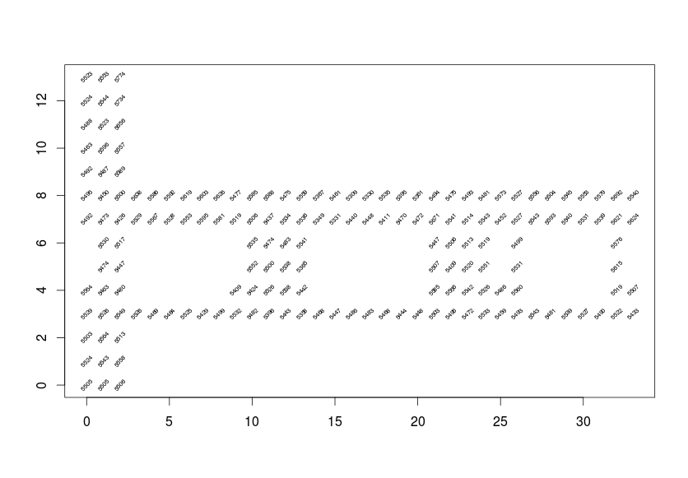
Smoothscatter plot Mean signal strength – median signal strength vs number of observations to check skew as a function of number of samples. The proximity of the 'skewness plot' to zero shows distributions of signal strengths is relative symmetrical with respect to location and is not a function of the number of observations.

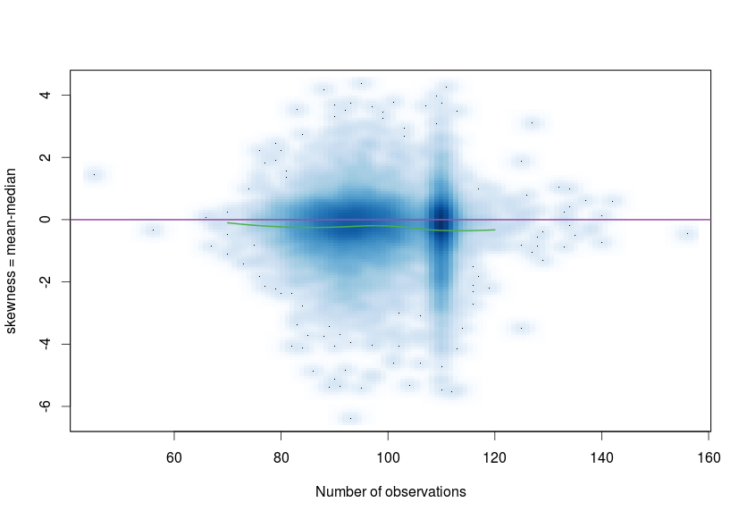

Thin plate spline model for signal mean signal strength at each access point fo a single fixed orientation value. Used to map mac addresses to locations in floor plan and visualise the decay of the signal as a function of distance.
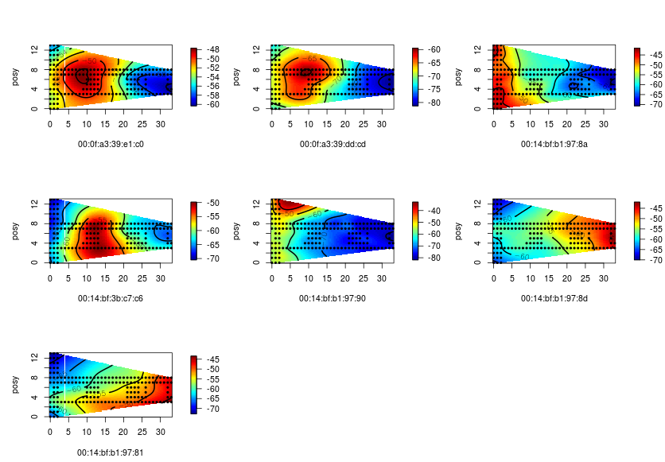

Selection of signal vs distance tiled by mac and angle (not show on charts). Linear regression lines superimposed to visualise utility of non-linear transformation of dependant variables.
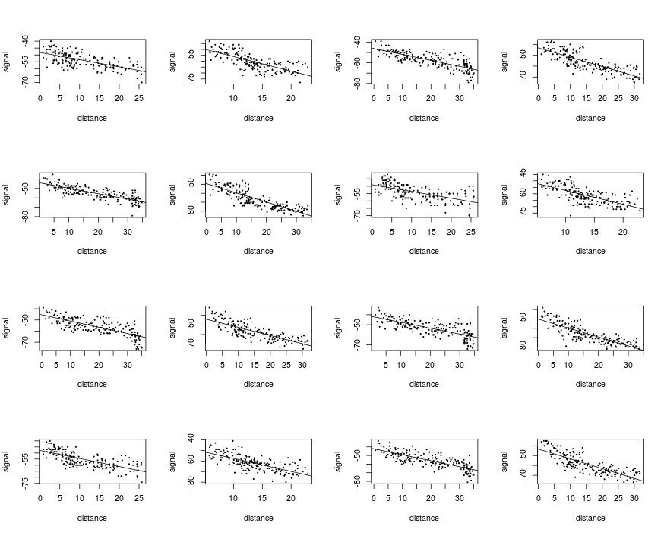

Estimates on training data of k=3 nearest neighbour estimates of device location. Circles show the actual location and point at end of line shows corresponding estimate.
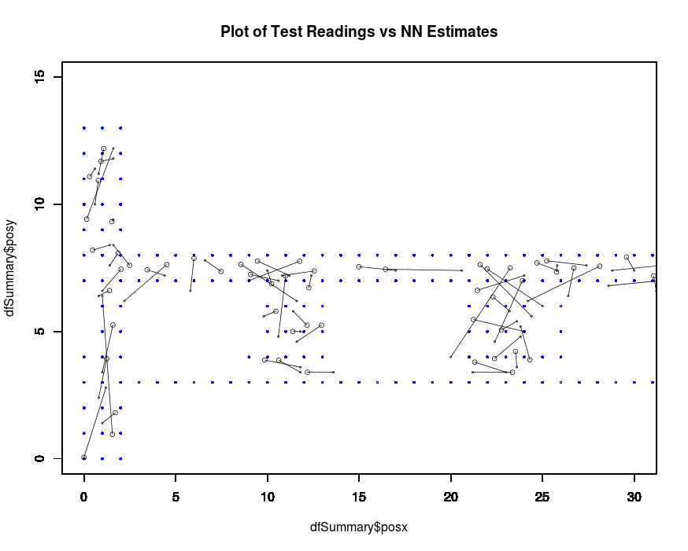

Cross validation plots for multiple runs. The selection of folds is based on random sampling of the training set and so each run of the CV analysis produces different results. Three runs are shown below. 11 folds use to create the charts. K=5 was chosen as the final value.
