The SGOMS Modeling Process
Matt Martin
Summer, 2015

This document is meant to provide some guidelines on how to go about creating and evaluating SGOMS models of an expert task. These steps come from the experience of working on a model of Gears of War 3 play, described briefly in A Method for Building Models of Expert Cognition in Naturalistic Environments, as well as in more detail in my honours thesis: Battling Aliens for Science: New Methods for Creating and Evaluating Models of Expert Cognition in Chaotic Simulated Environments. I describe the process we used for creating the model and evaluating it using video annotation software. There are probably better ways of getting the same results; this document provides one way of doing it that works.

First I describe how the model is created and eventually represented in a digital format. Then, I describe how a model is evaluated using Anvil annotation software.

Creating the Model

Model building usually takes the form of an iterative process of data gathering and model modification. Most SGOMS models are interested in the unit task / planning unit level of task analysis. This means that the relevant data is related to observable units of work that are not likely to be interrupted (the unit task), and groups of unit tasks which commonly occur together (the planning unit; see West & Nagy (2007) for more information about unit tasks and planning units).

As a quick reference:

Unit Tasks:
- Non-interruptible (should be islands of work that can be accomplished in one go)
- Avoid down time (avoid requiring waiting long for environmental info before firing)
- Avoid overload (can’t be too big or complex to be accomplished by the system)
- Procedurally driven (difficult to change or suppress consciously, hard to stop once initiated)

Planning Units:
- Can be interrupted
- Consist of lists of unit tasks (which can be in a specific order or unordered)
- Usually have terminology or names given to them by the expert community for easier communication (i.e., common ground).
- Are driven by declarative memory and based in constraint-based decision making.
- Can be modified consciously (e.g., can choose not to engage in certain unit tasks)

Data Gathering and Creating Preliminary Models
Data about expert tasks usually comes in the form of: documentation such as manuals and how-to guides for various procedures, field observation (including video/audio recording), and semi-structured interviews with experts. If access to experts is limited, it is probably best to start creating a model using existing documentation, leaving field observation and interviews until a largely completed model is in place. In my case, access to experts was not an issue (since I was one of the experts), so field observations consisting of analysing myself or others playing Gears of War 3 was a frequent occurrence.

Data gathering and creating/editing models happen in an iterative and cyclical manner. Generally, the first thing to do is to create a list of unit tasks involved in the task. That is, create a list of meaningful units of work that can be done with little risk of interruption and which avoid overload and down time. Doing this on paper works fairly well at the beginning stages. West and Nagy (2007) used a technique where they wrote down the name of each unit task and stuck them up on a wall. This allowed them to re-order and change unit tasks as they were creating their model of network administrators.

Once you get an idea of what the unit tasks are and how they fit together, you can begin to assign unit tasks to planning units. The same unit task can be reused in multiple planning units. Creating a paper and pencil model with the names of planning units and unit tasks has been done in the past, or one can create preliminary models using SGOMS GUI.

Creating the Process Model Using SGOMS GUI

SGOMS GUI is a useful tool for creating SGOMS models. It allows you to specify the firing conditions and behaviours of each unit task and planning unit. This is especially useful for creating later models with greater specificity than simple paper and pencil versions.

A number of technical hurdles have to be passed before SGOMS GUI can be used.

Downloading and Installing SGOMS GUI (and Getting Jython to Work)

SGOMS GUI is a piece of in-house software designed for creating SGOMS models that can be implemented in ACT-R. The latest version is version 1.5. It can be downloaded from: https://github.com/mattmartin256/SGOMS_GUI

SGOMS GUI is written in Jython and thus needs a Jython interpreter to run. I use an Eclipse plug-in for this called PyDev. You should download the latest stable version of Jython from the Jython website: http://www.jython.org/ (as of July 2015, this is v. 2.7). After downloading, you need to set up PyDev.

Here is a link to an online tutorial on how to set up PyDev with Eclipse so that it will run Jython code: http://www.jython.org/jythonbook/en/1.0/JythonIDE.html . It should have all the instructions you need to get Jython working. (You may need to adapt the instructions somewhat depending on the exact version of Jython you are using).

* Troubleshooting note: There have been some issues in the past about some versions of Jython not correctly importing certain Java modules related to loading/saving. This appears as a runtime error in the Eclipse console related to some import statements at the top of the code. Also, if this error occurs, the save/load functions won’t work. If this is an issue, you may have to use a different version of Jython. Version 2.5.4rc should work, as should version 2.5.3. Download the alternative version of Jython and keep track of where you save it. Simply follow the instructions of the tutorial above, but swap in the alternative version of Jython you just downloaded.

Once you get Jython set up, you can download or copy/paste the latest version of SGOMS GUI into a new PyDev project and run it.

How to Use SGOMS GUI

A complete how-to guide for SGOMS GUI can be found at https://github.com/mattmartin256/SGOMS_GUI/

Essentially, SGOMS GUI is meant to be a way of representing SGOMS models digitally. The firing conditions and behaviours of the planning units and unit tasks can be specified, making more detailed models possible. The firing conditions and behaviours of the unit tasks and planning units can be specified at the level of ACT-R syntax, or they can be described in a higher-level language such as Python pseudo-code or natural language. It is up to the modeler to determine how the firing conditions and behaviours of the model are specified. This depends on what sort of functionality one wants from the model.

For my thesis, the firing conditions of each planning unit and unit task were described in an ACT-R-esque pseudo-code that described the firing conditions in terms of changes to a theoretical ‘context buffer’ of an ACT-R model. For example, a firing condition of the ‘reload’ unit task was buffer_context = agent:gun_ammo_low. The behaviours of each unit task were described at a higher level such as “agent reloads”. The idea behind this was that we wanted a mechanistic way of making predictions about what an agent would do in a given context. This required a highly specific way of describing the context and firing conditions of the model. The behaviours were merely a means of describing the actions of an agent performing a particular unit task, which could be verified ‘by eye’ by the annotator. The context was updated manually by the annotators, so there was no particular need for behaviours to be specified at the level of ACT-R in the model. This way of doing things can be modified depending on the needs of the modeller.

How to Create the Situation Awareness Model

The situation awareness (SA) model is based on the process model created via SGOMS GUI. The SA model specifies every possible state of the context that can be represented. Its main function is to serve as a reference for the annotators when they are describing the context. The SA model is described in a bit more detail in the method section of my thesis Battling Aliens for Science...

For my thesis, the SA model was based entirely in the firing conditions of the planning units and unit tasks of the process model (i.e., the model built in SGOMS GUI that describes planning units, unit tasks, their firing conditions and behaviours). Every state of the context mentioned in the firing conditions (not behaviours) of the planning units and unit tasks was transcribed into a text file. This text file was created by manually copy/pasting the firing conditions from the GUI representation of the process model to the SA text file (by right-clicking on each unit task and clicking ‘edit node’). Furthermore, in cases where the variables mentioned were not exhaustive, the SA model was ‘filled in’ in order to be able to represent every state of the context. For example, if the state of the agent having ‘low health’ was part of the firing conditions of a unit task, but the state of having ‘high health’ was not mentioned in any of the firing conditions of any unit task, the state of ‘high health’ (or ‘not low health’ - it doesn’t really matter so long as every state is covered) was added to the SA model. This is so that the condition of not having low health could be represented in the context. This ‘filling in’ process was done merely for the sake of convenience for the annotation process. It allowed for easy copy/pasting of a consistent set of context variables into each time slot on the Anvil annotation. This is opposed to manually adding or removing relevant or irrelevant elements of the context whenever they appear. Experience showed that having to manually add or subtract elements of the context took a long time and was a source of human error. Having a consistent template to copy/paste and modify was less problematic.

An example of a ‘filled in’ working SA model can be found at: https://github.com/mattmartin256/SGOMS_Models/blob/master/SA%20Model_v.7b_GOW_SGOMS.txt

Evaluating the Model with Video Annotation

We use Anvil annotation software to analyse collected videos. This is done during the model evaluation phase to compare how well the model fits the video data. A number of hurdles have to be overcome before one can annotate using Anvil.

Downloading and Installing Anvil

Anvil can be downloaded from this site: http://www.anvil-software.org/download/index.html
Following the instructions on the Anvil website should let you download and install Anvil successfully. *Note that once Anvil is installed, simply double-click the ANVIL.BAT file to run the program.

Converting the Videos to an Appropriate Format

Anvil only supports a limited number of file types and codecs for playback. Check out the Anvil FAQ for a list of the supported codecs: http://www.anvil-software.org/#codecs

Most of the time, you will need to use conversion software to convert the video your camera took into an acceptable Anvil format. I will describe once of software I have used to convert .MOV files to a useable Anvil format. I will also briefly describe the progress I made towards converting .AVI files to the correct format, although I have not been successful in this endeavour.

Converting .MOV Files to the Right Format

If your unconverted video is of the .MOV type, follow these instructions to get Anvil to play it:
Download and install MPEG Streamclip.

Once running, open the file you want to convert by selecting:
File: Open Files

*The video should be playable in the main window. If not, you may need to use different software to convert the video (try the .AVI software listed below, and if that does not work, you’re on your own).

Select:
File: Export to Quicktime

A new window should appear:

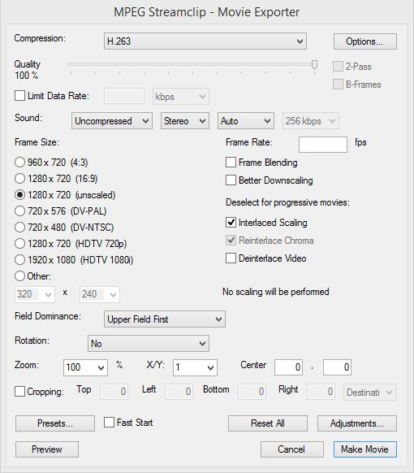

For the “Compression” selector, choose H.263.

Slide the “Quality” slider to 100% (yes it can be moved).

The rest of the options can be left alone (try to copy how it looks in the picture above). You can experiment with different settings, but I have found that these ones work ok.

Press the “Make Movie” button in the bottom right.

Select a save location and filename (it is good practice to indicate that the file is in H.263 format in the filename).

The exported .MOV file should be playable in Anvil.

Converting .AVI Files to the Right Format

I have not gotten this process to work yet, but here’s what I know:

The Anvil FAQ recommends software such as VirtualDub for converting .AVI files. From my experience .H263 seems to be the best codec to use with Anvil. If I were you, I would look up tutorials for how to use VirtualDub to convert to .H263 codec. I have had very little luck following the various tutorials online, but they would probably be the best place to start. I found that VirtualDub would often crash for unknown reasons, or the converted file would crash Anvil, or there would be an error etc. For testing purposes, take a 5-sec video to use as your test file, since it can take hours to convert larger videos (and leave you frustrated when it doesn’t work after two hours of converting). Also, make a copy of your original video and test the conversion software on the copy, not on the original.

Your best course of action is likely to try to get VirtualDub to work, since Anvil recommends it and it is apparently the go-to tool for editing .AVI files. Spend some time learning how to use the software, find some good tutorials (I can’t recommend any, since none of them worked for me), and be prepared for lots of trial and error. I wouldn’t move on to different software until you’re pretty sure that VirtualDub is a no-go, since you’ll need to invest a lot of time in any software you use. The ‘shotgun’ approach has not been effective for me.

Alternatively, there is a command-line video conversion tool called FFMPEG that can apparently handle any kind of conversion. I have not figured out how to use this tool effectively, since it is command-line based and the documentation is not clear to me. There are a number of third-party GUI front-ends to FFMPEG that are available for free. Again, I have not figured out how to use these tools effectively to convert .AVI files. XMedia Recode seems like a promising tool, but again, I have not gotten it to work. Beware that figuring out these tools is a serious time-sink, so if you can avoid the problem in the first place by taking a .MOV file, it’s probably your best bet.

Working with Specification Files

If you haven’t done so already, I would recommend spending some time watching the Anvil tutorial videos to get an idea of how Anvil annotation works: http://www.anvil-software.org/# . This will make the rest of what I’m about to say make more sense.

The annotation process is currently under development and will likely be different for each project. Anvil annotations consist of a series of tracks that encode a set of information about the video. Each track can be of a different type (e.g. a ‘primary’ type track, or a ‘subdivision’ track). The different track types have different functions that can be useful for different purposes. Every Anvil annotation file requires a specification (aka spec) file that encodes what each track is, what its type is, as well as other information such as the types of unit tasks or planning units there are, etc. Anvil saves information about the filled-in annotation file as a .anvil file.

An example of a filled-in working .anvil file can be found at: https://github.com/mattmartin256/SGOMS_Annotations . Use the file: Annotation_K,Checkout,Wave5 - MVI_0383.anvil as a working reference. The corresponding specification file is: SGOMS SPEC model v7i Failure5.xml . The corresponding video is: K,Checkout,Wave5 - 2015.01.07 - MVI_0383(H263) - Attempt2.mov . It will be useful to have the file open in order to have a reference that you can also play around with. The .anvil and .xml files are available on the GitHub link above. The videos are not online - you have to get it from the CCM lab. As of September 2015, there is a copy of each video on the AlienWare computer.

We will cover the basics surrounding how to add a new track, and how to specify a new set of values to the new track.

How to Create New Tracks in Anvil

This brief tutorial will show you how to create a new track in the Anvil specification (spec) file. It will not cover how to edit those tracks (that is in another tutorial further below). Following these instructions will result in a newly created track in the spec file that can later be edited.

To add a new track to an Anvil spec file:

In the main Anvil window toolbar, click:
Edit: Edit specification

A new Specification Editor window should appear.

In the leftmost panel of the new window, under “Tracks”, there should be clickable “Specification” field. Click on Specification to select it.

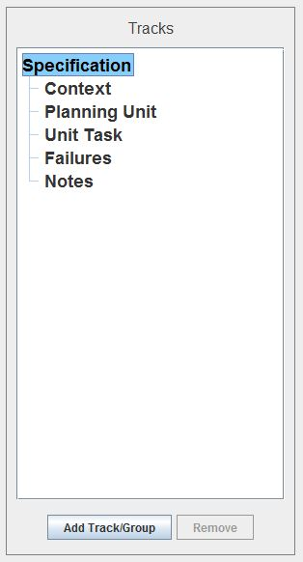

The button “Add Track/Group” should now become clickable. Click on it.

Select the “Add Track” option.

Give the track a name, and select the track type (primary is fine for most purposes).

You can move the order of the tracks by selecting a track, right clicking on it, and selecting “Move up” or “Move down”.

Save the spec file (optionally with a new name) by clicking:
File: Save specification (or Save specification as), in the toolbar of the Specification Editor Window.

After you have created the tracks you want, and saved the modified spec file somewhere, close the Specification Editor window.

***Anvil will not have automatically updated which spec file is being used in the current annotation (it will default to using the original specification selected when you opened the annotation file). You need to update which spec file the annotation points to in order to see the new tracks you just created. In the main Anvil toolbar, select:

Edit: Annotation properties

Select the spec file you want to use (i.e. the new one you just created).

Save the .anvil file (optionally with a new name) so that the new spec file is associated with the annotation.

Reopen the anvil file by clicking:
File: Reopen

The newly created track(s) should now be visible in the annotation timeline.

How to Set New Values for the Track

In the main Anvil window toolbar, click:
Edit: Edit specification

A new Specification Editor window should appear:

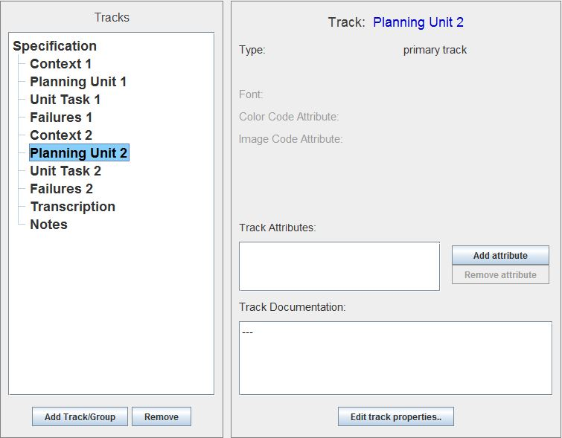

In the leftmost panel of the new window, under “Tracks”, there should be a set of tracks under the “Specification” field. Click on one of these tracks to select it.

Now click on the “Add Attribute” button in the middle panel.

A new dialog box should appear after clicking on the “Add attribute” button:

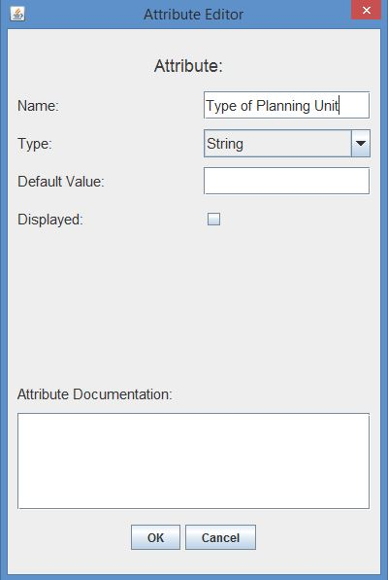

Give your attribute a name such as “Category” or “Type of Planning Unit”.

The Default Value and Displayed options can be left blank for now.

For the “Type” dropdown menu, select “ValueSet (Define New)”

A new dialog box will appear:

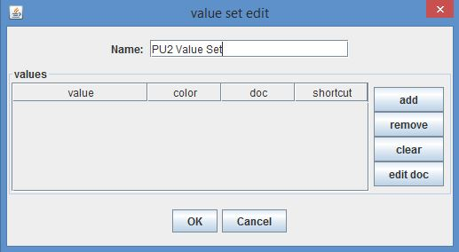

Give your value set a unique name.

Click the “add” button on the right.

A window will appear asking you to provide the name of the value. Input the name of the planning unit, such as “Defend position”.

Once the name is added, it will appear in the list of values. You can change the colour of the value by clicking on the “colour” column next to the value name. Add all of the planning units of your model now and give them a unique colour if you want.

*Note, the order of the values cannot be changed once they are put in. Make sure you add the planning units in the order you want them to appear (first one put in remains at the top).

Once you have defined your new value set, and pressed “OK”, you will be put back to the “Attribute Editor” window.
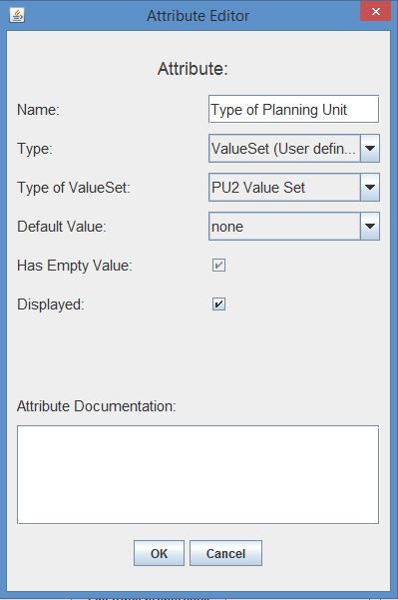

In the “Type of ValueSet” dropdown menu, select the value set we have just created. Leave the “Default Value” as none. The “Displayed” checkbox should be clicked on if you want the colour of the planning unit to show on the track.

Click “OK”

Your newly created attribute should now appear in the “Specification Editor” window:

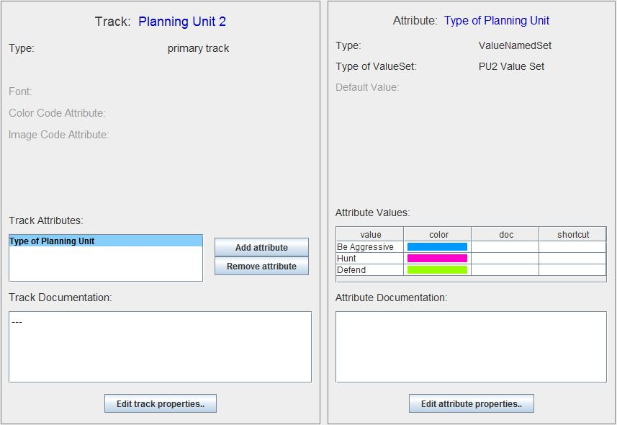

Save your specification file with a new name and close the specification editor window.

***Anvil will not have automatically updated which spec file is being used in the current annotation (it will default to using the original specification selected when you opened the annotation file). You need to update which spec file the annotation points to in order to see the modified tracks you just edited. In the main Anvil toolbar, select:

Edit: Annotation properties

Select the spec file you want to use (i.e. the new one you just created).

Save the anvil file (optionally with a new name) so that the new spec file is associated with the annotation.

Reopen the anvil file by clicking:
File: Reopen

You should now be able to use the track attributes you just created.

*Note: I have not figured out how to edit existing attributes. Usually, if you make a mistake creating an attribute or value set, you have to start from scratch.

Annotating the Video

If you haven’t done so already, I would recommend spending some time watching the Anvil tutorial videos to get an idea of how Anvil annotation works: http://www.anvil-software.org/# . This will make the rest of what I’m about to say make more sense.

The annotation process is currently under development and will likely be different for each project. Anvil annotations consist of a series of tracks that encode a set of information about the video. Each track can be of a different type (e.g. a ‘primary’ type track, or a ‘subdivision’ track). The different track types have different functions that can be useful for different purposes. Every Anvil annotation file requires a specification (aka spec) file that encodes what each track is, what its type is, as well as other information such as the types of unit tasks or planning units there are, etc. Anvil saves information about the filled-in annotation file as a .anvil file.

You need to have a working specification file before you can start annotating. You can play around with the default spec files provided by Anvil, but usually for an SGOMS project, you need to create a new one for your project. See the above two tutorials on how to do this.

An example of a filled-in working .anvil file can be found at: https://github.com/mattmartin256/SGOMS_Annotations . Use the file: Annotation_K,Checkout,Wave5 - MVI_0383.anvil as a working reference. The corresponding specification file is: SGOMS SPEC model v7i Failure5.xml . The corresponding video is: K,Checkout,Wave5 - 2015.01.07 - MVI_0383(H263) - Attempt2.mov . It will be useful to have the file open in order to have a reference that you can also play around with. The .anvil and .xml files are available on the GitHub link above. The videos are not online - you have to get it from the CCM lab. As of September 2015, there is a copy of each video on the AlienWare computer.

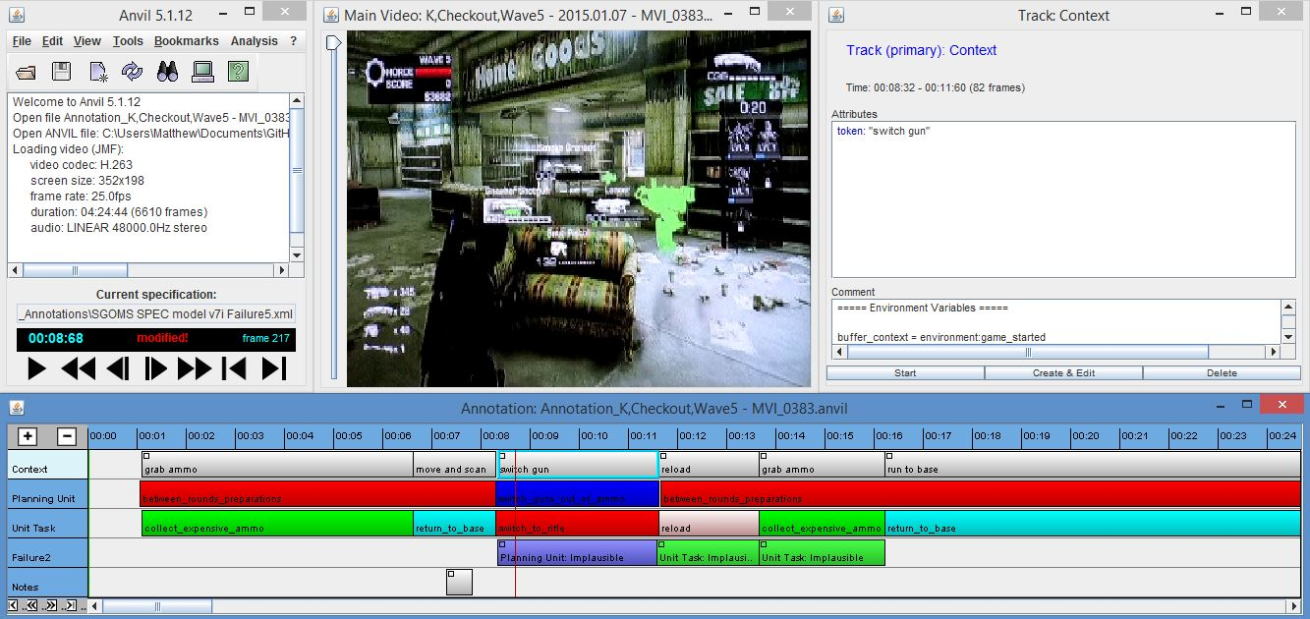

A screenshot showing the entire Anvil screen. The five different tracks can be seen at the bottom of the screen.

For my thesis, we used five different tracks for holding various kinds of information related to the video: a context track, a planning unit track, a unit task track, a failure track, and a notes track. We used the primary track type for each track, which is the most basic track type. Each section of the track was simply filled in ‘by eye’ by the annotator. This means that it was up to the annotator to decide when there was a change in the context or when a unit task or planning unit was taking place in the video. This method has its drawbacks, but can be ameliorated in future iterations of the method. The annotator decides which frame represents something ‘new’ happening (e.g., a change in the context, or a new unit task beginning to be used), and adds a new chunk to the relevant track accordingly. There is a certain amount of arbitrariness in this process that is unavoidable.

The context track was used to contain information related to the context of the scene. At each noticeable change in the context a new section of the context track was created and filled in. Each section of context track was filled in using the situation awareness (SA) model (see above) which specifies every possible way the context can be represented. The state of the context was put into the ‘comments’ section of each section of the context track. A brief description of what is happening at that point in time is also provided in the ‘token’ section of the time slice, although this is not strictly necessary. Every second of relevant video was filled in with a context chunk of some sort (i.e. there were no ‘gaps’ without a corresponding context, although time slices could cover multiple seconds).

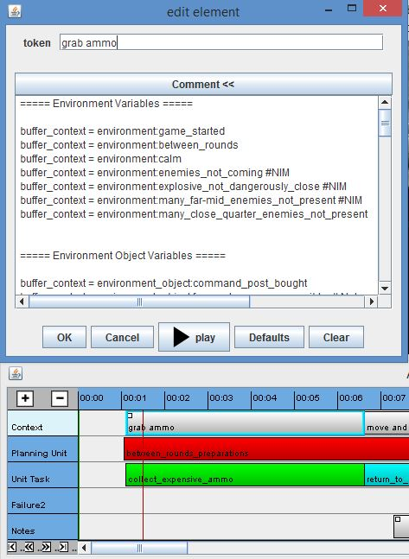

A screenshot of the context track being edited. The state of the context is represented in the comments section of each section of the track.

The planning unit track contains info about the planning unit that is unfolding in the video. For our purposes, providing the name of the planning unit is all the information given in the track. It was assumed that every second of relevant video was covered by a planning unit, so there were no ‘gaps’ between planning units. In the case where the action unfolding in the video could not be identified with a planning unit of the model, the planning unit ‘None’ would fill in the gap, and the gap would be noted in the failure track. Each planning unit specified in the model was given a ‘category’ in the specification file of the annotation (this corresponds to ‘Attribute values’ in the specification file). Each planning unit thus had an ‘Attribute value’ in the specification file so that it could be selected from a drop-down menu whenever a new section of planning unit was created or edited. This is done in the ‘Track Attributes’ section of the ‘Edit specification’ function of the Anvil GUI (see the section Working with Specification Files, above). Selecting the names of planning units from a drop-down list ensures consistency, which aids in the data-extraction process that takes place later.

The unit task track functions in a similar way to the planning unit track. Theoretically, a planning unit contains multiple unit tasks. For our project, there was no explicit way of representing which planning unit a unit task belonged to in the annotation, except for overlapping time codes between the two. The unit tasks and planning units were made to overlap ‘by eye’. Although this method is imprecise, it did not lead to large disparities between the beginning/end times of the planning units and unit tasks for my thesis project (less than 1% difference was found). A new set of ‘Attribute values’ in the specification file has to be provided that corresponds to each unit task of the model. In pretty much every other way, the unit task track follows the template of the planning unit track.

The failure track contains information about portions of the video where the observed behaviour does not fit the model. There are likely multiple ways of representing failures of the model. The following is the description of each failure type, as described in my thesis:

Failures could be one of six categories: “Planning unit: Does not exist”, “Planning unit: Implausible”, “Unit task: Does not exist”, “Unit task: Out of order”, “Unit task: Implausible”, and “Miscellaneous”. The first failure category, Planning unit: Does not exist, applied to sections of the video where the behaviour could not be described by a planning unit in the model. The second failure category, Planning unit: Implausible, described situations that could possibly be described in terms of the model, but which required describing the context in such a way that a reasonable observer would likely deem implausible. For example, if the planning unit “Switch guns out of ammo” required that the agent be low on ammo, but the player had only used three bullets out of his clip of 60, describing the agent’s status as being low on ammo would be considered unreasonable. The third and fourth categories, Unit task: Does not exist, and Unit task: Implausible, functioned in the same way as their corresponding planning unit counterparts. The fifth category, Unit task: Out of order, referred to situations where the order in which the agent engaged in unit tasks was different from that specified by the model. This only applied to portions of the model where the order of unit tasks was specified. Finally, the Miscellaneous failure category described any portions of the video where the model failed to capture important aspects of the player’s behaviour. For example, if the observed behaviour required multiple planning units to describe given the current model, but could better be captured as a single unit task within multiple different planning units, a Miscellaneous failure would be used to describe the situation of a non-parsimonious model. Usually, the time slice covered by a failure in the annotation track would correspond to the length of time of a planning unit or unit task that was problematic. This was not necessarily always the case, as a Miscellaneous failure might not correspond to a specific unit task or planning unit.

As is the case with the planning unit and unit task tracks, the categories of failure are represented in the specification file with different ‘Attribute values’.

The notes track was simply a track used for making notes about anything relevant to the annotation process. The track served no specific function, but was simply a convenient way for the annotator to make notes to himself as the model or annotation procedure developed.

Getting Data out of Anvil

Once your annotation is filled in with planning units and unit tasks, you need to get the data out somehow. Anvil provides a handy way of doing this. Simply right-click on the relevant track (e.g. the Planning unit track) and click “Show as table”. Anvil will provide a list of every instance of planning unit, including its name, start time (to the second), and end time (to the second). This info can be copy/pasted into an Excel file where the number of planning unit occurrences can be tallied, or their duration, etc. Excel files to use as templates can be found at: https://github.com/mattmartin256/SGOMS_GOW_Data

Following the templates in the above link should be relatively straightforward.

References:

West, R. L., & Nagy, G. (2007). Using GOMS for Modeling Routine Tasks Within Complex Sociotechnical Systems: Connecting Macrocognitive Models to Microcognition. Journal of Cognitive Engineering and Decision Making, 1(2), 186–211. http://doi.org/10.1518/155534307X232848

