class05.R

mattm

Fri Jan 25 13:26:54 2019

#title: "Crop Analysis Q3 2013"  
#author: Matt Maxwell  
#date: 1/25/19  
#output: html page

# Class 05 Graphics and plots with R  
#This is some narrative text that I can style **bold** and **italc** and add links to [webpages]()  
  
  
  
  
# Section 2A line plot  
  
#save data file into easy to call variable  
#read.table() and first call the zip file then the txt file   
#(i.e., tell R where to look)  
  
weight <- read.table("bimm143_05_rstats/weight_chart.txt", header = TRUE)  
  
View(weight)  
  
# ctrl + enter will get a readout of a function to visualize  
#Barry's black bloxes are helpful on the lesson page.  
  
plot(weight$Age, weight$Weight, typ ="b",  
 pch =15, col=c("red"), cex =1.5, lwd=2, ylim=c(2,10),  
 xlab="Age (months)", ylab="Weight(kg)",  
 main = "Baby weight with age")

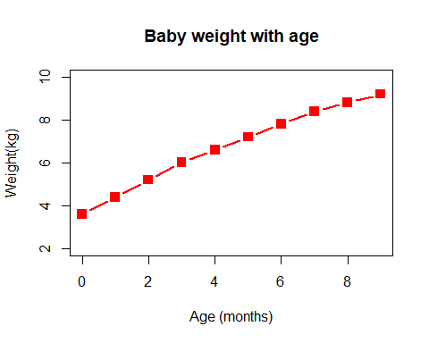

##Section 2B Bar plot  
#same workflow as before, but need to use a sep = function I found in the read.table help page.  
  
mouse <- read.table("bimm143_05_rstats/feature_counts.txt", header = TRUE, sep = "\t")  
  
View(mouse)  
  
## Need to utilize par() function to increase the barplot margin size  
#par() has a ton of options for modifying your graph  
par(mar=c(3.1, 11.1, 4.1, 2))  
  
barplot(mouse$Count, names.arg = mouse$Feature,  
 las = 1, horiz = TRUE, ylab = "",  
 main = "Number of features in the mouse GRCme38 genome",  
 xlim = c(0, 80000))

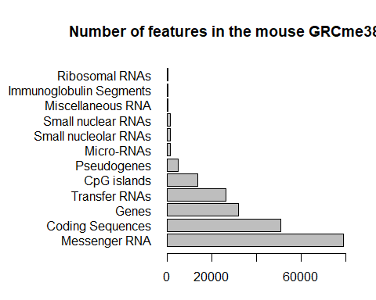

# Section 3A Providing color vectors  
  
  
mf <- read.table("bimm143_05_rstats/male_female_counts.txt", header = TRUE, sep = "\t")  
View(mf)  
# mfc <- read.delim("bimm143_05_rstats/male_female_counts.txt")  
  
barplot(mf$Count, names.arg =mf$Sample, col=rainbow(nrow(mf)), las=2, ylab="Counts", xlab = "Gender", main = "Male & Female Rainblow Plot")

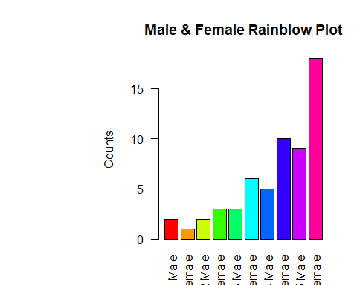

?hcl

## starting httpd help server ... done

## Section 3B  
#read delim function saves us time when dealing with complex data  
genes <- read.delim("bimm143_05_rstats/up_down_expression.txt")  
View(genes)  
  
#how many genes  
nrow(genes)

## [1] 5196

#how many genes are changing  
#want to adjust my par, I think  
par(mar=c(5, 5, 2, 1.5))  
palette(c("blue","gray","red"))  
plot(genes$Condition1, genes$Condition2, col=genes$State,  
 xlab = "Expression Condition 1", ylab = "Expression Condition 2")

