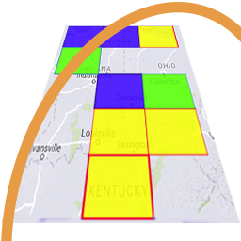
GridTracker ​v1.21.0620
An Amateur Radio Companion

June 20th, 2021

General Information

This is our June general release one critical fix and a minor enhancement.

Critical fix of an issue that when launching several logging utilities such as GridTracker and other logging programs that may all try to sync their LoTW logs at the same time and cause a trigger of LoTW’s log download abuse mechanism. Instead of pulling down the a complete log every time we update LoTW logs we now only pull down the full log one time and then only updated QSOs and new QSLs since the last time we checked. A cool-down timer was also added so that a check of LoTW can not occur more often then 5 minutes since the last check.

We want to thank everyone that contributes to GridTracker. Starting now if you donate to GridTracker and provide your call sign we’ll add you to the list. Then when your call sign will receive a special recognition icon next to it when is displayed within the program. If you’ve contributed to us in the past and want to be included, send an email with your call sign to ‘contact@gridtracker.org’.

ARRL Field Day is right around the corner! We’d love to see your Field Day setups including GridTracker, so feel free to share photos from your Field Day on Facebook, Twitter or Discord with the hashtag #GridTrackerFD.

Program Update
[Bug Fixes]
- Fix pulling down of LoTW logs at start-up with a differential log syncing mechanism that only get's changes since last sync, also cool down timer to prevent rapid reloading of LoTW log.
[Enhancements]
- Automatic pulling down of acknowledgments.json file daily when doing version check (if enabled).

GridTracker is:
Copyright © 1998-2020 by Stephen ‘Tag’ Loomis
Copyright © 2020-2021 by GridTracker.org
All rights reserved.

GridTracker uses the OSS compliant BSD 3 Clause License
Source code is available at GitLab: https://gitlab.com/gridtracker.org/gridtracker

