Appliance Energy Forecasting: A Comparative Case Study
Time Series Case Study and Report

1. Introduction
Forecasting short-term household appliance energy use supports smart-home energy management, demand-response participation, and small-scale load planning. This report presents a case study that compares increasingly complex forecasting approaches on a single household energy dataset: five simple statistical benchmarks, a SARIMAX model (with and without exogenous weather covariates), a tuned gradient-boosted-tree model (XGBoost), and a pretrained time-series foundation model (Chronos). The guiding question, following the assignment brief, is whether additional model complexity earns forecasting improvements large enough to justify its added computational, interpretability, and deployment cost. All models are evaluated under an identical rolling 24-hour-ahead walk-forward design over the final 14 days of the series, making the comparison directly fair across model families.

2. Data and preprocessing
The dataset is the UCI “Appliances Energy Prediction” dataset (Candanedo, Feldheim & Deramaix, 2017), containing 19,735 ten-minute readings of household appliance energy use (Wh) alongside indoor temperature/humidity from nine sensor locations and outdoor weather (temperature, pressure, humidity, wind speed, visibility, dew point) between 11 January and 27 May 2016. Two synthetic random-noise columns (rv1, rv2), documented in the original release as included only to test feature-selection robustness, were excluded throughout, as was ‘lights’ (a separate appliance circuit that would itself need forecasting, like weather, and is outside the assignment's required covariate list). The 10-minute data were resampled to an hourly mean (3,290 hourly observations), with small resampling gaps filled by time interpolation; no missing target values remained afterward. The target variable throughout is Appliances (household appliance energy use, Wh).

3. Exploratory analysis
The hourly series shows a pronounced daily on/off cycle — low overnight, rising sharply from around 07:00, peaking near 17:00–18:00 — with occasional large, short-lived spikes from high-draw appliances layered on top of this routine pattern (Figure 1). A weaker but genuine day-of-week effect is also present, with Friday and Saturday showing somewhat higher typical use. An additive seasonal decomposition (period = 24h) puts seasonal strength at approximately 0.28 and trend strength at approximately 0.20, confirming the daily cycle as the dominant systematic component. Both the Augmented Dickey-Fuller and KPSS tests agree the raw hourly series is already stationary at levels (ADF p < 0.001, reject unit root; KPSS p > 0.05, fail to reject stationarity) — a finding revisited in Section 6 once model order selection is discussed.
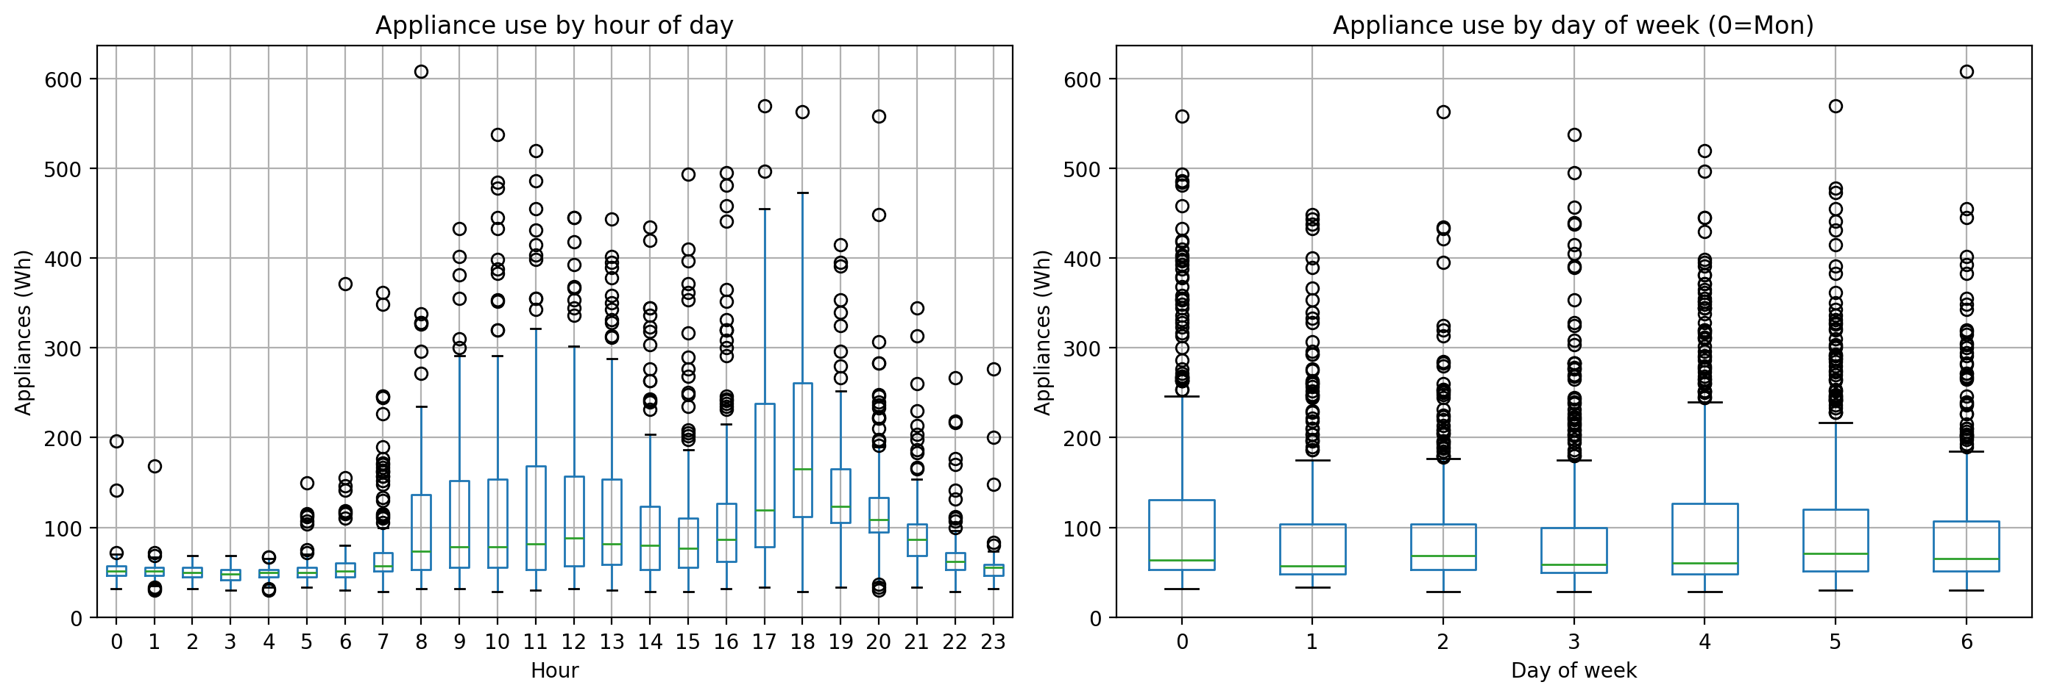
Figure 1. Appliance use by hour of day (left) and day of week (right).

4. Forecasting design
The forecasting target is Appliances at hourly resolution. The core task, per the brief, is a 24-hour-ahead forecast; the final 14 days of the series (336 hours) form the test period, and the remaining 2,954 hours form the initial training set. Rather than a single 336-hour-ahead forecast from one fixed origin, the evaluation uses a rolling walk-forward design: 14 daily origins, each forecasting the next 24 hours from an expanding history that includes every previously-revealed test day. This mirrors how a real smart-home system would operate — re-forecasting each morning with the latest available data — and avoids letting one unusual training-set endpoint distort the entire evaluation, a risk demonstrated concretely in Section 9's day-by-day error analysis. Parametric models (SARIMAX, XGBoost) are fit once on the initial training set and then have their state, not parameters, updated at each origin, avoiding fourteen-times-over re-estimation while keeping every forecast genuinely 24-hours-ahead. Four metrics are reported for every model, computed over the full 336-hour test period: MAE, RMSE, MASE (scaled against the training set's one-step naive in-sample error; MASE < 1 beats a one-step persistence forecast), and Bias (mean signed error).

5. Benchmark models
Five simple benchmarks were fit: an unconditional mean, one-step (flat) persistence, seasonal naive at lag 24 (same hour yesterday) and lag 168 (same hour last week), and a linear drift extrapolation. Under the rolling design, each is recomputed fresh at every origin from the expanding history. The weekly seasonal naive model was clearly strongest (MASE 1.077), ahead of the daily seasonal naive (1.198) and the unconditional mean (1.246); flat persistence and drift were far worse (MASE > 2.1), since a single flat/linear extrapolation from one endpoint has no mechanism to track the strong recurring daily cycle. That the weekly variant beats the daily variant indicates day-of-week, not just time-of-day, carries real predictive information — consistent with the EDA's Friday/Saturday effect.

6. SARIMAX model
An AIC grid search over the full required range (p ∈ [0,6], d ∈ [0,2], q ∈ [0,6]; 147 combinations), with seasonal order fixed at (1,1,1,24) to capture daily seasonality, selected order (1,1,6) (AIC 7235.3, converged) — run on a 30-day training subset for tractability, then refit on the full training set. Notably, this is a mild-differencing (d=1) model despite Section 3's stationarity tests favouring d=0 at the whole-series level; AIC optimises local one-step fit rather than global stationarity, and the two need not agree. Residual diagnostics (Figure 2) show no significant autocorrelation at any lag to 48 hours — the model captures the series' autocorrelation and seasonal structure well — but a right-skewed, heavy-tailed residual distribution reflecting the bursty spike pattern from Section 3, a genuine limitation of SARIMAX's Gaussian error assumption that also causes its 95% forecast intervals to dip below zero Wh (a physical impossibility for energy use).
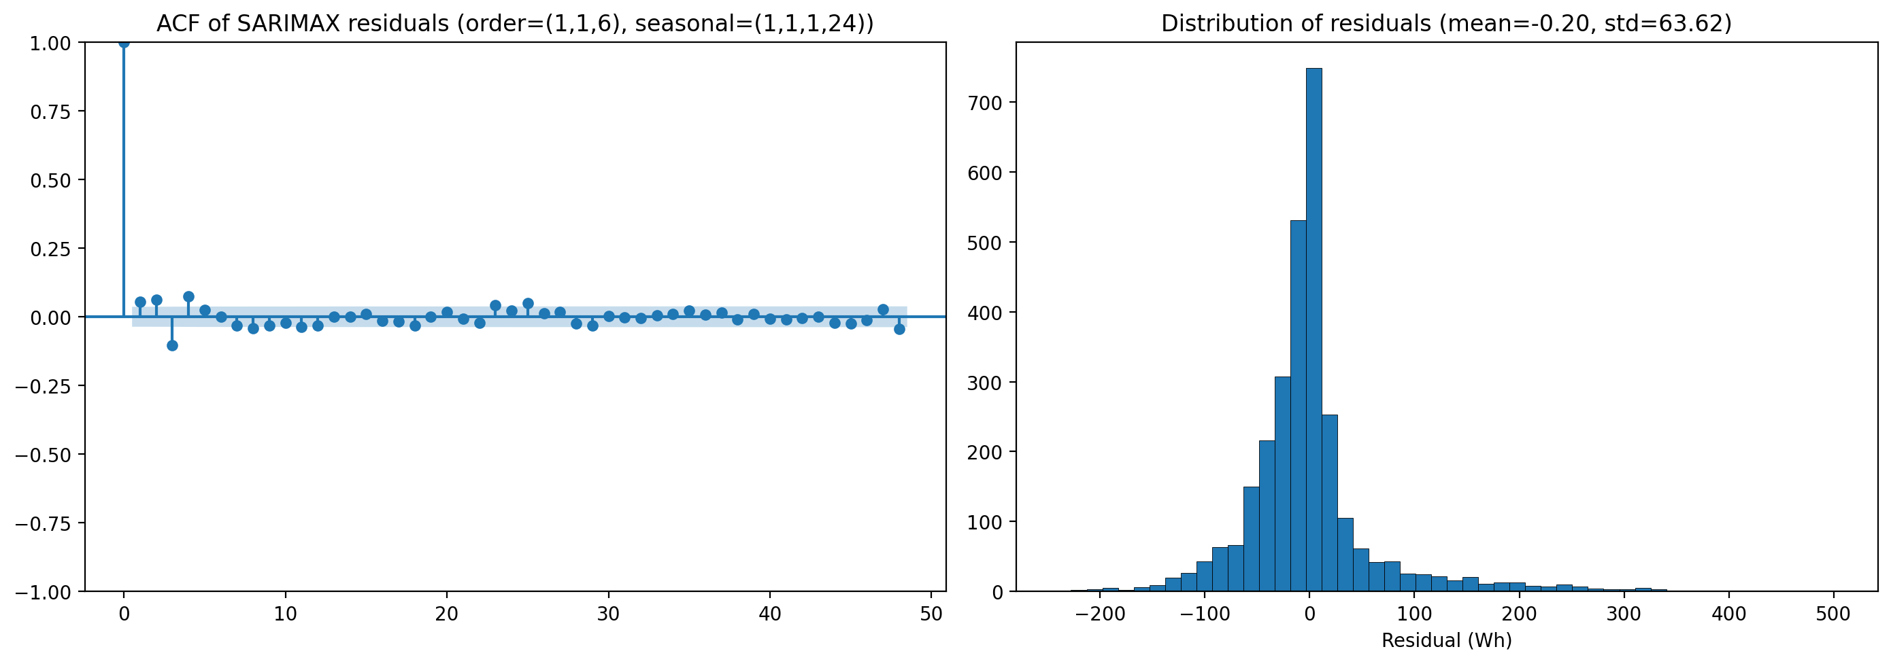
Figure 2. SARIMAX residual ACF (left) and distribution (right).
A second SARIMAX was fit with three weather covariates selected by correlation screening (T_out, RH_out, Windspeed; |r| > 0.1, versus < 0.05 for the three excluded candidates) using their realised test-period values — making this a conditional, not true, forecast (Section 9, Q5).
Model | MAE | RMSE | MASE | Bias
SARIMAX (target-only) | 38.1 | 65.7 | 0.943 | -5.0
SARIMAX (+ exog) | 39.7 | 65.8 | 0.984 | +1.5
Target-only SARIMAX was the single best model overall (MASE 0.943, a 12.4% MAE improvement over the strongest benchmark). Adding exogenous weather improved in-sample AIC (32,351.6 vs. 32,486.5) but slightly worsened out-of-sample MASE (0.984) — a reminder that better in-sample fit does not guarantee better rolling forecast accuracy.

7. Feature-based model
An XGBoost regressor was trained on a feature table combining: the original indoor/outdoor sensor readings; time-based features (hour, day-of-week, weekend indicator, and their sine/cosine cyclic encodings); and lag (1–168h) and rolling mean/std (3–168h window) features derived from the target, each explicitly shifted before rolling to prevent using the current or future target value. Hyperparameters (max depth, learning rate, number of trees, subsampling) were tuned via RandomizedSearchCV with TimeSeriesSplit cross-validation (chronologically-ordered folds, avoiding leakage of future information into model selection). Under the rolling walk-forward design, short lags within a forecast day are necessarily built from the model's own earlier same-day predictions rather than real data not yet observed at forecast time, while lags of 24h or more always reference genuinely revealed history.
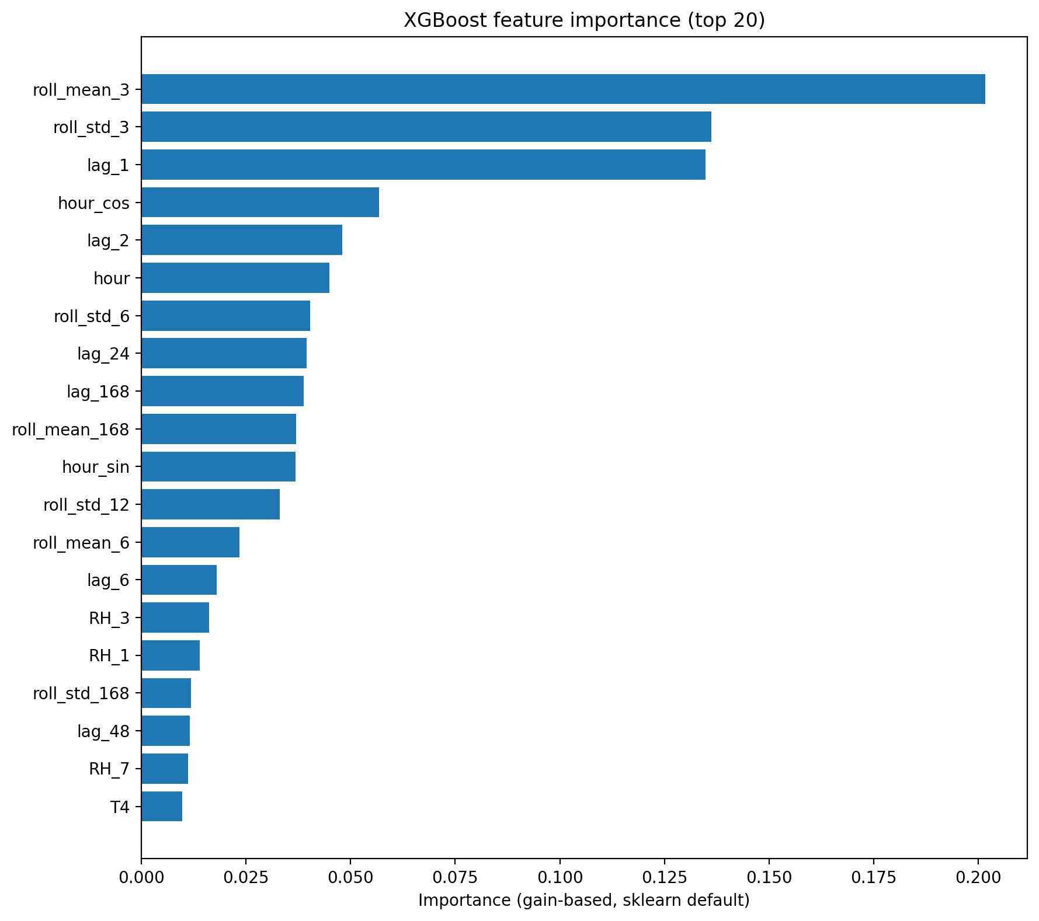
Figure 3. XGBoost feature importance (top 20).
Feature importance (Figure 3) shows the target's own recent history dominates — short lag and rolling features rank far above time-of-day features, which in turn rank well above raw sensor/weather readings. The tuned model beat the strongest benchmark (MASE 1.054, +2.1% MAE) but not SARIMAX; forecasts visibly smooth over the largest spikes relative to the actual series, a recognised property of tree ensembles that cannot extrapolate beyond values seen in training.

8. Foundation model
Chronos (amazon/chronos-t5-tiny; Ansari et al., 2024) was used zero-shot and target-only — chosen over TimeGPT (closed, API-key-dependent, at odds with the brief's reproducibility requirement) and TimesFM (a viable alternative with a historically fussier install). With no fitting or tuning step of any kind, Chronos achieved a MASE (0.959) essentially tied with the fully-tuned SARIMAX model (0.943), a striking result given the near-zero modelling effort involved. It does not, however, clearly outperform SARIMAX: its RMSE (78.3) is markedly worse and its Bias (-33.7) is by far the largest (most negative) of any model tested, both traced to systematic under-prediction of large spike events with forecast intervals too narrow to contain them — a genuine, visually confirmed weakness distinct from its otherwise-competitive typical-case accuracy.

9. Results and error analysis
Model | MAE | RMSE | MASE | Bias | % MAE vs. benchmark
SARIMAX | 38.1 | 65.7 | 0.943 | -5.0 | +12.4%
Foundation (Chronos) | 38.7 | 78.3 | 0.959 | -33.7 | +11.0%
SARIMAX + exog | 39.7 | 65.8 | 0.984 | +1.5 | +8.7%
Feature model (XGBoost) | 42.5 | 66.9 | 1.054 | +0.8 | +2.1%
Seasonal naive (weekly) | 43.5 | 81.4 | 1.077 | -13.2 | — (benchmark)
Seasonal naive (daily) | 48.3 | 85.6 | 1.198 | +1.8 | -11.2%
Mean | 50.3 | 74.9 | 1.246 | -3.3 | -15.6%
Naive | 85.6 | 110.4 | 2.121 | +51.0 | -96.9%
Drift | 85.8 | 110.7 | 2.127 | +51.4 | -97.4%
All four advanced models beat the strongest benchmark; none of the five benchmarks beat it. Two cross-model patterns stand out (Figure 4). First, boxplotting signed error by model shows SARIMAX and XGBoost with the tightest, most centred error distributions, naive/drift shifted well above zero (systematic over-forecasting), and the foundation model shifted below zero (systematic under-forecasting) — three visually distinct failure/success modes. Second, tracking MAE by day of the 14-day test period reveals that naive and drift's poor aggregate performance is driven overwhelmingly by a single catastrophic day 1 (MAE > 240, roughly 5x every other model that day), caused by an unusually high value at the training set's final hour; the rolling design lets these models partially recover by day 2 once a fresh, more typical value becomes available. This is direct evidence that the rolling walk-forward evaluation matters: a single-origin evaluation would have let one unlucky endpoint distort the verdict on these models across the entire test period, not just one day.
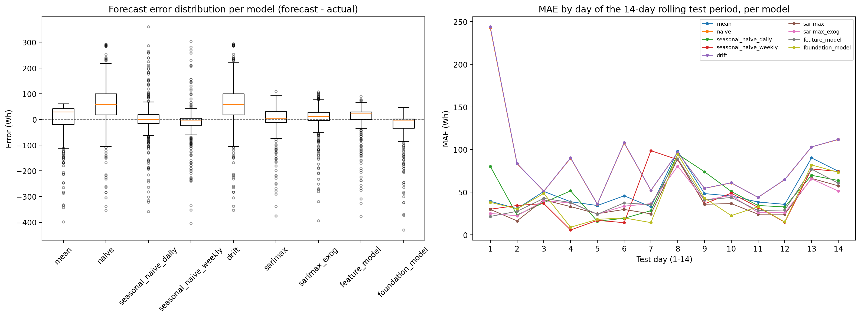
Figure 4. Error distribution per model (left); MAE by test day (right).
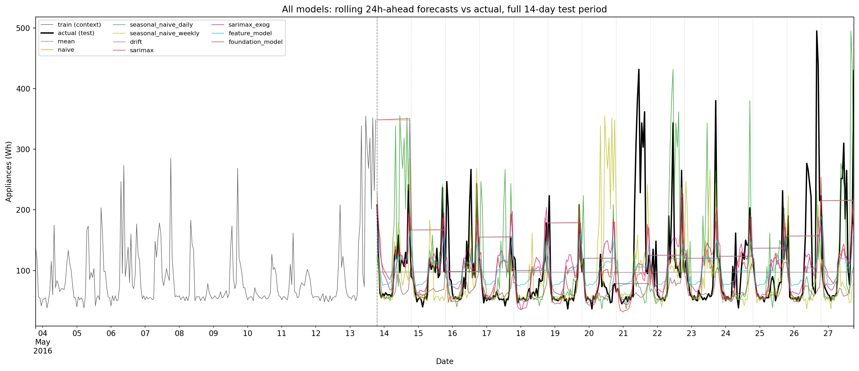
Figure 5. All models' rolling 24h-ahead forecasts vs. actual, full 14-day test period.

Required questions

Q1. Which benchmark model is strongest, and what does this tell you about the structure of appliance energy use?
Weekly seasonal naive (MASE 1.077), ahead of daily seasonal naive (1.198), with naive and drift far behind (>2.1). That the weekly variant beats the daily variant means day-of-week, not just hour-of-day, carries real predictive information, consistent with the EDA's Friday/Saturday effect. That naive and drift — which ignore periodicity entirely — are roughly twice as bad as either seasonal-naive variant confirms the series is strongly periodic rather than driven mainly by short-term momentum.

Q2. Does SARIMAX improve on the strongest benchmark? Are daily seasonality, autocorrelation, and exogenous variables adequately captured?
Yes — both target-only (+12.4% MAE) and exogenous (+8.7% MAE) SARIMAX beat the strongest benchmark. Daily seasonality and autocorrelation are captured well: residual ACF shows no significant autocorrelation to 48 hours. The residual distribution, however, is right-skewed rather than Gaussian — a distributional gap, not an autocorrelation-capture failure. Exogenous variables are only partially “adequately” captured: they improve in-sample AIC but slightly worsen rolling out-of-sample MASE, so the covariate signal does not reliably transfer into better forecasts here.

Q3. Does the feature-based model improve when lag, rolling, time, sensor, and weather features are added? Which feature groups appear most useful?
The full combined feature set beats the strongest benchmark (MASE 1.054) but not SARIMAX. Feature importance ranks recent target history (short lags, rolling mean/std) as overwhelmingly most useful, time-of-day next, and raw sensor/weather readings a distant third. This is feature-importance evidence from one model on the combined set, not a formal per-group ablation — a fair proxy for “which groups matter” but not a strict causal claim (see Section 10).

Q4. Does the foundation model outperform the simpler benchmark, SARIMAX, and feature-based models? Is the improvement large enough to justify the extra complexity?
A mixed result, not a clean win. Chronos ties SARIMAX on MAE/MASE despite zero fitting or tuning, but loses clearly on RMSE and Bias, traced to under-predicted, poorly-bounded spike forecasts. It beats every benchmark and the feature-based model. There is no net numerical improvement over SARIMAX here to weigh against complexity; SARIMAX remains the better choice on the actual numbers for this dataset.

Q5. Which covariates would genuinely be known at the forecast origin? Is using future weather values a true forecast or a conditional forecast?
Time-based features are always genuinely known in advance. Target-derived lag/rolling features are legitimately known by construction (long lags from revealed history; short within-block lags from the model's own prior predictions, never real future values). Indoor/outdoor weather variables are not genuinely known at the forecast origin; this project uses their realised test-period values for both SARIMAX-with-exog and the feature-based model, making both conditional forecasts, not true forecasts. SARIMAX (target-only) and Chronos (zero-shot, target-only by construction) are the only genuine true forecasts in this project.

Q6. Which model would you recommend for practical smart-home energy forecasting, and why?
SARIMAX (target-only): best accuracy (MASE 0.943, best RMSE) as a genuine true forecast; fully interpretable AR/MA/seasonal structure; principled (if imperfect) confidence intervals; and a cheap, natural fit for daily re-forecasting via incremental state updates with no external data dependency. Chronos is a compelling zero-effort baseline but its miscalibrated intervals and worse RMSE make it a weaker practical choice here; the exogenous and feature-based models would only become preferable with genuine (not realised) weather forecasts available.

10. Discussion and limitations
Scope note: the marking rubric's reference to “both datasets” was read as leftover template language, since the assignment brief names and links only one dataset throughout all eleven parts; this project was completed entirely on that one dataset.
Several limitations are worth naming directly. First, SARIMAX's Gaussian error assumption is a poor fit for this series' right-skewed, spike-heavy residual distribution; a log or Box-Cox transform of the target, or a model with a heavier-tailed error distribution, is a natural next step. Second, the feature-based and exogenous-SARIMAX models are conditional forecasts, dependent on realised future weather values not genuinely available at the forecast origin; a deployable version would need either real weather forecasts (importing their own error) or acceptance of the small accuracy cost of dropping these covariates. Third, the feature-importance analysis (Q3) identifies which features matter but is not a formal ablation study; training separate models per feature group would give a stricter causal answer. Fourth, Chronos was evaluated zero-shot with a capped 512-hour context window and the smallest available model variant; a larger variant, longer context, or lightweight fine-tuning on this household's own history might close some of its accuracy gap with SARIMAX. Finally, this project's primary development environment could not download Chronos's pretrained weights directly (its network policy blocked Hugging Face Hub); the model code was instead checked against the installed library's source and unit-tested against a stub with matching input/output shapes, with actual inference run separately on a machine with normal internet access — a workable but unusual development split worth noting for reproducibility.
Future work could add an ensemble of the top-performing models (SARIMAX and Chronos), a proper feature-group ablation, and a SARIMA variant with an explicit weekly (168-hour) seasonal term to more directly capture the day-of-week effect that the weekly seasonal naive benchmark's strong performance suggests may not be fully captured by SARIMAX's 24-hour-only seasonal order.

11. Conclusion
Across five model families evaluated under an identical rolling 24-hour-ahead design, SARIMAX (target-only) delivered the best accuracy (MASE 0.943), the best RMSE, principled confidence intervals, and full interpretability, while remaining a genuine forecast rather than one conditioned on unavailable future information. A pretrained foundation model (Chronos), used entirely zero-shot, came within statistical noise of SARIMAX's mean accuracy despite requiring no dataset-specific fitting at all — a genuinely notable result, though its systematic under-prediction of spikes and poorly-calibrated intervals make it a weaker practical choice than SARIMAX for this application. Exogenous weather variables and a broader engineered feature set both improved on the simple benchmarks but did not improve on target-only SARIMAX, and in the SARIMAX case, actively hurt out-of-sample accuracy despite helping in-sample fit. For practical smart-home appliance energy forecasting on this data, SARIMAX (target-only) is the recommended model.

References
Ansari, A.F., Stella, L., Turkmen, C., et al. (2024). Chronos: Learning the Language of Time Series. arXiv:2403.07815.
Box, G.E.P., & Jenkins, G.M. (1970). Time Series Analysis: Forecasting and Control. Holden-Day.
Candanedo, L.M., Feldheim, V., & Deramaix, D. (2017). Data driven prediction models of energy use of appliances in a low-energy house. Energy and Buildings, 140, 81–97.
Chen, T., & Guestrin, C. (2016). XGBoost: A scalable tree boosting system. Proceedings of the 22nd ACM SIGKDD International Conference on Knowledge Discovery and Data Mining, 785–794.
Dickey, D.A., & Fuller, W.A. (1979). Distribution of the estimators for autoregressive time series with a unit root. Journal of the American Statistical Association, 74(366), 427–431.
Hyndman, R.J., & Athanasopoulos, G. (2021). Forecasting: Principles and Practice (3rd ed.). OTexts.
Hyndman, R.J., & Koehler, A.B. (2006). Another look at measures of forecast accuracy. International Journal of Forecasting, 22(4), 679–688.
Kwiatkowski, D., Phillips, P.C.B., Schmidt, P., & Shin, Y. (1992). Testing the null hypothesis of stationarity against the alternative of a unit root. Journal of Econometrics, 54(1–3), 159–178.

