Hybrid Biomedical Image-Analysis Pipeline: Fluorescence Microscopy Nuclei Segmentation
AI Imaging Coding Case Study and Report
https://github.com/mattmessie/ai-imaging-pipeline
- Introduction
This report concerns a hybrid biomedical image-analysis pipeline for the chosen modality - fluorescence microscopy nuclei, which is represented by a synthetic 112-image set akin to the 2018 Data Science Bowl nuclei. For this data set, the pipeline performs a comparison of a direct description from a multimodal LLM trained on medical scans, and a classical-numerical-features-plus-LLM description, trains a U-Net convolutional model and evaluates it, and ultimately produces the complete image-analysis pipeline: raw images → segmentation → quantitative region features → JSON-formatted record → narrative description.
- Image Preparation, Multimodal LLM Description
The images were converted to grayscale and, as indicated in figure 1 below, appear to be 256×256 in size (shown are four of 80 training images). The pixel-intensity values are distributed as a bimodal histogram (plotted for all 80 training images), with the highest density near zero (background) and another peak at ~0.2–0.35 (foreground). This distribution suggests that Otsu thresholding would be a viable option for baseline segmentation (see Part 3).
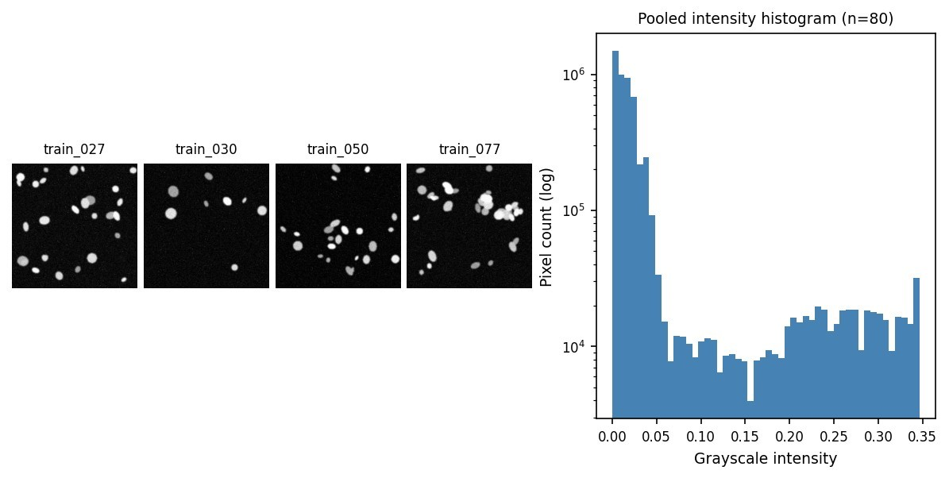
Figure 1. Sample training images (top) and pooled intensity histogram (bottom-right).
To evaluate the model on representative images, I used the train_062 image, which has 27 ground-truth nuclei (“normal” density, “normal” regime, i.e. median, not “cherry picked”). I asked the model to describe this image using two different prompts. The first prompt “What is in this image?” produced a verbose, but diagnostic-drift answer: while the model correctly identified the presence of the DAPI channel, it made guesses about the cells’ condition (“actively dividing or have recently divided”) and behavior (“state of rapid growth or proliferation”). By only looking at the picture, I could not tell if the cells were actively dividing or had divided recently: this requires additional tests to determine a cell’s cycle state. Similarly, the model’s assumptions about the cells’ behavior were unfounded. The optimized prompt asks the model to describe the image, and it limits the JSON’s verbosity, thus removing some of the opportunities to guess. Additionally, the optimized prompt makes the model explicitly state “uncertain” for the tissue_type : it does not assume that the tissue is connective or muscle and instead states that it is uncertain. While the model can reasonably guess the imaging modality (“fluorescence”), it does not attempt to reason about the sample beyond the information provided in the image.
Optimised prompt (Task 1):
“You are a scientific image-cataloguing assistant helping annotate microscopy images for a research dataset.
You are NOT a diagnostic tool. Do not provide any clinical, diagnostic, or disease-related interpretation, even if asked. Describe only what is visually present, in purely observational terms (shapes, brightness, spatial arrangement, apparent density, texture).
Respond with a JSON object with EXACTLY these four fields, and nothing else: { "modality": "<imaging modality if visually identifiable, else ‘uncertain’>", "tissue_type": "<general sample/tissue type if identifiable, else ‘uncertain’>", "notable_features": "<one short factual sentence on visually notable features>", "image_quality": "<good|moderate|poor>" }
If you are not confident about a field, write "uncertain" for that field rather than guessing. Respond with ONLY the JSON object — no preamble, no explanation, no markdown code fences.”

Classical Features and LLM Interpretation
Otsu thresholding (with morphological cleanup and small-object removal) plus connected-component labeling detected 22 objects in train_062 (27 ground-truth nuclei; some touching nuclei merged into single blobs). A regionprops feature table (area, perimeter, eccentricity, solidity, mean intensity, extent) was converted into a deterministic text summary and passed — numbers only, never the image to llama3.2.
Numbers-first prompt (Task 2, template):
“You are a scientific image-cataloguing assistant. You have NOT seen the image itself — you are working ONLY from a numeric summary produced by classical image segmentation (Otsu thresholding). Do not claim to have observed anything beyond what the summary states, and do not provide any clinical or diagnostic interpretation.
Image ID: <id> Summary: <regionprops-derived text summary>
Based ONLY on this summary, produce: 1. A JSON object with EXACTLY these four fields: { "n_objects": <integer, from the summary>, "density_class": "<sparse|moderate|dense>", "shape_regularity": "<highly irregular|irregular|regular|highly regular>", "quality_flag": "<ok|review_recommended|fail>" } 2. Then a one-paragraph description (3-4 sentences) suitable for a research report, grounded strictly in the summary’s numbers. Format your response EXACTLY as: JSON: {...} NARRATIVE: <paragraph>”
From this summary, you are to produce a JSON object with the exact n_objects, density_class (sparse/moderate/dense), shape_regularity (highly irregular/irregular/regular/highly regular), and quality_flag (ok/review_recommended/fail), and a paragraph grounded only in the summary numbers.
The response produced by the model was directly passing n_objects=22, however, the class density was incorrectly set to “dense” (GT: normal). There was nothing in the summary for the model to ground this claim based on a single image. shape_regularity=“irregular” is also questionable since the model could have chosen regular since the solidity is 0.95 and eccentricity is 0.69 which are both close to regular. The narrative portion explained “extent” (the ratio between an object’s area and the area of its bounding box in this particular implementation, and therefore a measure of dispersion) as “containing both small and large objects”. While the narrative is correct in explaining what extent is, it should not have mentioned it since it was an unrelated reasoning artifact that could mislead the reader into thinking that there were objects of different sizes when there were not.

U-Net Segmentation
The small U-Net (3-level encoder+bottleneck, base=16 channels, 483,153 parameters, same as the course lab skeleton) was trained with 10 epochs of combined BCE+Dice loss and Adam (lr=1e-3) using the real dataset (80 train / 20 val) after replacing the synthetic data generator in the lab with real images. No overfitting occurred, and valid and training losses dropped. The final valid Dice: 0.9828 and IoU: 0.9662 were obtained. This is better than the lab's benchmark (0.85–0.95) that the lab stated.
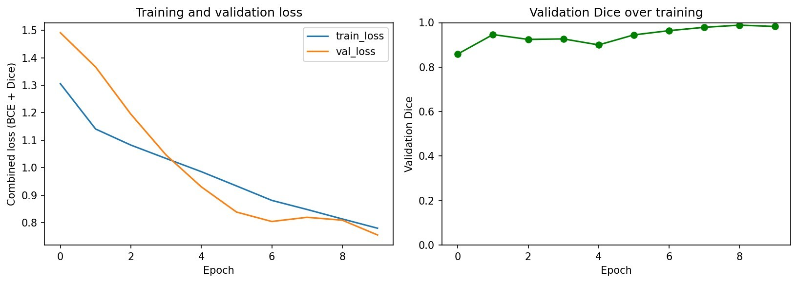
Figure 2. Training/validation loss and validation Dice across 10 epochs.
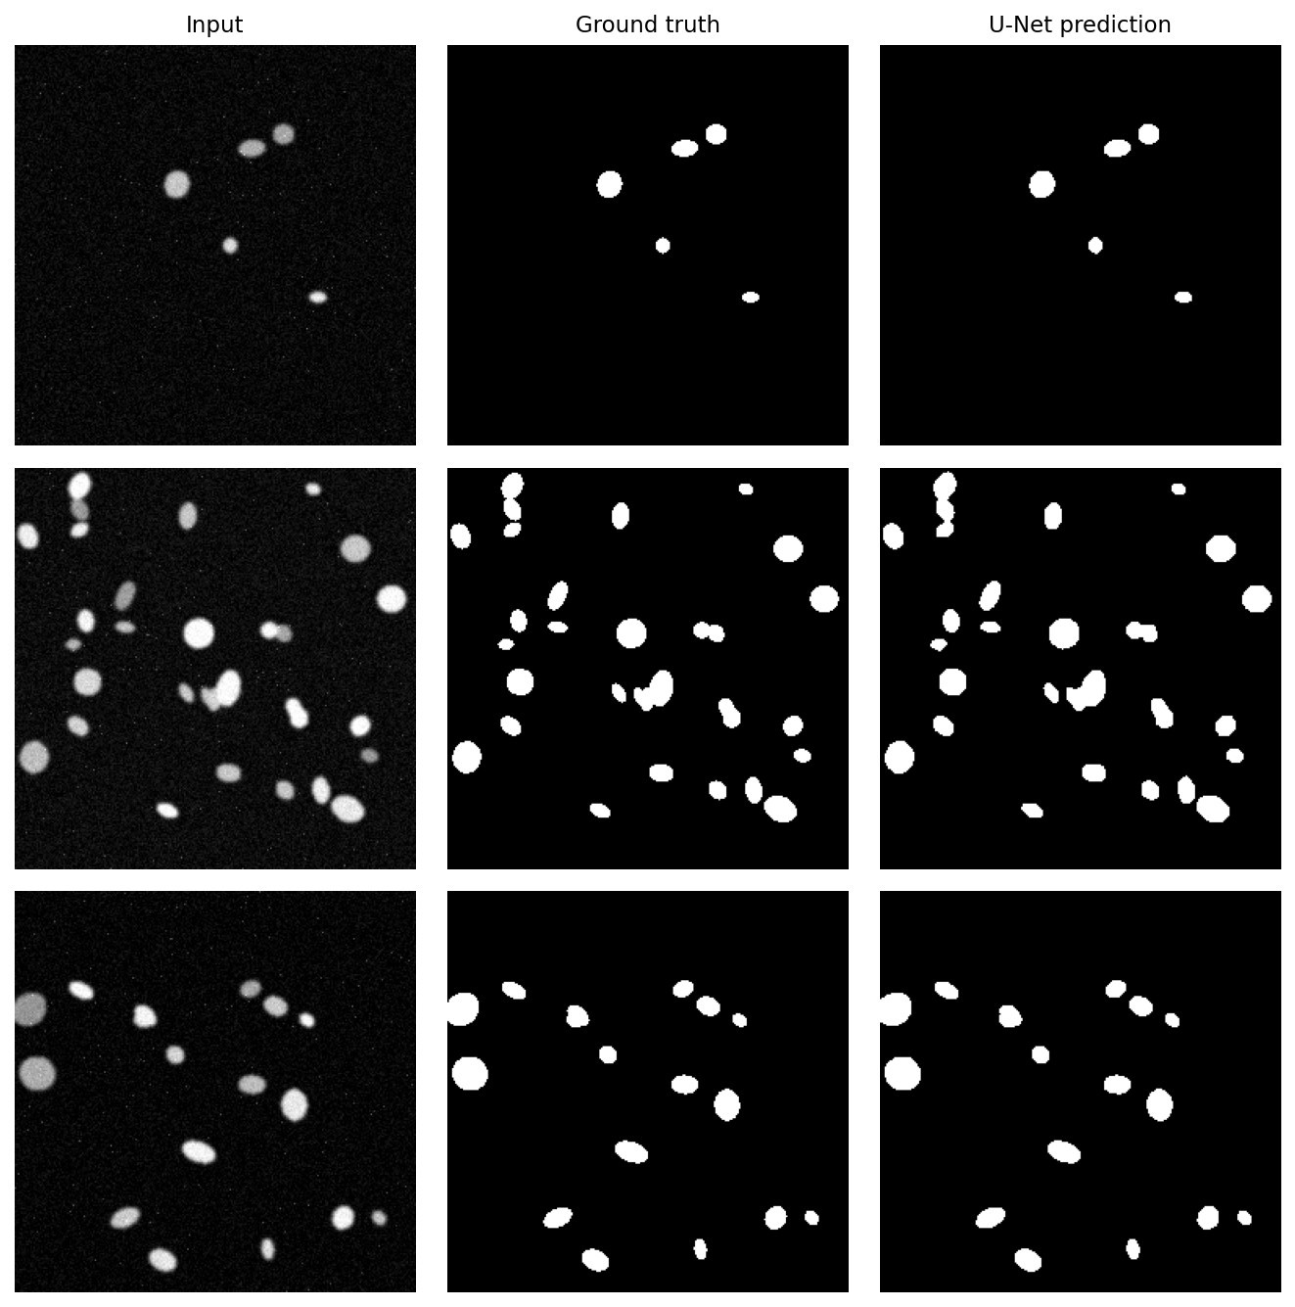
Figure 3. Input, ground truth, and U-Net prediction for three validation images.
A comparison against Otsu on the 12 unseen test images gives a two-part answer (Table 1). For the object counts (connected component labeling), there was essentially a tie (mean absolute error: Otsu 12.25, U-Net 12.58). This is not a failure of U-Net, as the ground-truth binary masks also erroneously merge some touching nuclei (only the separate 16-bit instance labels are correct; the U-Net was also trained on the binary masks) . However, for the pixel-level Dice, the metric that the model was actually optimized for, there was a clear, albeit moderate advantage for the U-Net: mean Dice of 0.9815 (U-Net) vs 0.9784 (Otsu), with a U-Net victory in 10 out of 12 cases. The biggest difference was in test_005 (clustered, 49 nuclei): Otsu had a Dice of 0.978, while U-Net had a Dice of 0.989. Notably, the best result for Otsu was also achieved on test_003 (normal, 21 nuclei): Dice of 0.981 vs 0.976 for U-Net.
Metric | Otsu | U-Net
Mean pixel Dice (12 test images) | 0.9784 | 0.9815
Mean pixel IoU (12 test images) | 0.9577 | 0.9638
Mean abs. object-count error | 12.25 | 12.58
Validation Dice / IoU (20 val images) | — | 0.9828 / 0.9662
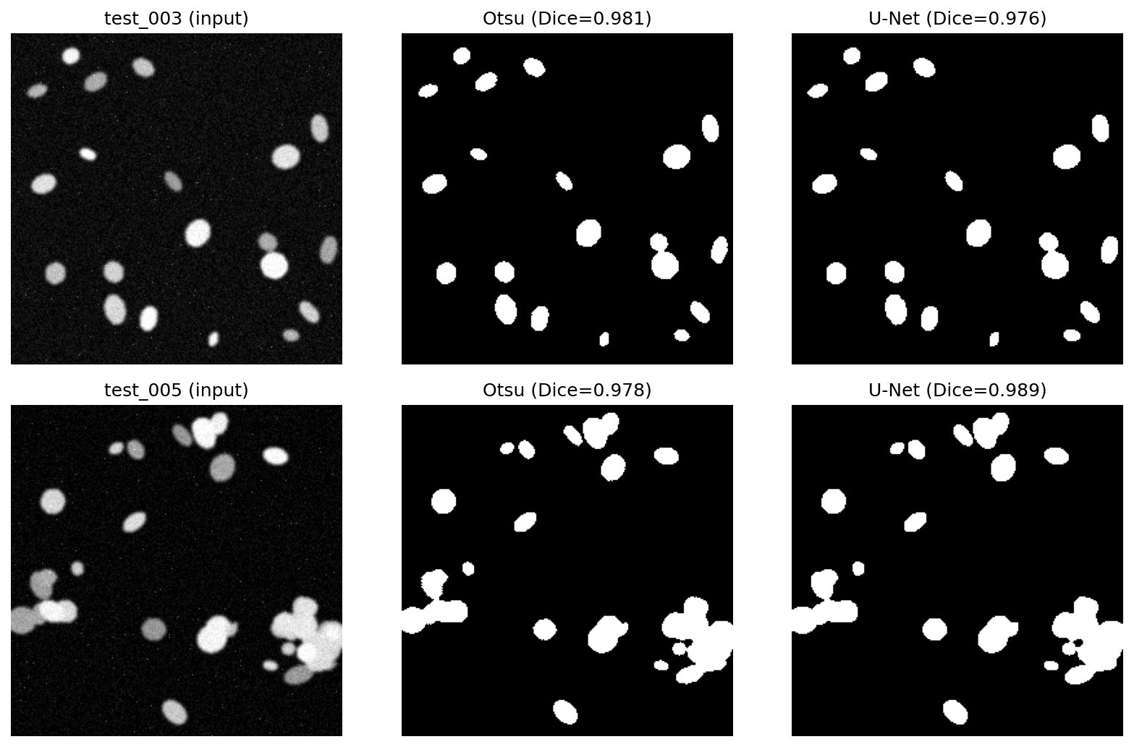
Figure 4. Best Otsu case (test_003, top) vs. largest U-Net advantage (test_005, bottom).

Hybrid Pipeline
The trained U-Net model was able to process all 12 test images not seen by it during the training phase. Each image was segmented into a mask after which the regionprops feature table was extracted and summarized in numbers for the llama3.2. The model responded with a five-field JSON and a paragraph for each image, which were then compiled into a CSV file containing the results for all the images. Note that for consistency, the same hybrid prompt (Task 4, template) was used for each image:
Hybrid prompt (Task 4, template):
“You are a scientific image-cataloguing assistant helping annotate microscopy images for a research dataset. You have NOT seen the image itself — you are working ONLY from a numeric summary produced by U-Net segmentation. Do not claim to have observed anything beyond what the summary states, and do not provide any clinical or diagnostic interpretation.
Image ID: <id> Summary: <regionprops-derived text summary>
Based ONLY on this summary, produce a JSON object with EXACTLY: image_id, n_objects, mean_area, density_class (<sparse|moderate|dense>), quality_flag (<ok|review_recommended|fail>); then a one-paragraph narrative grounded strictly in the summary. Format your response EXACTLY as: JSON: {...} NARRATIVE: <paragraph>”
Remarkably, for all the images, the density_class was “moderate”, despite the n_objects varying nearly five times from 8 to 42. The “mean_area” was correctly calculated for each image, as well as the “quality_flag”, which was “ok” for all the images since none of them were corrupted (unlike the test_corrupted group).
image_id | n_objects | mean_area | density_class | quality_flag
test_000 | 8 | 197 | moderate | ok
test_004 | 42 | 345 | moderate | ok
test_010 | 35 | 388 | moderate | ok
Table 2. Example rows from the aggregated CSV (full 12-row table in outputs/metrics/task4_hybrid_results.csv), showing correct numeric pass-through alongside uniformly uninformative density_class.

Required Questions
Q1. Which description is more useful/trustworthy — VLM (Task 1) or numbers-first (Task 2)?
Usefulness and reliability differ between the two models in this scenario. The improved VLM description better uses qualitative information that cannot be conveyed numerically, but only if restricted to specific values; otherwise, the prompt hallucinated, providing evidence not found in the image, such as cells "actively dividing." On the other hand, numerical results are more reliable when they concern simple data transfer ("n_objects"), but both methods fail when it comes to classifying the image according to certain criteria (density_ class).
Q2. Did the U-Net improve on Otsu? One example each did better.
The evaluation has two aspects. First, the instance counting. It was not improved as there is no actual difference between the results: 12.25 error for the first option and 12.58 for the second one. The reason is obvious as both options have the same limitation in instance segmentation that prevents the model from achieving a better result, which is the inability to fuse instances using binary masks. However, in terms of Pixel Dice, being the loss function that the models were trained on, U-Net has an advantage, having a better score for 10 out of 12 test images. While the mean value for Otsu is 0.9784, U-Net’s mean is 0.9815. U-Net has an advantage for most of the test samples, including test_005, which has a cluster of objects (0.9780 for Otsu and 0.989 for U-Net). The only image where Otsu performed better is test_003, having a more regular distribution of objects (0.9810 vs. 0.976 for U-Net).
Q3. Report Dice/IoU. What do they mean, and where does the model make mistakes?
Dice: 0.9828, IoU: 0.9662. Both metrics evaluate the overlap between predicted and ground-truth masks on a scale from 0 to 1, with IoU being stricter than Dice, as IoU = Dice / (2 – Dice). The results demonstrate that the degree to which predictions match reality is only loosely linked to the number of objects present in the image. For example, the scene with the fewest objects, test_006, achieved the lowest Dice score, whereas the scenes with the most objects, test_004 and test_010, yielded the best results. As can be seen from the images, the mistakes were made mostly on the edges of objects, which CNNs tend to smooth out during upsampling.
Q4. Where can the LLM hallucinate, what reduces the risk, and why does JSON-assource-of-truth help?
The main issues detected in the tasks included generating information with no factual basis (e.g., responding to Task 1 as “actively dividing” with no evidence), inconsistency (optimizing Task 1 responses resulted in different answers on subsequent runs in terms of either modality or quality), incorrect categorical judgments (e.g., incorrect density categories in Task 2; always “moderate” density in Task 4, regardless of the number of objects present, which varied between 8 and 42), and incorrect logic applied to factual statements (e.g., incorrect judgment in Task 2 about the spatial distribution, despite correctly citing the relevant numbers).
The main ideas that helped resolve the issues included basing responses on descriptions rather than judgments, accepting uncertainty (however, the option was scarcely used), using numbers to make statements that otherwise would involve perception and therefore be subject to error, providing a response based on an enumerated list, setting the temperature to zero when applicable, and using JSON as the preferred format.
Q5. Would you trust any part of this system clinically? What single change would help most?
No. There are three primary reasons why the results would not extrapolate to the beyond the confines of this particular work. Firstly, the entire dataset that was utilized in this experiment was purely artificial and minuscule, and thus, not indicative of real-life biological tissues. Secondly, the algorithm was not able to distinguish between the two closely located nuclei in a satisfactory manner. Finally, each step in the process involving the large language model had multiple systematic errors on the given dataset already, hence why it is currently marked as “not cleared for clinical use”. The top priority for further development would be to improve the segmentation model so that it is able to better identify individual nuclei and utilize either the provided 16-bit instance labels or switch to the marker-based watershed algorithm.
Discussion and Limitations
The data set is entirely synthetic, ensuring reproducibility and providing an exact answer key. This however, limits interpretation of the results to the artificial setting (see Q5). Aside from the change proposed in Q5, future directions could include error analysis by region or object size for the U-Net (Q3) and providing the LLM with detailed calibration information before asking it to predict density_class.

References
Caicedo, J.C., et al. (2019). Nucleus segmentation across imaging experiments: the 2018 Data Science Bowl. Nature Methods, 16, 1247–1253. Dice, L.R. (1945). Measures of the Amount of Ecologic Association Between Species. Ecology, 26(3), 297–302.
Grattafiori, A., et al. (2024). The Llama 3 Herd of Models. arXiv:2407.21783.
Otsu, N. (1979). A Threshold Selection Method from Gray-Level Histograms. IEEE Trans. Systems, Man, and Cybernetics, 9(1), 62–66.
Ronneberger, O., Fischer, P., & Brox, T. (2015). U-Net: Convolutional Networks for Biomedical Image Segmentation. MICCAI 2015. van der Walt, S., et al. (2014). scikit-image: image processing in Python. PeerJ, 2:e453.

