Matt Miller & Kai Blumberg

HW #1

2.2

a. mean = 29.96296, median = 25

b. mode = 25 & 35 (both have count = 4). It is bimodal

c. midrange = 41.5

d. Q1 = 20.5, Q3 = 35

e. min = 13.0, Q1 = 20.5, median = 25.0, Q3 = 35.0, max = 70.0

f. 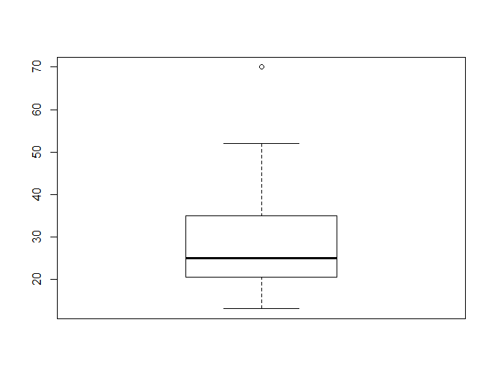

g. A Q-Q plot plots the quantiles of one dataset vs the quantiles of a different dataset, while a quantile plot plots the cumulative distribution of a dataset vs its own quantiles. A Q-Q compares two datasets, while a quantile plot only uses a single dataset and compares its quantiles vs its CDF.

2.3

Median interval is 20-50. Approximate median is 32.94

2.4

a. Age mean = 46.44, age median = 51, age standard deviation = 13.2186, fat mean = 28.783, fat median = 30.7, fat standard deviation = 9.2544

c.

2.8

a. Euclidean distances

|  |  |  |  |  |  |
| --- | --- | --- | --- | --- | --- |
|  | X1 | X2 | X3 | X4 | X5 |
| Euclidean | 0.1414214 | 0.6708204 | 0.2828427 | 0.2236068 | 0.6082763 |
| Manhattan | 0.2 | 0.9 | 0.4 | 0.3 | 0.7 |
| Supremum | 0.1 | 0.6 | 0.2 | 0.2 | 0.6 |
| Cosine | 0.9999914 | 0.9957523 | 0.9999695 | 0.9990282 | 0.9653634 |

Euclidean: x1, x4, x3, x5, x2

Manhattan: x1, x4, x3, x5, x2

Supremum: x1, x4/x3, x2/x5

Cosine: x5, x2, x4, x3, x1

b.

Normalized Euclidean distances

|  |  |  |  |  |
| --- | --- | --- | --- | --- |
| X1 | X2 | X3 | X4 | X5 |
| 0.004149351 | 0.092170915 | 0.007812321 | 0.044085487 | 0.263198051 |