Instructions:

Add an unused property to the tables you will stash, name Stash.

Modify the default T4 template. We need all the properties to be virtual so we can intercept calls to the properties to prevent modifications and attempts at navigation requiring lazy-loading. However, if all the properties are virtual, EF will dynamically create a proxy if change tracking or lazy-loading is enabled. We modify the template to render all the properties as virtual except the Stash property.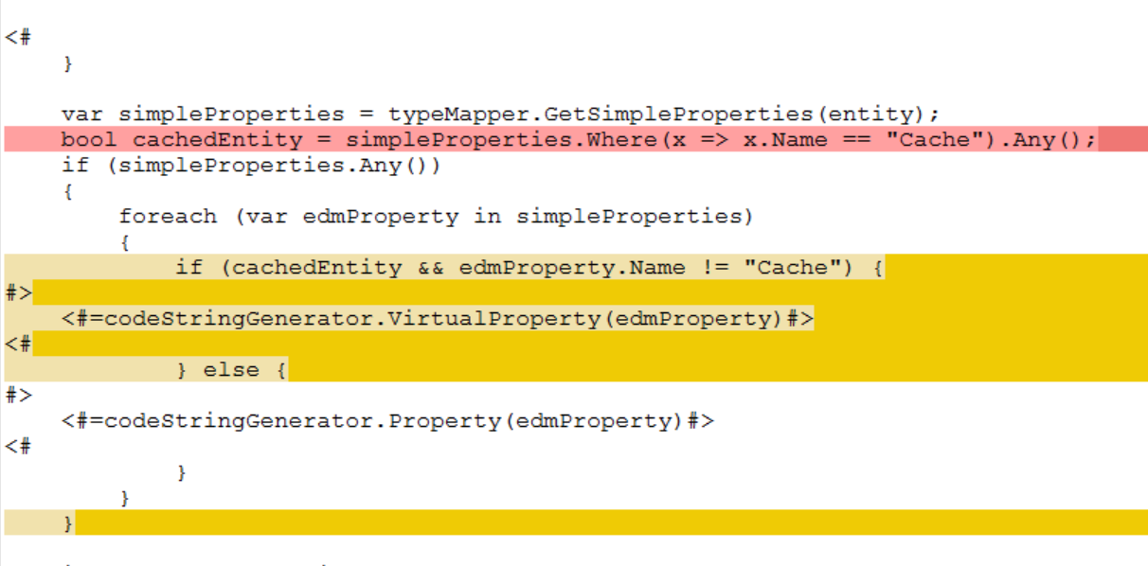

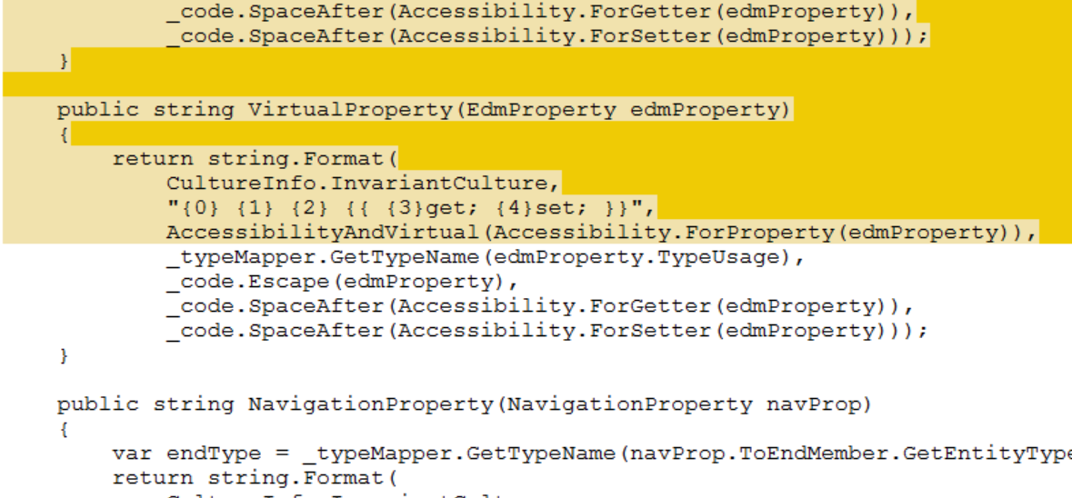

There are three T4 templates to generate partial classes for the stashed entities and stash interfaces and classes.

You need to write the stash repository and interface by hand.

The general idea is to load a bunch of data into the stash when the application starts and save trips to the database.

Configure as singleton with Ninject.

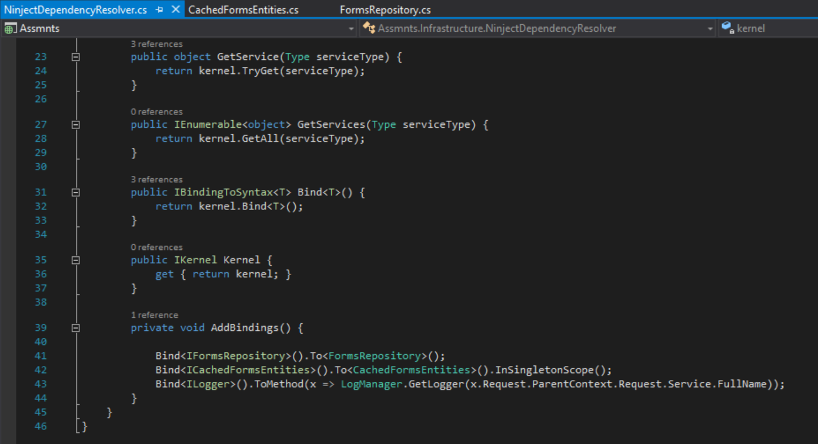

Use the stash in your main repository to look up data that doesn’t change between deployments.

