# Virtual Box Setup

1. Install Virtual Box

<https://carleton.ca/scs/2021/install-virtualbox/>

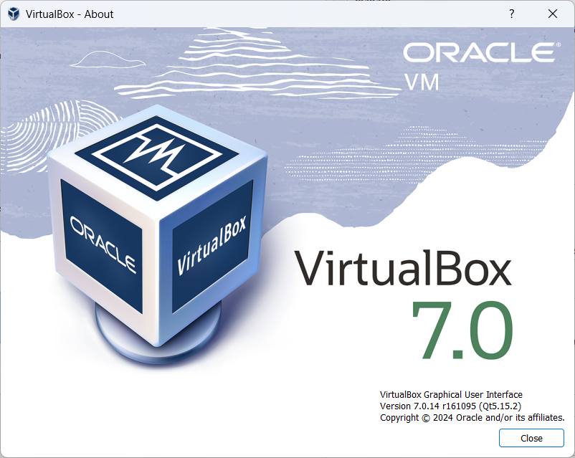

1. Start with COMP3000-W24.ova virtual machine (ubuntu 22.04)

<https://carleton.ca/scs/tech-support/virtual-machines/>

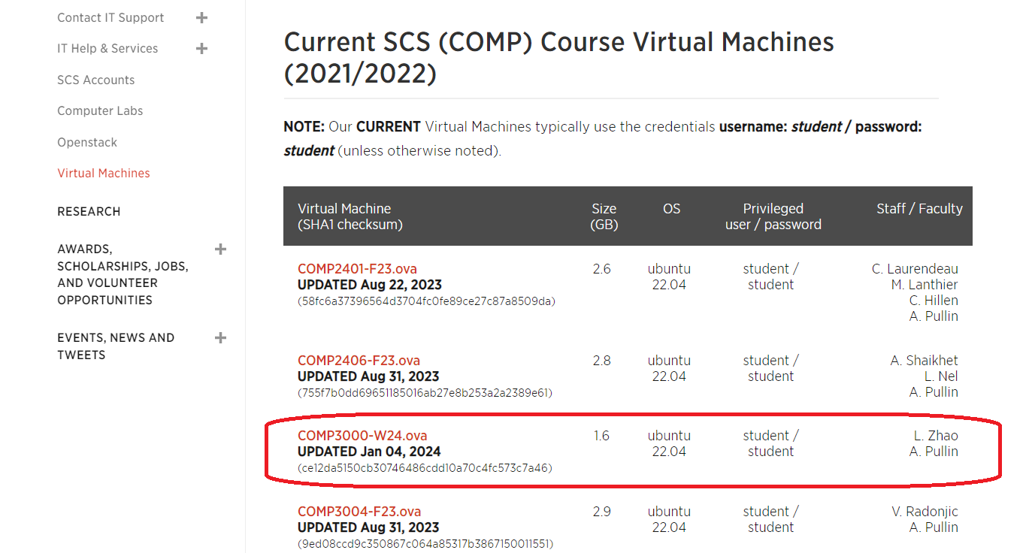

1. Configure Virtual Machine
   1. 20 GB Memory
   2. 8 Processors
   3. 200 GB Storage

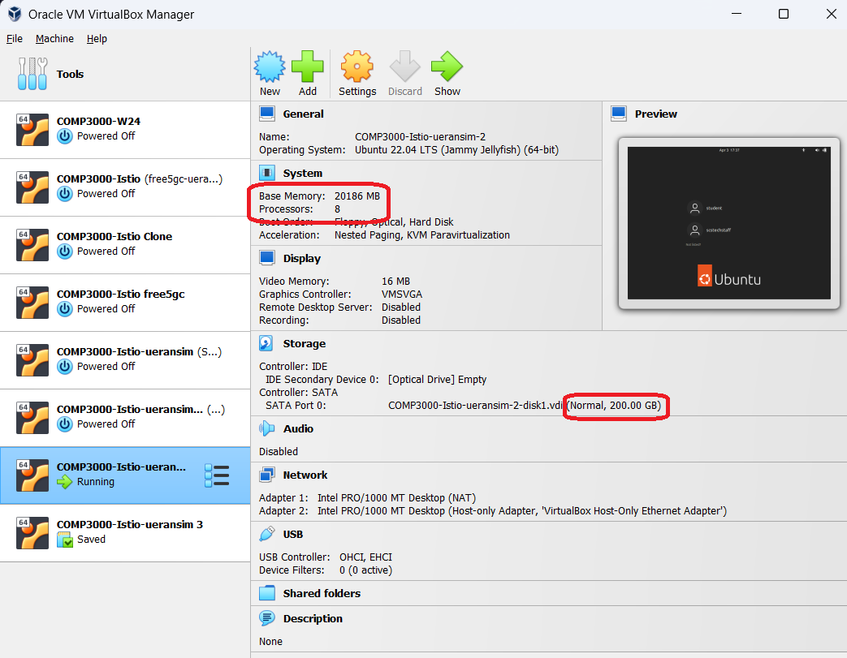

# Install Terminus

1. Download Terminus <https://termius.com/download/windows>
2. Configure Terminus Host to 192.168.56.101 (virtual machine)
3. Credentials: student/student

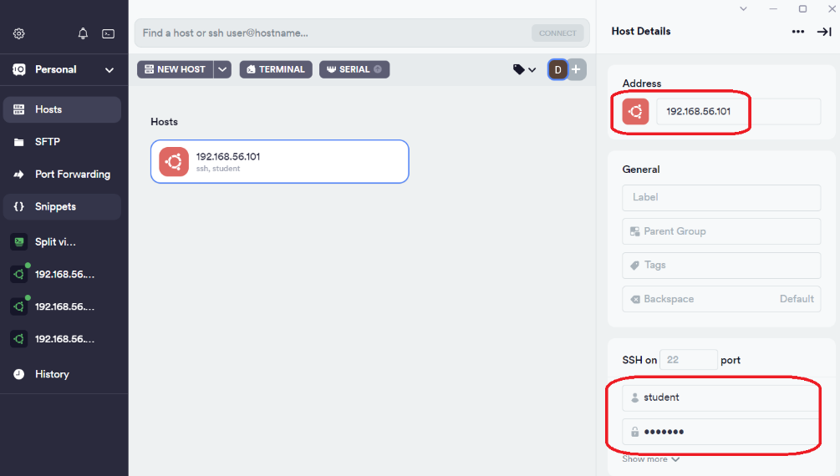

# Install Kubernetes (Minikube)

1. Update packages
   1. sudo apt update -y
   2. sudo apt upgrade -y
   3. sudo apt install -y curl wget apt-transport-https
2. Install minikube
   1. wget <https://storage.googleapis.com/minikube/releases/latest/minikube-linux-amd64>
   2. sudo cp minikube-linux-amd64 /usr/local/bin/minikube
   3. sudo chmod +x /usr/local/bin/minikube
3. Start minikube
   1. minikube start --driver=docker --cpus=8 --memory=16g --disk-size=20g --cni=calico
   2. minikube status  
      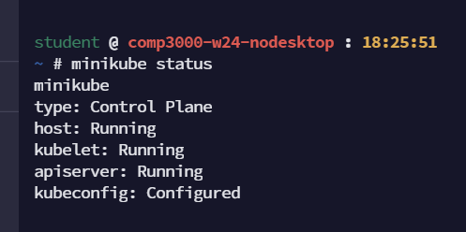
4. Install kubectl
   1. curl -LO https://storage.googleapis.com/kubernetes-release/release/`curl -s [https://storage.googleapis.com/kubernetes-release/release/stable.txt`/bin/linux/amd64/kubecl](https://storage.googleapis.com/kubernetes-release/release/stable.txt%60/bin/linux/amd64/kubecl)
   2. chmod +x kubectl
   3. sudo mv kubectl /usr/local/bin/
   4. kubectl version -o yaml  
      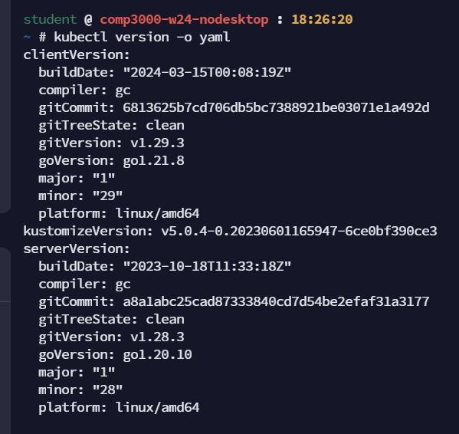

# Install Helm

1. curl -fsSL -o get_helm.sh <https://raw.githubusercontent.com/helm/helm/master/scripts/get-helm-3>
2. chmod 700 get_helm.sh
3. ./get_helm.sh
4. helm list -A  
   

# Install Multus-CNI Plugin

1. git clone <https://github.com/k8snetworkplumbingwg/multus-cni.git>
2. cd multus-cni
3. cat ./deployments/multus-daemonset-thick-plugin.yml | kubectl apply -f –
4. kubectl -n kube-system get pods  
   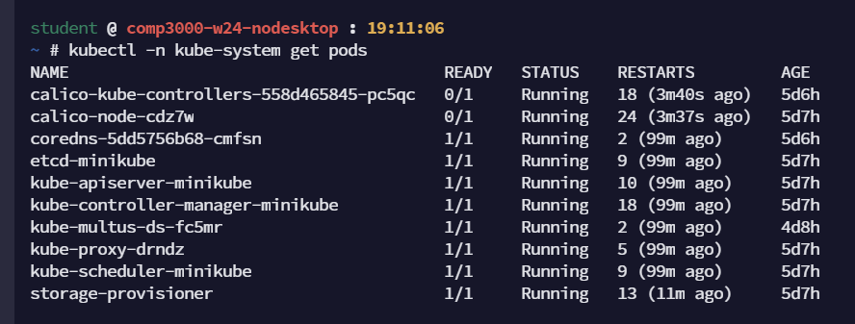

# Install gtp5g

1. git clone https://github.com/free5gc/gtp5g.git && cd gtp5g
2. make clean && make
3. sudo make install

# Install Istio

1. kubectl create namespace istio-system
2. helm install istio-base istio/base -n istio-system --set defaultRevision=default
3. helm install istiod istio/istiod -n istio-system --set global.proxy.privileged=true –wait
4. helm install --namespace istio-system kiali-server kiali/kiali-server
5. kubectl -n istio-system get pods  
   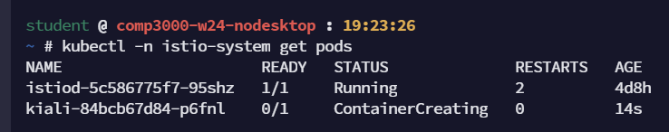

# Create free5gc namespace with Istio-injection enabled

1. kubectl create namespace free5gc
2. kubectl label namespace free5gc istio-injection=enabled
3. kubectl get namespace -L istio-injection  
   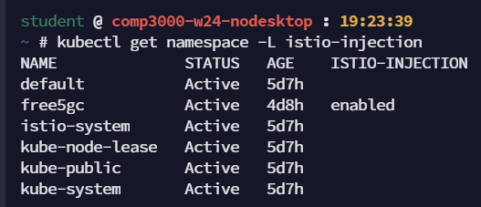

# Enable istio mtls

1. Create Istio Peer Authentication  
   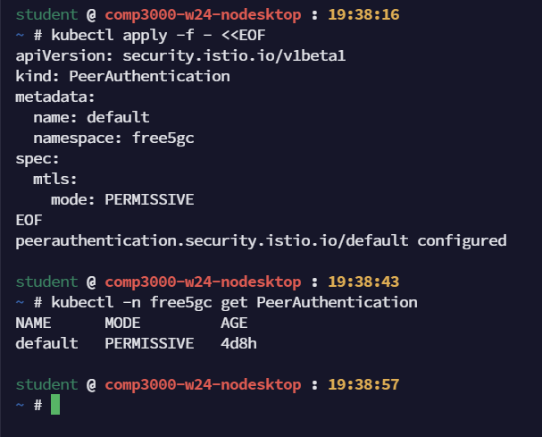

# Install free5gc

1. helm -n free5gc install free5gc-v1 towards5gs-helm/charts/free5gc
2. kubectl -n free5gc get pods   
   (notice that there are 2 containers for each POD (i.e. istio-proxy sidecar)  
   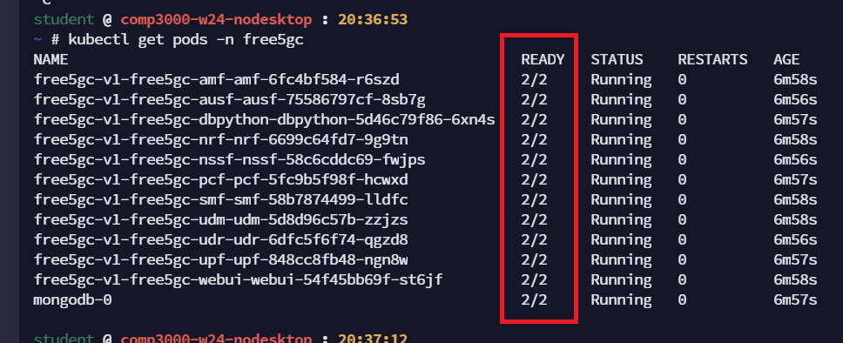

# Install ueransim

1. helm -n free5gc install ueransim towards5gs-helm/charts/ueransim
2. kubectl -n free5gc get pods  
   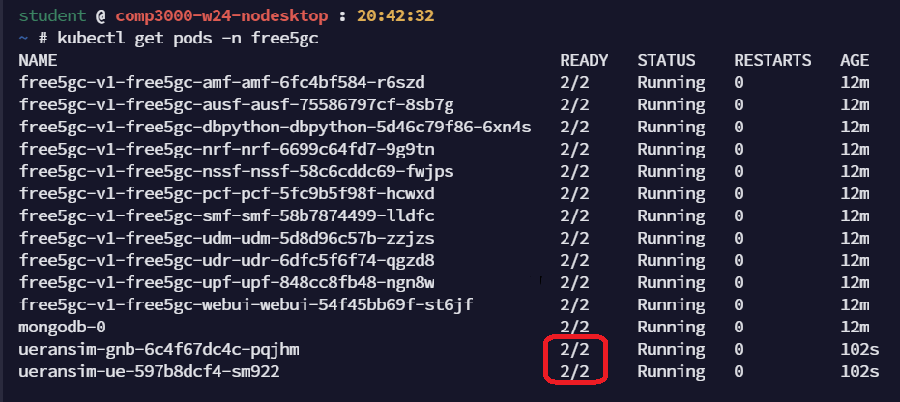
3. kubectl -n free5gc logs ueransim-gnb-6c4f67dc4c-pqjhm  
   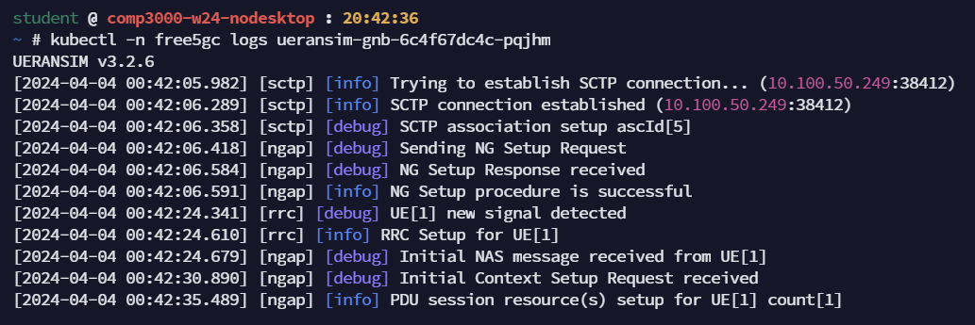
4. kubectl -n free5gc logs ueransim-ue-597b8dcf4-sm922  
   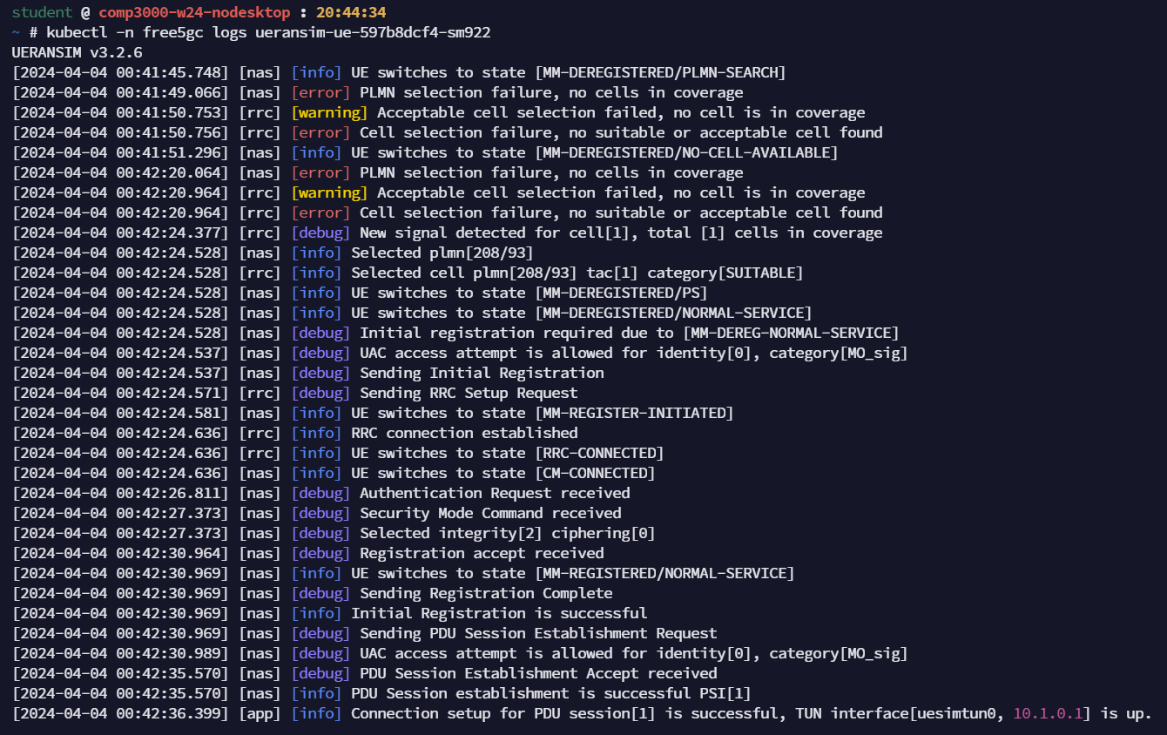
5. kubectl -n free5gc exec -it ueransim-ue-597b8dcf4-sm922 -- bash
6. root@ueransim-ue-597b8dcf4-sm922:/ueransim/build# ./nr-cli imsi-208930000000003 -e "ps-list"  
   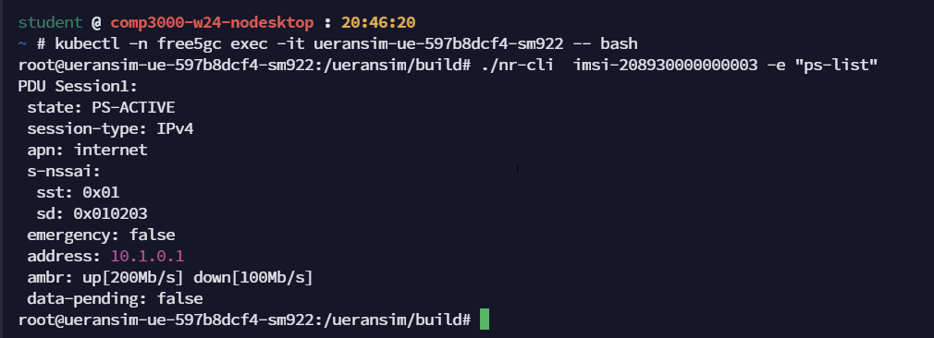
7. ip a  
   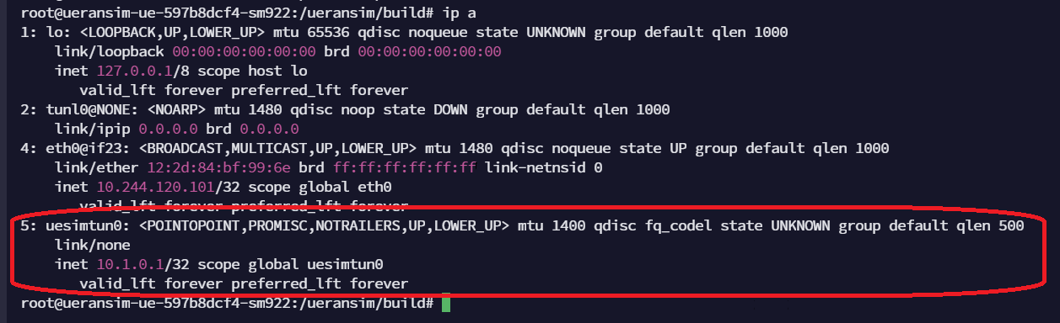

# Ping using uesimtun0 interface

1. ping -I uesimtun0 www.google.ca  
   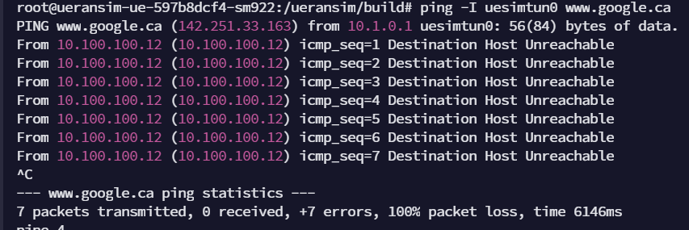

# Example of a Tcpdump from an istio-proxy side car

1. kubectl -n free5gc exec -it free5gc-v1-free5gc-amf-amf-6fc4bf584-r6szd -c istio-proxy -- bash
2. istio-proxy@free5gc-v1-free5gc-amf-amf-6fc4bf584-r6szd:/$ cd /dev
3. istio-proxy@free5gc-v1-free5gc-amf-amf-6fc4bf584-r6szd:/dev$ sudo tcpdump -vvvv -i any -s 0 -w istio-amf.cap  
   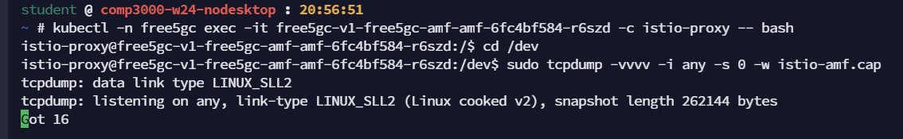
4. kubectl cp free5gc/free5gc-v1-free5gc-amf-amf-6fc4bf584-r6szd:/dev/istio-amf.cap -c istio-proxy istio-amf.cap  
   