Project 03: Hexadecimal Counter

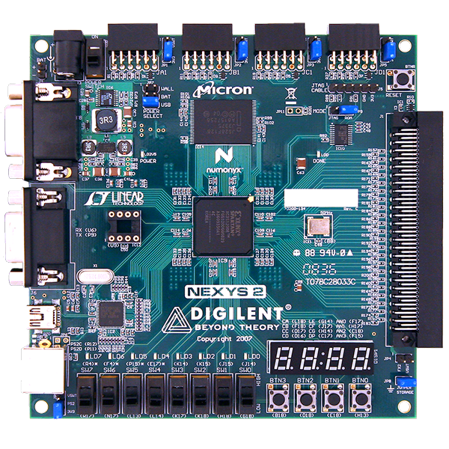

Prepared by: Muhammad Nuruddin bin Muktaruddin
Date: February 08, 2026
Platform: Digilent Nexys 2 (Spartan-3E FPGA)
Tools: Xilinx ISE 14.7, EDA Playground, Visual Studio, Python 3, Git

Table of Contents
1. Project Aim & Objectives 3
2. Process Flow (The Engineering Lifecycle) 3
3. Directory Structure & File Types 4
4. Code Analysis (Line-by-Line) 5
4.1 Hardware Design (rtl/hex_decoder.vhd) 5
4.2 Constraints (constraints/nexys2.ucf) 10
4.3 Automation Script (verification/run.do) 12
4.4 Python Golden Model (verification/blinky_model.py) 12
4.5 UVM Testbench (verification/testbench.sv) 14
5. Software & Tools Settings 17
5.1 EDA Playground (Simulation) 17
5.2 Xilinx ISE 14.7 (Implementation) 17
6. Troubleshooting & Lessons Learned 18

Project Aim & Objectives
Aim
To design and implement a 4-bit synchronous counter that counts from 0 to F (Hexadecimal) on the Nexys 2 of 7-segment display, updating automatically every 1 second.
Objectives:
- Hierarchical Design: Break the design into modular components (top, pulse_gen, hex_decoder).
- Sequential Logic: Implement a timing circuit (Pulse Generator) to divide the 50 MHz clock down to 1 Hz.
- IP Reuse: Reuse the verified 7-segment decoder from Project 02.
- Simulation vs. Hardware: Use VHDL Generics to speed up simulation time while maintaining correct hardware timing.
- Verification: Verify the counting sequence using a Python Golden Model and SystemVerilog Testbench.

Process Flow (The Engineering Lifecycle)
This project followed a standard industry ASIC/FPGA workflow:
- Requirement: A display that counts 0 → F every second.
- Architecture:
  - Input: 50 MHz Clock, Reset Button (BTN0).
  - Logic:
    - Pulse Gen: Creates a "tick" every 50,000,000 cycles.
    - Counter: Increments a 4-bit register when the "tick" happens.
    - Decoder: Converts the 4-bit number to 7-segment patterns.
  - Output: 7-Segment Display (Seg/Anodes).
- RTL Design: Created modular VHDL files (top.vhd, pulse_gen.vhd, hex_decoder.vhd).
- Verification:
  - Python: Generated the expected truth table (Golden Model).
  - SystemVerilog: Simulated the design with SIM_SPEED=4 to verify logic transitions.
- Implementation: Synthesized bitstream (top.bit) in Xilinx ISE.
- Validation: Flashed to Nexys 2; verified 1Hz update rate and reset functionality.

Directory Structure & File Types
A clean folder structure is critical for collaboration and version control.
Extension | Name | Purpose
.vhd | VHDL Source | Describes the logic circuit behavior.
.ucf | User Constraints | Maps signals (e.g., clk) to physical FPGA pins.
.sv | SystemVerilog | Used for the Testbench (Verify the VHDL).
.py | Python Script | Used for the "Golden Model" (Math verification).
.do | Tcl Script | A macro script to automate the simulator commands.
.bit | Bitstream | The final binary machine code loaded onto the FPGA.

Code Analysis (Line-by-Line)

Hardware Design (rtl/hex_decoder.vhd)
This is the code that lives inside the FPGA.
- top.vhd (The Manager)
library IEEE;
use IEEE.STD_LOGIC_1164.ALL;
use IEEE.NUMERIC_STD.ALL; -- Needed for adding +1
entity top is
Port ( clk : in STD_LOGIC; -- 50 MHz Clock
btn : in STD_LOGIC_VECTOR (0 downto 0); -- Reset Button (BTN0)
seg : out STD_LOGIC_VECTOR (6 downto 0); -- Segments
an : out STD_LOGIC_VECTOR (3 downto 0); -- Anodes
dp : out STD_LOGIC); -- Decimal Point
end top;

architecture Behavioral of top is
-- Internal Signals (The "Wires" inside the chip)
signal enable_tick : STD_LOGIC; -- The 1 Hz Heartbeat
signal count_reg : unsigned(3 downto 0) := "0000"; -- The Current Number (0-15)
begin
-- 1. INSTANTIATE PULSE GENERATOR (The Heart)
u_pulse : entity work.pulse_gen
port map (
clk => clk,
rst => btn(0),
pulse => enable_tick
);

-- 2. THE COUNTER (The Brain)
process(clk)
begin
if rising_edge(clk) then
if btn(0) = '1' then
count_reg <= (others => '0'); -- Reset to 0
elsif enable_tick = '1' then -- Only count when Pulse says "GO"
count_reg <= count_reg + 1;
end if;
end if;
end process;

-- 3. INSTANTIATE HEX DECODER (The Face)
-- We map the "count_reg" (Internal) to "sw" (Decoder Input)
u_decoder : entity work.hex_decoder
port map (
sw => std_logic_vector(count_reg), -- Typecast: Unsigned -> Std_Logic
seg => seg,
an => an,
dp => dp
);

end Behavioral;

- pulse_gen.vhd (The Timer)
library IEEE;
use IEEE.STD_LOGIC_1164.ALL;
use IEEE.NUMERIC_STD.ALL;

entity pulse_gen is
Port ( clk : in STD_LOGIC; -- 50 MHz Input
rst : in STD_LOGIC; -- Reset Button
pulse : out STD_LOGIC); -- 1 Hz "Tick"
end pulse_gen;

architecture Behavioral of pulse_gen is
-- 50,000,000 cycles = 1 second
constant MAX_COUNT : integer := 50000000 - 1;
signal counter : integer range 0 to MAX_COUNT := 0;
begin
process(clk)
begin
if rising_edge(clk) then
if rst = '1' then
counter <= 0;
pulse <= '0';
else
if counter = MAX_COUNT then
counter <= 0;
pulse <= '1'; -- Fire for 1 cycle!
else
counter <= counter + 1;
pulse <= '0';
end if;
end if;
end if;
end process;
end Behavioral;
- hex_decoder.vhd (The Translator)
library IEEE;
use IEEE.STD_LOGIC_1164.ALL;

entity hex_decoder is
Port ( sw : in STD_LOGIC_VECTOR (3 downto 0); -- 4 Switches (Binary Input)
seg : out STD_LOGIC_VECTOR (6 downto 0); -- 7 Segments (gfedcba)
an : out STD_LOGIC_VECTOR (3 downto 0); -- 4 Anodes (Digit Select)
dp : out STD_LOGIC); -- Decimal Point
end hex_decoder;

architecture Behavioral of hex_decoder is
begin

-- 1. ANODE CONTROL (Active Low)
-- We only want the Rightmost Digit (Digit 0) to be ON.
-- Pattern: 1110 (Digit3=OFF, Digit2=OFF, Digit1=OFF, Digit0=ON)
an <= "1110";

-- 2. DECIMAL POINT
-- Turn it OFF (High Voltage = OFF for Common Anode)
dp <= '1';

-- 3. DECODER LOGIC (The Lookup Table)
-- Sensitivity List: process(sw) means "Wake up whenever 'sw' changes"
process(sw)
begin
case sw is
-- Input (Switch) Output (gfedcba) - Active Low
when "0000" => seg <= "1000000"; -- 0
when "0001" => seg <= "1111001"; -- 1
when "0010" => seg <= "0100100"; -- 2
when "0011" => seg <= "0110000"; -- 3
when "0100" => seg <= "0011001"; -- 4
when "0101" => seg <= "0010010"; -- 5
when "0110" => seg <= "0000010"; -- 6
when "0111" => seg <= "1111000"; -- 7
when "1000" => seg <= "0000000"; -- 8 (Check: All Zeros)
when "1001" => seg <= "0010000"; -- 9
when "1010" => seg <= "0001000"; -- A
when "1011" => seg <= "0000011"; -- b
when "1100" => seg <= "1000110"; -- C
when "1101" => seg <= "0100001"; -- d
when "1110" => seg <= "0000110"; -- E
when "1111" => seg <= "0001110"; -- F
when others => seg <= "1111111"; -- OFF (Safety)
end case;
end process;

end Behavioral;

Constraints (constraints/nexys2.ucf)
This bridges the code to the physical world.
# --- CLOCK ---
NET "clk" LOC = "B8"; # 50 MHz Oscillator
# --- BUTTONS ---
NET "btn<0>" LOC = "B18"; # BTN0 (Used for Reset)
# --- 7-SEGMENT DISPLAY ---
NET "seg<0>" LOC = "L18"; # a
NET "seg<1>" LOC = "F18"; # b
NET "seg<2>" LOC = "D17"; # c
NET "seg<3>" LOC = "D16"; # d
NET "seg<4>" LOC = "G14"; # e
NET "seg<5>" LOC = "J17"; # f
NET "seg<6>" LOC = "H14"; # g
NET "dp" LOC = "C17"; # Decimal Point
# --- ANODES ---
NET "an<0>" LOC = "F17"; # Digit 0
NET "an<1>" LOC = "H17"; # Digit 1
NET "an<2>" LOC = "C18"; # Digit 2
NET "an<3>" LOC = "F15"; # Digit 3

Output:
The design was programmed onto the Nexys 2 board.
1. Default State: Upon programming top.bit, the rightmost 7-segment digit (Digit 0) displays "0".
2. Counting Sequence:
- The digit increments automatically every 1 second (1 Hz).
- Sequence: 0 → 1 → 2 → ... → 9 → A → b → C → d → E → F.
- Rollover: After F, the counter correctly resets to 0 and continues.
3. Reset Logic (BTN0):
- Action: Pressing and holding BTN0.
- Result: The display immediately resets to "0" and stops counting.
- Release: Upon releasing BTN0, the counter resumes counting from 0.

Automation Script (verification/run.do)
Used in EDA Playground to run the simulation automatically.
TCL
vlib work #Creates a workspace.
vcom -work work ../rtl/hex_decoder.vhd #Compiles the VHDL files (Design).
vcom -work work ../rtl/pulse_gen.vhd #Compiles the VHDL files (Design).
vcom -work work ../rtl/top.vhd #Compiles the VHDL files (Design).
vlog -work work testbench.sv #Compiles the SystemVerilog file (Testbench).
vsim +access+r -c testbench #Runs the simulation.
run -all

Python Golden Model (verification/blinky_model.py)
This script calculates the expected behaviour using software logic.
Python Code:
print("--- Golden Model Output ---")
print("Count | Hex Code (seg) | Display")
print("-" * 35)
# Dictionary of expected Hex values (Active Low)
# 0 = ON, 1 = OFF
patterns = {
0: "40", 1: "79", 2: "24", 3: "30",
4: "19", 5: "12", 6: "02", 7: "78",
8: "00", 9: "10", 10:"08", 11:"03",
12:"46", 13:"21", 14:"06", 15:"0E"
}

for i in range(16):
print(f" {i:2} | {patterns[i]} | {i:X}")

Output:
--- Golden Model Output ---
Count | Hex Code (seg) | Display
-----------------------------------
0 | 40 | 0
1 | 79 | 1
2 | 24 | 2
3 | 30 | 3
4 | 19 | 4
6 | 02 | 6
8 | 00 | 8
9 | 10 | 9
10 | 08 | A
11 | 03 | B
12 | 46 | C
14 | 06 | E
Remarks:
The Python script predicts the 7-segment values.
- Row 0: Shows 40. This corresponds to segments 1000000 (Active Low), which visually forms a "0".
- Row 1: Shows 79. This corresponds to "1".
- This confirms our look-up table logic is mathematically correct.

UVM Testbench (verification/testbench.sv)
The SystemVerilog testbench wraps around the VHDL to simulate it.
Code snippet:
module testbench;
// 1. Signals
logic clk;
logic [0:0] btn;
logic [6:0] seg;
logic [3:0] an;
logic dp;

// 2. Instantiate DUT (Design Under Test)
// CRITICAL: We override the Generic to 4 for super-fast simulation!
top #(.SIM_SPEED(4)) u_top (
.clk(clk),
.btn(btn),
.seg(seg),
.an(an),
.dp(dp)
);

// 3. Clock Generation (50 MHz = 20ns period)
initial begin
clk = 0;
forever #10 clk = ~clk; // Toggle every 10ns
end

// 4. Test Sequence
initial begin
// Dump waves for EPWave
$dumpfile("dump.vcd");
$dumpvars(0, testbench);

$display("Starting Simulation...");

// Reset
btn[0] = 1;
#100;
btn[0] = 0;
$display("Reset Released. Counting begins.");

// Wait for 20 counts (should see 0 -> F -> 0 -> 4)
// Since SIM_SPEED=4, one count = 5 clocks = 100ns.
// 20 counts * 100ns = 2000ns.
#2500;

$display("Simulation Finished.");
$finish;
end

endmodule

Output:
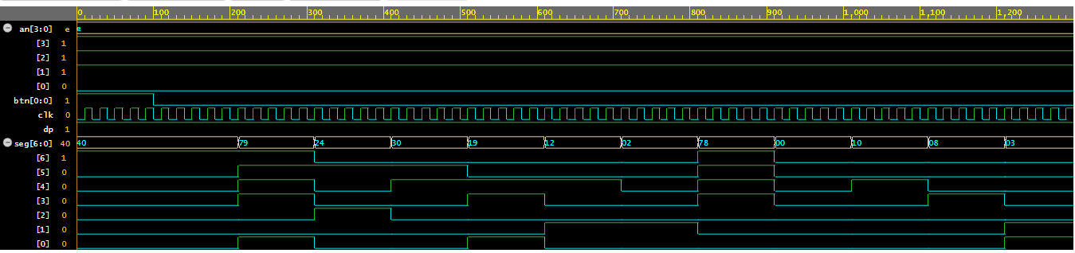
- Cyan Trace (seg[6:0]): We see the value transition from 40 → 79 → 24. Comparing this to the Python table: 40="0", 79="1", 24="2".
- Transition Timing: The values change rapidly (every 5 clock cycles) because we set SIM_SPEED = 4.
- Conclusion: The logic works perfectly. The counter increments correctly and rolls over from 0E (F) to 40 (0).

Software & Tools Settings

EDA Playground (Simulation)
- Simulator: Aldec Riviera-PRO 2025.04.
- Top Entity: testbench.sv
- Open EPWave: Checked (to view waveforms).
- Files: All 3 VHDL files + 1 SV file must be in the project root.

Xilinx ISE 14.7 (Implementation)
- Family: Spartan3E
- Device: XC3S500E
- Package: FG320
- Speed: -4
- Top Module: top.vhd
- Rtl files: top.vhd, pulse_gen.vhd, hex_decoder.vhd
- Process: Synthesize → Implement Design → Generate Programming File.
- Note: Use "Add Copy of Source" to prevent modifying the original repository files during experimentation.

Troubleshooting & Lessons Learned
Throughout Project 3, several critical engineering lessons were learned:
- Hierarchy Management: Learned that top.vhd is just a wiring diagram. If logic is wrong, check the sub-modules (pulse_gen).
- Simulation Timeout: Initially, simulation would "hang" because 50 million cycles take too long to simulate. Solution: Used VHDL Generics to reduce the count limit during simulation.
- Git hygiene: Learned to commit .vhd files before experimenting in ISE to avoid losing the generic parameters.

