Project 01: Switch-Controlled

LED Blinky

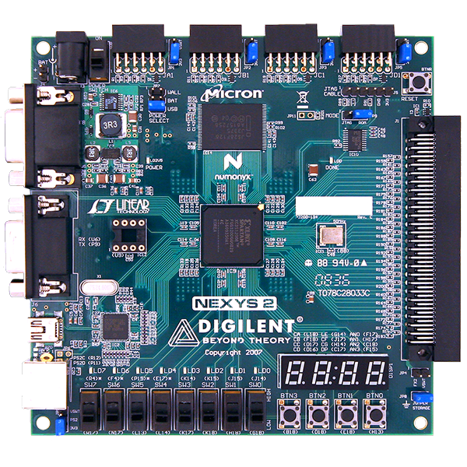

Prepared by: Muhammad Nuruddin bin Muktaruddin
Date: January 29, 2026
Platform: Digilent Nexys 2 (Spartan-3E FPGA)
Tools: Xilinx ISE 14.7, EDA Playground, Visual Studio, Python 3, Git

Table of Contents
1. Project Aim & Objectives 3
2. Process Flow (The Engineering Lifecycle) 3
3. Directory Structure & File Types 4
4. Code Analysis (Line-by-Line) 4
4.1 Hardware Design (rtl/blinky.vhd) 4
4.2 Constraints (constraints/nexys2.ucf) 5
4.3 Automation Script (verification/run.do) 5
4.4 Python Golden Model (verification/blinky_model.py) 6
4.5 UVM Testbench (verification/testbench.sv) 7
5. Software & Tools Settings 9
5.1 EDA Playground (Simulation) 9
5.2 Xilinx ISE 14.7 (Implementation) 9
6. Troubleshooting & Lessons Learned 10

Project Aim & Objectives
The primary goal of this project was to establish a complete RTL-to-Bitstream workflow for FPGA development. It moves beyond a simple "Hello World" by introducing conditional logic based on physical user input.
Specific Objectives:
- Hardware Control: Toggle an LED on/off using a physical slide switch.
- Verification Strategy: Use a Python Golden Model to verify logic before implementation.
- Simulation: Use UVM (Universal Verification Methodology) in EDA Playground to visualize timing.
- Version Control: Maintain a clean, professional Git repository, separating source code from build artifacts.

Process Flow (The Engineering Lifecycle)
The project followed a strict industry-standard lifecycle to ensure reliability.
- Requirement Analysis: Defined the inputs (Switch 0) and outputs (LED 0).
- Golden Model (Python): Wrote a Python script to calculate the expected "truth."
- RTL Design (VHDL): Wrote the hardware description code.
- Verification (EDA Playground): Simulated the VHDL against the Python model to catch logic errors.
- Synthesis (Xilinx ISE): Compiled the VHDL into physical gates for the Spartan-3E chip.
- Pin Planning (UCF): Mapped abstract VHDL signals to physical pins on the Nexys 2 board.
- Implementation: Generated the .bit file and programmed the board.

Directory Structure & File Types
A clean folder structure is critical for collaboration and version control.
Extension | Name | Purpose
.vhd | VHDL Source | Describes the logic circuit behavior.
.ucf | User Constraints | Maps signals (e.g., clk) to physical FPGA pins.
.sv | SystemVerilog | Used for the Testbench (Verify the VHDL).
.py | Python Script | Used for the "Golden Model" (Math verification).
.do | Tcl Script | A macro script to automate the simulator commands.
.bit | Bitstream | The final binary machine code loaded onto the FPGA.

Code Analysis (Line-by-Line)

Hardware Design (rtl/blinky.vhd)
This is the code that lives inside the FPGA.
VHDL
library IEEE;
use IEEE.STD_LOGIC_1164.ALL; -- Standard signal definitions
use IEEE.NUMERIC_STD.ALL; -- Allows math operations (unsigned)

entity blinky is
Port ( clk : in STD_LOGIC; -- 50MHz Clock Input
sw : in STD_LOGIC_VECTOR (0 downto 0); -- Switch Input
led : out STD_LOGIC_VECTOR (0 downto 0)); -- LED Output
end blinky;

architecture Behavioral of blinky is
signal counter : unsigned(25 downto 0) := (others => '0');
begin
process(clk)
begin
if rising_edge(clk) then
counter <= counter + 1; -- Count up every clock tick

-- CONDITIONAL LOGIC
if sw(0) = '1' then
led(0) <= counter(25); -- Blink (Bit 25)
else
led(0) <= '0'; -- Force OFF
end if;
end if;
end process;
end Behavioral;

Constraints (constraints/nexys2.ucf)
This bridges the code to the physical world.
Plaintext
NET "clk" LOC = "B8"; # Pin B8 -> 50MHz Crystal Oscillator
NET "sw<0>" LOC = "G18"; # Pin G18 -> Switch 0
NET "led<0>" LOC = "J14"; # Pin J14 -> LED 0 (Yellow)
Output:
The design was programmed onto the Nexys 2 board (Spartan-3E). The physical validation confirmed that Switch 0 (SW0) correctly acts as the "Enable" signal for the blinking logic.
Switch Input (SW0) | Logic State | Expected Output (LED0) | Observed Behaviour | Status
LOW (0) | Disabled | Forced OFF (Logic 0) | LED remained completely dark. | PASS
HIGH (1) | Enabled | Blinking (~0.74 Hz) | LED toggled ON/OFF continuously with a visible period of approx. 1.3 seconds. | PASS

Analysis of Timing:
The hardware utilizes Bit 25 of the binary counter driven by the 50 MHz onboard oscillator.
- Calculation: F_blink = 50,000,000/ (2^26) = approx. 0.745 Hz
- Observation: The LED blink rate matched the calculated frequency (slow, human-visible toggling), confirming the clock division logic is functioning correctly on the physical silicon.
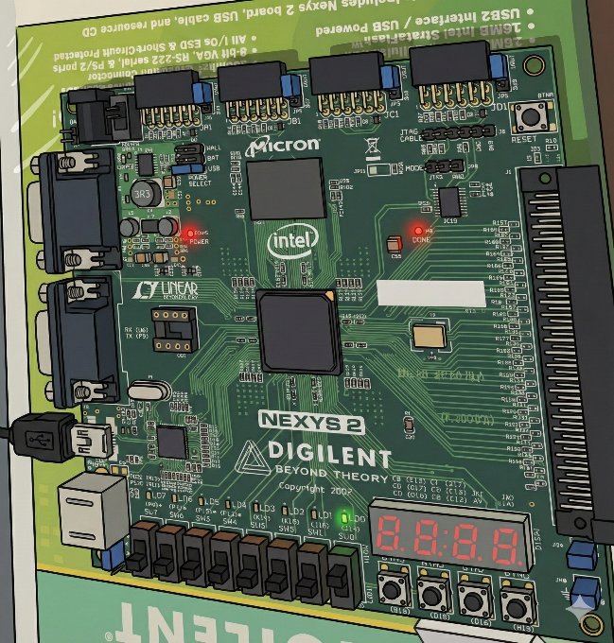
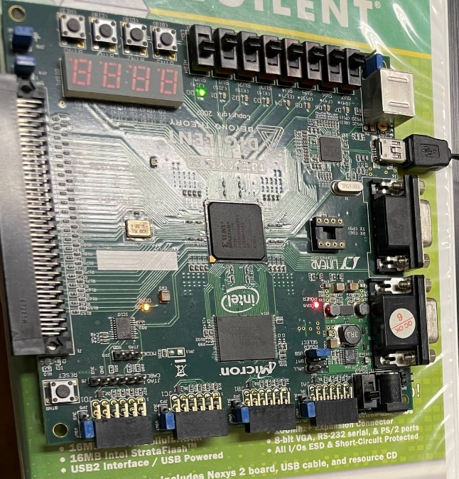

Automation Script (verification/run.do)
Used in EDA Playground to run the simulation automatically.
Tcl
vlib work # Create "work" library
vcom ../rtl/blinky.vhd # Compile VHDL Source
vlog +incdir+... testbench.sv # Compile Testbench
vsim -c top -L uvm_1_2 # Run Simulator (Command Line)
run -all # Run until finished

Python Golden Model (verification/blinky_model.py)
This script calculates the expected behaviour using software logic.
Python Code:
class BlinkyFPGA:
def __init__(self, simulation_mode=False):
# State Variables (Registers)
self.counter = 0
self.sw = 0
self.led = 0
# PARAMETERIZATION:
# Hardware uses Bit 25 (Slow). Simulation uses Bit 4 (Fast).
if simulation_mode:
self.target_bit = 4
else:
self.target_bit = 25
def rising_edge_clk(self):
"""Emulates the behavior of the VHDL process(clk)"""
# 1. Counter Logic: Increment by 1
self.counter += 1

# 2. Rollover Logic: Simulate 26-bit hardware limit
if self.counter >= 67108864:
self.counter = 0

# 3. Switch Logic (The core verification target)
if self.sw == 1:
# If Switch is ON, LED takes value of the Target Bit
# (Right shift by target_bit and mask with 1)
self.led = (self.counter >> self.target_bit) & 1
else:
# If Switch is OFF, LED is forced to 0
self.led = 0

# --- MAIN EXECUTION BLOCK ---
if __name__ == "__main__":
# Create instance in Simulation Mode (Fast)
dut = BlinkyFPGA(simulation_mode=True)
dut.sw = 1 # Force switch ON

# Run loop to print cycle-by-cycle behavior
for i in range(35):
dut.rising_edge_clk()
print(f"{i:<10} | {dut.counter:<10} | {dut.led}")

Output:
>>> MODE: Simulation Speedup (Bit 4)
Cycle | Counter | LED
------------------------------
0 | 1 | 0
1 | 2 | 0
2 | 3 | 0
3 | 4 | 0
4 | 5 | 0
5 | 6 | 0
6 | 7 | 0
7 | 8 | 0
8 | 9 | 0
9 | 10 | 0
10 | 11 | 0
11 | 12 | 0
12 | 13 | 0
13 | 14 | 0
14 | 15 | 0
15 | 16 | 1 <-- LED Turns ON (Bit 4 High)
16 | 17 | 1
17 | 18 | 1
18 | 19 | 1
19 | 20 | 1
20 | 21 | 1
21 | 22 | 1
22 | 23 | 1
23 | 24 | 1
24 | 25 | 1
25 | 26 | 1
26 | 27 | 1
27 | 28 | 1
28 | 29 | 1
29 | 30 | 1
30 | 31 | 1
31 | 32 | 0 <-- LED Turns OFF (Bit 4 Low)
32 | 33 | 0
33 | 34 | 0
34 | 35 | 0

UVM Testbench (verification/testbench.sv)
The SystemVerilog testbench wraps around the VHDL to simulate it.
Code snippet:
// 1. INTERFACE: Defines the wires connecting Testbench to DUT
interface blinky_if;
logic clk;
logic [0:0] sw;
logic [0:0] led;
endinterface

// 2. DRIVER: The "Hand" that flips switches
class blinky_driver extends uvm_driver;
// ... (UVM registration code) ...

virtual task run_phase(uvm_phase phase);
// TEST SCENARIO
vif.sw = 0; // Start with Switch OFF
#2000; // Wait 2000 nanoseconds
vif.sw = 1; // Turn Switch ON
#5000; // Wait 5000 nanoseconds
endtask
endclass

// 3. TOP MODULE: The physical connection
module top;
// Generate Clock: Toggle every 10ns (50 MHz)
logic clk;
initial begin
clk = 0;
forever #10 clk = ~clk;
end

// Instantiate Interface
blinky_if vif();
assign vif.clk = clk;

// Instantiate DUT (Device Under Test) - Connecting VHDL to SV
blinky dut (
.clk(vif.clk),
.sw(vif.sw),
.led(vif.led)
);

// Start UVM Test
initial begin
uvm_config_db#(virtual blinky_if)::set(null, "*", "vif", vif);
run_test("blinky_test");
end
endmodule
Output:
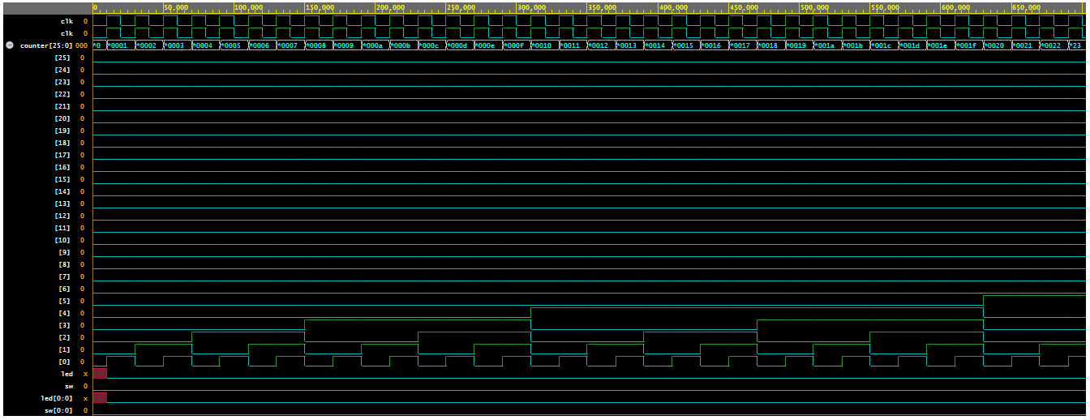

Software & Tools Settings

EDA Playground (Simulation)
- Limitation: Cloud simulators are slow. Simulating 1 second of real time (50 million cycles) takes hours.
- Workaround: We implemented a "Simulation Speedup" parameter.
  - Hardware Mode: Uses Bit 25 (Slow blink).
  - Simulation Mode: Uses Bit 4 (Fast blink, only 16 cycles).
- Tools Used: Aldec Riviera-PRO (simulator) and UVM 1.2 (verification library).

Xilinx ISE 14.7 (Implementation)
- Role: Synthesizes the VHDL into hardware gates.
- Setting: Configured for Spartan-3E (XC3S500E-4FG320).
- Crucial Step: Manually adding the source files from the clean 01_Blinky directory instead of creating them inside the project folder.

Troubleshooting & Lessons Learned
Throughout Project 1, several critical engineering lessons were learned:
- The "Ghost Folder" Issue:
  - Mistake: Created nested folders like 00_Logbook/00_Logbook.
  - Fix: Flattened the directory structure. Always check file paths before committing.
- Git "Trash" Files:
  - Mistake: The repository was initially cluttered with .ise, .ncd, and .html files.
  - Fix: Created a .gitignore file to automatically exclude build artifacts.
- Naming Mismatch (Critical):
  - Mistake: The UCF file used old names (clk_50mhz, led_out) while the new VHDL used standard names (clk, led). This caused synthesis failure.
  - Fix: Updated UCF to match VHDL port names exactly.
- Python Path Issue:
  - Mistake: Windows "App Execution Alias" prevented Python from running in VS Code.
  - Fix: Used the py launcher or installed Python directly from the Microsoft Store.

