Project 02: Hexadecimal Decoder

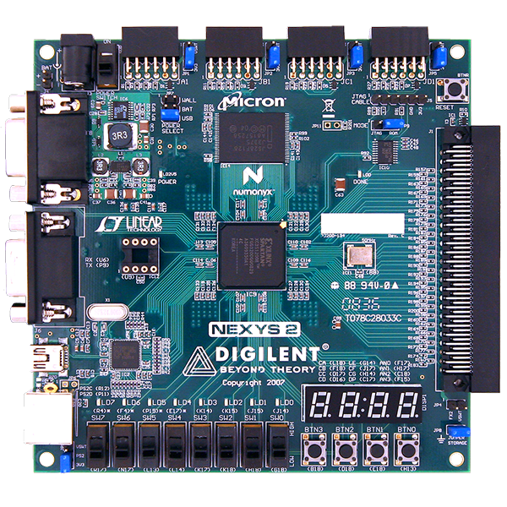

Prepared by: Muhammad Nuruddin bin Muktaruddin
Date: February 05, 2026
Platform: Digilent Nexys 2 (Spartan-3E FPGA)
Tools: Xilinx ISE 14.7, EDA Playground, Visual Studio, Python 3, Git

Table of Contents
1. Project Aim & Objectives 3
2. Process Flow (The Engineering Lifecycle) 3
3. Directory Structure & File Types 4
4. Code Analysis (Line-by-Line) 5
4.1 Hardware Design (rtl/hex_decoder.vhd) 5
4.2 Constraints (constraints/nexys2.ucf) 6
4.3 Automation Script (verification/run.do) 8
4.4 Python Golden Model (verification/blinky_model.py) 8
4.5 UVM Testbench (verification/testbench.sv) 11
5. Software & Tools Settings 13
5.1 EDA Playground (Simulation) 13
5.2 Xilinx ISE 14.7 (Implementation) 13
6. Troubleshooting & Lessons Learned 14

Project Aim & Objectives
Aim
To design and implement a Combinational Logic Circuit on an FPGA that decodes a 4-bit binary input (from physical slide switches) into a human-readable Hexadecimal character (0-9, A-F) on a 7-Segment Display.
Objectives:
- Logic Design: Implement a 4-to-7 binary decoder using VHDL case statements (Look-up Table approach).
- Hardware Control: Master the Common Anode driving technique (Active Low Logic: 0 = ON, 1 = OFF) required for the Nexys 2 display.
- Verification: Develop a "Golden Model" in Python to mathematically verify the segment patterns before implementation.
- Simulation: Validate the logic using a directed SystemVerilog testbench in a cloud-based simulator (EDA Playground).
- Implementation: Synthesize the design, apply pin constraints, and generate a bitstream using Xilinx ISE 14.7.

Process Flow (The Engineering Lifecycle)
This project followed a standard industry ASIC/FPGA workflow:
- Requirement Analysis: Defined the input (4-bit binary) and output (7-bit "gfedcba" pattern + Anode control).
- Golden Model Generation (Python): Wrote a Python script to generate the Truth Table. This confirmed that displaying "8" requires 0000000.
- RTL Design (VHDL): Translated the Truth Table into a VHDL case statement.
- Verification (SystemVerilog): Created a testbench to drive inputs 0x0 to 0xF and verified the output waveform.
- Constraints Definition (UCF): Mapped VHDL signals to physical pins on the Spartan-3E (e.g., sw<0> to Pin G18).
- Synthesis & Implementation (Xilinx ISE): Generated the .bit file.
- Hardware Validation: Flashed the board and manually verified all 16 states (0-F).

Directory Structure & File Types
A clean folder structure is critical for collaboration and version control.
Extension | Name | Purpose
.vhd | VHDL Source | Describes the logic circuit behavior.
.ucf | User Constraints | Maps signals (e.g., clk) to physical FPGA pins.
.sv | SystemVerilog | Used for the Testbench (Verify the VHDL).
.py | Python Script | Used for the "Golden Model" (Math verification).
.do | Tcl Script | A macro script to automate the simulator commands.
.bit | Bitstream | The final binary machine code loaded onto the FPGA.

Code Analysis (Line-by-Line)

Hardware Design (rtl/hex_decoder.vhd)
This is the code that lives inside the FPGA.
VHDL
library IEEE;
use IEEE.STD_LOGIC_1164.ALL; -- Standard signal definitions
use IEEE.NUMERIC_STD.ALL; -- Allows math operations (unsigned)

entity hex_decoder is
Port ( sw : in STD_LOGIC_VECTOR (3 downto 0); -- 4-bit Binary Input
seg : out STD_LOGIC_VECTOR (6 downto 0); -- 7 Segments (g-a)
an : out STD_LOGIC_VECTOR (3 downto 0); -- 4 Anodes (Digit Select)
dp : out STD_LOGIC); -- Decimal Point
end hex_decoder;

architecture Behavioral of hex_decoder is
begin
-- 1. ANODE CONTROL: Select only the Rightmost Digit (Digit 0)
-- '0' = ON for Anodes. "1110" turns ON Digit 0, others OFF.
an <= "1110";

dp <= '1'; -- Turn Decimal Point OFF (High Voltage)

-- 2. DECODER LOGIC: Updates instantly when 'sw' changes
process(sw)
begin
case sw is
-- Input Output (gfedcba) - Active Low
when "0000" => seg <= "1000000"; -- Display 0
when "1000" => seg <= "0000000"; -- Display 8 (All Segments ON)
-- ... (Full table 0-F implemented here)
when others => seg <= "1111111"; -- Default OFF (Safety)
end case;
end process;
end Behavioral;

Constraints (constraints/nexys2.ucf)
This bridges the code to the physical world.
Plaintext
# INPUTS (Switches)
NET "sw<0>" LOC = "G18"; # LSB
NET "sw<3>" LOC = "K17"; # MSB

# OUTPUTS (7-Segment Display)
NET "seg<0>" LOC = "L18"; # Segment 'a'
NET "seg<6>" LOC = "H14"; # Segment 'g'
NET "dp" LOC = "C17"; # Decimal Point

# ANODES (Digit Selection)
NET "an<0>" LOC = "F17"; # Digit 0 (Rightmost)
NET "an<3>" LOC = "F15"; # Digit 3 (Leftmost)
Output:
The design was programmed onto the Nexys 2 board. All 16 input combinations of the 4-bit switch vector (sw[3:0]) were tested. The 7-segment display output matched the expected Hexadecimal values exactly, confirming the Active Low logic and pin constraints.
Binary Input (SW3-SW0) | Decimal Value | Expected Hex | Observed Display | Status
0000 (All Low) | 0 | 0 | 0 | PASS
0001 (SW0 High) | 1 | 1 | 1 | PASS
0010 (SW1 High) | 2 | 2 | 2 | PASS
0011 (SW1+0 High) | 3 | 3 | 3 | PASS
0100 (SW2 High) | 4 | 4 | 4 | PASS
0101 (SW2+0 High) | 5 | 5 | 5 | PASS
0110 (SW2+1 High) | 6 | 6 | 6 | PASS
0111 (SW2+1+0 High) | 7 | 7 | 7 | PASS
1000 (SW3 High) | 8 | 8 | 8 | PASS
1001 (SW3+0 High) | 9 | 9 | 9 | PASS
1010 (SW3+1 High) | 10 | A | A | PASS
1011 (SW3+1+0 High) | 11 | B | b (Lowercase)* | PASS
1100 (SW3+2 High) | 12 | C | C | PASS
1101 (SW3+2+0 High) | 13 | D | d (Lowercase)* | PASS
1110 (SW3+2+1 High) | 14 | E | E | PASS
1111 (All High) | 15 | F | F | PASS
*Note: 'B' and 'D' are displayed in lowercase ('b', 'd') to avoid confusion with '8' and '0'.

Automation Script (verification/run.do)
Used in EDA Playground to run the simulation automatically.
Tcl
vlib work # Create library
vcom hex_decoder.vhd # Compile VHDL Design
vlog testbench.sv # Compile SystemVerilog Testbench
vsim +access+r -c top # Initialize Sim (Enable Read Access for Waveforms)
run -all # Run until completion

Python Golden Model (verification/blinky_model.py)
This script calculates the expected behaviour using software logic.
Python Code:

def get_seven_segment_code(value):
"""
Returns the 7-bit pattern (gfe_dcba) for a given hex digit (0-15).
Logic: 0 = ON, 1 = OFF
"""
# Map: '0' needs a,b,c,d,e,f ON (0). g OFF (1).
# Pattern: g f e d c b a
patterns = {
0: "1000000", # 0
1: "1111001", # 1 (only b, c on)
2: "0100100", # 2
3: "0110000", # 3
4: "0011001", # 4
5: "0010010", # 5
6: "0000010", # 6
7: "1111000", # 7
8: "0000000", # 8 (all on)
9: "0010000", # 9
10: "0001000", # A
11: "0000011", # b (lower case)
12: "1000110", # C
13: "0100001", # d (lower case)
14: "0000110", # E
15: "0001110" # F
}
return patterns.get(value, "1111111") # Default OFF

# --- MAIN EXECUTION ---
if __name__ == "__main__":
print(f"{'Hex':<5} | {'Binary (gfedcba)':<18} | {'Active Low Check'}")
print("-" * 45)

for i in range(16):
hex_char = hex(i).upper().replace("0X", "")
pattern = get_seven_segment_code(i)
print(f"{hex_char:<5} | {pattern:<18} | {'Valid'}")
Output:
Hex | Binary (gfedcba) | Active Low Check
---------------------------------------------
0 | 1000000 | Valid
1 | 1111001 | Valid
2 | 0100100 | Valid
3 | 0110000 | Valid
4 | 0011001 | Valid
5 | 0010010 | Valid
6 | 0000010 | Valid
7 | 1111000 | Valid
8 | 0000000 | Valid
9 | 0010000 | Valid
A | 0001000 | Valid
B | 0000011 | Valid
C | 1000110 | Valid
D | 0100001 | Valid
E | 0000110 | Valid
F | 0001110 | Valid

UVM Testbench (verification/testbench.sv)
The SystemVerilog testbench wraps around the VHDL to simulate it.
Code snippet:
// Testbench for Hex Decoder
module top;
// Signals
logic [3:0] sw; // 4 Switches
logic [6:0] seg; // 7 Segments (Output)
logic [3:0] an; // Anodes (Output)
logic dp; // Decimal Point (Output)

// Instantiate the VHDL DUT (Device Under Test)
hex_decoder dut (
.sw(sw),
.seg(seg),
.an(an),
.dp(dp)
);

// Test Logic
initial begin
$dumpfile("dump.vcd"); // Create waveform file
$dumpvars;

// Title
$display("-------------------------------------------");
$display("HEX | SW (Input) | SEG (Output) | Check");
$display("-------------------------------------------");

// Loop from 0 to 15 (0x0 to 0xF)
for (int i = 0; i < 16; i++) begin
sw = i; // Apply Input
#10; // Wait 10ns for logic to settle

// Print status
// %h = Hex format, %b = Binary format
$display(" %h | %b | %b |", sw, sw, seg);
end

$display("-------------------------------------------");
$finish; // End simulation
end
endmodule
Output:
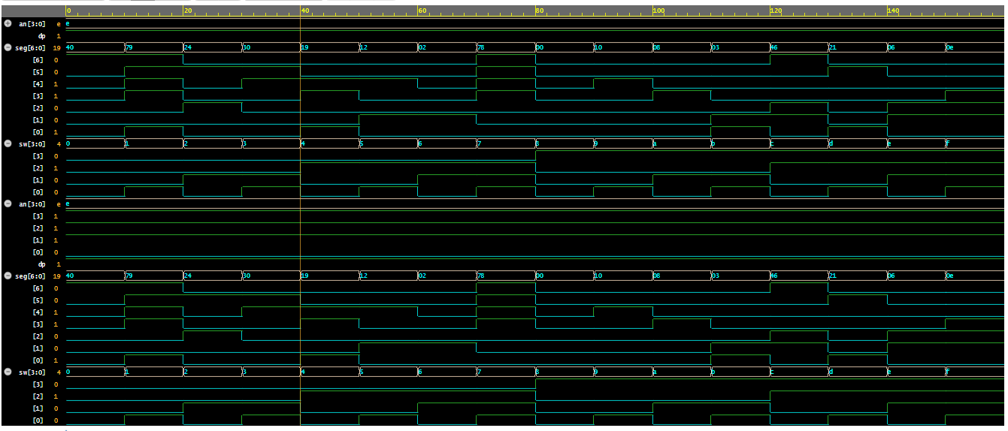

Software & Tools Settings

EDA Playground (Simulation)
- Simulator: Aldec Riviera-PRO 2023.04 (or later).
- Testbench Language: SystemVerilog / Verilog.
- Design Language: VHDL.
- Run Options: Checked "Use run.do Tcl file".
- Waveform Viewer: EPWave (Enabled via +access+r flag).

Xilinx ISE 14.7 (Implementation)
- Family: Spartan3E
- Device: XC3S500E
- Package: FG320
- Speed: -4
- Top Module: hex_decoder
- Process: Synthesize → Implement Design → Generate Programming File.

Troubleshooting & Lessons Learned
Throughout Project 1, several critical engineering lessons were learned:
- Waveform "Read Access" Error:
- Issue: Initially, EPWave would not load, and the console reported KERNEL_0085 "sw" does not have read access.
- Solution: Added the +access+r flag to the vsim command in run.do. This forces the simulator to expose signals for waveform viewing.
- Common Anode Logic:
- Concept: The Nexys 2 display is Common Anode, meaning the FPGA must sink current (Output 0) to turn a segment ON.
- Verification: The Python Golden Model proved that "8" corresponds to 0000000 (All Zeros), preventing logic inversion errors in VHDL.
- Digit Ghosting:
- Concept: Since all 4 digits share the same segment lines, enabling all Anodes (an <= "0000") would show the same number on all 4 digits.
- Implementation: Fixed an <= "1110" to ensure only the rightmost digit displays the value.

