**Population Density**

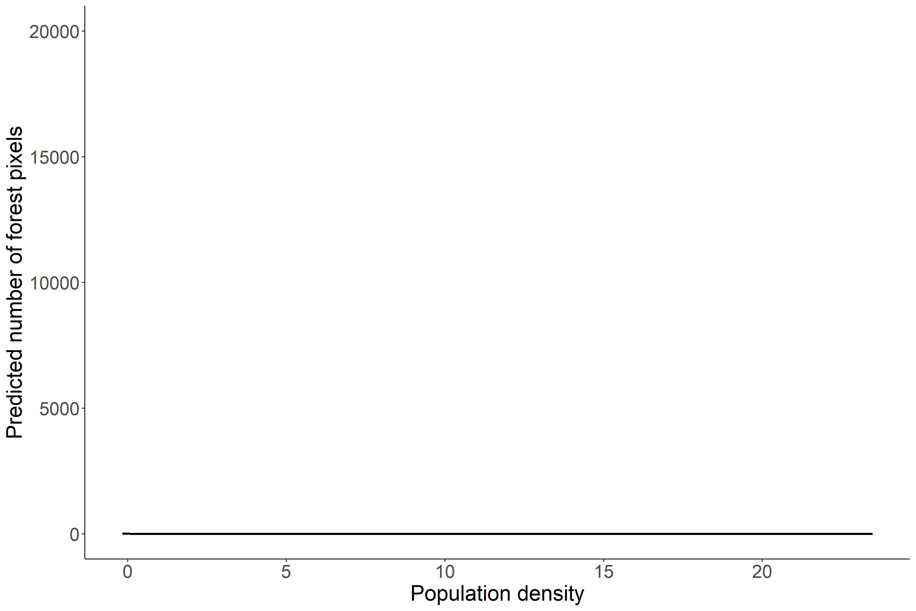

Figure. Global predicted effects of population density on forest cover for the whole of Cambodia. Population density is centered and scaled.

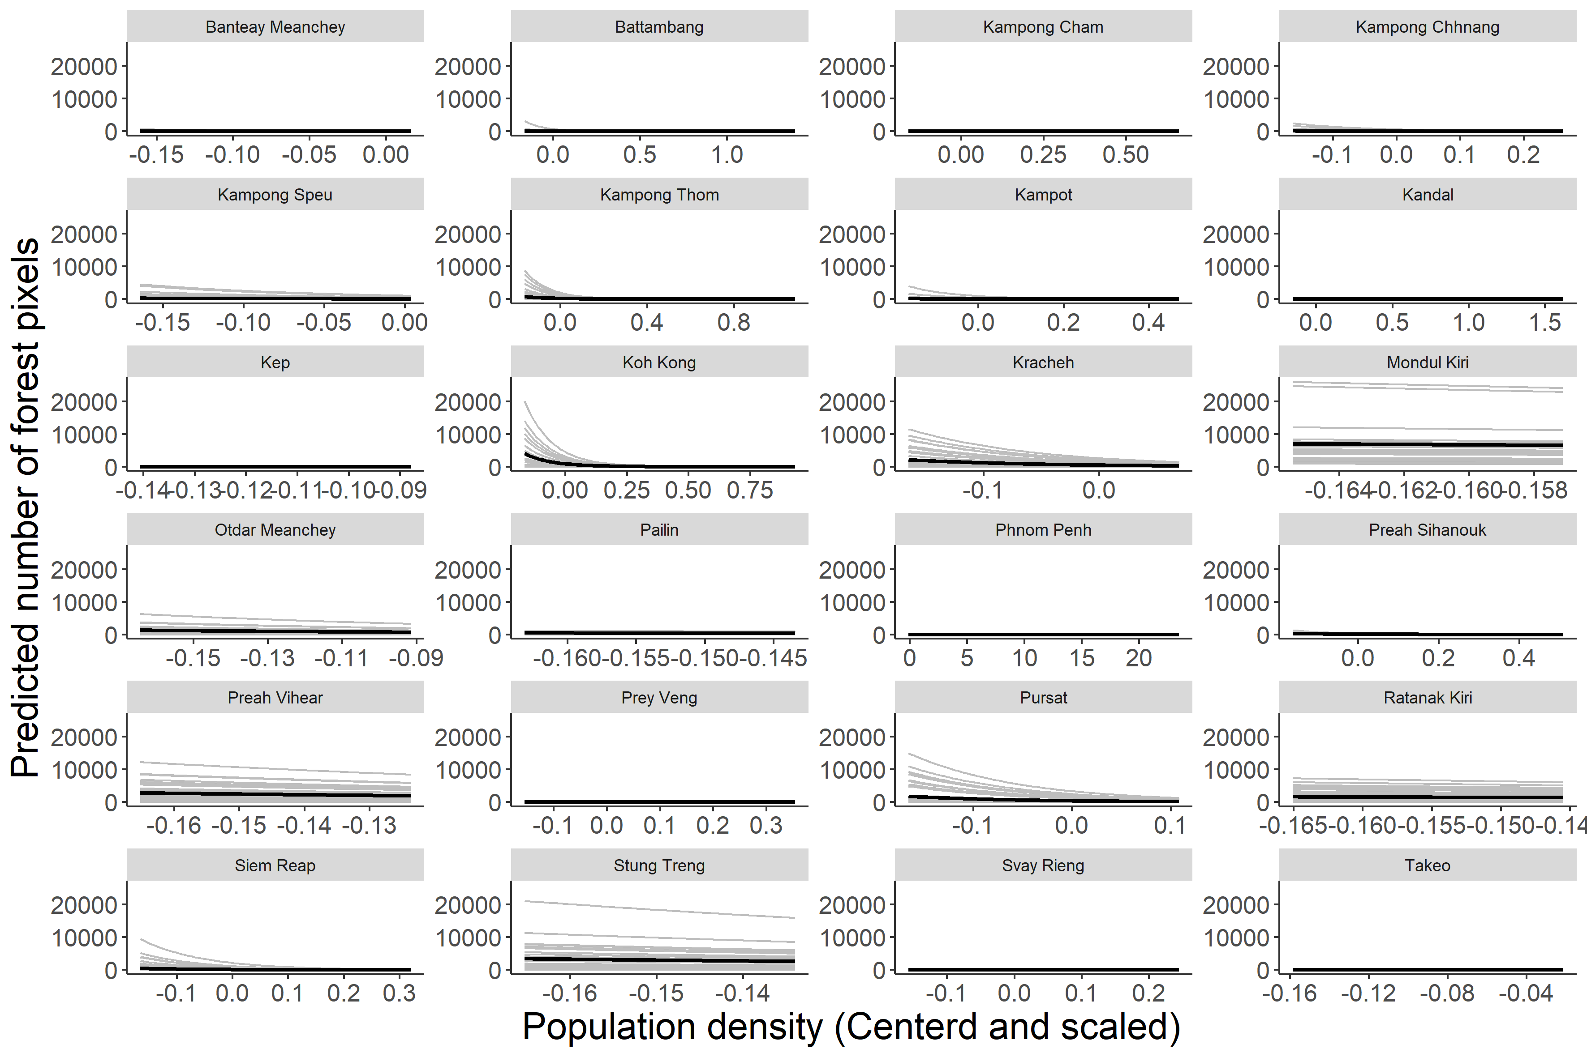

Figure. The predicted effects of population density on forest cover (forest pixels). Dark lines are the mean predictions for all communes within a province. Grey lines are the predictions for each individual commune within each province. Population density on the x axis is centered and scaled. Note the free x axes. Currently the range of population density values used for the predictions are limited to the actual range found within that province.

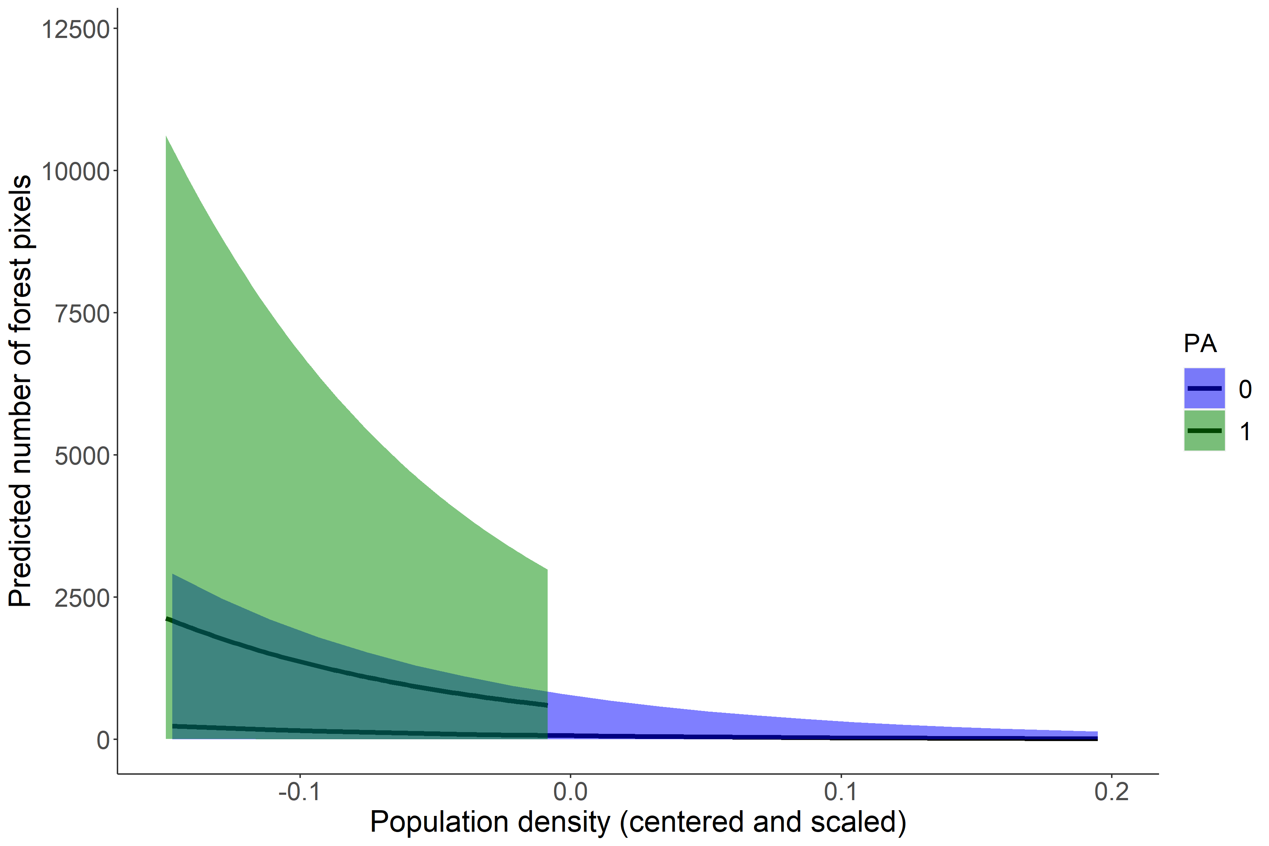

Figure. The predicted effects of population density on forest cover (in pixels) when a commune contains a protected area (1) or does no contain a protected area (0). The black lines are the mean predictions for all communes within each group, and the error ribbons are the 95% quantiles from all individual commune predictions. Note: I have right-truncated the x axis, because there are a handful of outlier communes that drag the x axis way up, making it impossible to see the interesting parts of the plot

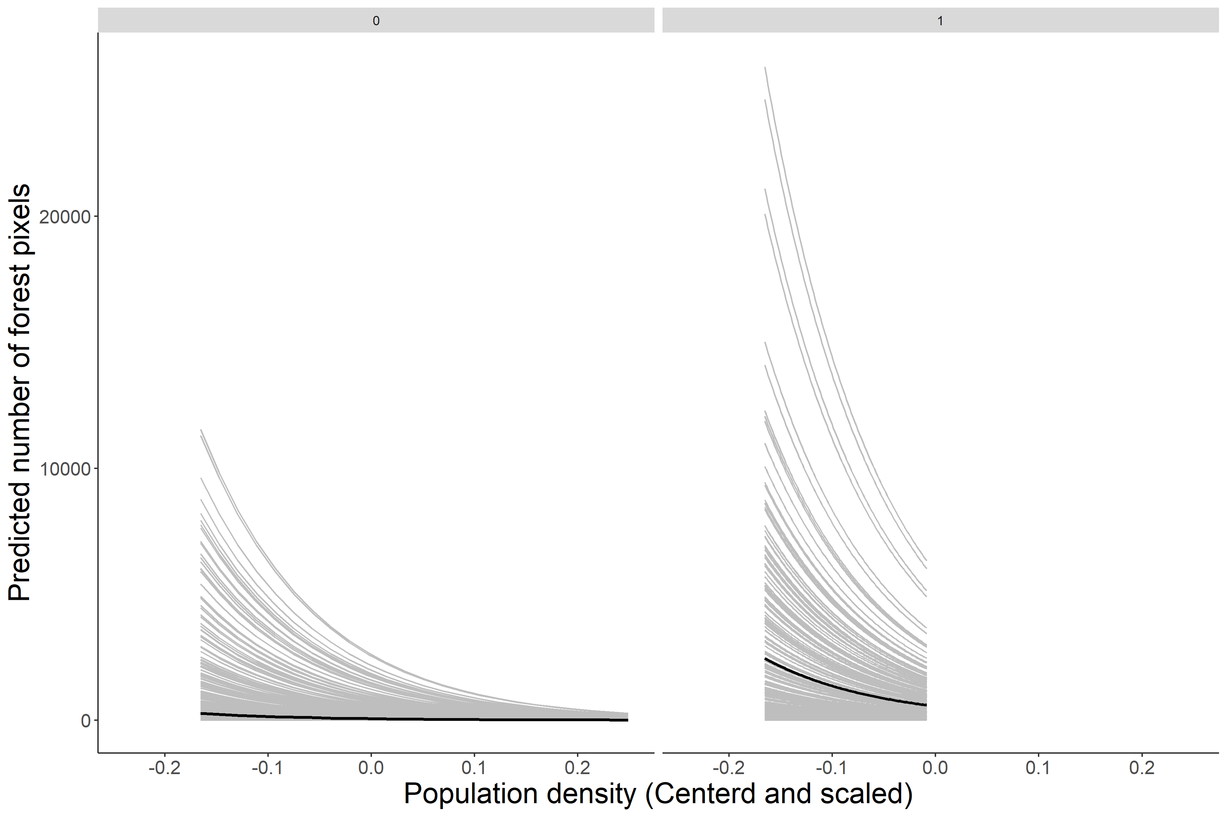

Figure. These are the same results as the above figure, but instead of 95% quantile ribbons I have plotted the predicted lines for all communes within each group. Left panel = communes with no PA, right panel = communes with PA. Black line is still the mean, light grey lines are the individual commune predictions. Note: I have right-truncated the x axis, because there are a handful of outlier communes that drag the x axis way up, making it impossible to see the interesting parts of the plot