**tibamoja – User Guide**

**Client**

Signs up in the homepage

The client uses the form in the home page to sign up in tibamoja application,

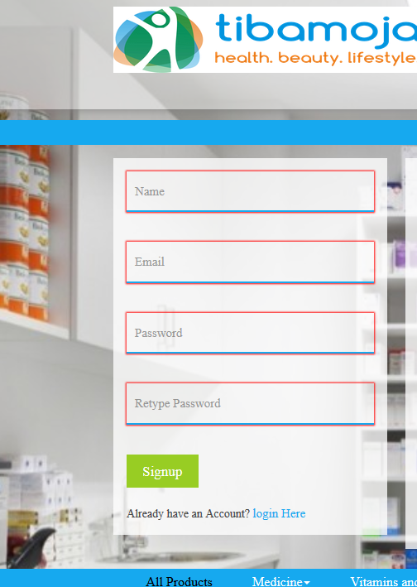

An email will be sent and prompt for activation:



Click the link to activate, then you can either login on webapp or mobile app to continue shopping.

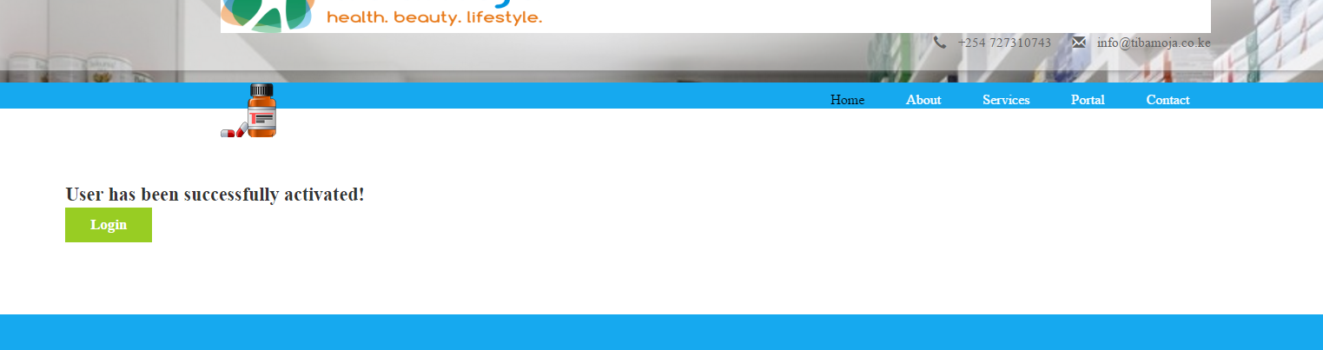

User can now login using the url: <http://www.tibamoja.co.ke/login>:

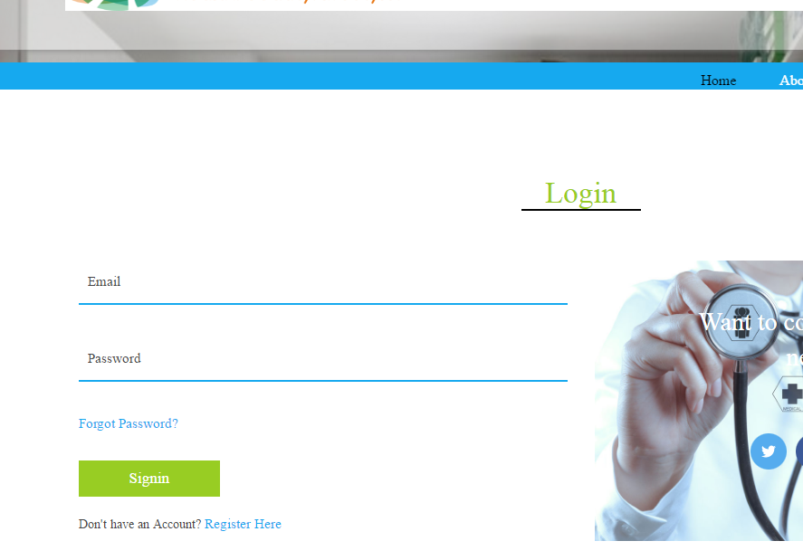

This will take you to a secure page where you can view, upload prescription, view invoices, orders, or even shop for medical products.



The button adds to cart adds an item to the cart. As shown:

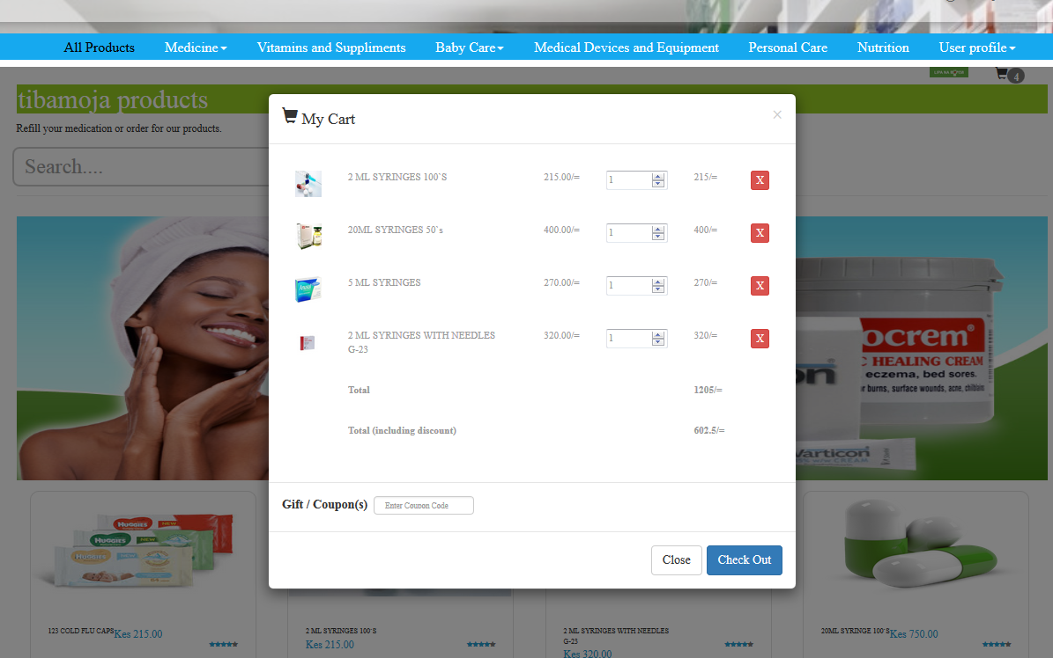

The check out will process the selected products and an email sent to the user, and another to the pharmacy indicating a new order has been made :



The body of the email is as shown:

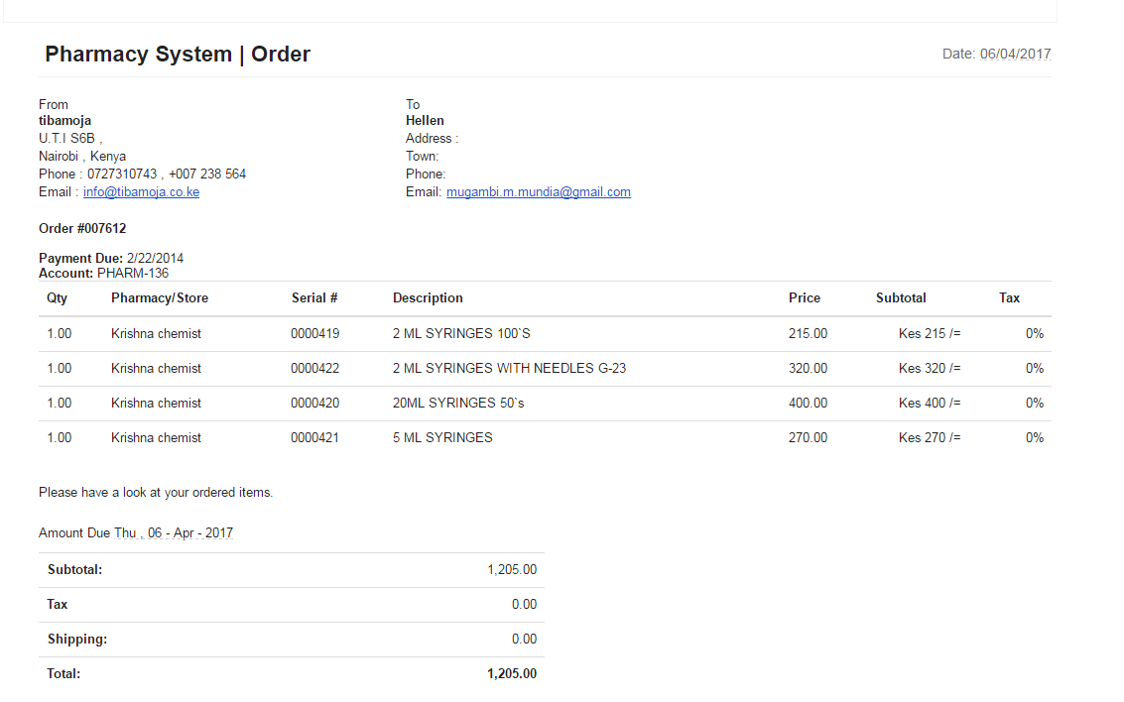

Chemist admin section:

All pharmacy/store admins can create an account using the menu on the web application ‘Portal’ click on

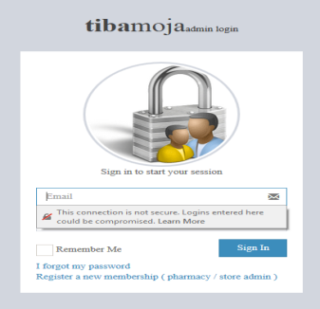The signup link which will give the below form:

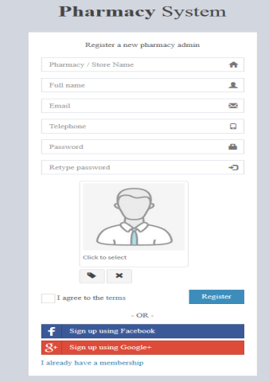 After a successful login, the pharmacy/store admin can have a view of all accessible backend portal functions, main modules:

* Stores

1. Pharmacy ~ pharmacy/store entries
2. Drugs ~ enter drugs prices, assign category to drugs , add categories etc
3. Coupons & Discounts ~ generate coupons and drug discounts

* Person

1. Patient ~ list patients in the system
2. Staff ~ pharmacy/store staff
3. System users ~ list the system users
4. Supplier ~ list of the drug suppliers

* Patient

1. Patient refill ~ display each patients refill, dosage, doctors comments etc
2. Patient Insurance ~ entry of patients insurance details
3. Patient bill ~ displays the patients bill
4. Patient payments ~ displays the patients payments
5. Immunizations ~ list the immunizations carried out to the patient
6. Prescription uploads ~ manages the prescriptions uploaded

* Transactions

1. New patient orders ~ lists new patients orders made , allows for order confrimation
2. Confirmed orders ~ list the confirmed orders
3. Invoices ~ lists the patient invoices

* Admin

1. Users ~ displays the list of users subscribed in the system
2. Roles ~ assigns roles or modules to be accessed by the staff
3. Settings ~ this contains system global settings

Pharmacy entry:

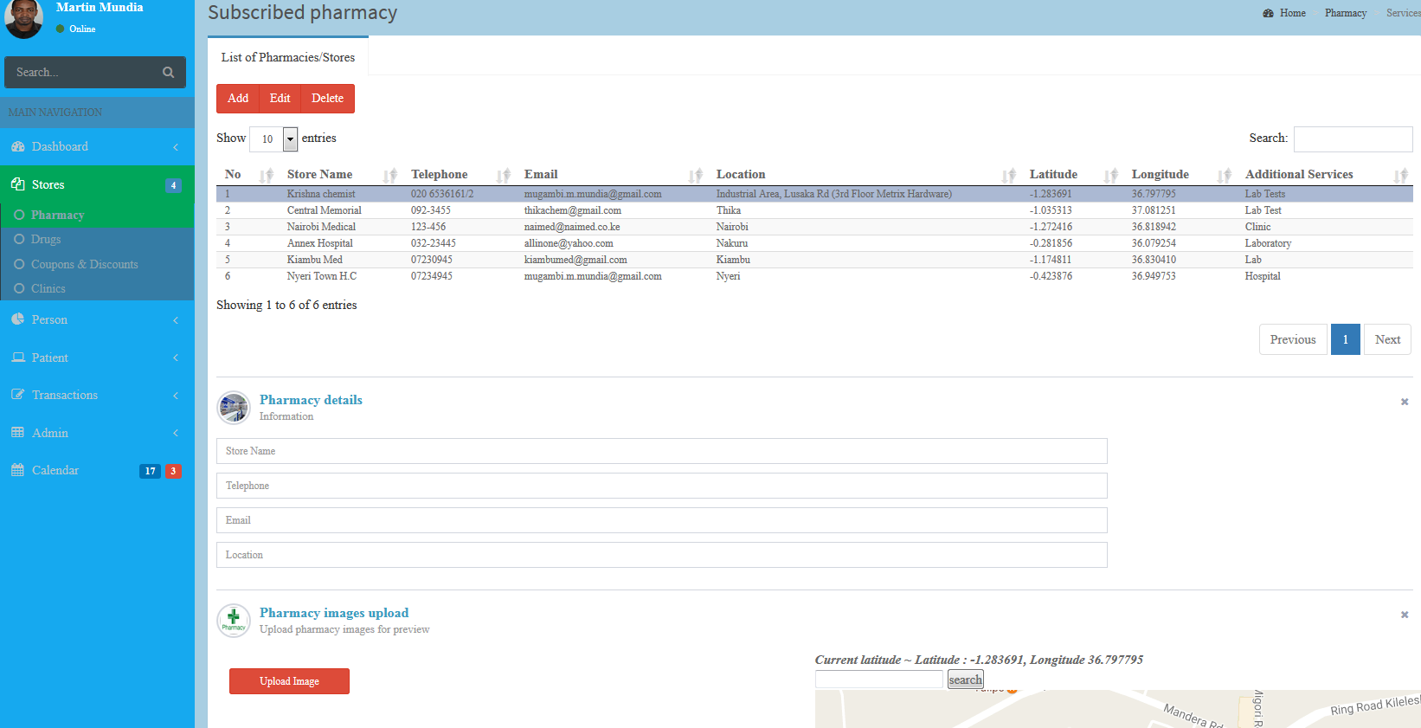

This page shows how pharmacy/stores are entered into the system,

Note, by dragging the map will give coordinates of the pharmacy location which you can edit, so as to allow access of location in the mobile application.

A Pharmacy admin is responsible of entering a drug list which can be uploaded using the Upload list buttons shown:

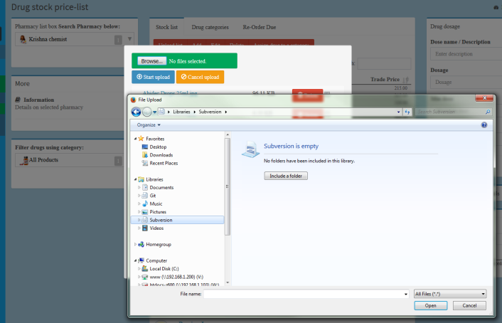

The drug list is linked to the pharmacy store; ensure you have the right store selected.

Second tab in drug is the Drug categories; this allows entry (add/edit/delete) of categories in the system:

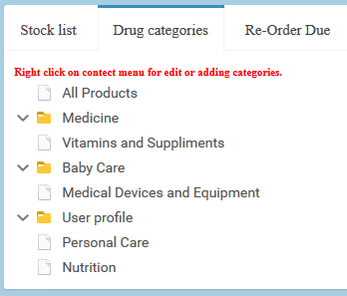

To edit /add /delete a category, right click for options:

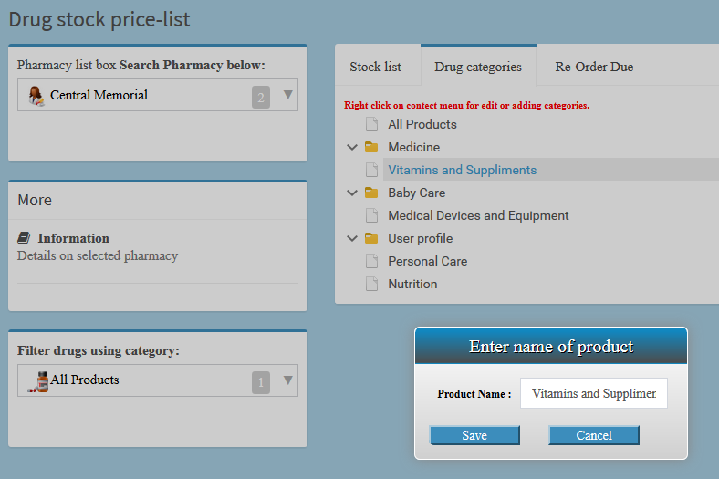

**NB: these are the categories in a drill down on the end user page.**

Still on the drug to assign a drug to a particular category use the button ‘Assign to a category’ which will display a from as shown:

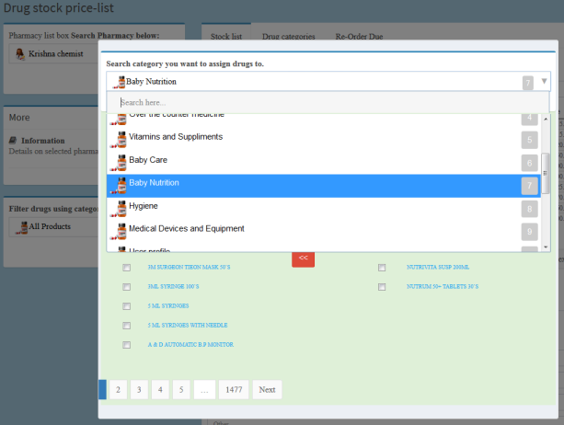

On the far right you can enter the dosage of the medication so that it can be visible to the user.

Next is the coupon, this page allows for generation of coupon codes and their prices:

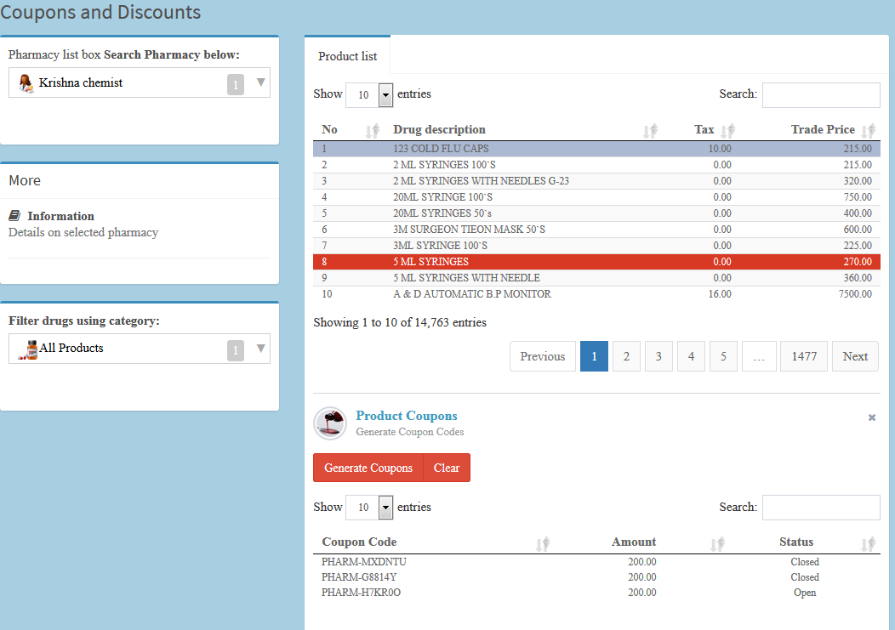

Used coupons will display as closed.

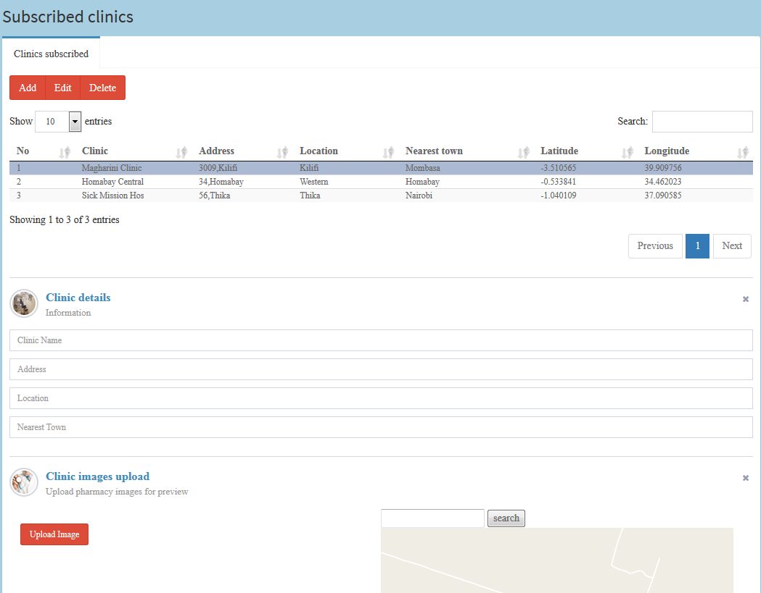

The clinics section has similar entry as the pharmacy, also set the location.

Patients enrolled will be shown on this page:

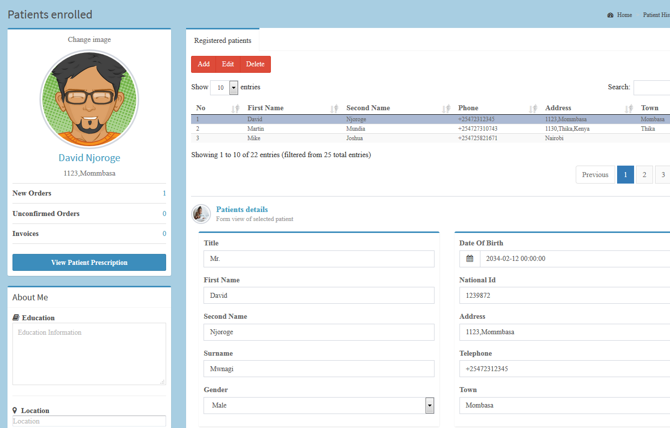

The next modules involve patient operations:

* Patient

1. Patient refill ~ display each patients refill, dosage, doctors comments etc
2. Patient Insurance ~ entry of patients insurance details
3. Patient bill ~ displays the patients bill
4. Patient payments ~ displays the patients payments
5. Immunizations ~ list the immunizations carried out to the patient
6. Prescription uploads ~ manages the prescriptions uploaded

So moving straight to the transaction module, this will display, the orders made , by users in mobile or the web application.

First is the New Patient Orders:

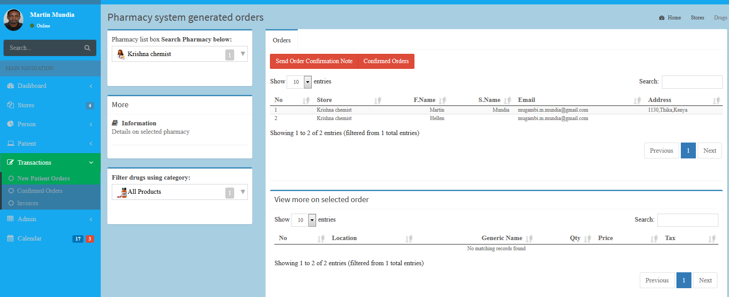

At this section you are able to see the order that was created by the user we registered ‘hellen’,

Pharmacy/chemist will now confirm the order, using the Send Order Confirmation note.

The importance of this:

* Ensure the order quantity user requested is available
* Ensure drug is available

The order confirmation forms will popup:

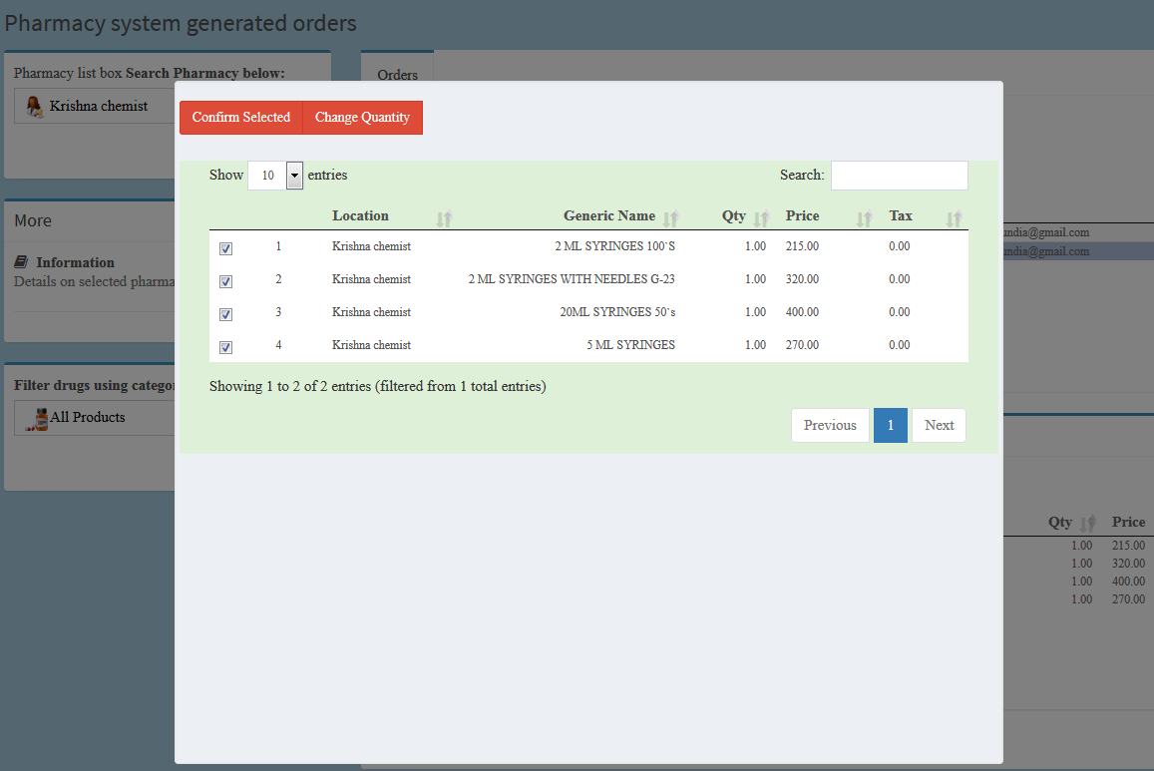

Select all the items you want to confirm, in addition you can adjust the quantity then click on confirm selected.

This will send an order confirmation note to the client.

Click on the confirmed orders you will see Helen’s order there which you can now send an invoice to her by clicking the Send Invoice button

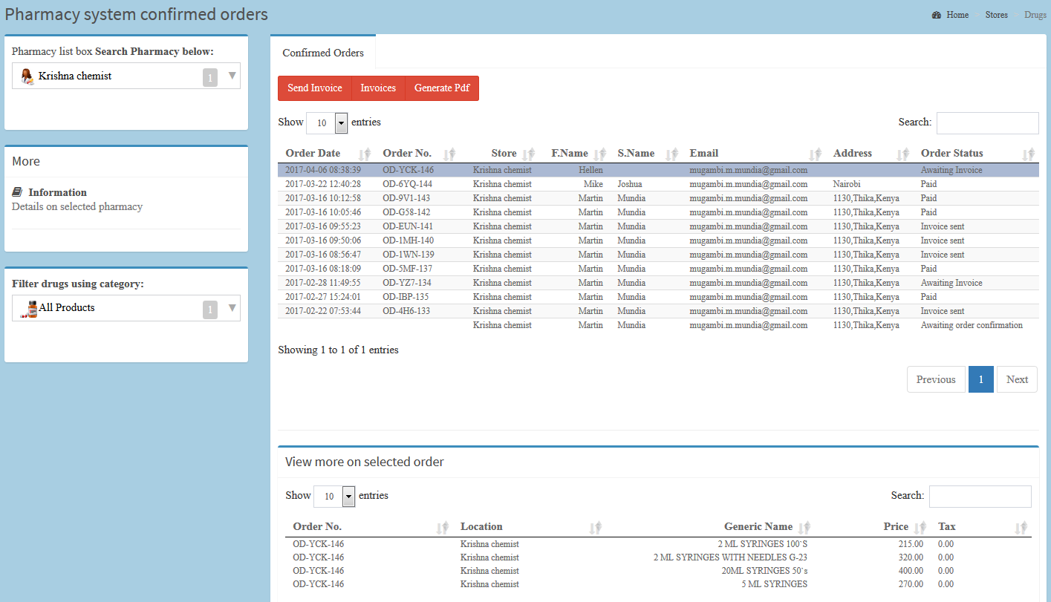

The generate invoice button will give you a pdf preview that you can print for the invoice:

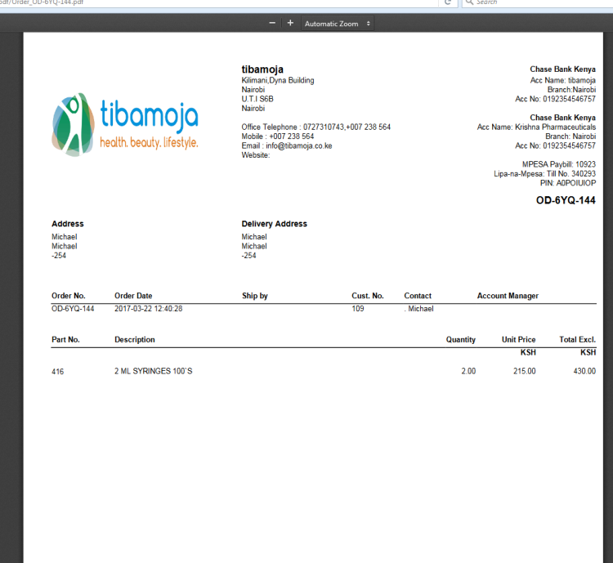

NB : Bank account in the pdf reflect bank account for the pharmacy/store,

The invoice sent will contain the payment links that allow the user to make the payment as shown:

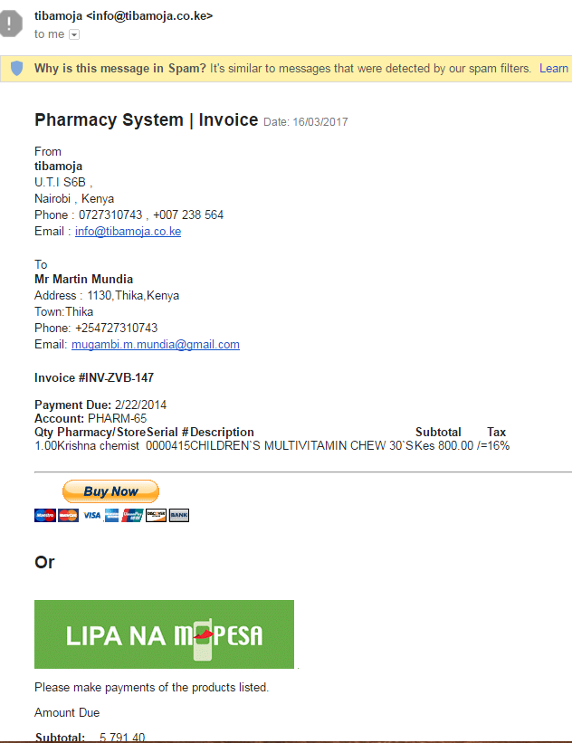

Clicking on the lipa na mpesa, a message will be displayed:

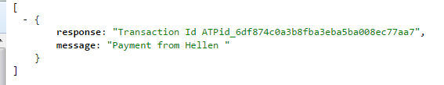

On your mobile, a USSD prompt will request you whether you need to complete the payment by entering your Mpesa pin as shown:

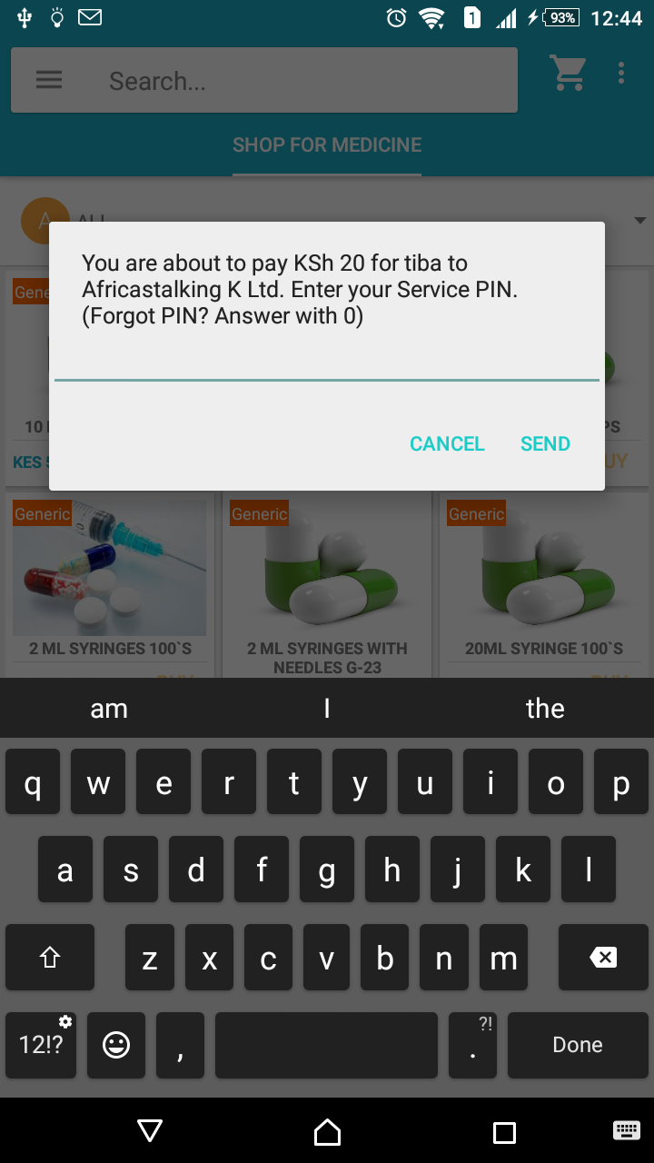

Once you enter the transaction is executed and Invoice flagged as paid.

The Paypal option will allow you to transact through card payment or PayPal account as shown:

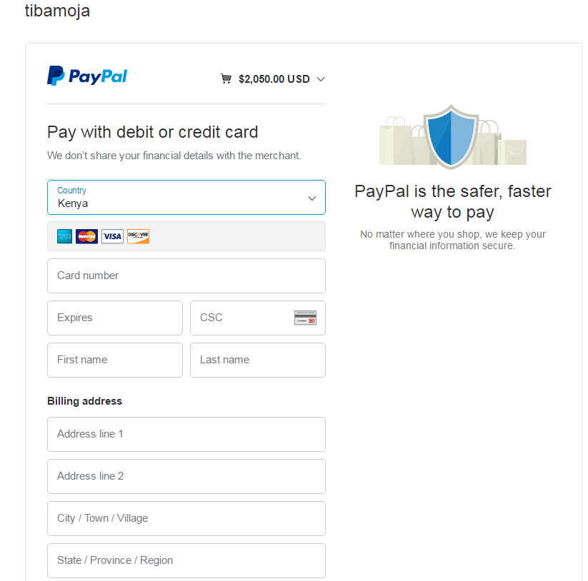

On the Backend the product statuses will be shown as paid:

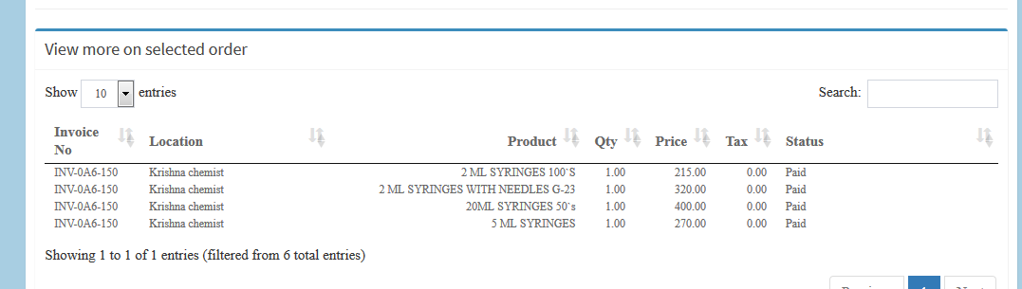

At the module Patient > Patient Payments, you will view what the patient has paid as shown below :

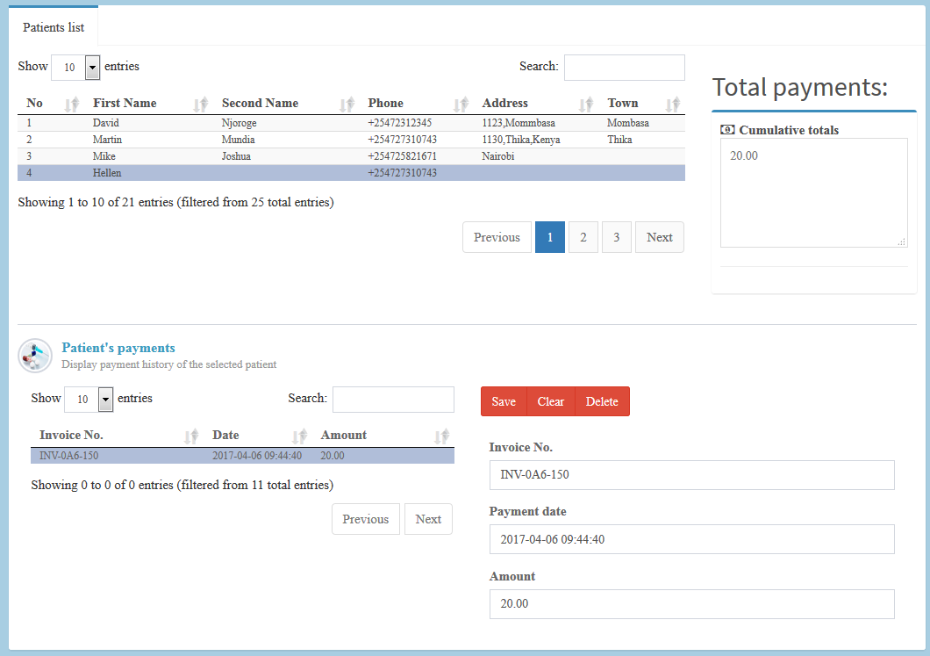

NB: Amount 20/= adjusted for payment demo purposes.

Super Admin Privilege.

This section will allow you to view super privileges, login is as the pharmacy/store admin , but has to be approved by the developer.

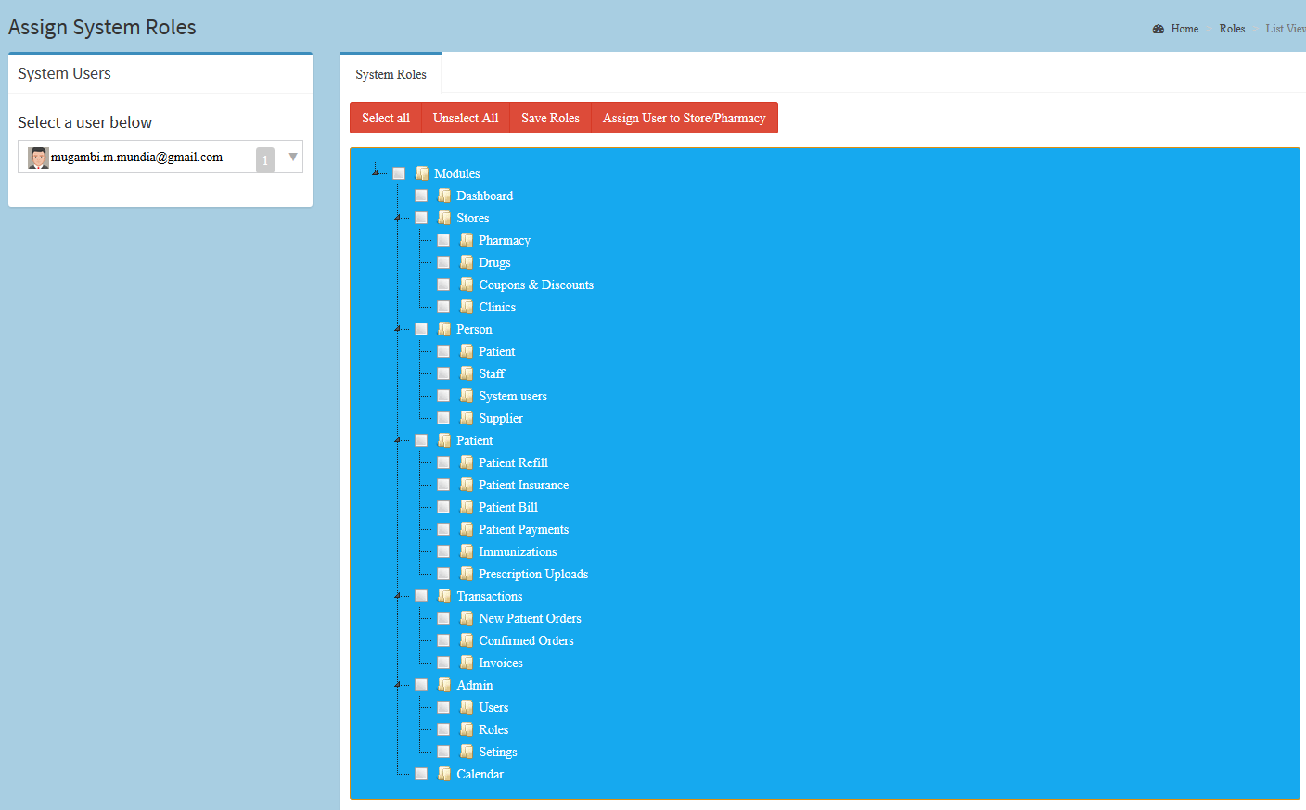

A pharmacy/store admin can be assigned which modules to access.

The button Assign user to store / pharmacy allows the user to only view products of that store once logged in the backend as shown:

