**Title: Title of your manuscript**

First Author1,2 Second Author2, and Third Author3

1 First Affiliation

2 Second Affiliation

3 Third Affiliation

##### Abstract

Your abstract.

# Introduction

Your introduction (Wright et al. 2004). Some more text (Kraft et al. 2008). More text (Hubbell 2001).

# Material and Methods

Your Material and Methods. We fitted XXXX:

$$N_{ij}∼NB(μ_{ij},ϕ) (1)$$

where $μ_{ij}$ is xxxxxx, xxxxxxxx,

$$μ_{ij}×v_{i}=exp(Σβ_{jk}z_{ik}) (2)$$

where $β_{jk}$ is xxxxxx. Prior for $ϕ$ in Eq. (1) was specified as xxxxx.

We found XXX (Fig. 1 and Table 1). We also found xxx (Fig. 2) yay! We did not find xxxx.

# Discussion

Some texts.

# References

Hubbell, S. P. 2001. The Unified Neutral Theory of Biodiversity and Biogeography. Princeton University Press.

Kraft, N. J. B., R. Valencia, and D. D. Ackerly. 2008. Functional traits and niche-based tree community assembly in an Amazonian forest. Science 322:580–582.

Wright, I. J., P. B. Reich, M. Westoby, D. D. Ackerly, Z. Baruch, F. Bongers, J. Cavender-Bares, T. Chapin, J. H. C. Cornellssen, M. Diemer, J. Flexas, E. Garnier, P. K. Groom, J. Gulias, K. Hikosaka, B. B. Lamont, T. Lee, W. Lee, C. Lusk, J. J. Midgley, M. L. Navas, Ü. Niinemets, J. Oleksyn, H. Osada, H. Poorter, P. Pool, L. Prior, V. I. Pyankov, C. Roumet, S. C. Thomas, M. G. Tjoelker, E. J. Veneklaas, and R. Villar. 2004. The worldwide leaf economics spectrum. Nature 428:821–827.

##### 

Table 1: . Summary of the regression model.

|  |  |  |  |  |
| --- | --- | --- | --- | --- |
|  | Estimate | Std. Error | t value | Pr(>|t|) |
| **(Intercept)** | 54.31 | 6.128 | 8.863 | 1.289e-09 |
| **wt** | -8.656 | 2.32 | -3.731 | 0.000861 |
| **cyl** | -3.803 | 1.005 | -3.784 | 0.0007472 |
| **wt:cyl** | 0.8084 | 0.3273 | 2.47 | 0.01988 |

##### 

##### Figures

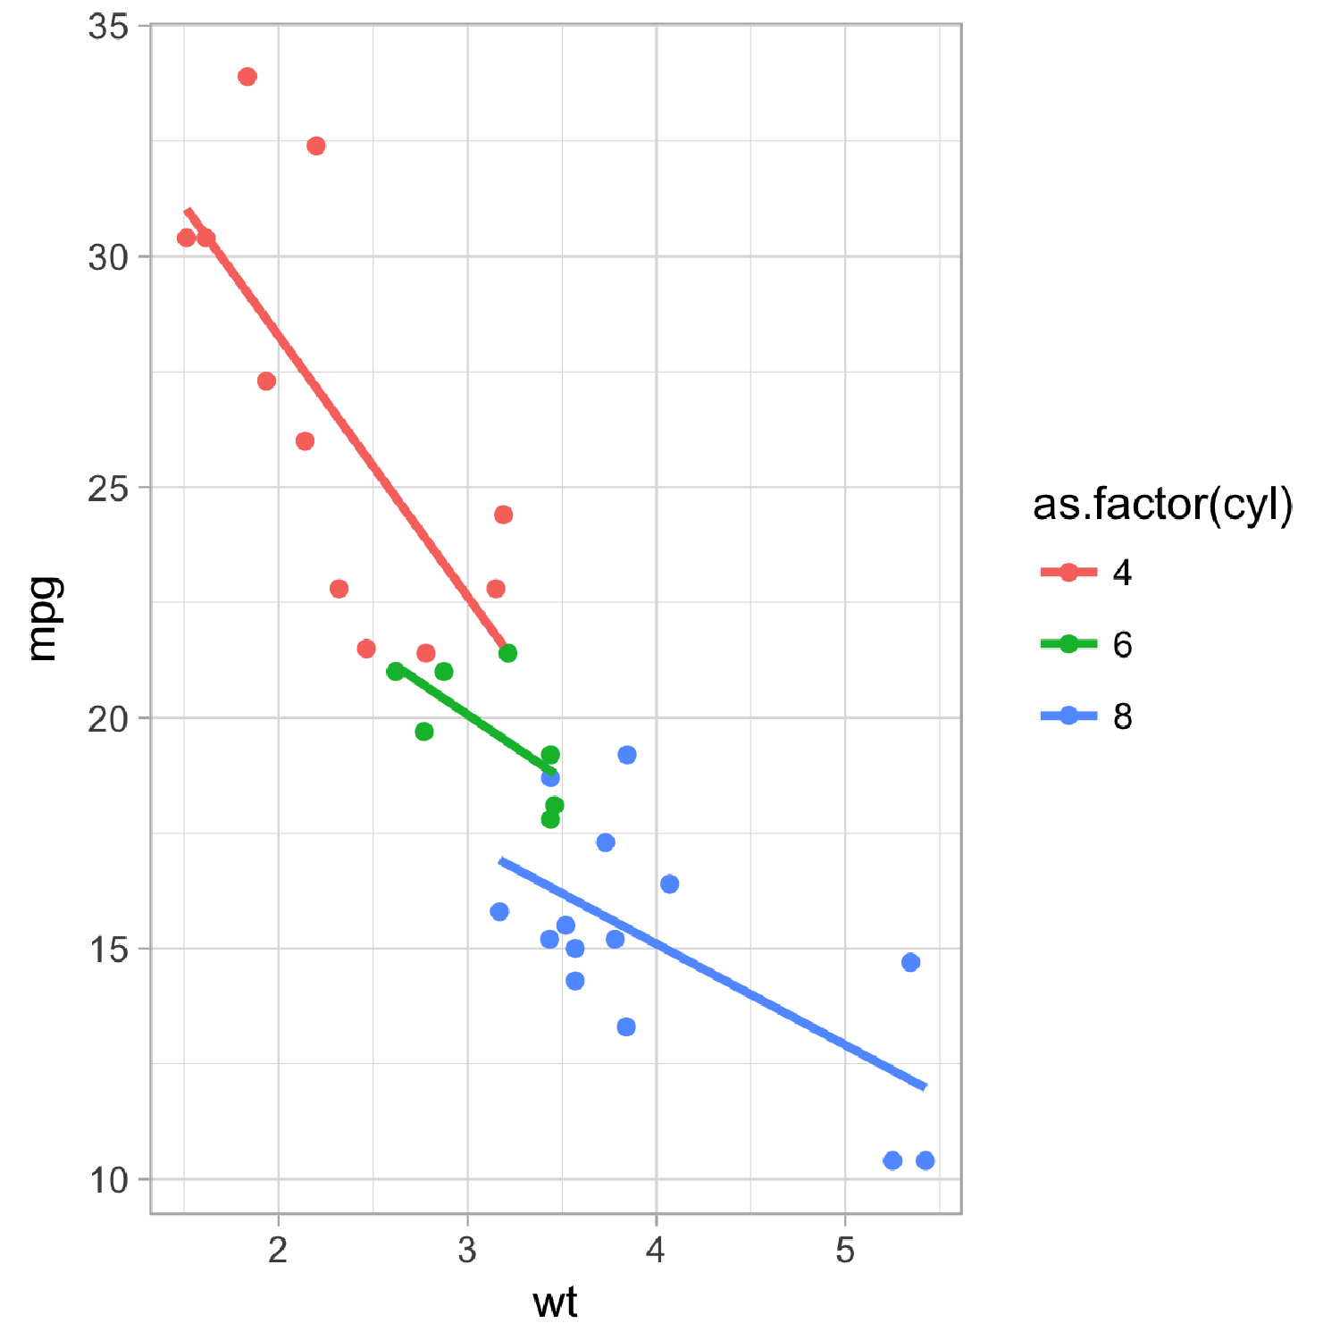

Figure 1: Scatter plot of XXX. Each point indicates XXXX.

##### 

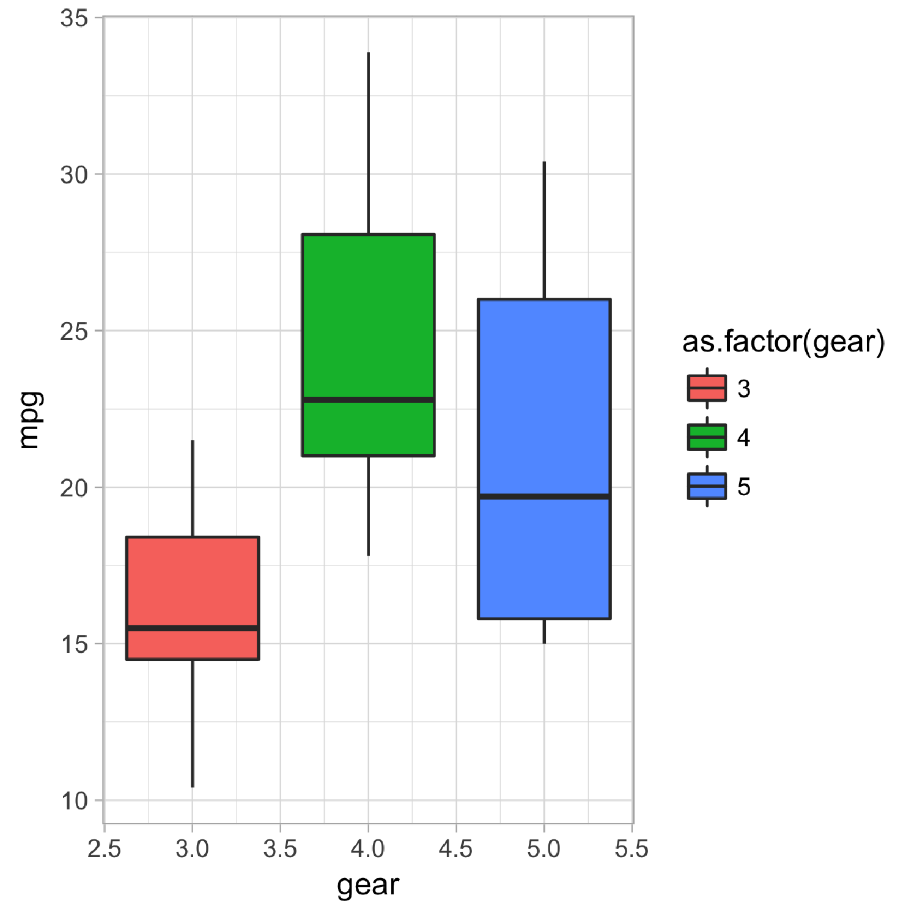

Figure 2: Boxplot of XXXX.