**Lab Number:3**

**Lab Title: MANETS**

**Abstract:** This was designed to create an understanding of larger wireless network, and how to ease the creation process within ns2. Further analysis is carried out with use of graphic representation of the generated trace files, with the focus on the difference between two protocols.

**Aim Objectives and Goals:** The aim of this lab was to develop and understanding of how to create larger topologies within ns2 and how to compare trace files.

* Understand how to incorporate traffic and movement files within a scenario in NS2
* Understand how to generate scenario traffic and movement files
* Understand how to compare two protocols using the properties of the connection
* Understand how to graphically represent properties of network connection using graphs generated from trace files

**Observations, Results, and Discussion:**

EX4

* Changing number of nodes from 25 to 100
* updating network grid limit from 150 to 500

EX5

Q1:

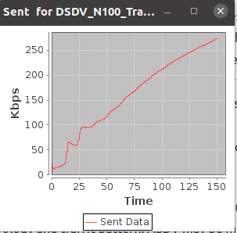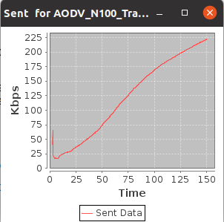

As expected we can see here that the DSDV protocol sends more data throughout the connection period. This is due to the proactive nature of the DSDV protocol. This means that nodes are continuously sending updates on routing. In contrast the ADSV protocol has a reactive nature meaning it only receives and processes updates when the current routing becomes an issue eg. lost/new node. Thus meaning that more data will be processed through a DSDV network than a similar ASDV.

These characteristic can also be shown when comparing jitter. With ASDV being reactive it can mean that a delay in the updating of routing information can cause some delay in sent packets. This is the opposite in DSDV as routing information is known quicker than ASDV. This is shown below as the DSDV encounters no jitter, when compared to the ASDV.

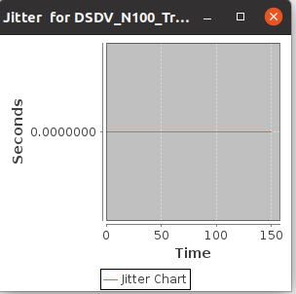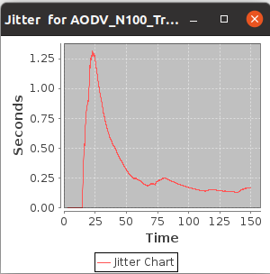

This difference in characteristics can also have positive effects on the network.

Given that there is typically less data being transferred with ASDV , efficiency can be improved in some cases.Especially in terms of generating faster throughput by limiting the time needed to establish new nodes.

This is shown in the two graphs below:

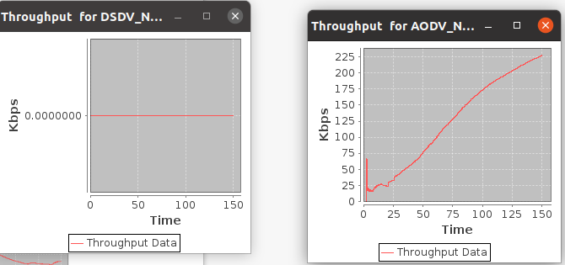

**Location of Practical Work:** /home/gla/mjo1/Documents/Networking_Labs/lab3