HandShake user manual v0.5
Author: Matthew Oppenheim
Contact: matt.oppenheim@gmail.com
v0.5 Apr 2020
See section Project files and website on where to obtain the latest version of this manual and the supporting files.
Table of Contents
Introduction 1
Safety 2
Parts 2
How to make your microbit wrist holder 2
Parts 3
Assembly 3
Operating Instructions 7
Getting code onto the Microbit transmitter and receiver boards 7
Use 8
How to alter the sensitivity 8
Controlling a PC application 9
Blink flasher 9
Leostick keyboard key press 9

Introduction
HandShake is designed to help enable people with mobility disability to interact with switchable software through hand gesture. It is aimed at people who cannot use push buttons or joysticks but who can make a voluntary hand or arm movement. There's no reason that HandShake couldn't be used with leg or foot motion, but I haven't tried this!
The HandShake hardware consists of two BBC micro:bit boards. One is a transmitter, which is worn on the user's wrist. The second is the receiver, which is attached to the communication device or computer using a micro USB cable. To attach the transmitter micro:bit to my wrist, I use a modified smart phone arm band. The transmitter detects a gesture and then communicates this to the receiver micro:bit. This second micro:bit says 'There's been a gesture!' to the communications device. This enables the wearer to control software through hand motion. More details of this project can be found online here.
A short YouTube video showing HandShake being tested at Beaumont College, Lancaster, UK can be seen here:
https://youtu.be/gRrBVgBbUFQ
The only part that cannot be bought off the shelf is something to fix the microbit and the battery pack to the user's wrist or arm. Pimoroni do sell a hard case with a wrist strap which may be suitable, but I have not yet tested this:
https://shop.pimoroni.com/products/hard-case-for-micro-bit
Instructions on how to build your own wrist holder for a micro:bit using a £5 smart phone arm band are included in this manual. The rest of this manual shows how to get code onto the micro:bits and onto the communication device. Optionally, you can use a Freetronics Leostick to pretend to be a keyboard to control switchable software through a key press. Then you also need to get some code onto the Leostick. All of this code is on the GitHub site mentioned at the start of this document. There are plenty of websites and YouTube videos that can help you with this if the instructions here aren't clear enough. Let me know if anything is not clear so that I can improve this manual.
I used Python 3.5 when writing the code. Testing took place on Windows 7, 8 and 10.
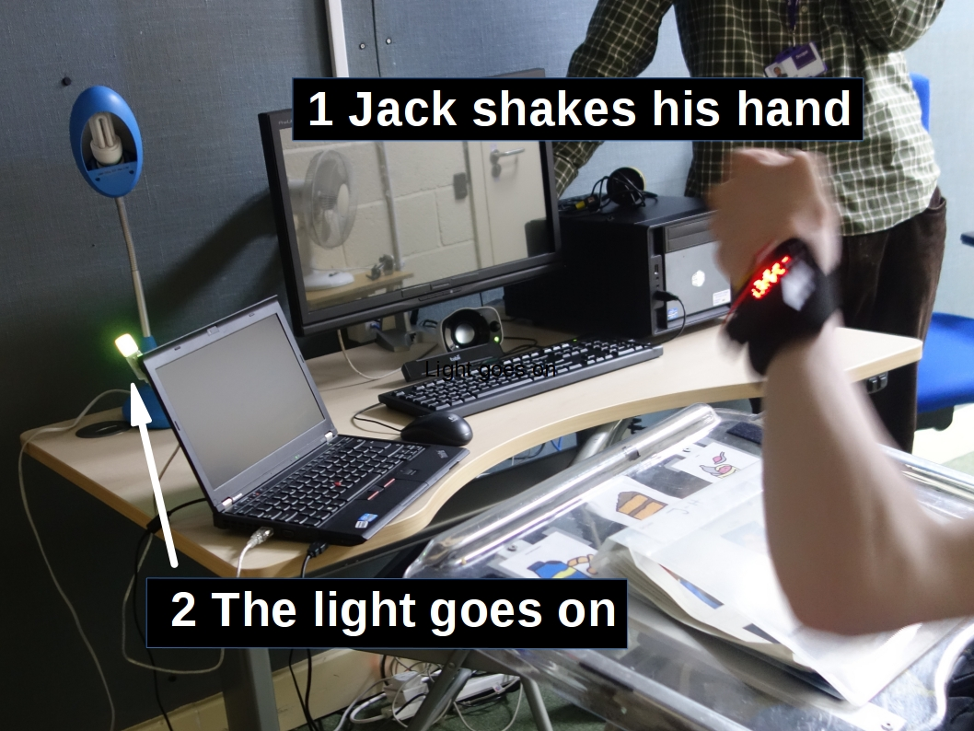Illustration 1: Testing HandShake, using a light to show when a gesture is detected

Project files and website
Download the latest version of this manual and code from:
https://github.com/hardwaremonkey/microbit_assistive_technology
Click on the ‘clone or download’ button and download and extract the files from the zip file.
Project website at:
http://seismicmatt.com/handshake/

Safety
The BBC micro:bit was designed to be used in education with 11-12 year olds.
The transmitter board is powered by two AAA batteries in a case. Normal safety practice should be followed with the batteries – keep them dry.

Parts
2 x BBC micro:bit boards
1 x AAA battery pack for a microbit board
1 x wrist holder - construction instructions below
optional
Freetronics Leostick - to enable HandShake to control software. This is optional if you are just using the blink(1) to help a student associate hand movement with an external change.
https://www.freetronics.com.au/products/leostick#.WZSSoJ_6y00
blink(1) LED - to have HandShake make pretty lights flash – this is optional if you are looking to control software through a keystroke only.
https://blink1.thingm.com/
1 x USB extension cable if you are using the blink(1) so that you can mount the blink(1) somewhere that the student can clearly see it.

How to make your microbit wrist holder
This section shows you how to convert a £3 iPod 7 arm band into a wrist or arm holder for a BBC micro:bit board and battery. The photo shows the creation with a micro:bit and battery pack being modelled by the local electronics wear supermodel.

Parts
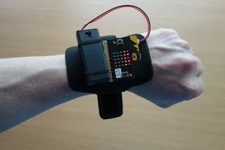Illustration 2: micro:bit transmitter and battery pack on the wrist holder
I purchased a 'King of Flash New iPod Nano 7th Generation Premium Water Resistant Armband Case' from eBay for the princely sum of £3.
You'll need a needle and some thread.
About 20cm of 3mm or so wide elastic.

Assembly
Start of by laying out your arm band smart phone holder. This is the last time you'll be seeing it in one piece.
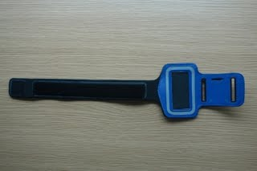
Remove the plastic iPod holder bit with a few minutes of cutting with a suitably sharp instrument.
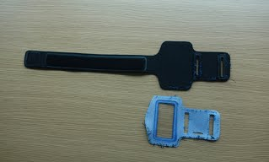
You need to sew back one of the plastic belt reinforcements on to the first of the two belt slots.
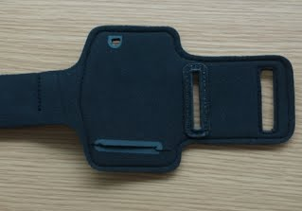
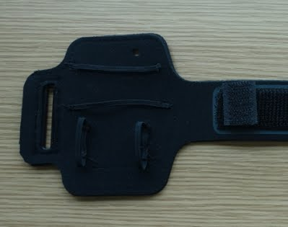
You can cut off the neoprene with the second slot. If you are using the modified arm band to attach to the wrist, then you can also trim down the length of the belt as it is sized to be long enough to go around a biceps. Even my weedy biceps are much larger than my wrist. Sew on some elastic loops to hold the micro:bit board and the battery holder. I bought a 1m piece of 3mm black elastic from eBay to do this.
To get the belt to stick to itself and close the holder, I used some sticky back Velcro of the 'hook' gender. I stuck two pieces back to back to form a Velcro 'gender bender'. This sticks to the belt part of the Velcro on the holder, next to where the board and battery will sit.
The assembled wrist holder with the micro:bit and battery pack is shown below. I use a AAA battery holder with a switch on it that I also bought from eBay for about £2 instead of the 'always on' battery pack that came with the micro:bit.
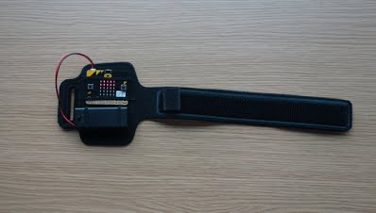
If you are worried about the battery pack flying off after a violent wrist motion, you can double secure it with some sticky back Velcro between the back of the battery pack and the neoprene of the wrist mount.

Operating Instructions
The transmitter microbit goes on your wrist, the receiver microbit is connected to your PC or laptop using a micro USB cable. Each microbit needs to have the correct Micropython code loaded. To have the system interact with Sensory Software's Grid 2, a Freetronic's Leostick needs to be in another USB port on the PC. The Leostick needs some code loaded on to it. See section Leostick keyboard key press.
Finally, a python script needs to be running on the communications device that the receiver microbit is plugged into.

Getting code onto the micro:bit transmitter and receiver boards
We need to get some code into the microbits. Let's deal with the transmitter, which is the microbit worn on the wrist. To get code onto the microbit we need to download and install the BBC Micropython programming package called mu. Full instructions can be found here:
https://github.com/mu-editor/mu
Plug in the microbit to a USB port. Double click on the name 'MICROBIT' in a file browser to connect the board with your device.
Load the python script called shake_send.py into mu. Then click on 'flash' and the code will be loaded onto the microbit.
Unplug this microbit. This is now the transmitter microbit.
To set up the receiver microbit which will remain plugged into your computer or communications device to receive shake signals from the transmitter board, plug the receiver microbit into your computer. Double click on the name 'MICROBIT' in a file browser to connect the board with your computer.
Load the python script called shake_receive.py into mu. Click on 'flash' to load this onto the microbit. Now you have the receiver set up.
Now when you restart the microbit, you should see an array of lit LEDs, the number of which change as you move your hand around. See Illustration 3.

Use
As you move the transmitter microbit, you will see bright LEDs light and turn off. The harder you shake the board, the more LEDs will light up. The LEDs go off as the motion of the board slows down. See Illustration 3. If you look closely at the transmitter board, you will also see some faint LEDs. The number of faint LEDs stays the same as you move the board around. The number of faint LEDs lit shows the sensitivity of the board. The more faint LEDs there are, the lower the sensitivity, so the harder the board has to be shaken to cause a trigger to be sent to the communication device.
Once there are more bright LEDs lit than faint ones, the board triggers that a gesture has been detected and signals the receiver board that this has happened. The LEDs on both of the transmitter and receiver will flash a chequered chessboard pattern when it triggers that a shake has been detected. See Illustration 4.
The receiver shows a diamond pattern on it while it is operating in between detections - see Illustration 5.
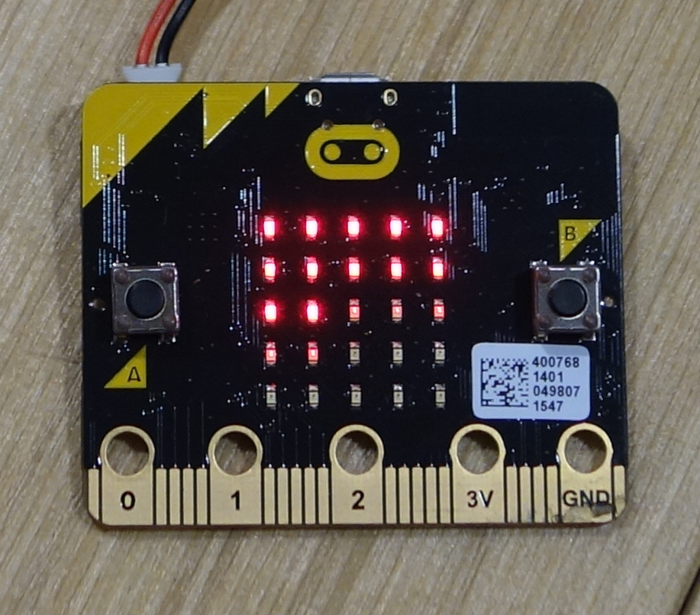Illustration 3: Transmitter in normal operation. The bright LEDs are the amount of shake detected, the faint ones show the detection threshold. | 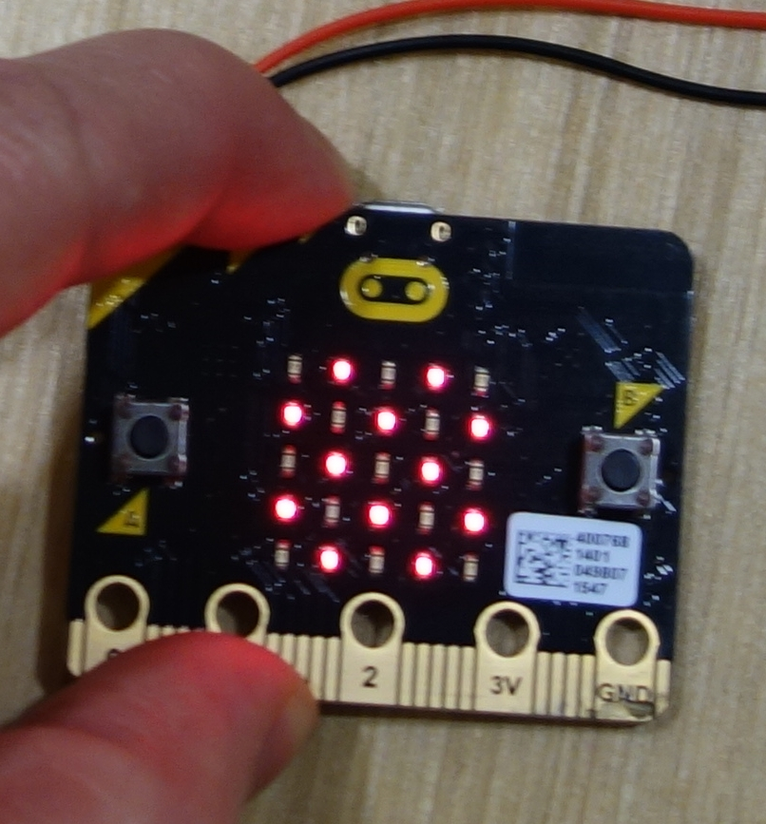Illustration 4: Transmitter showing that a shake is detected. The receiver makes the same pattern when a gesture is detected.

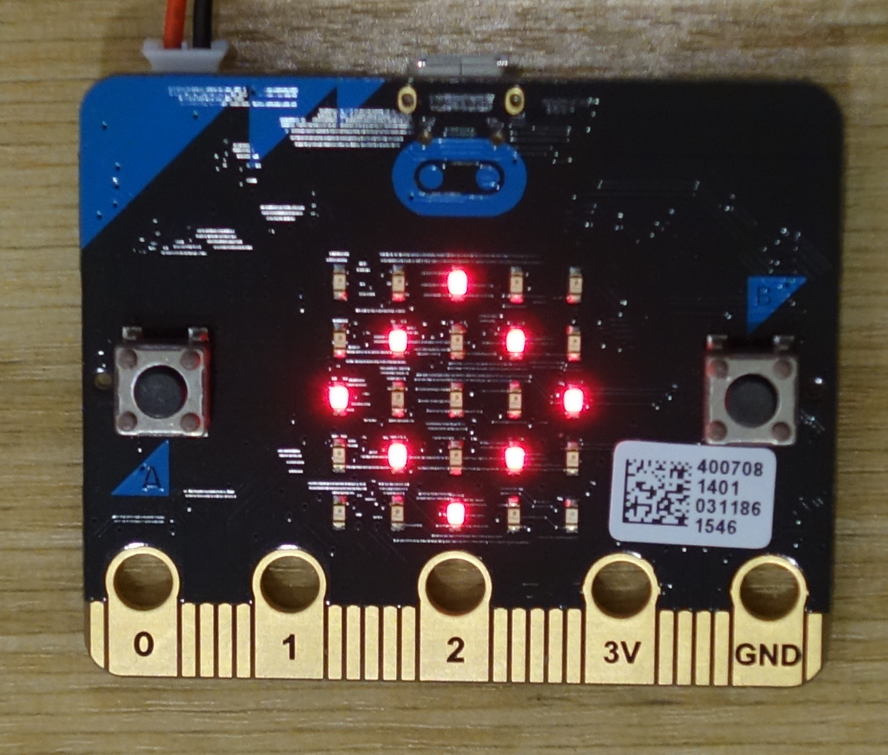Illustration 5: Receiver microbit turned on. | 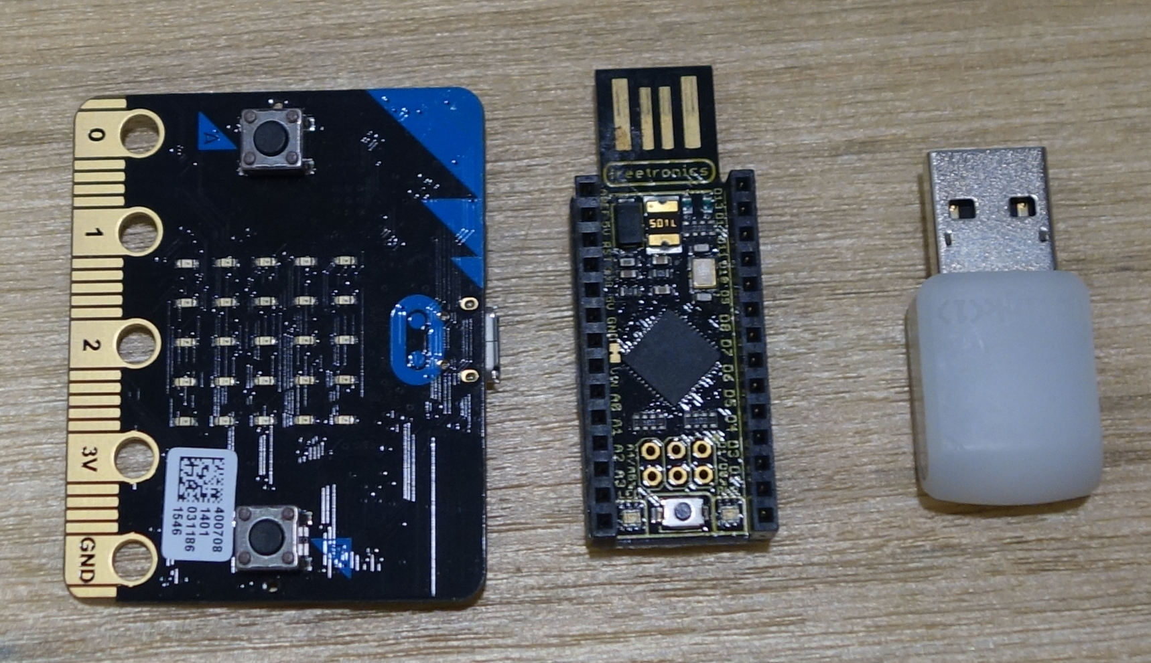Illustration 6: Left to right: micro:bit, Leostick, Blink(1)

How to alter the sensitivity
The micro:bit has two buttons, labelled 'a' and 'b'. You can alter the sensitivity of the system by using the buttons on either the transmitter or the receiver. Or both. This means that the transmitter can be in use and you can alter the shake detection threshold without having to interfere with whoever is using it.
Pushing the button labelled 'a' causes a '-' symbol to appear briefly on the transmitter's LEDs. This makes it easier for a gentle shake to be detected. Each time you press the button a single faint LED will turn off and remain off and the sensitivity to a shake is increased.
Pushing the button labelled 'b' will make a '+' symbol appear on the LED. This will make it harder for a gentle shake to be detected. Each time you press the button, a single faint LED will be lit and remain lit. You will need to shake the board harder to get it to trigger.
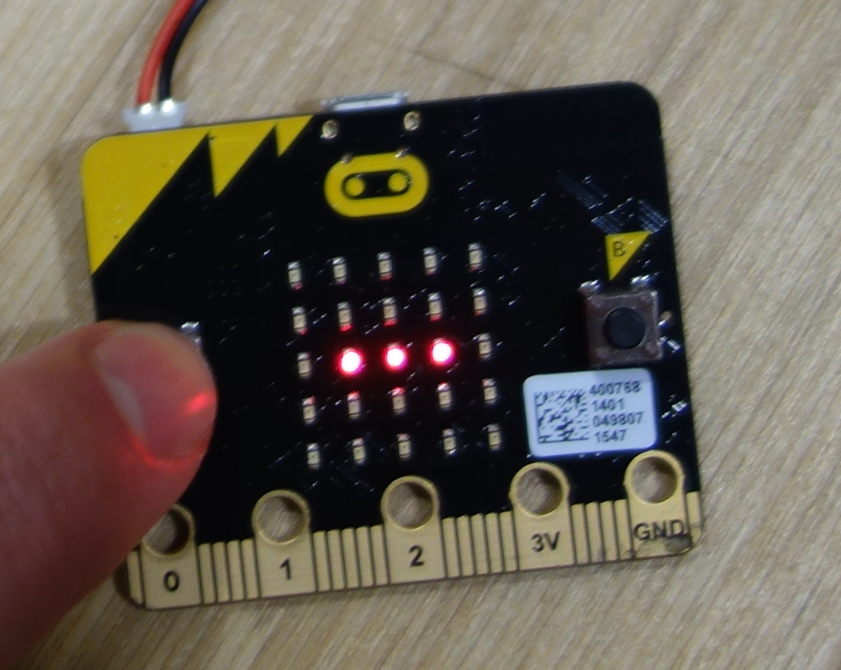 | 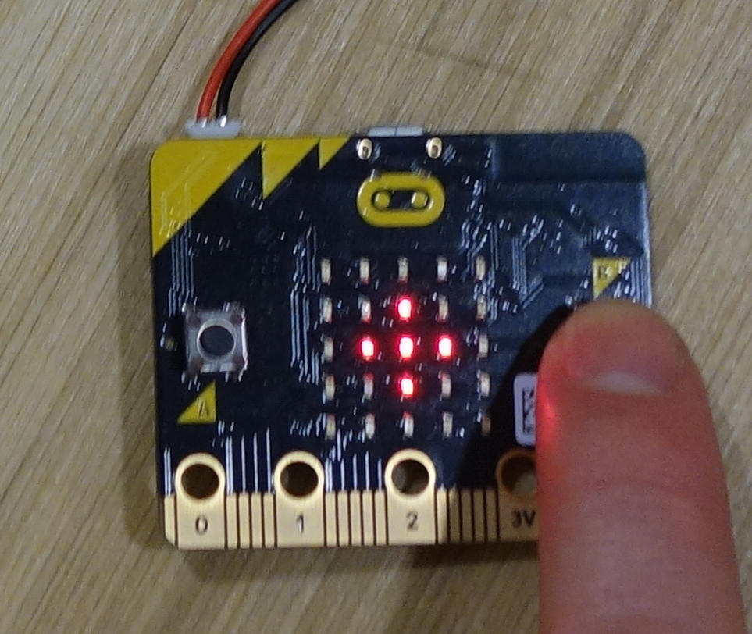
Button A press. HandShake now needs a gentler shake to react to. | Button B press. HandShake now needs a harder shake to react to.

The transmitter board records the last sensitivity set when it is powered off. This means that you don't have to tune in the sensitivity for the same user each time that the board is turned on.

Running the python script on the communication device
The Python script takes the signal from the receiver microbit and passes it on to the blink(1) and the Leostick. The script does not mind if neither, one or both of these devices are attached.
I packaged up the Python script into a cx_freeze container, so ideally you do not need to install Python. The cx_freeze container has an executable file called blink_leo.exe that runs the software.
If you download the files from Github and unzip the zip file, the directory windows_executable_cx_freeze has all the necessary files to run the application – see section Project files and website on where to find the GitHub files and how to download them. If you double click on the file:
"...\microbit\hand_gesture\base\windows_executable_cx_freeze\build\exe.win-amd64-3.6\blink_leo.exe"
A command window should open up running the application. This will look for the microbit, then look for the Leostick, then look for the blink(1). I t can take a few seconds for each device to be found. The Leostick will flash when it is located. Each time that a shake is detected, this will be logged, the blink(1) will flash (if one is attached) and a keystroke sent to whichever window has ‘focus’ if a Leostick is attached. If the Leostick is attached, try opening up a terminal window or text editor then click on it to give this focus. Each time a shake is detected you will see the letter ‘z’ appear. Configure Grid 3 to run from this key press and you can now operate the software using shake detection.
Example output from running blink_leo.exe
looking for microbit
scanning ports
pid: None vid: None
pid: 516 vid: 3368
found target device pid: 516 vid: 3368 port: COM4
looking for leostick
scanning ports
pid: None vid: None
pid: 516 vid: 3368
pid: 32822 vid: 9025
found target device pid: 32822 vid: 9025 port: COM5
handshaking with leostick
sent L to Leostick
from Leostick:
opening and monitoring microbit port
17:27:50 microbit: running_time: 307803

17:27:50 microbit: shake

shake detected
open failed
17:27:51 microbit: running_time: 308526

17:27:51 microbit: shake

Python installation
If the cx_freeze download does not work for you, or you want to develop the underlying script, then you need to download Python and a few libraries. The underlying Python script can be run from the command line.

Download and install the 64-bit python3.6 installation. There are plenty of websites and YouTube videos that will walk you through this.

There are a few libraries that need to be installed that the python script uses. These are pypiwin32, pyusb, webcolors and blink1

From a terminal type:

pip install pypiwin32 pyusb webcolors blink1

Do not install pywin32. This is outdated. We need pypiwin32.
To run the software, go to the directory:

microbit_AT/hand_gesture/base

type:

python blink_leo.py

The script will open in a new terminal. See section Running the python script on the communication device on what happens when the application is run.

Controlling a PC application using HandShake
Plug the receiver board in to your laptop or PC using a USB cable. If you run one of the receiver python scripts, this will detect the receiver microbit and respond to messages from it. The receiver microbit will send out a message through the USB cable to the PC when it receives a message from the transmitter board that a gesture has been detected.
There are two example applications. One causes a blink(1) multicoloured LED to flash. This is useful for tuning in the sensitivity with a new user. The second application spoofs a key being pressed on the keyboard by using a Leostick. This allows programs like Sensory Software’s Grid 2 to be controlled using the system.
Both of these use the same python script running on the PC. This is blink_leo.py. Download this from the GitHub site mentioned at the start of this document. You need to have python 3 installed for this to run. Plus a couple of python libraries that it calls.

Blink(1) programmable LED
I wrote a script to make the blink(1) USB LED flash a pretty pattern when a shake is detected with HandShake. Plug in the blink(1) to a free USB port and the receiver microbit before running the script. The script identifies that both the microbit and the blink(1) are connected to USB ports and sends a command to the blink(1) to flash whenever a code is received from the receiver microbit that a shake has been detected.
No drivers are needed for the blink(1) with Windows.

Leostick keyboard key press
Software like Sensory Software's Grid 2 does not respond to software keyboard key strokes. I know as I tried and failed. Then I contacted the author of the software to verify this. Some might say a sensible man would have contacted the author first. The only way I found to interact with it was by using an Arduino Leonardo or clone, which can be coded to pretend to be a physical keyboard. It is a bit of a circuitous route getting your hand shake from the transmitter into Grid 2, but it works fast enough that you do not notice. The transmitter tells the receiver that a shake has been detected. Then the receiver tells the script running on the PC or laptop. This in turn sends a trigger to the Leonardo or Leostick. The Leostick then says 'I'm a keyboard, here's a key press'. Which controls the Grid 2 software. Simple!
Here's the flow of information:
Transmitter -> *shake detected* -> receiver -> PC -> Leostick -> PC -> Grid
The Grid 2 software must be configured to run from a keyboard press and the key press to respond to is the character 'z'.
I use Freetronic's Leostick 2 as the pretend keyboard as it has a small form factor. It is the size of a small USB stick. It needs to have the program 'keyboard_leo_3.ino' loaded on to it. This program is on the GitHub site in the base directory. There are plenty of sites on the web that teach you how to load code onto an Arduino clone better than I can here. You should also visit the Freetronics site at:
https://www.freetronics.com.au/pages/leostick-getting-started-guide#.WaB0mZ_6y00
You can use the code without any modification with an Arduino Leonardo. You need to change the PID and VID that is looked for in the python script though, as this will differ between a Leostick and a Leonardo. The Leonardo is larger than the Leostick but cheaper. You need the Leonardo or the Leostick as these can pretend to be a physical keyboard, whereas the regular Arduino cannot.
The Leostick needs a driver to be installed with Windows unless you are using Windows 10. For details on how to do this see:
https://www.freetronics.com.au/pages/installing-the-usb-driver-file-for-windows#.W3RQnp8oS00

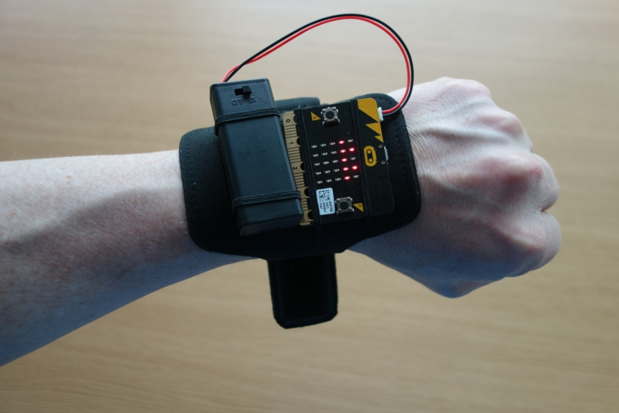Illustration 7: The microbit, battery holder and wrist mount

Potential radio problem if more than one HandShake is in use
The micro:bit radio is set to use one of the 65,000 channel and group combinations available to it. Two micro:bit handshake systems could interfere. Fixing this interference requires changing a couple of lines of code in the transmitter and receiver scripts for one of the systems, to have it use a different channel or group. If you are using multiple handshake systems in the same area, send me an email and I will send out some code with a different channel and group configuration. Or, as the microbit is deployed to year 7 in the UK – ask a friendly 12-year old to do this!

