For 85%:

Write an application called M006App that has a button (JButton) labeled “Change”, a red circle and a green square (each 50 pixels across). Each time the button is pressed, the circle grows by 10 pixels and the square shrinks by 10 pixels. Whenever a shape gets too small (less than or equal to 20 pixels across) or too big (greater than or equal to 100 pixels across) it reverses its growth pattern (i.e., if it was shrinking, it now grows, or vice versa.).

All instance variables must be declared private.

Use M006 as the folder/directory name to store the java files.

For an Additional 10 Percentage Points (Total of 95%):

Define the circle and square using two separate classes; Circle and Square.

Again, all instance variables must be declared private.

These class definitions may be placed in a single or multiple .java files

For Another 15 Percentage Points (Total of 110%):

Define a “super” class called Shapes for the common items shared by both the Circle and Square “sub-classes”. (I would like for you to use your understanding of inheritance for this portion.)

The instance variables associated with the “super” class should be declared as private.

Please see notes on the following page.

Notes:

- Only one version for this program is to be submitted for evaluation! If multiple versions are submitted, no credit will be given for any version.

- A sample display is provided below:

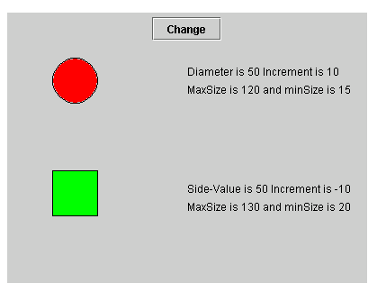

The comments at the right-side of the display are optional.

