

|  |
| --- |
| Prototype1 |
| 29/06/15 15:10 |
| **Author:** John Doe  **File name:** Prototype1.vp  **Version** 1.0 |

|  |
| --- |
| Site Map |
|  |

|  |
| --- |
|  |

01. Site Map / Prototype1 

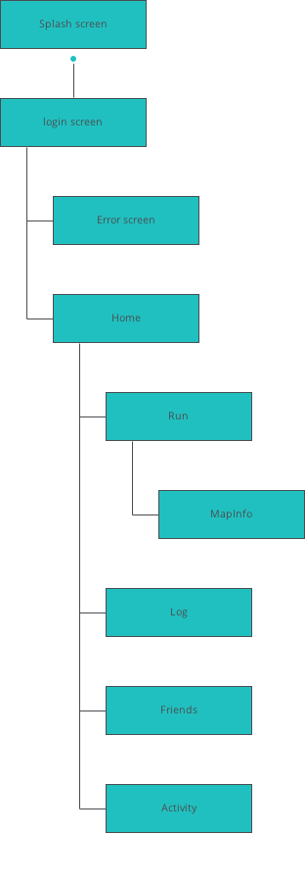

|  |
| --- |
| Screens |
|  |

|  |
| --- |
|  |

02. Screens / Prototype1 

Splash screen

|  |
| --- |
|  |

Interactions

|  |  |
| --- | --- |
| 1 | **on Page Load:** goes to 'login screen' with effect: fade 🡪 |

02. Screens / Prototype1 

login screen

|  |
| --- |
|  |

Interactions

|  |  |
| --- | --- |
| 2 | **on Click:** goes to 'Error screen' with effect: slide left 🡪 |
| 3 | **on Click:** goes to 'Home' 🡪 |

02. Screens / Prototype1 

Error screen

|  |
| --- |
|  |

Interactions

|  |  |
| --- | --- |
| 4 | **on Click:** goes to 'login screen' with effect: slide right 🡪 |

02. Screens / Prototype1 

Home

|  |
| --- |
|  |

02. Screens / Prototype1 

Run

|  |
| --- |
|  |

Interactions

|  |  |
| --- | --- |
| 5 | **on Click:** goes to 'MapInfo' 🡪 |

02. Screens / Run 

Other states

|  |  |
| --- | --- |
|  |  |
|  |  |

02. Screens / Prototype1 

MapInfo

|  |
| --- |
|  |

Interactions

|  |  |
| --- | --- |
| 6 | **on Click:** goes to 'Run' 🡪 |

02. Screens / MapInfo 

Other states

|  |  |
| --- | --- |
|  |  |
|  |  |
|  |  |

02. Screens / Prototype1 

RunActive

|  |
| --- |
|  |

Interactions

|  |  |
| --- | --- |
| 7 | **on Page Load:** goes to 'RunSummary' 🡪 |

02. Screens / RunActive 

Other states

|  |  |
| --- | --- |
|  |  |
|  |  |
|  |  |
|  |  |

02. Screens / Prototype1 

RunPlayback

|  |
| --- |
|  |

Interactions

|  |  |
| --- | --- |
| 8 | **on Click:** goes to 'Home' 🡪 |

02. Screens / RunPlayback 

Other states

|  |  |
| --- | --- |
|  |  |
|  |  |
|  |  |

02. Screens / Prototype1 

RunSummary

|  |
| --- |
|  |

Interactions

|  |  |
| --- | --- |
| 9 | **on Click:** goes to 'RunPlayback' 🡪 |

02. Screens / Prototype1 

Log

|  |
| --- |
|  |

02. Screens / Prototype1 

Friends

|  |
| --- |
|  |

02. Screens / Prototype1 

Activity

|  |
| --- |
|  |

|  |
| --- |
| Templates |
|  |

|  |
| --- |
|  |

03. Templates / Prototype1 

Essentials

|  |
| --- |
|  |

Interactions

|  |  |
| --- | --- |
| 10 | **on Click:** goes to 'Home' 🡪 |
| 11 | **on Click:** goes to 'Run' 🡪 |
| 12 | **on Click:** goes to 'Log' 🡪 |
| 13 | **on Click:** goes to 'Friends' 🡪 |
| 14 | **on Click:** goes to 'Home' 🡪 |
| 15 | **on Click:** goes to 'Run' 🡪 |
| 16 | **on Click:** goes to 'Log' 🡪 |
| 17 | **on Click:** goes to 'Friends' 🡪 |
| 18 | **on Click:** goes to 'Activity' 🡪 |
| 19 | **on Click:** goes to 'login screen' 🡪 |

03. Templates / Prototype1 

Run

|  |
| --- |
|  |

Interactions

|  |  |
| --- | --- |
| 20 | **on Click:** goes to 'Home' 🡪 |
| 21 | **on Click:** goes to 'Run' 🡪 |
| 22 | **on Click:** goes to 'Log' 🡪 |
| 23 | **on Click:** goes to 'login screen' 🡪 |
| 24 | **on Click:** goes to 'login screen' 🡪 |
| 25 | **on Click:** goes to 'login screen' 🡪 |
| 26 | **on Click:** goes to 'login screen' 🡪 |
| 27 | **on Click:** goes to 'Home' 🡪 |
| 28 | **on Click:** goes to 'Run' 🡪 |
| 29 | **on Click:** goes to 'Log' 🡪 |
| 30 | **on Click:** goes to 'login screen' 🡪 |
| 31 | **on Click:** goes to 'login screen' 🡪 |
| 32 | **on Click:** goes to 'login screen' 🡪 |
| 33 | **on Click:** goes to 'login screen' 🡪 |
| 34 | **on Click:** goes to 'login screen' 🡪 |
| 35 | **on Click:** goes to 'login screen' 🡪 |
| 36 | **on Click:** goes to 'login screen' 🡪 |
| 37 | **on Click:** goes to 'login screen' 🡪 |
| 38 | **on Click:** goes to 'login screen' 🡪 |
| 39 | **on Click:** goes to 'Activity' 🡪 |
| 40 | **on Click:** goes to 'Friends' 🡪 |
| 41 | **on Click:** goes to 'Log' 🡪 |
| 42 | **on Click:** goes to 'Run' 🡪 |
| 43 | **on Click:** goes to 'Home' 🡪 |

03. Templates / Prototype1 

Template 1

|  |
| --- |
|  |

|  |
| --- |
| Scenarios |
|  |

|  |
| --- |
|  |

04. Scenarios / Prototype1 

default

|  |
| --- |
|  |

|  |
| --- |
| Data Masters |
|  |

|  |
| --- |
|  |

05. Data Masters / Prototype1 

Mail

|  |  |  |
| --- | --- | --- |
| Attribute name | Type | Values |
| From | text | values |
| Subject | text | values |
| Body | text | values |
| Read | text | values |
| Date | text | values |
| Picture | file upload | values |
| Star | file upload | values |

Run

|  |  |  |
| --- | --- | --- |
| Attribute name | Type | Values |
| name | text | values |
| description | text | values |
| favorite | file upload | values |
| isFavorite | true/false | values |

Run2

|  |  |  |
| --- | --- | --- |
| Attribute name | Type | Values |
| name | text | values |
| description | text | values |
| favorite | file upload | values |

Run3

|  |  |  |
| --- | --- | --- |
| Attribute name | Type | Values |
| name | text | values |
| description | text | values |
| favorite | file upload | values |

RunData

|  |  |  |
| --- | --- | --- |
| Attribute name | Type | Values |
| id | text | values |
| name | text | values |
| location | text | values |
| city | text | values |
| distance | text | values |
| tokens | text | values |
| favorites | text | values |
| favorited | text | values |
| recent | text | values |