Matthew Provini

Mahmoud Ezat

*Team 6 - Go Getters*

***Getter* System Design Document**

*Getter* System Design Document

# **Introduction** (MP)

The purpose of this is to provide a layout and plan the functions that are needed to create the Getter application. In this document, you will find a distinct summary of the feature necessities, together with diagrams outlining the layout utilities. The class Diagrams will define all of the design gadgets, their attributes, and their techniques. Additionally, the First Cut Domain Sequence Diagrams will be used to show the uses of each system used in Getter on a timeline.

# **Class Diagrams** (ME)

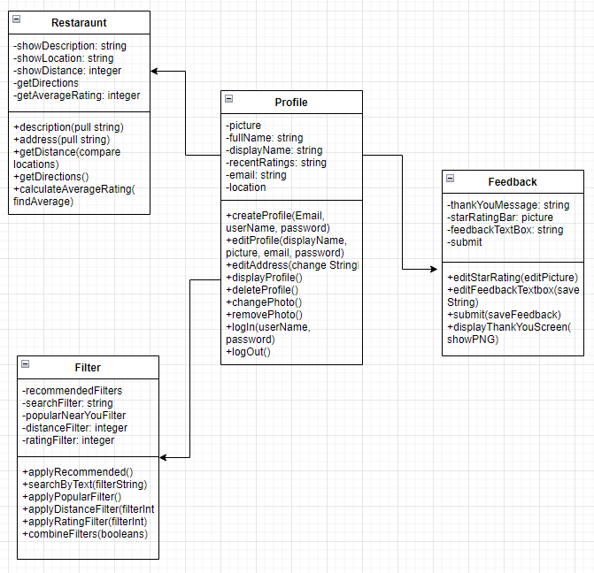

# **First Cut Domain Sequence Diagrams** (MP)

