**VASP_HW1**

1. Perform a calculation to find the minimum energy configuration (volume and ions positions) of Si in both FCC and Diamond structures (relax both the ions and the volume). Report the energy and the lattice parameter of each structure and compare their energies.

FCC: E0= -4.878, 1 atom; Lattice Parameter= 3.9 A

Cubic: E0= -10.827, 2 atoms, **-5.414 per atom**; Lattice Parameter = 5.5 A

Cubic is more energetically favorable

1. Starting from the structures obtained in problem1 calculate the energy vs. volume and the bulk modulus of both structures.

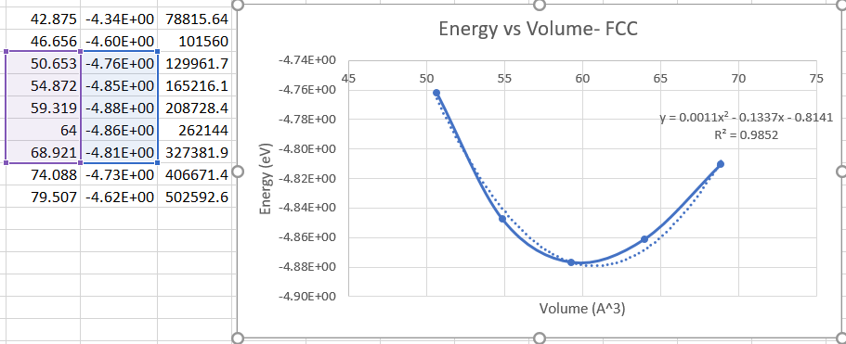 Bulk Modulus B= V*y’’,

y’’=0.0022, volume at minimum energy V= 60.7 A^3, **B= 0.134 Ev/A^3**

**B=21.40 GPa**

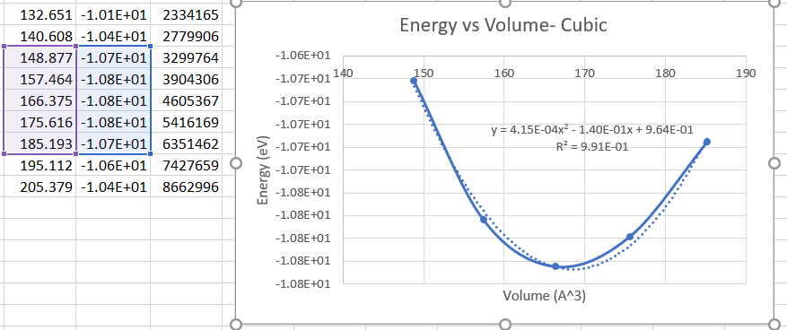Bulk Modulus y’’= 0.00083, volume at minimum energy = 168.2 A^3, **B= 0.140 ev/A**

**B=22.37 GPa**

1. Starting from the diamond structure obtained in problem1 perform convergence test with respect to K-points and cutoff energy.

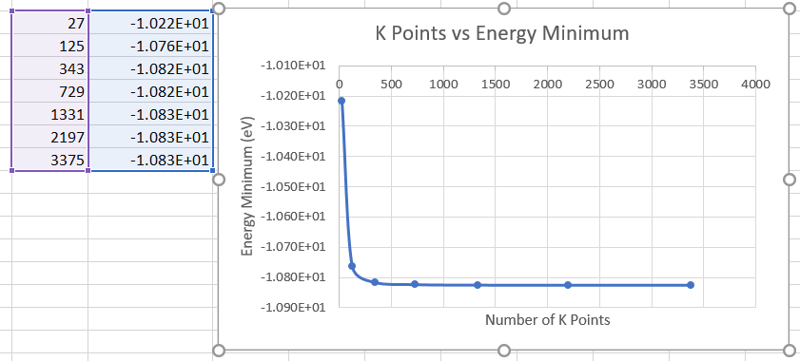

**K Points > 343 (7x7x7) shows very little change in energy minimum**

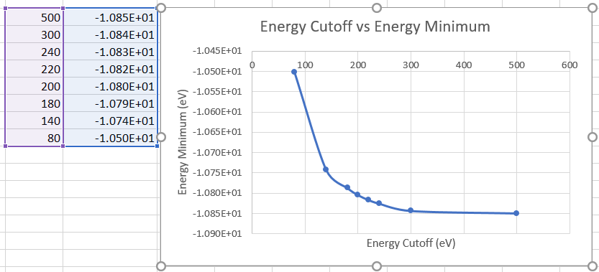

**Energy Cutoff > 300 eV shows very little change in energy minimum**

1. Start Ex4 and Ex5 (under Lab7) from the GitHub and include the outputs in your HW folder on the GitHub.