**Project Brief Form 2019-20**

|  |  |  |  |  |  |
| --- | --- | --- | --- | --- | --- |
| *Student Name* | **(in capitals)**  **MATTHEW RANKIN** | | *Id Number* | | **B620005** |
| *Supervisor* | **(in capitals)**  **ANDREA SOLTOGGIO** | | | | |
| *Programme* | **(e.g. Computer Science BSc)**  **Computer Science and Mathematics** | *Module code* | | **(e.g. COC251)**  COC255 | |

|  |
| --- |
| ALL BOXES IN THIS SECTION SHOULD BE TICKED.  mage result for tick in white box The attached project brief is agreed between the supervisor and the student as a  description of the proposed project work.  mage result for tick in white box A provisional workplan is attached. (on subsequent pages)  mage result for tick in white box The Brief Ethical Clearance Checklist (BECC) form has been filled and submitted.  mage result for tick in white box If any answers on the Brief Ethical Clearance Checklist have been marked as **Yes**, the advanced Ethical Clearance Checklist (ECC) has been completed and submitted. *If the question on ‘Positions of Authority’ is answered yes, because fellow students will provide feedback on the project, the generic protocol G05-P2 is listed at the end of the form in the space for additional information.*  mage result for tick in white box If a †, * or # symbol appears with any answer on the ECC, except in the case above, as well as handing in a completed ECC form with this brief, a copy has been sent to Jackie Green: [J.A.Green@lboro.ac.uk](mailto:J.A.Green@lboro.ac.uk), Secretary to the Ethics Approvals (Human Participants) Sub-Committee. |

|  |
| --- |
| Part C students to highlight/mark the column matching their project module code.  Part D (COD290) students to highlight the column matching their part C project module code. |
| |  |  |  |  |  |  |  |  | | --- | --- | --- | --- | --- | --- | --- | --- | | Project Code -->  Project Title -->  Programme(s) --> | COC251  CS  (CS) | COC252  Computing  (C+M, IMC, ITMB,  IMWD) | COC253  IT  (C+M, IMC, ITMB,  IMWD) | COC255  CS+Math  (CS-Math) | COC257  CS+AI  (CS-AI) | COC259  Web Dev  (WebDev) | COC800  Software  (China) | | Requires programming content. | X | X |  |  | X |  | X | | Requires CS and maths content. |  |  |  | X |  |  |  | | Requires AI content. |  |  |  |  | X |  |  | | Requires IT content. |  |  | X |  |  |  |  | | Must be Web-based |  |  |  |  |  | X |  | | Requires a real customer. |  | X (ITMB) | X (ITMB) |  |  |  |  |   Bottom of Form |

|  |  |
| --- | --- |
| *Student signature:* |  |

# **Project Description**

* **Abstract:**

The purpose of the project is to create a chatbot which will use 3rd party APIs and structures to bring together a responding bot that answers queries from a user. I will integrate parts of software from different areas as well as creating a neural network which uses deep learning in order for the bot to train itself to model complex relationships.

* **How it Communicates:**

The interface will be use Telegram API, which is an instant messaging service like WhatsApp or Facebook, to communicate with the user. The user will then be able to ask the bot inside this application questions and receive the appropriate responses.

* **System**

Python is the desired language for this project due to the many capabilities as well as endless libraries which can aid towards the creation of a chatbot. The chatbot will use Machine Learning and complex mathematical algorithms to enhance performance.

* **NLP + Sentiment Analysis:**

Natural Language Processing (NLP) and sentiment analysis APIs will also be integrated into my bot in order for human-to-machine communications. The implication of these API will allow for the building of conversation flow between the human and the bot. This will create real life-like interactions due to the machine learning algorithms and real life data to allow for a deep learning chatbot. The best way of deep learning is from human-to-human conversations, Python libraries such as NLTK and Tensorflow will become useful when I reach the stage of deep learning within the project.

* **Conclusion:**

To consider this project successful, I would aim to create a working communicating chatbot that has integrated API’s. The bot would have capabilities of understanding the user through processing a request using NLP and sentiment analysis and providing a response that is helpful and meaningful to that user. Progression in the project would see the introduction of a deep learning bot that can replicate complex relations within human-to-human conversations.

* **References:**

Telegram: <https://core.telegram.org/api/obtaining_api_id>

Sentiment analysis: <https://towardsdatascience.com/sentiment-analysis-concept-analysis-and-applications-6c94d6f58c17>

Python:

<https://www.invensis.net/blog/it/benefits-of-python-over-other-programming-languages/>

Deep learning:

<https://hackernoon.com/deep-learning-chatbot-everything-you-need-to-know-r11jm30bc>

NLTK:

<http://www.nltk.org/>

Requirements:

<https://chatbotsmagazine.com/how-to-document-chatbot-requirements-7df81275cc66>

**Workplan with Gantt Chart**

Below is the Gantt Chart I have created to keep organised with deliverables and tasks throughout the project:

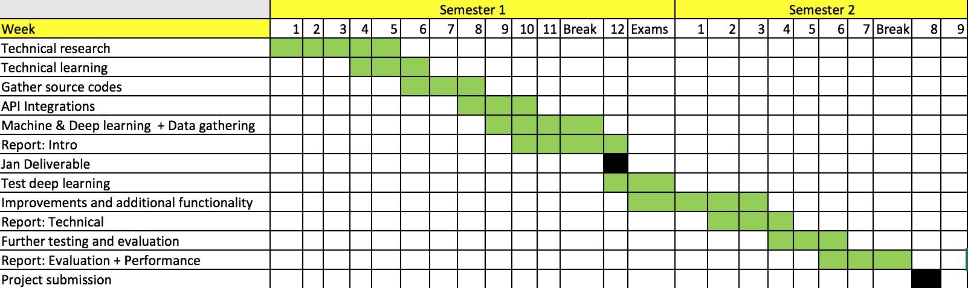

**Ethical Checklist for Taught Student Projects**

All students should discuss with their supervisor whether their project might conflict with the University’s ethical principles which can be found in the [Ethical Policy Framework.](http://www.lboro.ac.uk/media/wwwlboroacuk/content/universitycommittees/ethicscommitee/MASTER%20Ethical%20Framework.pdf)

Students should complete the second column in the table below, discussing with their supervisor as appropriate.

|  |  |  |
| --- | --- | --- |
| **Aspect of project** | **Does the project involve this aspect? (Yes / No)** | **If Yes, follow the process(es) below** |
| Experiments with human participants | NO | Follow guidance from the Ethical  Advisory (Human Participants) SubCommittee |
| Activity falling under the Human  Tissues Act | NO | Follow guidance from the Human Tissue Act Licence Sub-Committee |
| Funding by philanthropic gifts | NO | Follow guidance in Appendix 5 of the Ethical policy Framework |
| Military Applications | NO | Follow guidance in Appendix 6 of the Ethical policy Framework |
| Animal testing | NO | Contact the Research Office |
| Possible conflict with ethical principles partially or wholly outside the above. | NO | Complete the general ethical checklist in Appendix 2 of the Ethical Policy Framework and forward to Dean of School or designated nominee along with project description. |

# Student Declaration

I confirm that I have discussed the ethical checklist with my supervisor and, if appropriate, followed the relevant guidance / made the relevant application.

Student name: Matthew Rankin

Signature: 

Date: 30/10/19

**Staff Declaration to be entered in Feedback section**