**Fixsel project**

Physical Pixel

Goal: think through screens and environments and porosity of digital information and space. What happens when digital information moves off/out of screens and into our spaces and environments? When we no longer (only) engage with digital information through ‘windows’ into a digital world?

Potential source for prompts: Thrift, Simondon, Hayles, Kirschenbaum, Balsamo, Bachelard, Mcluhan (programmed world).

Tech: ATTiny powered RGB LED inside origami 'water balloon'

colour of led set using conductive traces on outside

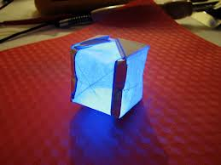

Build Process:

Trace printed circuit on paper using bare paint

Install ATTiny, LED, and Battery

Let dry (15 min)

Fold paper into origami balloon.

Process of use:

hold pixel near screen image

Hold traces to run through colours (web safe)  until find one that matches pixel on screen.

move pixel to alternative place and attach with sticky tape.

Parts:

Attiny 85

rgb led

cr2032

double-sided tape

bare paint (tubes)

paper square (precut with printed traces)