208pix/14pix=bricks = 14.857bricks

American Brick = (8x4x2.25) CONFIRMED by 14/4 ratio of pixel brick~3.5 very close to 8/2.25~3.5555

Thus multiply by

http://www.hintsandthings.co.uk/workshop/bricks.htm

203mm or 0.203m or 0.0203dekameters/brick

Yields a fire escape width of:

0.3016dekameters.

Height calc:

678-473 for height in pixels=205

In bricks that is 14.643

In decameters this is .2973dekameters.

Approximately a .30dekameter square. (number I might use).

Subway diverges from Top street to left or right 50% chance.

http://www.nysubway.com/map/zoom-midtown.html

google maps Anthony (0ld, new is Worth) and Orange (0ld,new is Baxter)

Cross (now (supposedly mosco)) will be called “All Saints’ Crossing”

Orange Street

Anthony Street

Anthony Street=150degree

All Saints’ Crossing=180some degree

Orange Street=270some degree

Sign post. What type? Arc, lamp or post

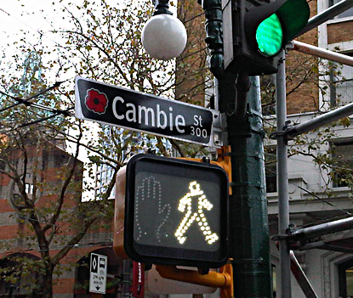
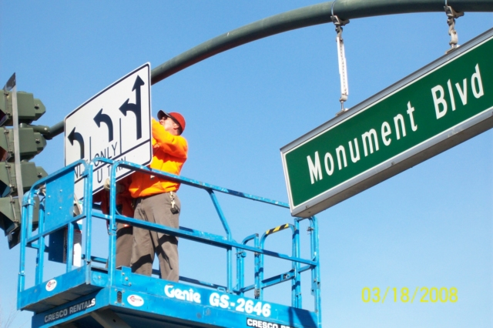
or reg…
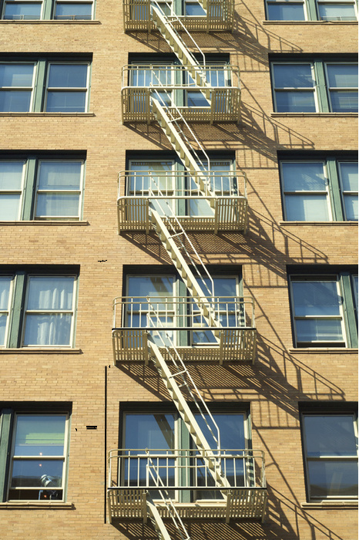
Black lines are how I determined pixel length.
Telephone pole:

http://en.wikipedia.org/wiki/Utility_pole

25ft high = .762 dekameters
125ft spacing (urban) = 3.81 dekameters
Circumference1= 43.5in = 0.11049 dekameters
C2= 27in = 0.06858 dekameters
Diameter1=0.03517dkm
D2= 0.02183dkm

“For example, a class 1 pole has a minimum top circumference of 27 inches. If it is 25 feet long and cedar (most utility poles are cedar), the circumference measured 6 feet from the bottom must be at least 43.5 inches.” http://www.sizes.com/materls/utilitypole.htm

Note six feet underground….

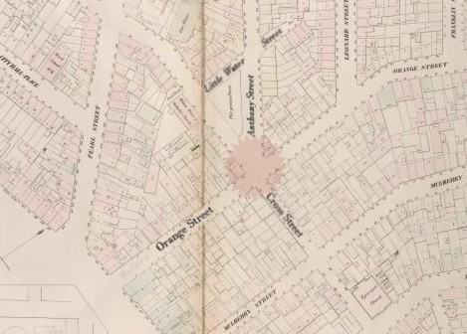

Subways – 30in. depth (street level to ceiling)

http://www.nycsubway.org/articles/rapid_transit_chamber_commerce_14.html

Need to rotate: see wiki, the other picture I found was right: it was a north/south split. Rotate 60 degrees for fair measure (not the full 90, because that would be too good/evil).

http://en.wikipedia.org/wiki/Five_Points,_Manhattan

This brings up a new point… scaffolds!
Also, Black Ops Sky huts from The misty night level on the rooftops! Possibly the most inspirational realistic imagery I’ve ever seen.

